**US_294154_Cognizant: Capture lease transaction from customer**

**Understanding of the requirement**

Collect the transactions from the plaid for a particular lease.

Match the selected transaction to the Rent Track, So that Rent Track can create the orders(Payment history)

**Assumptions**:

* Sandbox account and credentials for plaid connection are provided and we are able to access
* Any changes made in Rent Track API call, will be notified
* Any changes made in Plaid connection API call, will be notified
* GitLab Apiary access will be provided

**High level Technical design and solution**

* 1. Impacted Modules

BCM Modules

* 1. Impacted Workflows
     1. Overview:

**RentTrack API: GET /api/tenant/payment_accounts**

BCM will invoke the above payment account Rent Track API call to get the payment account details for the tenant user.

**RentTrack API: GET /api/tenant/leases**

BCM will invoke the above lease Rent Track API call to get the active lease details for the tenant user.

**RentTrack API : POST /api/tenant/transaction_finders**

Once we get lease details and payment account details, BCM will invoke the above create transaction finder api to create the transaction finder for that lease

BCM will store the transaction_finder_id in customer_data table against the ucid and brand.

**RentTrack API : GET /api/tenant/leases/{leaseId}/transaction_finders/{id}/search**

Once the transaction finder has been created, BCM will do search on the created transaction finder using the lease Id and transaction finder id

### **RentTrack API : POST /api/tenant/transaction_finders/{id}/match**

If transaction finder search found a single transaction, then BCM will invoke the above API to match transaction which will be the order of the Rent Track. Finally return with status Transaction Found.

If transaction finder search found a multiple transactions, then BCM will invoke the return the multiple transactions to allow the user to select the valid transaction with the status as “Multiple”.

If transaction finder search found no transaction, then BCM will invoke send the message as “We will continue for searching” and with the status “Missing”

### **RentTrack API : GET /api/tenant/transaction_finders/{id}/search**

If BCM receives the widen search transaction request, then BCM will invoke the above Rent Track API to search for the transactions with the maximum range of filter params.

* + 1. API Involved:

**GET /api/tenant/payment_accounts**

* + - * + BCM is the consumer
        + Error Codes:

200 - Returned when successful

204 - No content with such parameters

500 - Internal Server Error

**GET /api/tenant/leases**

* + - * + BCM is the consumer
        + Error Codes:

200 - Returned when successful

204 - No content with such parameters

500 - Internal Server Error

**POST /api/tenant/transaction_finders**

* + - * + BCM is the consumer
        + Payload : amount_min, amount_max, window_open, window_close, payment_account_url, lease_url
        + Error Codes:

201 - Returned when successful

400 - Error validating data. Please check parameters and retry.

404 - Payment Account or Consumer Lease not found

500 - Internal Server Error

GET **/api/tenant/leases/{leaseId}/transaction_finders/{id}/search**

* + - * + BCM is the consumer
        + Query Params : amount_min, amount_max, window_open, window_close
        + Error Codes:

200 - Returned when successful

204 - No content with such parameters

400 - Error validating data. Please check parameters and retry.

404 - Transaction Finder not found

500 - Internal Server Error

GET **/api/tenant/transaction_finders/{id}/search**

* + - * + BCM is the consumer
        + Query Params : amount_min, amount_max, window_open, window_close
        + Error Codes:

200 - Returned when successful

204 - No content with such parameters

400 - Error validating data. Please check parameters and retry.

404 - Transaction Finder not found

500 - Internal Server Error

POST **/api/tenant/transaction_finders/{id}/match**

* + - * + BCM is the consumer
        + Query Params : transaction_finder id
        + Payload : transaction object
        + Error Codes:

200 - Returned when successful

204 - No content with such parameters

400 - Error validating data. Please check parameters and retry.

404 - Transaction Finder not found

500 - Internal Server Error

* + 1. Messaging Infrastructure: N/A
    2. UI Screens: N/A
  1. DB Changes:

Customer Data and Auditing Table

Rent Track access token will be fetched from customer data based on ucid.

* 1. Dependencies

RentTrack API and Plaid connection

* 1. Blocker Inputs needed

N/A

* 1. Design Patterns considered and the chosen one

SOA

* 1. Sequence diagram

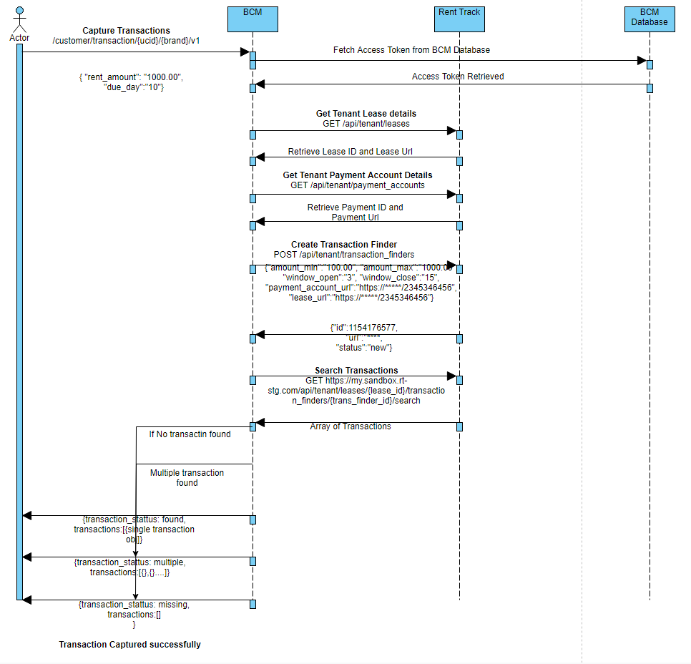

**Business** :

**Step 1 :**

BCM will receive the request for capturing transactions from the RSP(UI).

Request Payload

{

rent_amount : ”10.00”,

due_day : ”15”

}

**Step 2 :**

BCMwill fetch the access token based on the ucid and brand of the customer.

**Step 3 :**

With the access_token, BCM will invoke the below lease Rent Track API call to get the active lease details for the tenant user.

**RentTrack API: GET /api/tenant/leases**

**Response Payload :**

|  |  |  |  |
| --- | --- | --- | --- |
| Parameter | Type | Versions | Description |
| 200 - Returned when successful |  |  |  |
| [] | array of objects (Lease) | * |  |
| [][id] | integer | * |  |
| [][url] | string | * |  |
| [][status] | string | * |  |
| [][rent] | string | * |  |
| [][start_at] | string | * | Format "YYYY-MM-DD" |
| [][finished_at] | string | * | Format "YYYY-MM-DD" |
| [][due_day] | string | * |  |

**Step 4:**

BCM will invoke the above payment account Rent Track API call to get the payment account details for the tenant user.

**RentTrack API: GET /api/tenant/payment_accounts**

**Response Payload :**

| Parameter | Type | Versions | Description |
| --- | --- | --- | --- |
| 200 - Returned when successful |  | | |
| [] | array of objects (Payment) | * |  |
| [][id] | integer | * |  |
| [][url] | string | * |  |
| [][contract_url] | string | * |  |
| [][payment_account_url] | string | * | Deprecated. Please, use {payment_account.url} instead. |
| [][deposit_account_url] | string | * |  |
| [][status] | string | * | Status of payment execution: {'active'|'close'|'flagged'} |
| [][type] | string | * | {'recurring'|'one_time'|'immediate'} |
| [][rent] | string | * |  |
| [][amount] | string | * |  |
| [][other] | string | * |  |
| [][variable_recurring_limit] | string | * |  |
| [][day] | integer | * |  |
| [][deliver_date] | string | * | Optional. Returned only if supported. Format "YYYY-MM-DDThh:mm:ss" |
| [][month] | integer | * | Get startMonth |
| [][year] | integer | * | Get startYear |
| [][end_month] | integer | * | Get endMonth |
| [][end_year] | integer | * | Get endYear |
| [][paid_for] | string | * | Format:"YYYY-mm" |
| [][fee] | double | * |  |
| [][execute_date] | string | * | Format "YYYY-MM-DDThh:mm:ss" |
| [][payment_account] | object (PaymentAccount) | * |  |
| [][payment_account][id] | integer | * |  |
| [][payment_account][url] | string | * |  |
| [][payment_account][nickname] | string | * |  |
| [][payment_account][type] | string | * |  |
| [][payment_account][last_four] | string | * |  |
| [][payment_account][expiration] | string | * | Format: "YYYY-mm" |
| [][payment_account][institution_id] | string | * |  |
| [][payment_account][plaid_account] | boolean | * |  |
| [][payment_account][card_brand] | string | * |  |

**Step 5**

Once we get lease details and payment account details, BCM will invoke the below create transaction finder api to create the transaction finder for that lease

**RentTrack API : POST /api/tenant/leases/{leaseId}/transaction_finders**

**Request Payload**

| Parameter | Type | Required? | Format | Description |
| --- | --- | --- | --- | --- |
| amount_min | float | true | {not blank} |  |
| amount_max | float | true | {not blank} |  |
| window_open | integer | true | {not blank} | Day of the month to open transactions window 1-31 |
| window_close | integer | true | {not blank} | Day of the month to close transactions window 1-31 |
| payment_account_url | custom handler result for (ResourceUrlEncodedRelation) | true |  | Resource url for Payment Account. Can be included on url. |
| lease_url | custom handler result for (ResourceUrlEncodedRelation) | true |  | Resource url for Consumer Lease. Can be included on url. |

**Response Payload :**

|  |  |  |  |
| --- | --- | --- | --- |
| Parameters | Type | Version | Description |
| 201 - Returned when successful |  |  |  |
| id | integer | * |  |
| url | string | * |  |
| status | string | * | Status of transaction finder: {'new'|'matched'|'searching'|'multiple'|'missing'|'closed'} |

**Step 6:**

Once the transaction finder has been created, BCM will initiate search on the created transaction finder using the transaction finder id using the below api

**RentTrack API : GET /api/tenant/leases/{leaseId}/transaction_finders/{id}/search**

**Response Payload:**

| Parameter | Type | Versions | Description |
| --- | --- | --- | --- |
| 200 - Returned when successful |  | | |
| [] | array of objects (PlaidTransaction) | * |  |
| [][transaction_id] | string | * |  |
| [][amount] | string | * |  |
| [][name] | string | * |  |
| [][category_id] | string | * |  |
| [][date] | DateTime | * | Format: "YYYY-MM-DD" |

**Step 7:**

BCM will send back the response of the search request to the invoker.

**Case 1:** If transaction finder search found a single transaction, then BCM will send back the below response to the invoker

**Response Payload to UI :**

{

“transaction_status” : ”Found”,

“transactions”: [

{

"transaction_id":"23445345",

"amount":"100.00",

"name":"abc",

"category_id":"122434",

"date":"2019-05-05"

}

]

}

**Case 2:** If transaction finder search found a multiple transactions, then BCM will send back the below response to the invoker

**Response Payload to UI :**

{

“transaction_status” :”Multiple”,

“transactions”: [

{

"transaction_id":"23445345",

"amount":"100.00",

"name":"abc",

"category_id":"122434",

"date":"2019-05-05"

},

{

"transaction_id":"23445348",

"amount":"100.00",

"name":"xyz",

"category_id":"122434",

"date":"2019-05-02"

},

]

}

**Case 3:** If transaction finder search found no transaction, then BCM will send back the below response to the invoker

**Response Payload to UI :**

{

“transaction_status” : ”Missing”

}

**Step 8:**

For the Case 1 and Case 2: If the transaction has been selected by the user, RSP will invoke the match call to the BCM

**Step 9:**

For the Case 1 and Case 2: BCM will fetch the access token for the customer based on the ucid and brand.

**Step 10:**

For the Case 1 and Case 2: BCM will invoke the below RentTrack API to match the user selected transaction.

### **RentTrack API : POST /api/tenant/transaction_finders/{id}/match**

**Request Payload :**

| Parameter | Type | Required? | Format | Description |
| --- | --- | --- | --- | --- |
| transactions | custom handler result for (Relation) | true | {not blank} | Array with selected transaction ids for promote and create orders |

**Response Payload:**

| Parameter | Type | Versions | Description |
| --- | --- | --- | --- |
| 201 - Returned when successful |  | | |
| [] | array of objects (Order) | * |  |
| [][id] | integer | * |  |
| [][url] | string | * |  |
| [][status] | string | * |  |
| [][contract_url] | string | * |  |
| [][reference_id] | string | * | Original transaction reference from processor |
| [][payment_source] | string | * |  |
| [][type] | string | * | {'bank'|'card'} |
| [][error] | object (Error) | * | Return just if Order not in successfully status as example 'error' or 'cancelled' |
| [][error][message] | string | * |  |
| [][error][code] | integer | * |  |
| [][message] | string | * |  |
| [][rent] | string | * | Format "<float>". Example: "100.00" |
| [][other] | string | * |  |
| [][total] | string | * | Format "<float>". Example: "100.00" |
| [][fee] | string | * |  |
| [][paid_for] | string | * | Format: "YYYY-mm". '2014-09' is paid for September |
| [][created_at] | integer | * | Format: <timestamp> |
| [][deposited_at] | string | * | Format: "YYYY-MM-DD". Example: "2016-05-03" |
| [][deliver_at] | string | * | Format: "YYYY-MM-DD". Example: "2016-05-03" |
| [][reported_at] | array | * | Format: array with key => value where key - bureau, value - date in format "YYYY-MM-DD". Example: ['trans_union' => '2018-05-15', 'experian' => '2018-05-14', 'equifax' => '2018-05-13'] |
| [][delivery_method] | string | * | {'electronic'|'check'|'external'} |
| [][landlord_version] | string | * | Should be '1'|'2' |
| [][check_number] | string | * |  |

**Step 11:**

BCM will the send back the response for the match call of the selected transaction.

**Response Payload to UI :**

**{** "id": 3863051395,  
 "status": "pending",  
 "type": "external",  
 "reference_id": "RKyZrrjrV4S5GXneMQeWINRnM9b45pFRgRdAE",  
 "payment_source": "Plaid Checking",  
 "paid_for": "2019-10",  
 "delivery_method": "external"

**}**

**Step 12:**

For the Case 3: If the BCM receives widen search request from RSP(UI), then BCM will invoke the below RentTrack api with the maximum range of filter parameters.

**RentTrack API : GET /api/tenant/transaction_finders/{id}/search**

**Clarifications**:

**Code / Framework References**

**Misc:**