**US_294156_Cognizant: Capture lease details for users dashboard**

**Understanding of the requirement**

Get lease details to display it in dashboard

**Assumptions**:

* Valid Lease details is received from RentTrack
* Sandbox Access will be provided
* GitLab Apiary access will be provided

**High level Technical design and solution**

* 1. Impacted Modules

BCM Modules

* 1. Impacted Workflows
     1. Overview:

BCM will provide an API to get lease details from the RentTrack for the given customer.

BCM will invoke the RentTrack API to get the active leaseId of the extra credit user.

Once the active leaseId has been received, BCM will invoke the RentTrack API to get the lease details of the extra credit customer.

* + 1. APIs Involved:

GET /api/tenant/leases

* + - * + BCM is the consumer
        + Error Codes:

201 - Returned when successful

400 - Error validating data. Please check parameters and retry.

409 - User exists.

500 - Internal Server Error

GET /api/tenant/leases/{leaseId}

* + - * + BCM is the consumer
        + Payload : leaseId
        + Error Codes:

201 - Returned when successful

400 - Error validating data. Please check parameters and retry.

409 - User exists.

500 - Internal Server Error

* + 1. Messaging Infrastructure: N/A
    2. UI Screens: N/A
  1. DB Changes:

Customer_Data and Auditing Table

Access_token will be fetched from the customer_data table based on the ucid.

* 1. Dependencies

RentTrack API

* 1. Blocker Inputs needed

The sandbox access need to be provided

* 1. Design Patterns considered and the chosen one

SOA

g) Sequence Diagram

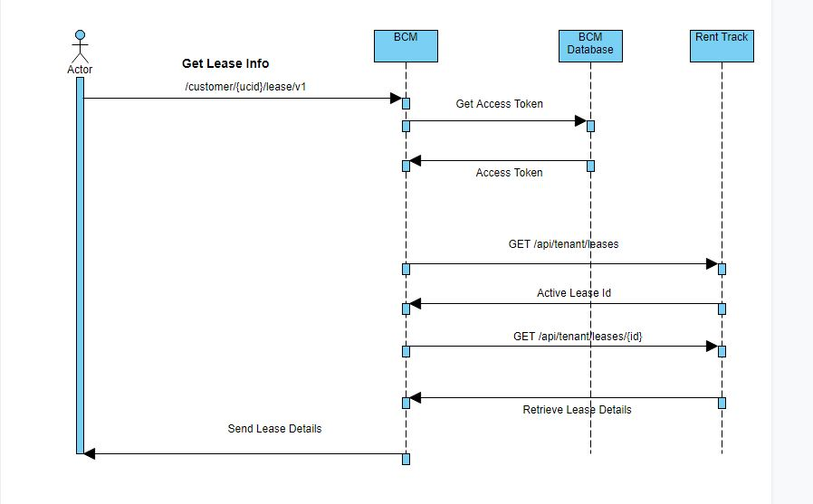

**Business** :

BCM will provide an API to get lease details from the RentTrack for the given customer.

**Clarifications**:

1. What are the fields should be sent from BCM to requestor ?

- TBD

**Code / Framework References**

**Misc:**