Project 02 - Container Health Monitoring & Auto-Recovery

01 - Environment Setup, Container Start, GitHub Remote Configuration
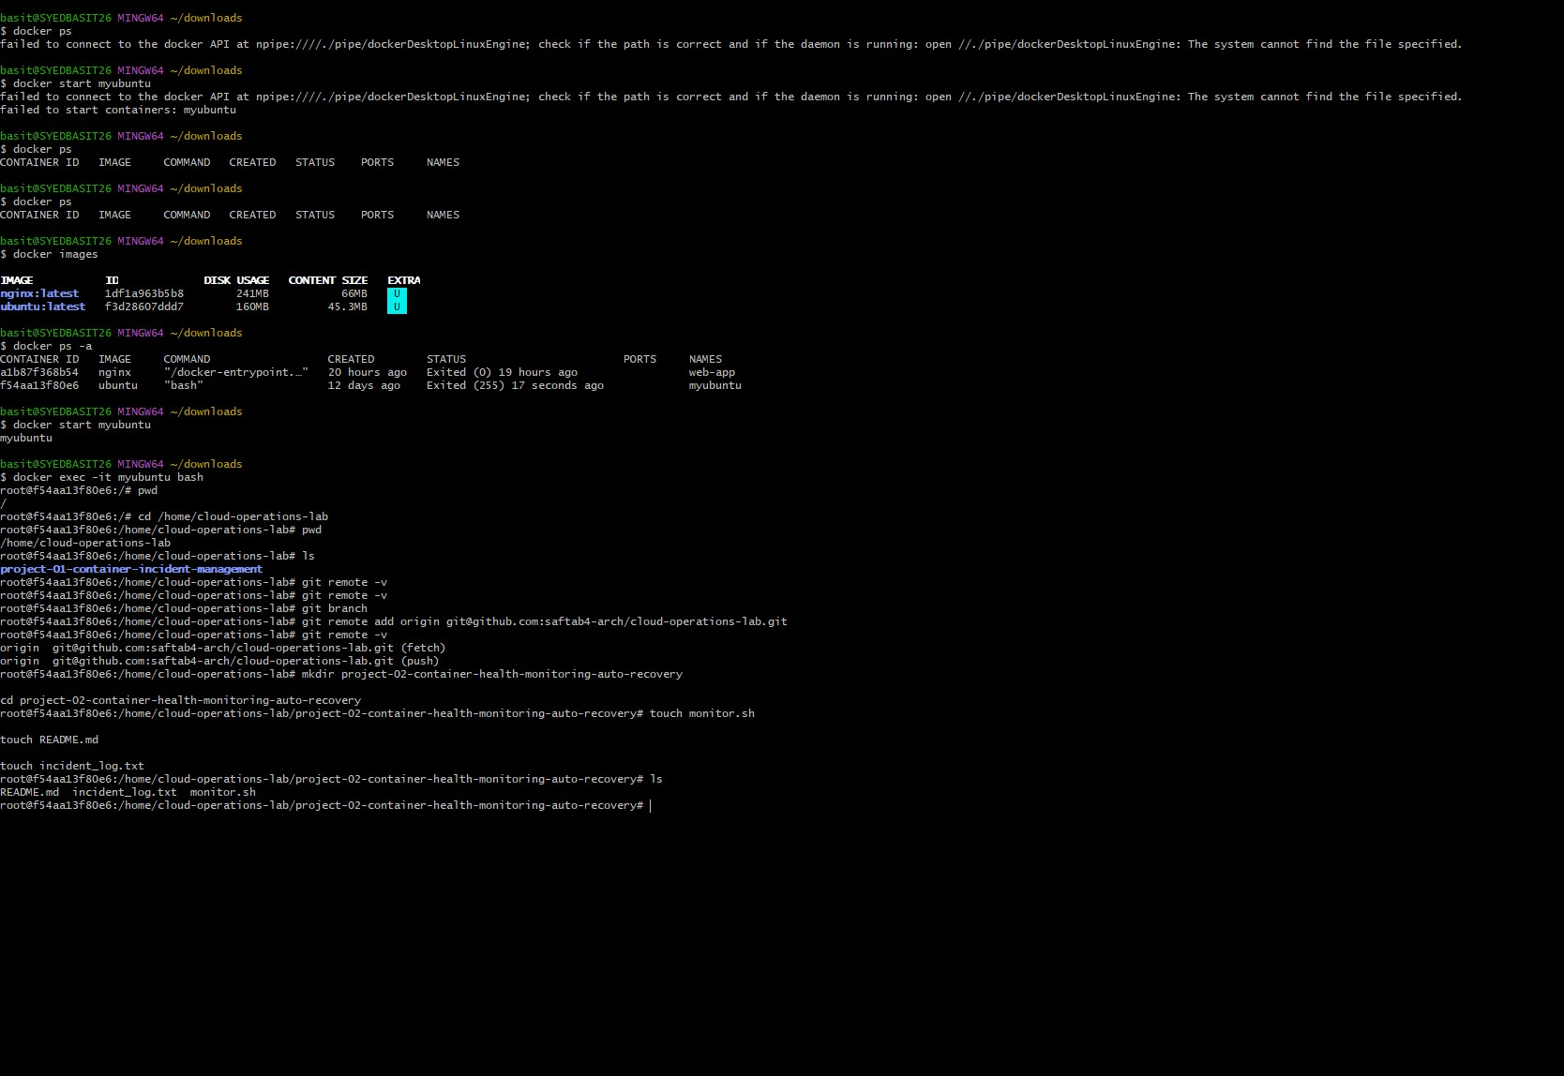

02 - Verify Container Status
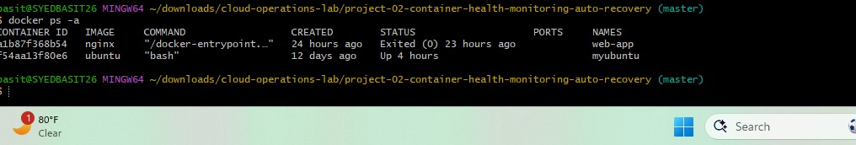

03 - Create GitHub Issue with GitHub CLI
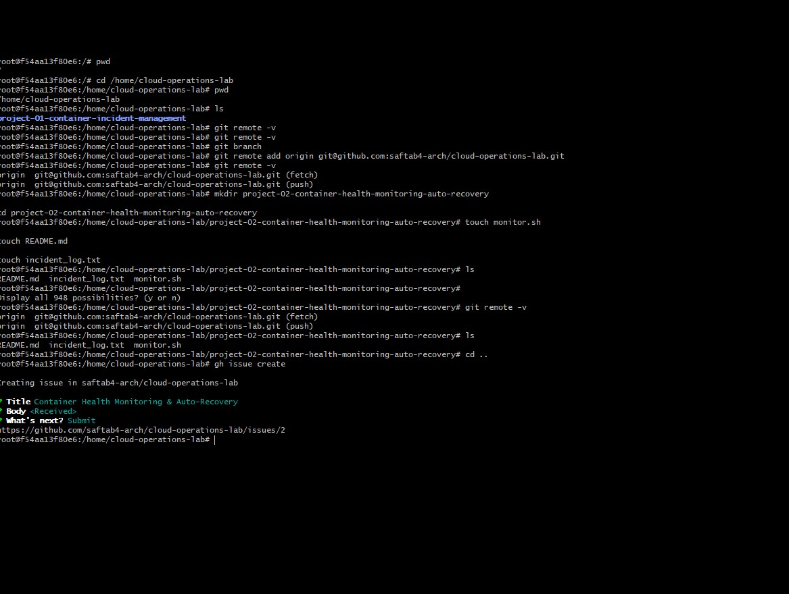

04 - GitHub Issue Created
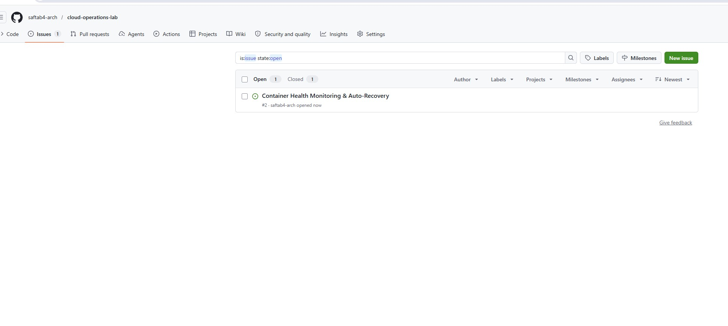

05 - Jira Ticket Created
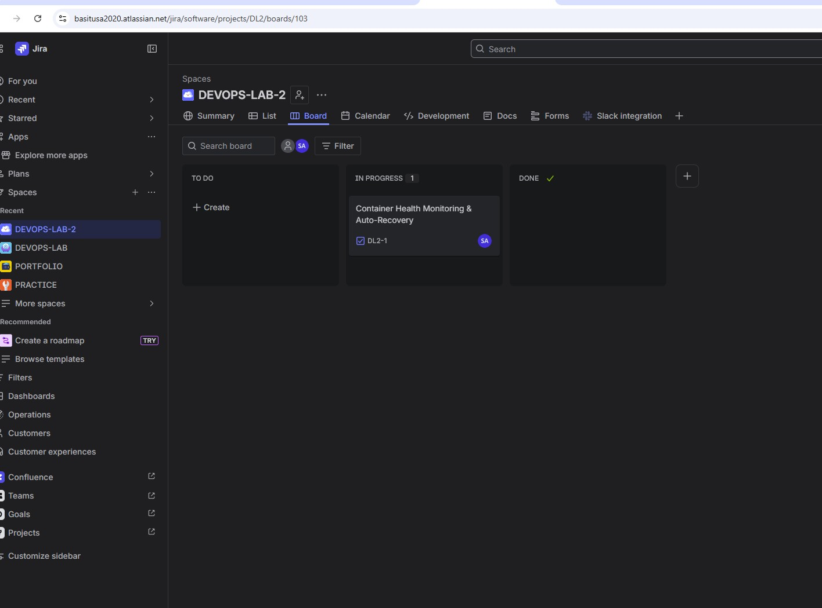

06 - Jira Ticket Workflow Completed
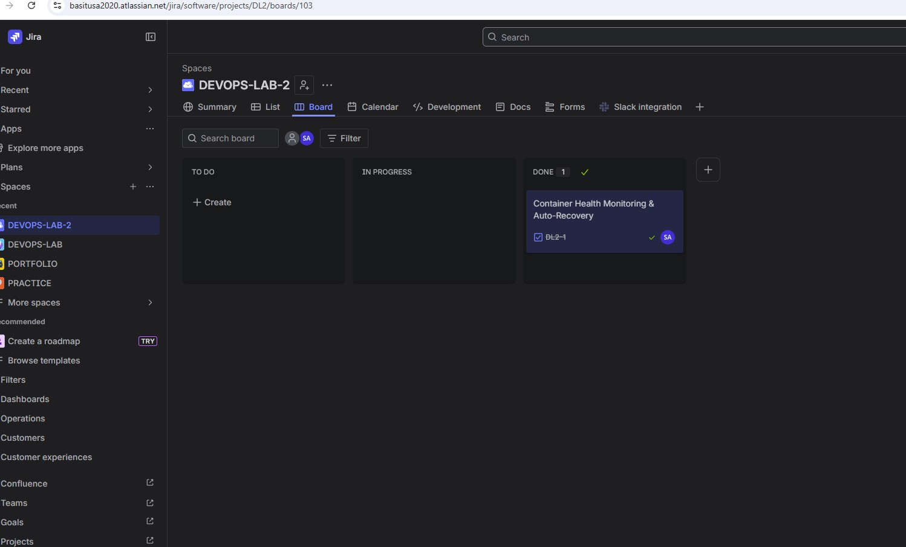

07 - Auto-Recovery Bash Script
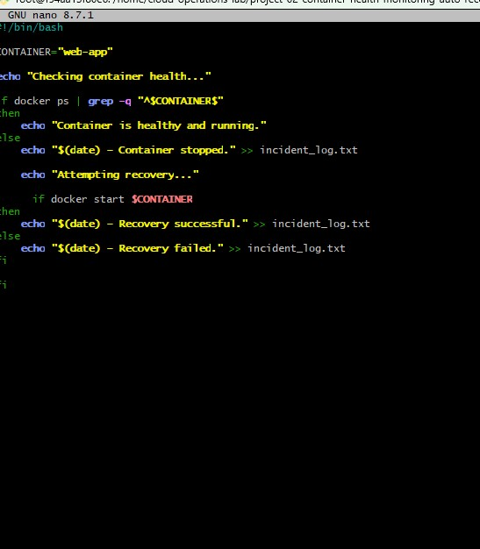

08 - Script Execution and Recovery Validation
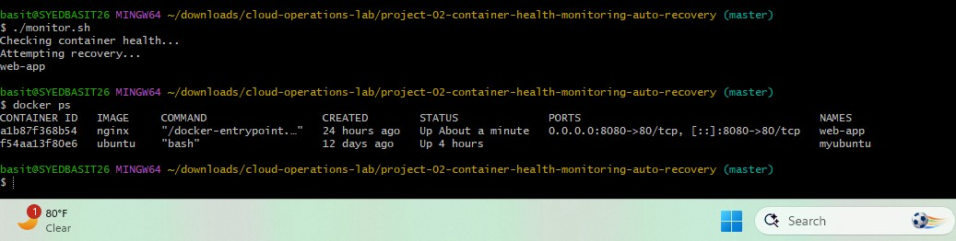

09 - Incident Log Evidence
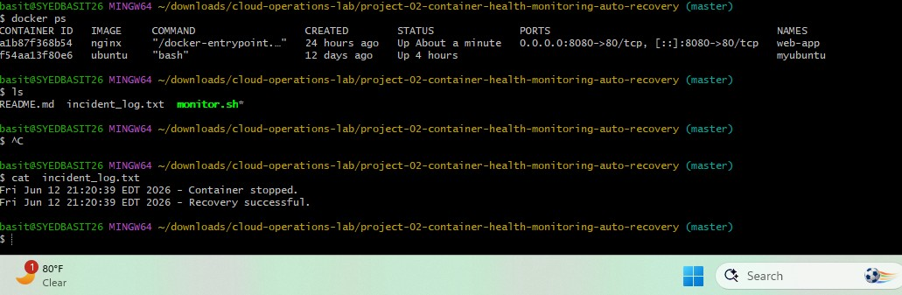

10 - Jira Ticket Updated with Results
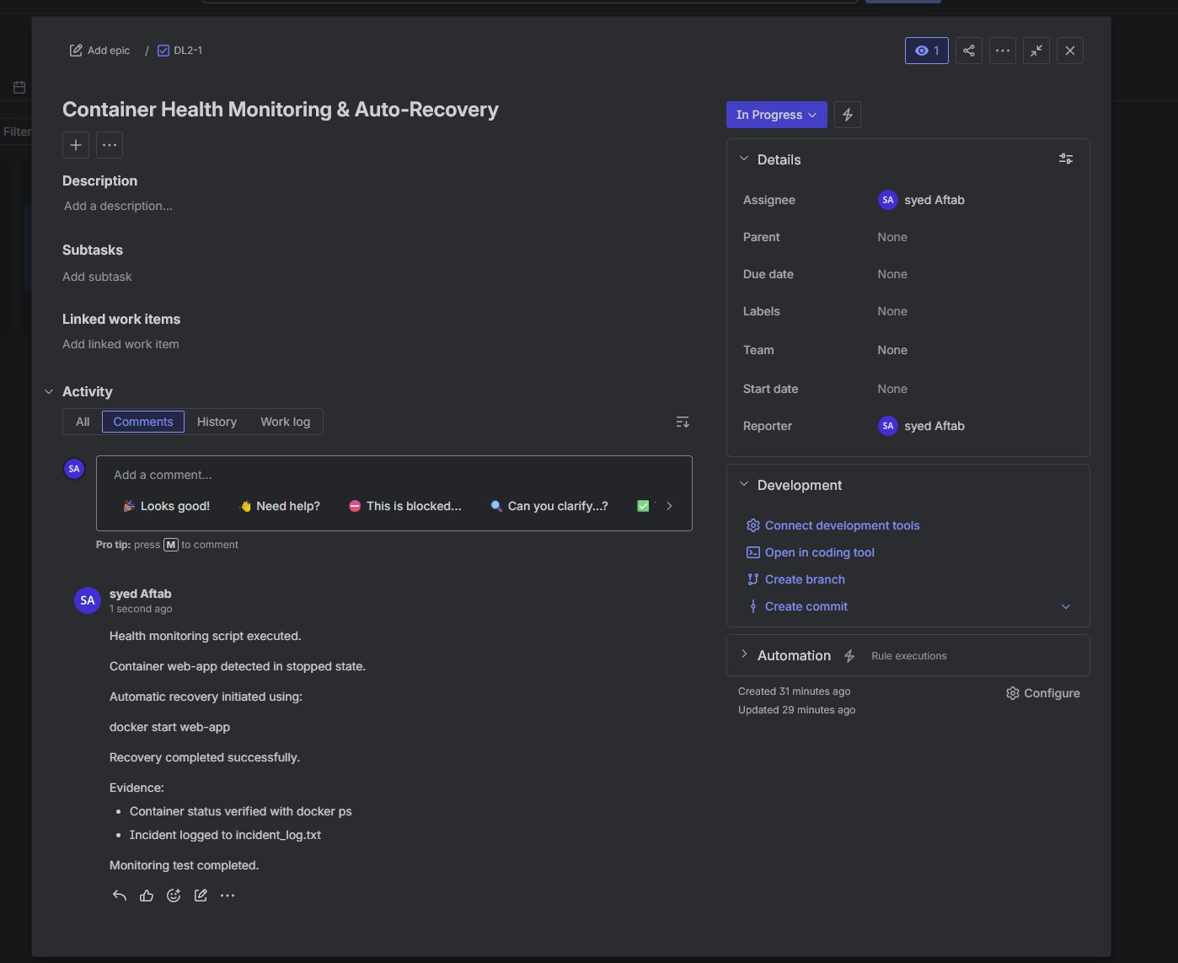

11 - Slack Integration Alerts
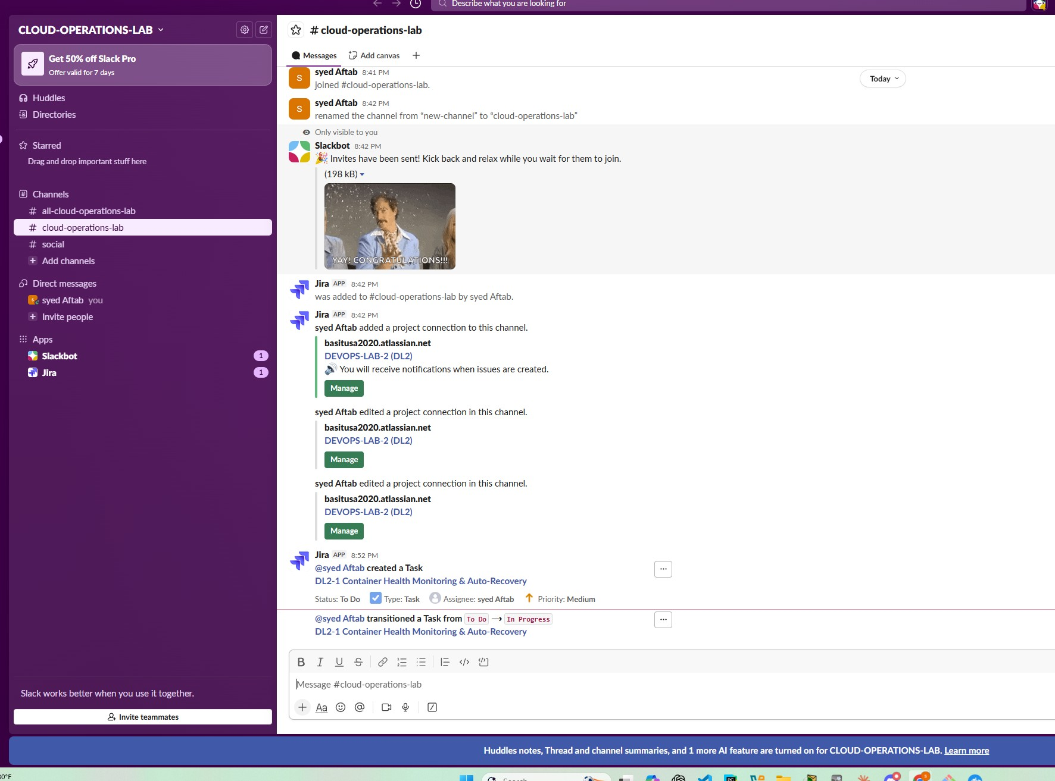

12 - Slack Notification - Ticket Completed
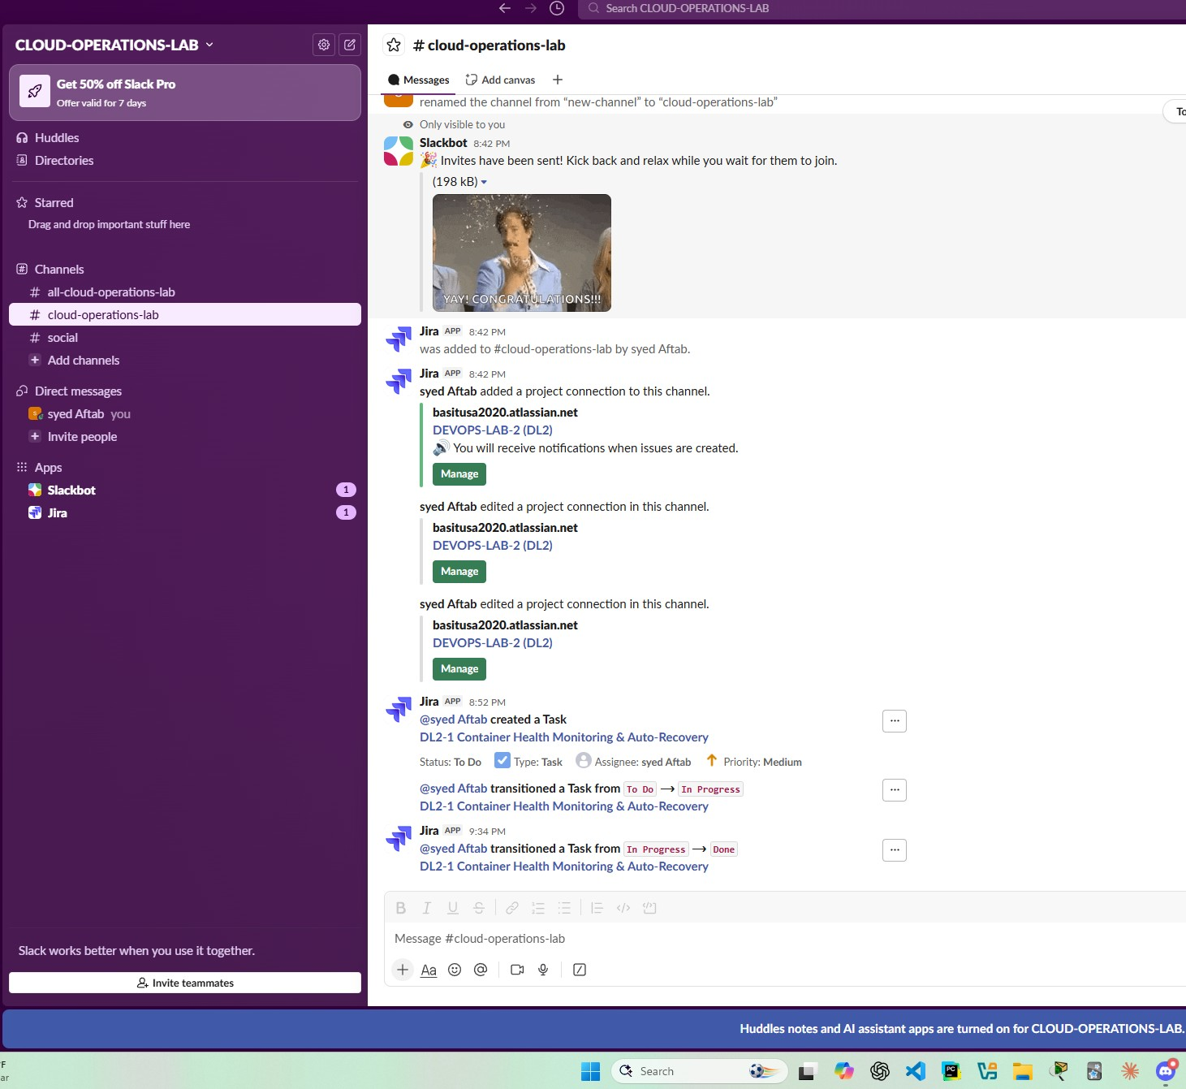

13 - GitHub Issue Closed
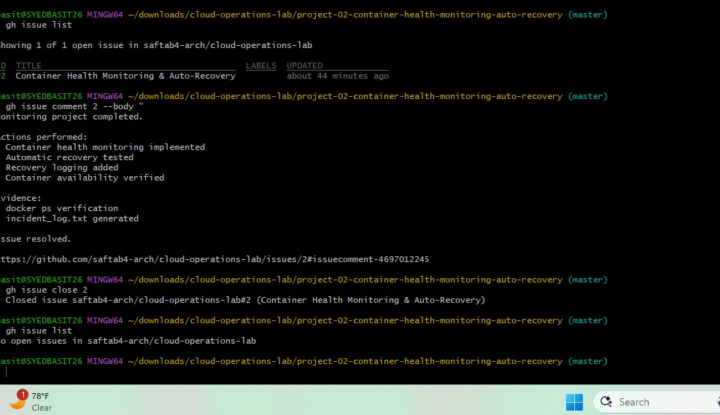

14 - Jira Ticket Resolved
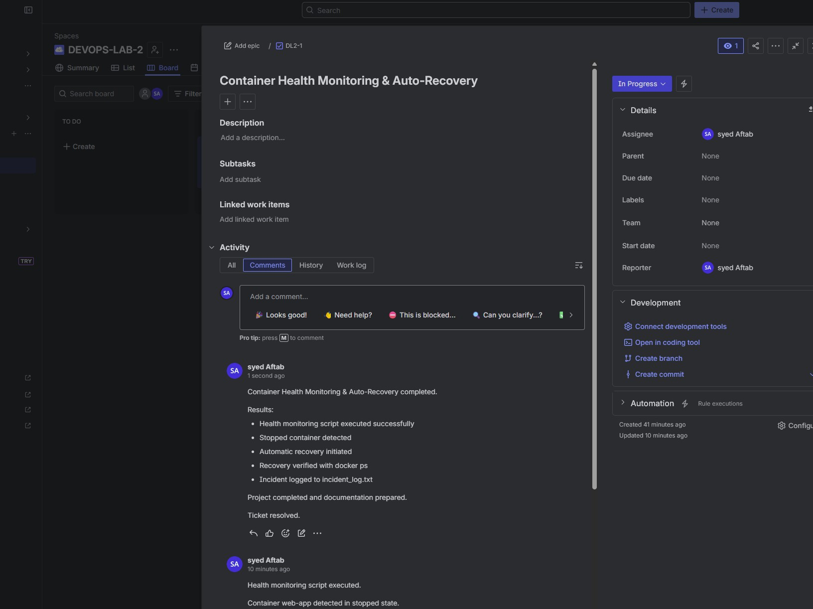

15 - Project Pushed to GitHub
