**1. Using our own terms and diagrams, explain INCEPTIONNET ARCHITECTURE.**

**Ans:** InceptionNet is an artificial neural network architecture developed by Google and introduced in 2014. It is an architecture for convolutional neural networks (CNNs) and is used for image classification and recognition.

InceptionNet is composed of modules called Inception Modules. Each Inception Module consists of a number of convolutional layers with different filter sizes and depths. This allows the network to learn different levels of abstractions from the input image. The input image is first convolved with a series of convolutional layers in the first Inception Module. This produces an output which is then passed through another set of convolutional layers in the second Inception Module. This process is repeated until the output of the last Inception Module is reached.

The output of the InceptionNet is then passed through a fully-connected layer and then a softmax layer which produces the final classification.

In summary, InceptionNet is a powerful convolutional neural network architecture which uses multiple Inception Modules to learn different levels of abstractions from an input image, and then uses a fully-connected layer and a softmax layer for classification.

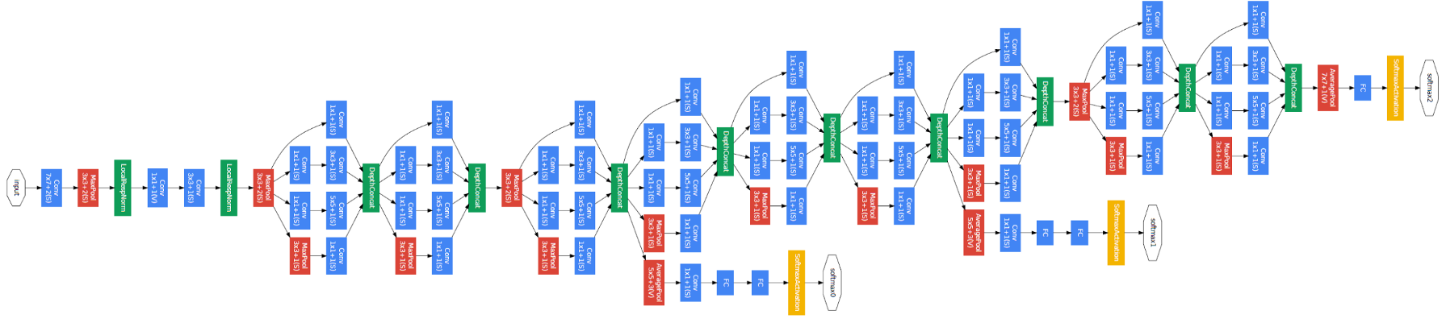

**2. Describe the Inception block.**

**Ans:** The Inception block is a type of convolutional neural network (CNN) architecture developed by Google for image analysis. It is composed of a series of convolutional layers and pooling layers, which are used to extract features from an image. The Inception block is designed to capture a large number of different features at different scales by using a combination of 1x1, 3x3, and 5x5 convolutional filters. It also uses a global average pooling layer to reduce the dimensionality of the features extracted. The Inception block is an important component of the GoogLeNet architecture, which won the ImageNet Large Scale Visual Recognition Challenge in 2014.

**3. What is the DIMENSIONALITY REDUCTION LAYER (1 LAYER CONVOLUTIONAL)?**

**Ans:** The Dimensional Reduction Layer (1 Layer Convolutional) is a type of Convolutional Neural Network (CNN) layer used to reduce the number of parameters in a network, while still maintaining a high level of accuracy. It is used to increase the efficiency of the network without compromising its performance. The layer typically consists of a 1x1 convolutional filter, which is used to reduce the number of features in a given input. By using a 1x1 convolution, the layer can reduce the number of parameters while still effectively capturing the features of the data.

**4. THE IMPACT OF REDUCING DIMENSIONALITY ON NETWORK PERFORMANCE**

**Ans:** Reducing the dimensionality of a network can have a number of positive impacts on performance. Dimensionality reduction can reduce the complexity of the network, which can reduce the computational overhead associated with training the network. By reducing the number of features that the network needs to process, the model can learn faster and more accurately. Additionally, dimensionality reduction can reduce overfitting, as it eliminates redundant features that may contribute to the model's memorization of the training data. Finally, it can also reduce the storage requirements for the network, as fewer features require less space.

**5. Mention three components. Style GoogLeNet**

**Ans:**

1. Inception Modules: Inception modules are a key component of the GoogLeNet architecture. They are a form of convolutional layer that uses a combination of 1x1 and 3x3 convolutional filters to reduce the size of the input while maintaining the same receptive field.
2. Auxiliary Classifier: GoogLeNet uses an auxiliary classifier to help with overfitting and improve the accuracy of the network. The auxiliary classifier is a convolutional neural network (CNN) layer placed on top of the main classification layer. It helps to improve the accuracy of the model by providing additional training data.
3. Global Average Pooling (GAP): GAP is a type of pooling operation used by GoogLeNet for reducing the spatial dimensions of the input. The output of the GAP layer is a vector of size equal to the number of channels in the input image. This vector is then flattened and fed into the fully connected layers of the network.

**6. Using our own terms and diagrams, explain RESNET ARCHITECTURE.**

**Ans:** ResNet architecture is a type of convolutional neural network (CNN) designed to enable deeper network architectures. It is composed of a series of convolutional layers, shortcut connections, and activation functions. It was first introduced in 2015 by researchers at Microsoft Research.

The basic structure of ResNet consists of a series of convolutional layers, followed by a shortcut connection and an activation function. The shortcut connection allows the network to skip over a few layers and still retain the information from earlier layers. This helps the network to learn more complex features, while avoiding the vanishing gradient problem. The activation function helps the network to learn nonlinear relationships between the inputs and outputs.

The diagram below illustrates the basic structure of a ResNet architecture.