1. What are escape characters, and how do you use them?

In Python strings, the backslash "" is a special character, also called the "escape" character. It is used in representing certain whitespace characters: "\t" is a tab, "\n" is a newline, and "\r" is a carriage return

2. What do the escape characters n and t stand for?

"\t" is a tab, "\n" is a newline

3. What is the way to include backslash characters in a string?

print('its a back slash \ in a line')

4. The string "Howl's Moving Castle" is a correct value. Why isn't the single quote character in the word Howl's not escaped a problem?

We can use double quotes in with single quotes

5. How do you write a string of newlines if you don't want to use the n character?

print("printing something in new line",end = '\n')

print("newline")

6. What are the values of the given expressions?

'Hello, world!'[1]

'Hello, world!'[0:5]

'Hello, world!'[:5]

'Hello, world!'[3:]

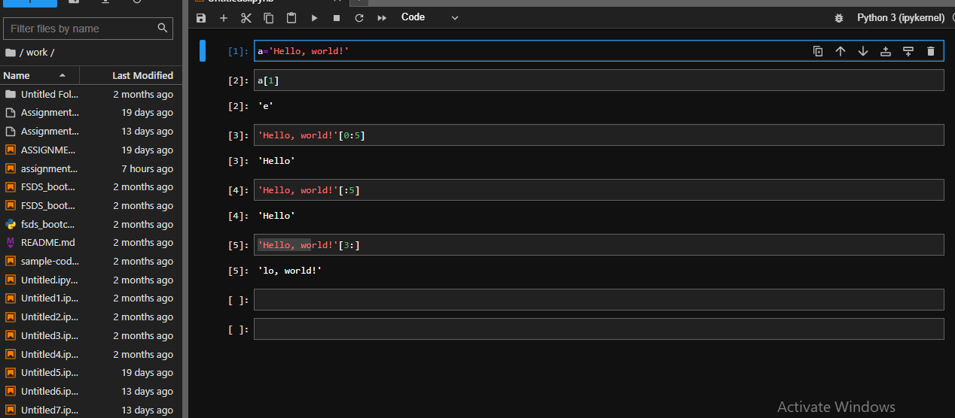

7. What are the values of the following expressions?

'Hello'.upper()

'Hello'.upper().isupper()

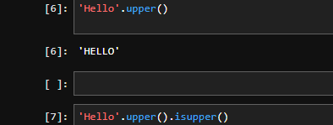

'Hello'.upper().lower()

8. What are the values of the following expressions?

'Remember, remember, the fifth of July.'.split()

'-'.join('There can only one.'.split())

['Remember,', 'remember,', 'the', 'fifth', 'of', 'July.']

['There', 'can', 'only', 'one.']

9. What are the methods for right-justifying, left-justifying, and centering a string?

str ="Safura"

str.ljust(10,"-")

str ="Safura"

str.ljust(10,"-")

str ="Safura"

str.centre(10,"-")

10. What is the best way to remove whitespace characters from the start or end?

str =”safura "

str.lstrip()

str ="safura “

str.rstrip()