PROJECT
SQL If-else

Database schema:
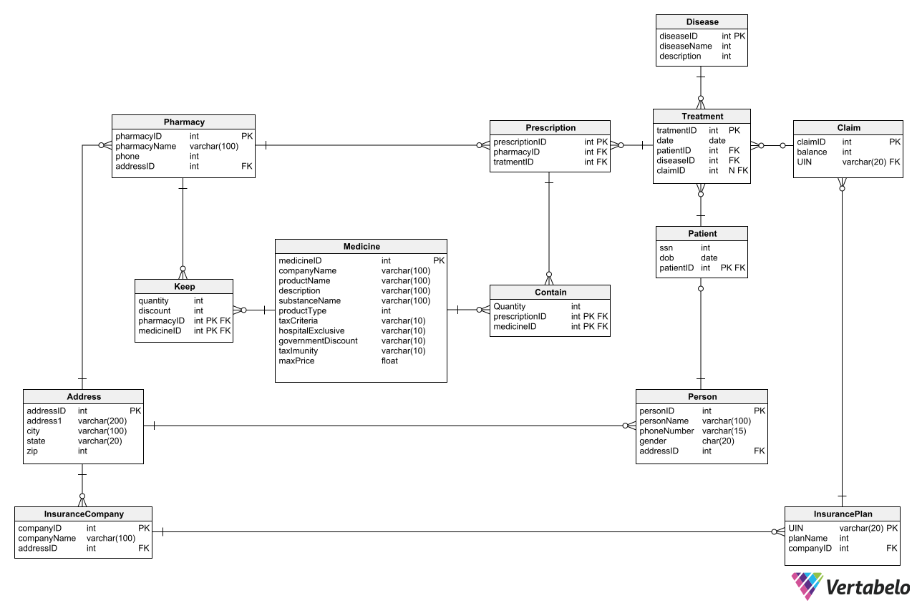

Problem Statement 1:
Insurance companies want to know if a disease is claimed higher or lower than average. Write a stored procedure that returns “claimed higher than average” or “claimed lower than average” when the diseaseID is passed to it.
Hint: Find average number of insurance claims for all the diseases. If the number of claims for the passed disease is higher than the average return “claimed higher than average” otherwise “claimed lower than average”.

Problem Statement 2:
Joseph from Healthcare department has requested for an application which helps him get genderwise report for any disease.
Write a stored procedure when passed a disease_id returns 4 columns,
disease_name, number_of_male_treated, number_of_female_treated, more_treated_gender
Where, more_treated_gender is either ‘male’ or ‘female’ based on which gender underwent more often for the disease, if the number is same for both the genders, the value should be ‘same’.
Problem Statement 3:
The insurance companies want a report on the claims of different insurance plans.
Write a query that finds the top 3 most and top 3 least claimed insurance plans.
The query is expected to return the insurance plan name, the insurance company name which has that plan, and whether the plan is the most claimed or least claimed.

Problem Statement 4:
The healthcare department wants to know which category of patients is being affected the most by each disease.
Assist the department in creating a report regarding this.
Provided the healthcare department has categorized the patients into the following category.
YoungMale: Born on or after 1st Jan 2005 and gender male.
YoungFemale: Born on or after 1st Jan 2005 and gender female.
AdultMale: Born before 1st Jan 2005 but on or after 1st Jan 1985 and gender male.
AdultFemale: Born before 1st Jan 2005 but on or after 1st Jan 1985 and gender female.
MidAgeMale: Born before 1st Jan 1985 but on or after 1st Jan 1970 and gender male.
MidAgeFemale: Born before 1st Jan 1985 but on or after 1st Jan 1970 and gender female.
ElderMale: Born before 1st Jan 1970, and gender male.
ElderFemale: Born before 1st Jan 1970, and gender female.

Problem Statement 5:
Anna wants a report on the pricing of the medicine. She wants a list of the most expensive and most affordable medicines only.
Assist anna by creating a report of all the medicines which are pricey and affordable, listing the companyName, productName, description, maxPrice, and the price category of each. Sort the list in descending order of the maxPrice.
Note: A medicine is considered to be “pricey” if the max price exceeds 1000 and “affordable” if the price is under 5. Write a query to find

