


TenUp Software Services
Bakkar Safvan Altaf
210303108052 | 06-01-2025
Full Stack Developer


 |  |  |  |  | 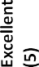

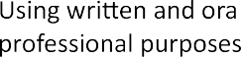





Bakkar Safvan Altaf
210303108052 | 06-01-2025

Prof. Shaleen Shukla
PIET - IT
94282 82968

