CHAPTER 1: Overview of the Company

### **1.1 HISTORY**

Since **2014**, they took their first major step by introducing **Object Interaction**, an innovative concept that became the foundation of their signature products. This marked the beginning of their journey in delivering high-quality solutions tailored to evolving business and individual needs. With a focus on innovation, they set out to create impactful products that would shape their industry.

By **2015**, they had established strategic partnerships with leading **U.S.-based firms**, which helped them expand their market presence and extend their client base. These collaborations provided valuable industry insights, enabling them to refine their offerings and align with global standards. Through these partnerships, they strengthened their reputation, building trust and credibility among clients and industry leaders.

In **2018**, they took another significant leap by launching **TenUp**, a premier **software application and consulting services firm**. This initiative was designed to offer cutting-edge technological solutions, helping businesses optimize operations and enhance efficiency. With a strong foundation, an expanding clientele, and a commitment to continuous innovation, they positioned themselves as a trusted industry leader, adapting to the ever-changing demands of the digital world.

### **1.2 SCOPE OF WORK**

The scope of this project encompasses the design, development, and deployment of a **Generative AI-powered Chatbot API Platform**, which enables users to create customized chatbot solutions tailored to their specific knowledge base. The platform will provide seamless **authentication and user management**, allowing individuals and businesses to log in, define their chatbot requirements, and integrate the generated API into their respective websites.

To achieve this, the project will involve multiple key components:

1. **User Interaction & Input Processing** – Users will provide data in the form of prompts, documents, or structured knowledge bases, which will be processed to generate an intelligent chatbot model.
2. **AI & NLP Integration** – Leveraging **Natural Language Processing (NLP) and Large Language Models (LLMs)**, the chatbot will be trained to understand, process, and respond accurately to user queries.
3. **Vector Database for Knowledge Retrieval** – A **Vector Database** will be implemented to store and retrieve user-provided information efficiently, ensuring precise and context-aware responses.
4. **Custom API Generation** – Based on the analyzed data, the platform will generate **custom APIs** for each user, allowing seamless integration with their existing websites or applications.
5. **Frontend & Backend Development** – The platform will feature a **React.js frontend (optional) for user-friendly interaction** and a **Django backend** to handle API management, database connectivity, and system logic.
6. **Scalability & Performance Optimization** – Ensuring the platform can handle multiple chatbot requests simultaneously, optimizing response time, and securing API endpoints.
7. **Security & Data Privacy** – Implementing encryption techniques and access controls to safeguard user data and prevent unauthorized access.

This project aims to provide a **highly flexible, intelligent, and user-friendly chatbot solution** that caters to different domains, businesses, and individual needs. The integration of **Generative AI, LLM models, and Vector DB** ensures that chatbots deliver **contextually accurate, dynamic, and interactive responses** while maintaining efficiency and scalability.

1.3 Organization Chart

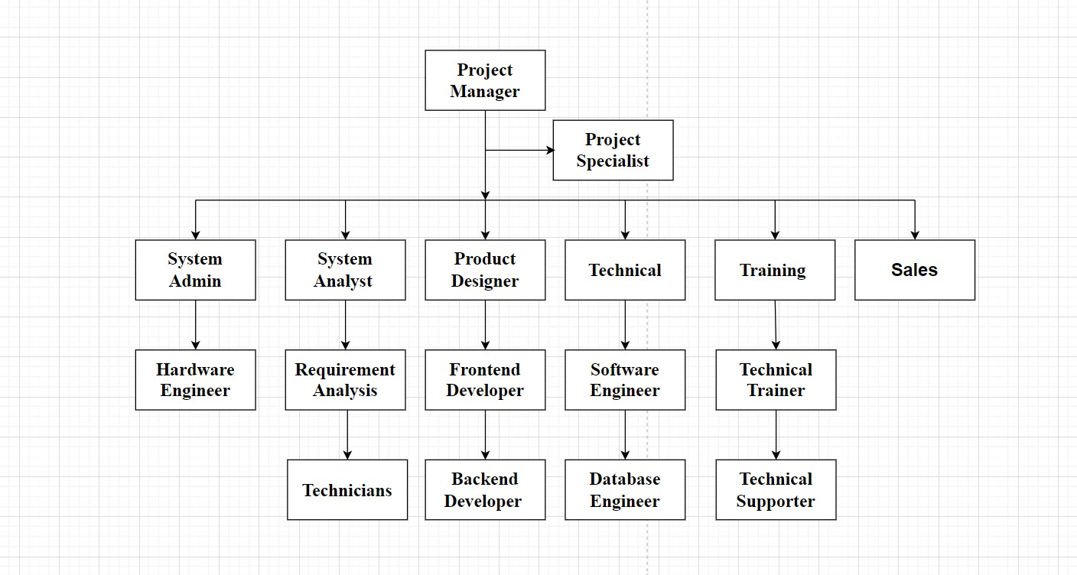

Fig 1.3 Organization chart

1.4 Capacity of the Company

**Introduction**

The capacity of a software consulting and development firm like TenUp Software is determined by several key factors, including workforce expertise, technological infrastructure, project scalability, and client engagement strategies. As a leading software solutions provider, TenUp has strategically built a robust operational model that ensures high-quality service delivery while maintaining flexibility and scalability to meet evolving market demands.

**1. Workforce and Expertise**

One of the most critical factors influencing TenUp’s capacity is its highly skilled workforce. The company employs a team of experienced professionals specializing in various domains, including:

1. **Software Development** – Engineers proficient in full-stack development, enterprise solutions, and SaaS applications.
2. **Cloud & DevOps Specialists** – Experts in cloud-native development, infrastructure automation, and CI/CD pipelines.
3. **Blockchain & AI Engineers** – Skilled in emerging technologies such as machine learning, deep learning, and decentralized applications.
4. **Data Scientists & Analysts** – Professionals who design and implement scalable data solutions for enterprise clients.
5. **UI/UX Designers & Product Managers** – Teams focused on enhancing user experience and optimizing product workflows.

By leveraging a diverse talent pool, TenUp ensures that it can take on projects of varying complexity and scale without compromising efficiency or quality.

**2. Technological Infrastructure**

A company’s capacity is also defined by its infrastructure and ability to support large-scale operations. TenUp has invested in:

* **Cloud Computing & Storage** – Utilizing AWS, Google Cloud, and Azure for efficient deployment and data handling.
* **Enterprise-Grade Security & Compliance** – Ensuring that projects adhere to industry standards such as GDPR, ISO, and HIPAA.
* **Scalable DevOps Pipelines** – Automated testing and deployment systems to speed up software development cycles.
* **AI & Blockchain Integration** – Leveraging next-generation technologies to enhance automation, security, and transparency in business operations.
* These investments allow TenUp to manage multiple projects concurrently while maintaining a high standard of execution.