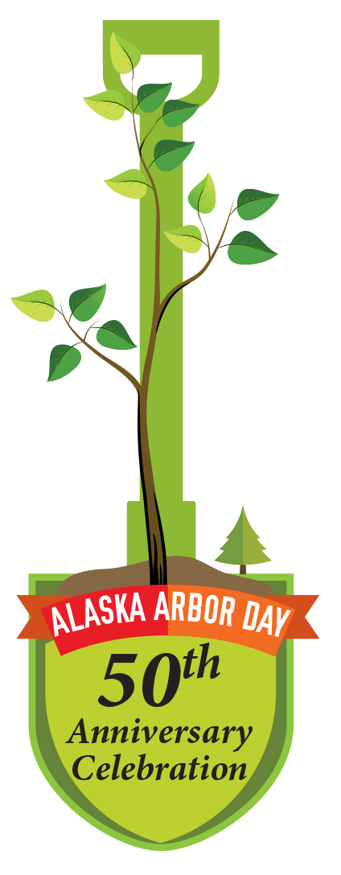
Arbor Day Grants, 2016
Alaska Community Forest Council
PO Box 241282, Anchorage, Alaska 99524 / 907-786-6315 / http://forestry.alaska.gov/community/council
The Alaska Community Forest Council is a nonprofit organization with 15 members from across the state. Members advise the Division of Forestry on how to develop and deliver community forestry programs to Alaskans, support education, and encourage public involvement in community forestry.
The Alaska Community Forest Council shares the mission of the Alaska Community Forestry Program to help communities build effective, self-sustaining community forestry programs with strong local support.
Grants are intended to help the meet this goal by funding projects that:
- Generate awareness of and participation in Arbor Day (officially May 16, 2016);
- Increase public awareness of the benefits of trees and forests and build support for planting and caring for public trees;
- Provide a public demonstration of the benefits of trees and/or proper tree selection, planting, and care;
- Use trees to solve community problems. Examples include: reduce or treat stormwater, create wind breaks or living snow fences, restore streams or rivers, plant fruit trees to provide healthy food, screen surfaces prone to graffiti, calm traffic, and beautify your schoolyard.

Requirements
• Applicant must be a government entity or nonprofit organization with IRS 501(C)3 status.
• Applicants may apply for a grant of from $100 to $500. Approximately $6,000 is available for grants.
• Grant funds may not be used for wages or benefits.
• If trees and shrubs are planted with grant funds, follow practices described in Plant a Tree: Alaska's Guide to Tree Selection, Planting, & Care. See link below.
Trees must be:
- Planted on public land and be covered by a three-year, budgeted maintenance plan.
- Of high quality, appropriate for the site, and meet the American Standard for Nursery Stock 2014. http://americanhort.org/documents/ANSI_Nursery_Stock_Standards_AmericanHort_2014.pdf
- If you would like help writing specifications to ensure that you receive trees in excellent condition and form, please contact us.
• Grant funds were provided to the Council from the U.S. Forest Service through the Alaska Division of Forestry. Any media (print, online etc.) or public event produced in association with this grant shall recognize the support of the Alaska Community Forest Council, Alaska Division of Forestry, and U.S. Forest Service.

Proposal
Complete an application (http://www.forestry.org/media/docs/ak/2016ArborDayGrantApplication.docx) Be creative and find ways to reach a large audience in your community.

Selection Criteria
- Quality, clarity and organization of project and budget.
- Extent to which project generates awareness of and participation in Arbor Day.
- Extent to which project increases public awareness of the benefits of trees and forests and builds support for planting and caring for public trees.
- Extent to which project demonstrates the benefits of trees and/or proper tree selection, planting, and care.
- Project’s benefits to the community and its ability to solve a problem or meet a need.

Application Process
Complete the attached two-page application. The deadline for the application to be received by the Division of Forestry is 4:30 p.m., Friday, February 12, 2016. The Alaska Community Forest Council and Community Forestry staff will review applications and grant awards will be announced no later than March 1, 2016. Upon approval of the proposal, the council and grantee will sign a grant agreement.

For more information or assistance
Please call if you need help preparing your proposal. We can provide information to help you design a successful project, including Plant a Tree: Alaska's Guide to Tree Selection, Planting, and Care, online at http://forestry.alaska.gov/Assets/uploads/DNRPublic/forestry/pdfs/community/publications/PlantATreeWeb2011.pdf
Information and publications are also available at http://forestry.alaska.gov/community/publications.
Gino Graziano
907-786-6315
gagraziano@alaska.edu
E-mail (preferred), mail, or deliver proposal to:
Gino Graziano, council member, at gagraziano@alaska.edu or
Alaska Community Forest Council
PO Box 241282
Anchorage, AK 99524

