OREGON SOCIETY OF AMERICAN FORESTERS

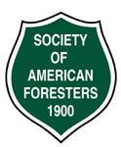

4033 SW Canyon Road • Portland, OR 97221 • 503.224.8046

CHAPTERS: Blue Mountain • Capital • Central Oregon • Columbia Gorge • Coos • Emerald • John Day
Mary’s Peak • Oregon State University • Portland • Shasta-Cascade • Siskiyou • Tillamook-Clatsop • Umpqua

Professionals advancing the science, technology, practice, and teaching of forestry to benefit society.

