INDEX

|  |  |
| --- | --- |
| Sno | Topics |
| 1. | Certificate |
| 2. | Acknowledgement |
| 3. | Resources |
| 4. | Code |

CERTIFICATE

This is to certify that Sai Kamal Mudiganti, Sai Charan and Mohammed Safwan, students of class 12th 'A' and 12th ‘C’ have successfully completed the project on the topic of “'Desktop application of Medical and Chemical Drugstore” under the guidance of Mrs. Sravanthi during the year 2022-23.

Teacher’s Signature

ACKNOWLEDGMENT

Our team would like to express special thanks of gratitude to our teacher Mrs. Sravanthi as well as our Principal K Sheshadri who gave us the golden opportunity to do this wonderful project on the topic 'Desktop application of Medical and Chemical Drugstore which also helped us in doing a lot of research and we learned about new python libraries, integrating sql servers with python code. Secondly, we would like to extend our thanks to online resource websites like stack overflow and geeksforgeeks which helped us a lot in finishing this project within the time limit. We have made this project not only for marks but to also increase our knowledge and skillset in the field of informatics practices.

RESOURCES

The resources used in this project include:

* Python 3.10 – Python version used
* Atom IDE – Editor used to write the code in
* MySql – As the backend server
* Tkinter – Python module for GUI
* MySql connector – Database connection
* Images Folder – The images used in the app
* Internet – To get information regarding products

CODE

Firstly, we start by importing necessary packages needed for the project

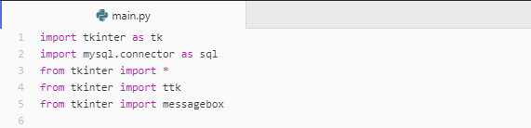

We now create a tkinter window that will be our base

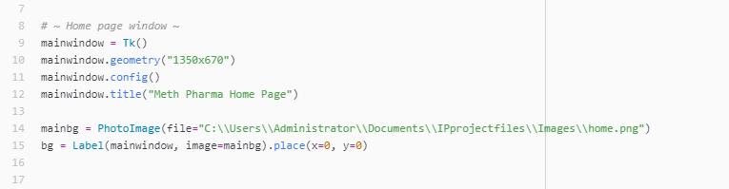

Note here that all the images being imported in this project are stored in a folder named “Images”.

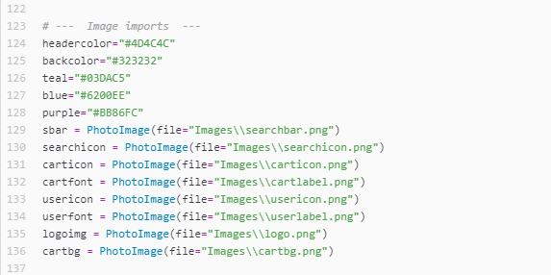

The next step is to create a header where we will have our search bar, sign in button and cart button

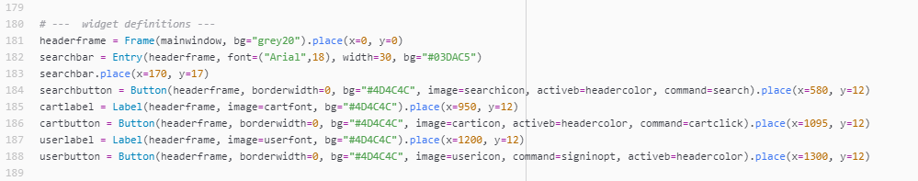



We will assign functionality to these buttons. Starting with the sign in button. When clicked it will open a new window that will take in entries of username and password and store them in our mysql database. This will also have log in functionality.

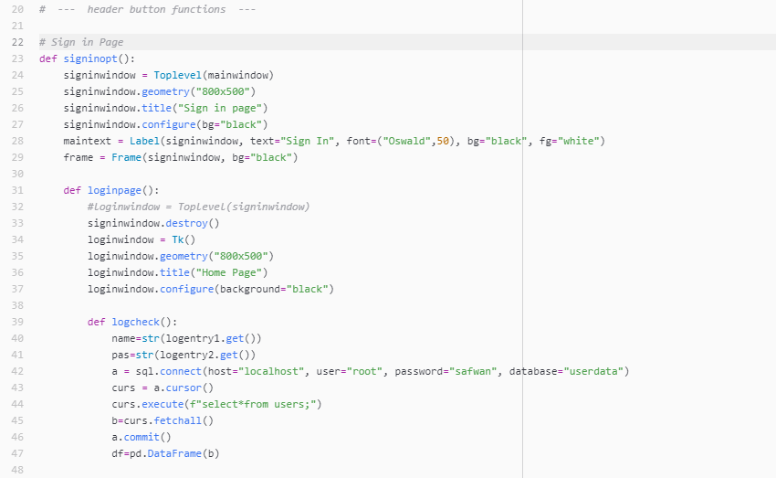

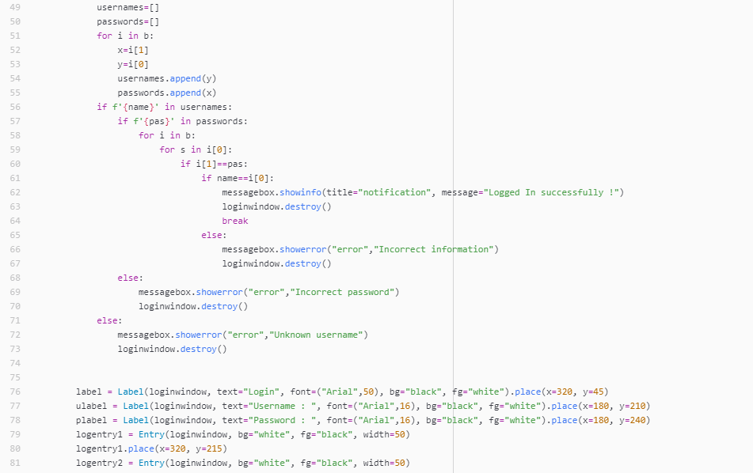 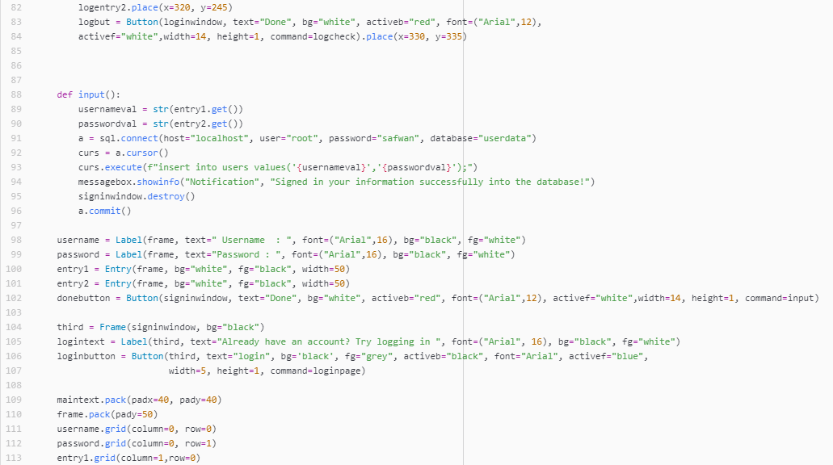 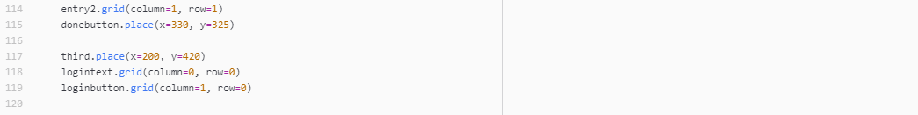

This completes the sign in and log in pages. The outputs are given next.

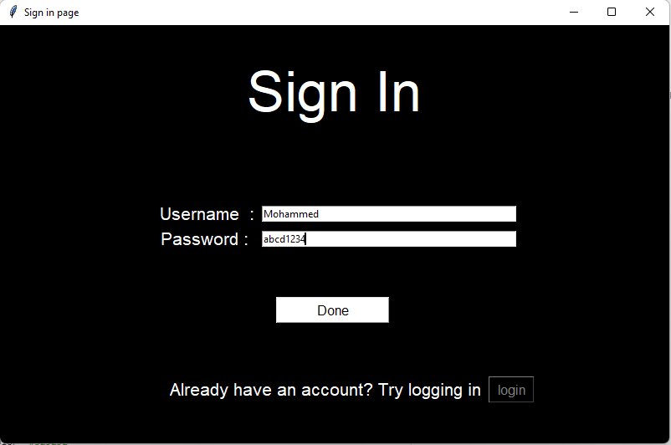 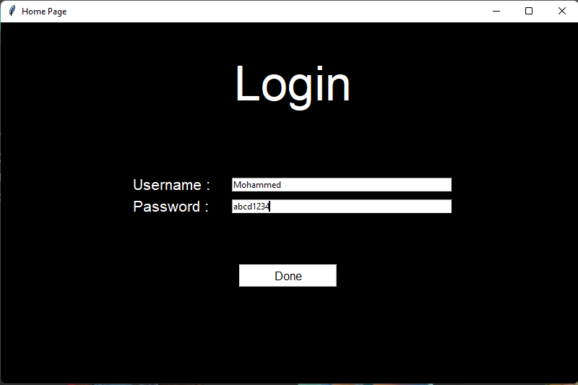

These pages will show notification or error signs depending on success or failure of the event on clicking of buttons

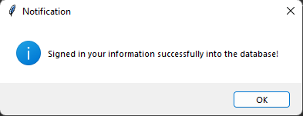

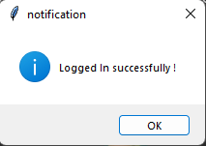 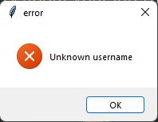 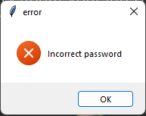

The second functionality is for the adding to cart and checking out system

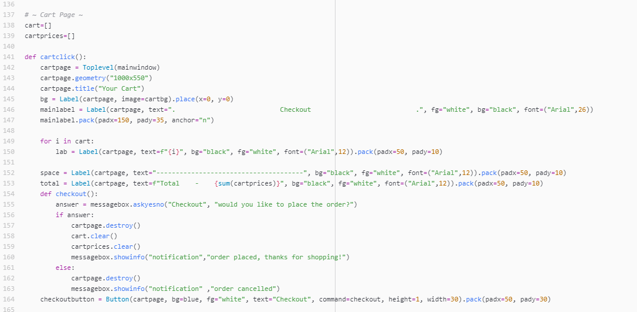

The page is ready, adding to cart will work when we create our product objects later. The next button is the search one, productsobj is a list.

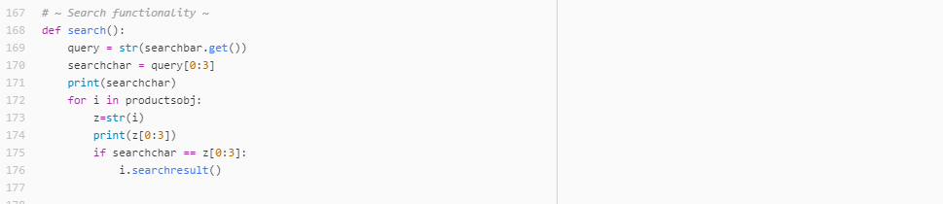

Let’s now create a class that will be used to make objects of our products

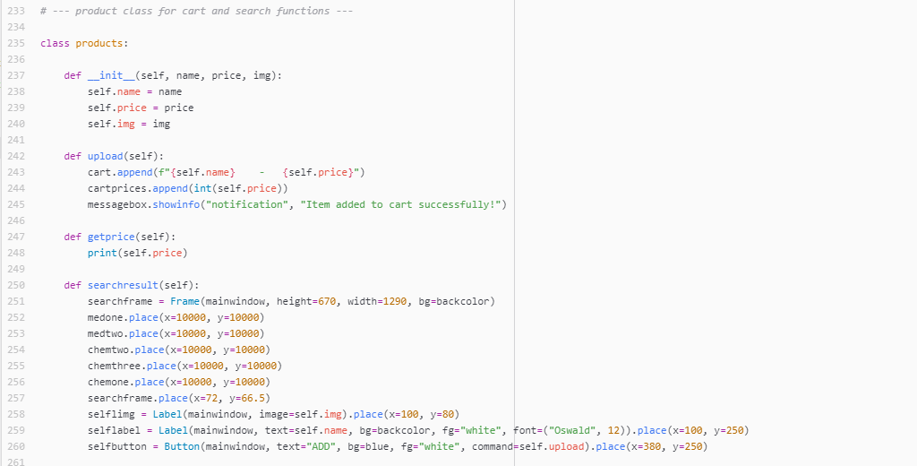

The images used are imported as below

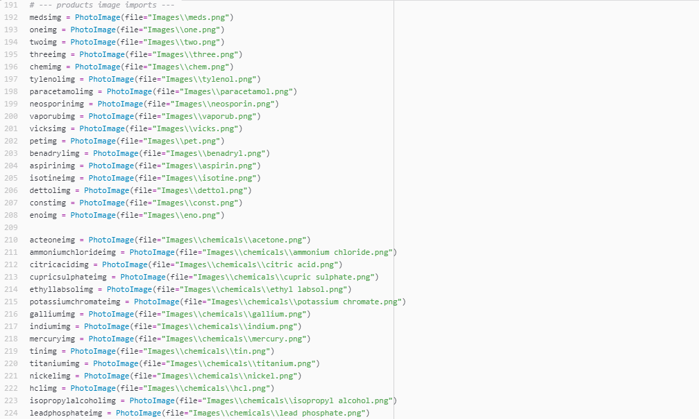

In the next few snippets of code, we will be creating widgets to be placed in the main window, we will have 5 such pages of widgets including a home page, 2 medicine product pages and 3 chemical product pages.

These pages can be accessed by a side menu with buttons.

We also create the objects of the products according to the product() class we defined before.

The products will have labels describing them and an add to cart button that will append their name in the empty cart list we created before.

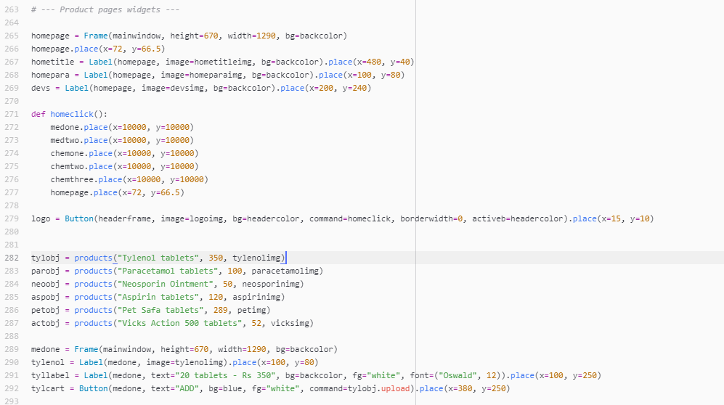 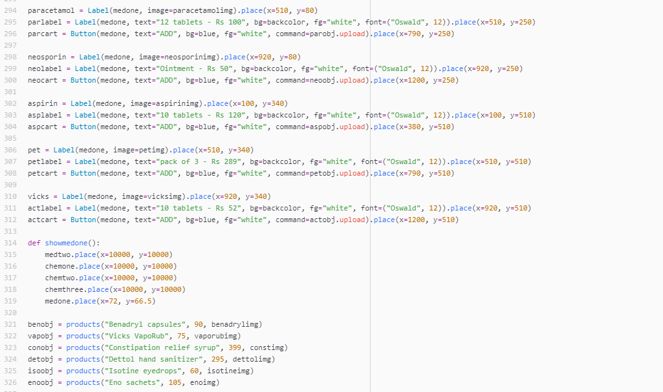 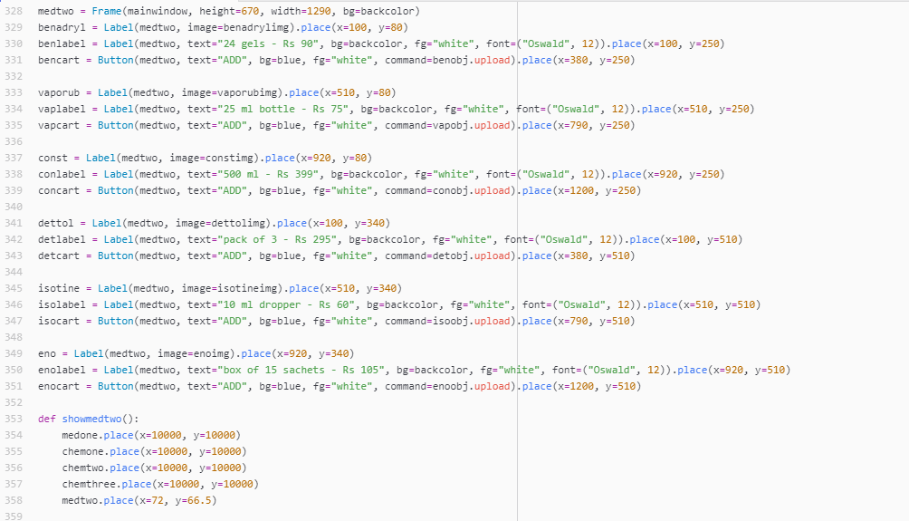 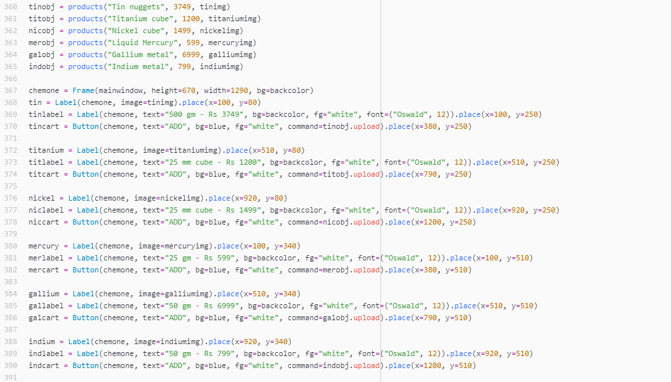 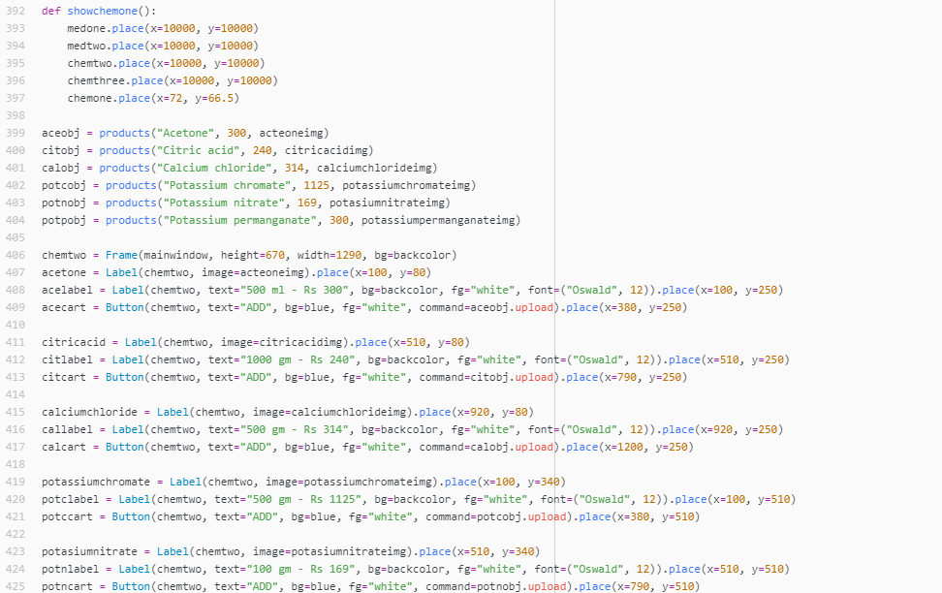 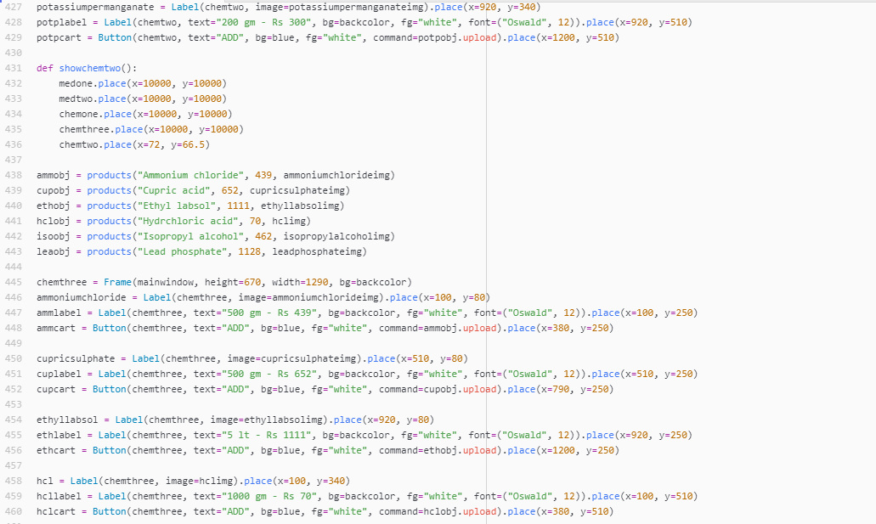 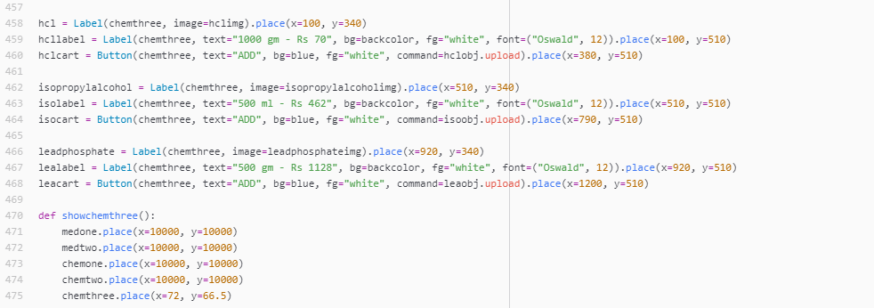

To traverse through these pages, we can have a side menu that holds all the buttons to these pages. The code for that is down below

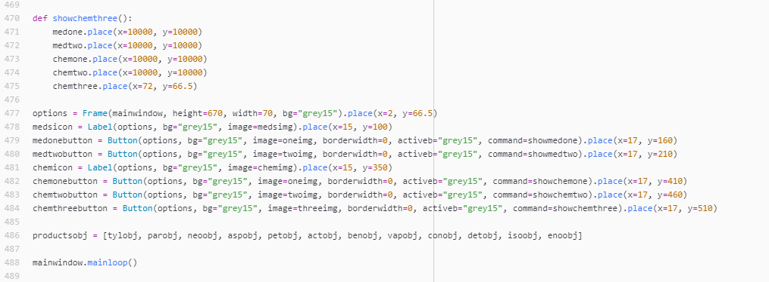

This packs up our entire code for the project. Let us now look at the outputs of these pages and also the add to cart function.

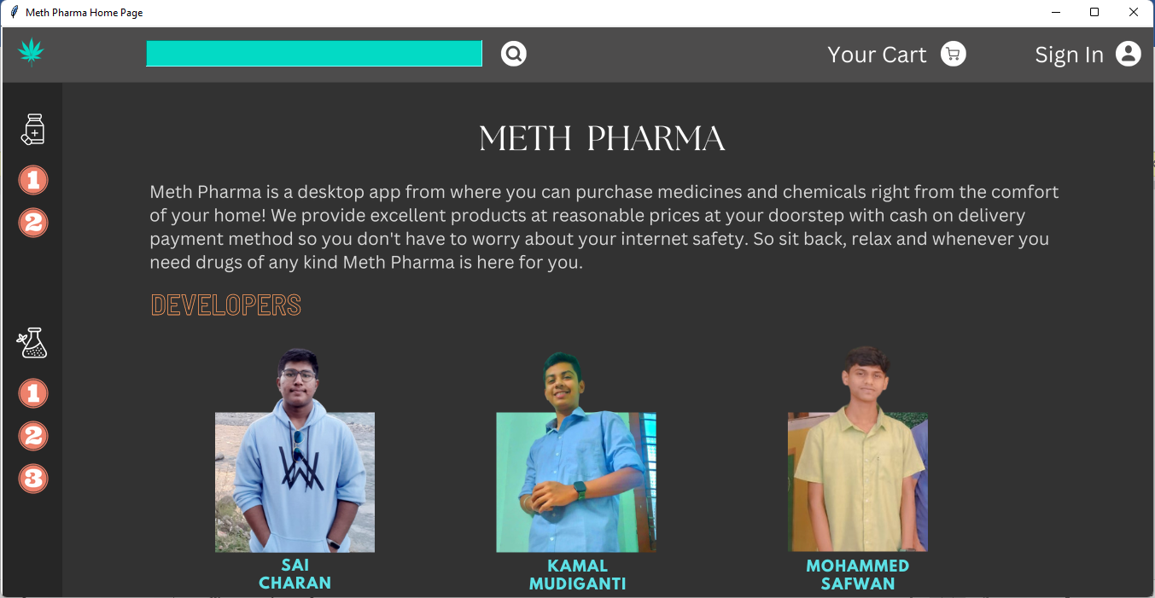

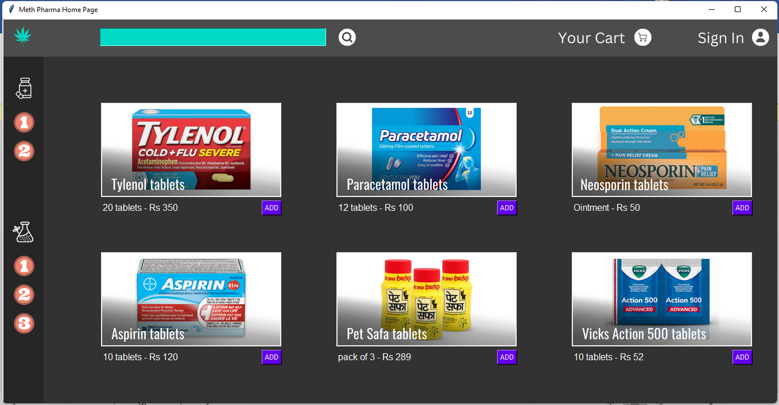 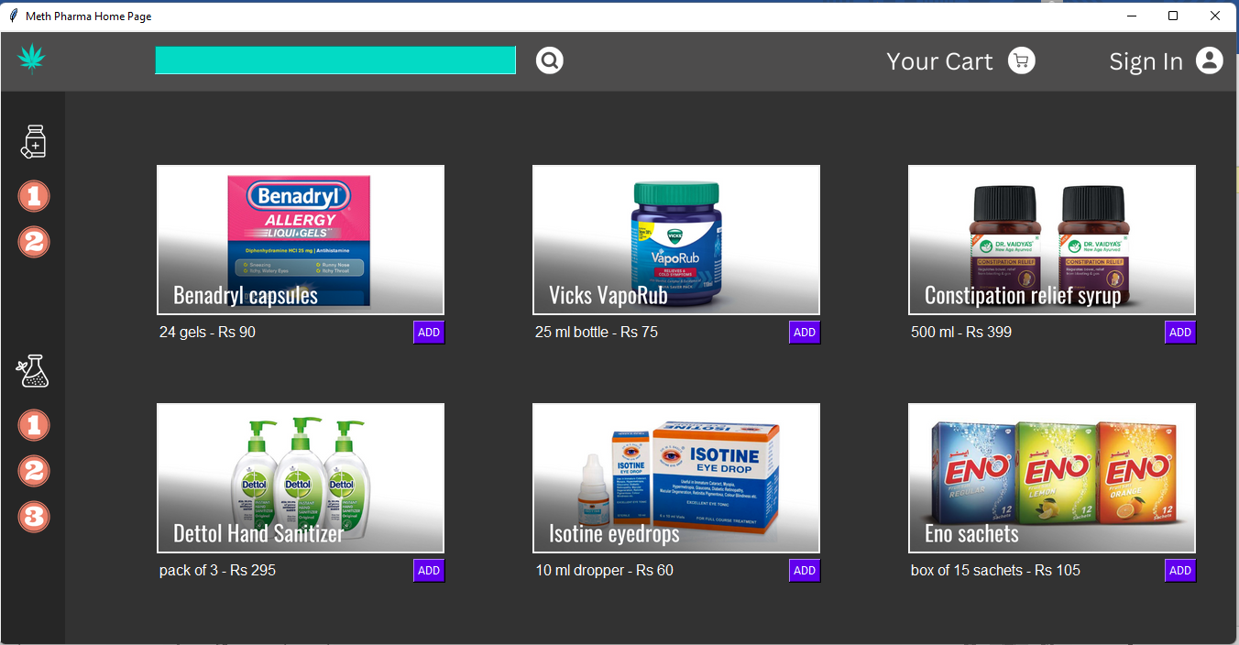 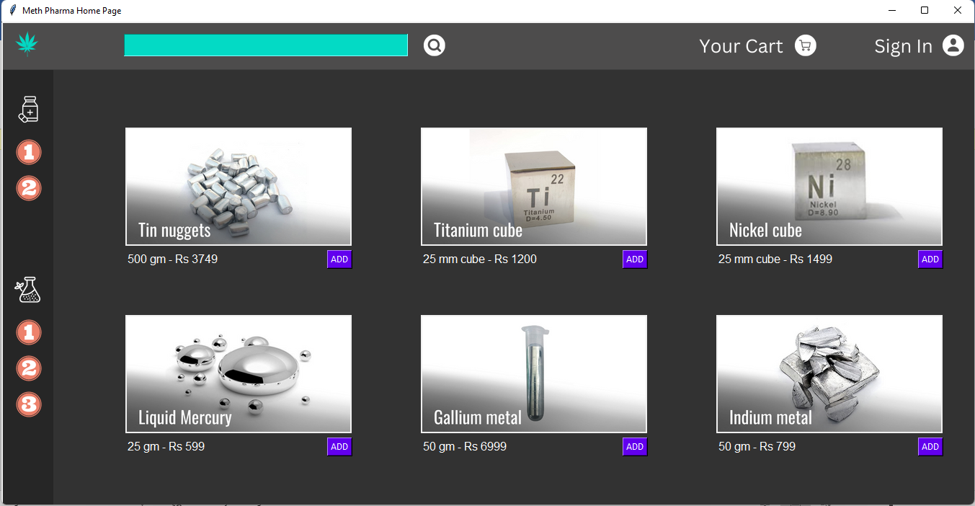

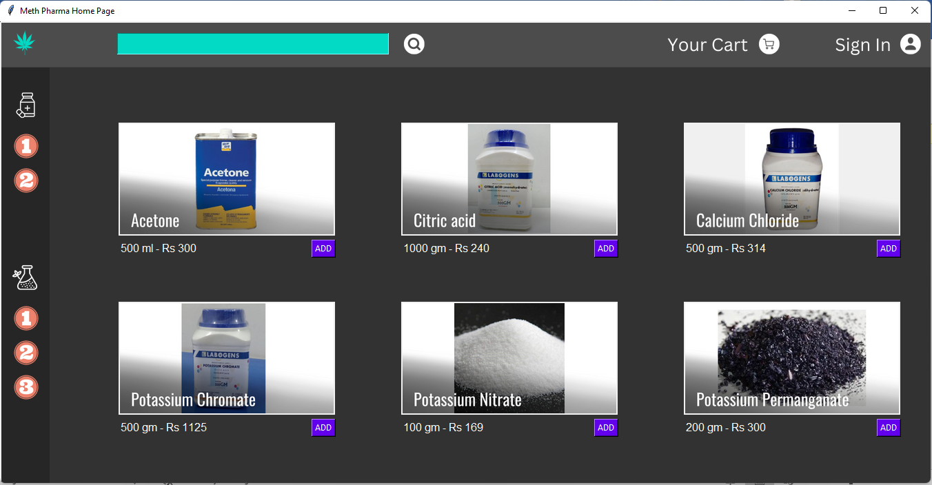 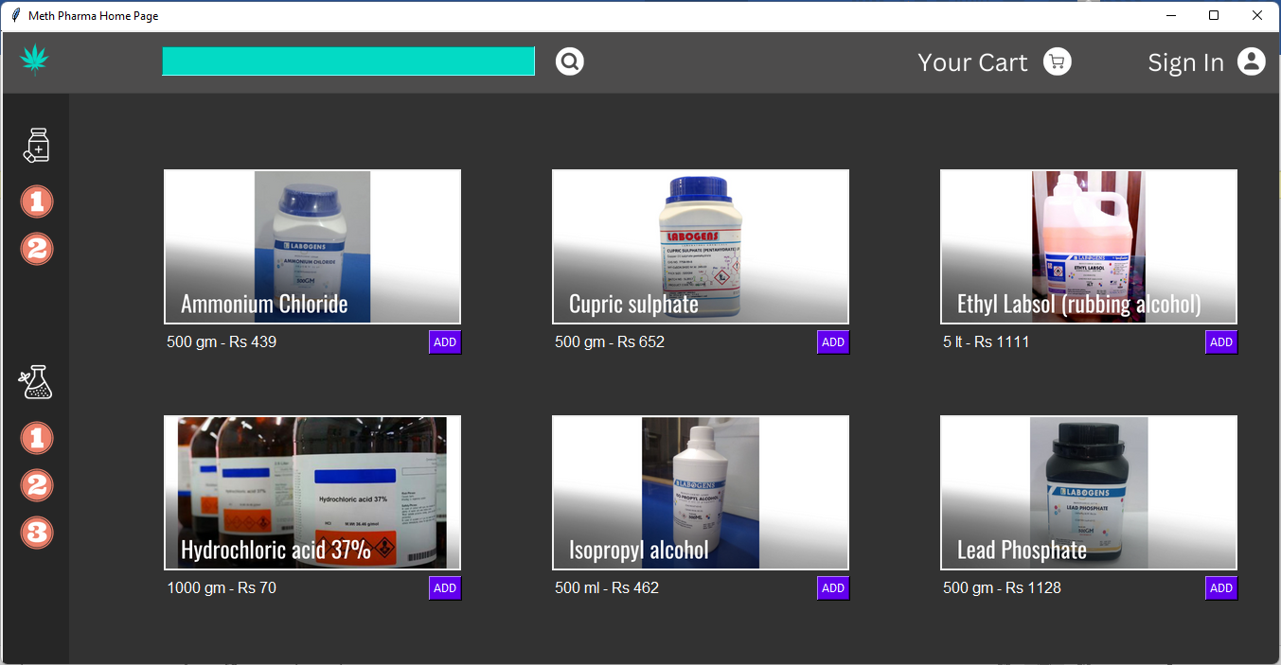

These are all the product pages that appear on clicking on the respective buttons on the side button menu. Now lets add some products to cart by clicking the given buttons and see how the cart page looks.

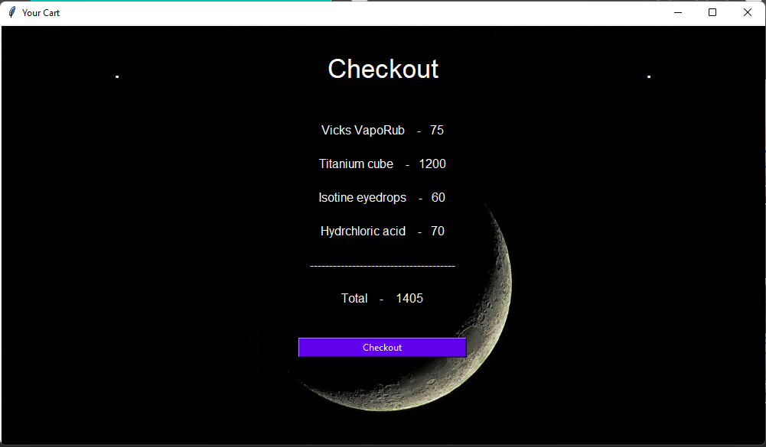

On clicking the checkout button we see a messagebox that asks for further options based on user interest.

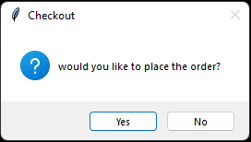

On clicking yes, we see this messagebox :

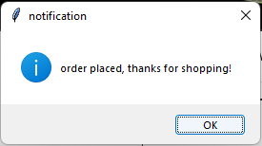

This also clears the cart so that the user can start shopping again.

If we had clicked in no option. The order would have been cancelled and a messagebox like the one below would appear.

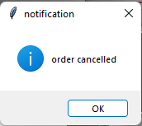

This doesn’t clear the already existing items in the cart so that the user can continue shopping where he left off.

That concludes the whole application of “Meth Pharma”, a tkinter GUI which allows a user to create an account and login t it whenever they want, add given placements of products to the cart and checkout and place the order. This app is connected to mysql where it stores the usernames and passowords of the users when they sign in so it can allow them to log back in through the login page. The table in mysql database after a few people tried the application looks like this.

