FUNCTIONS

A normal function will be like…

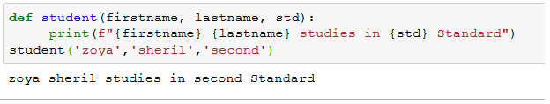

**Positional and Keyword Arguments**

Python functions can contain two types of arguments: *positional arguments* and *keyword arguments*. Positional arguments must be included in the correct order. Keyword arguments are included with a keyword and equals sign. The **order** of these arguments **matters** when they’re passed **positionally**. But when we use keyword/named arguments, it’s the name that matters, not the position.

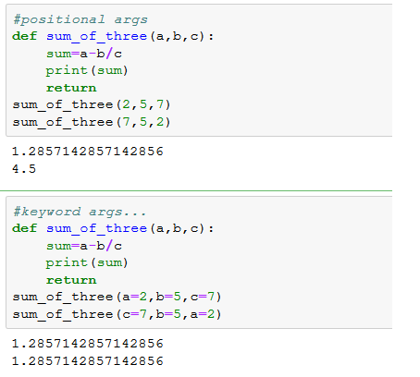

Positional arguments

The below figure shows the replacement of arguments given at the time of function call or positional arguments.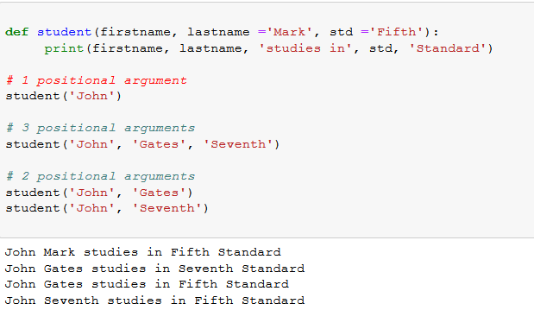

The same code can be replaced with f-string, then same output obtains.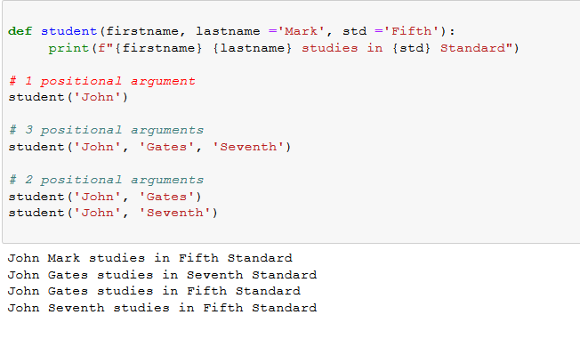

Using format() function in the above cases

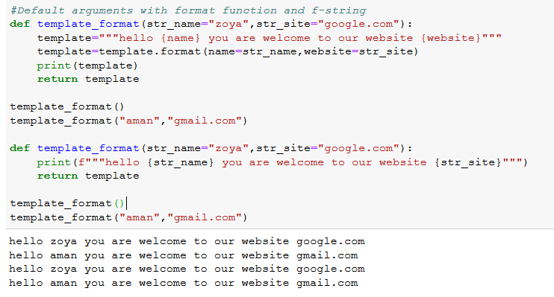

Different formatting techniques are…..