**Assignment-1**

**BSCS**

**Semester-VI**

Given below is Neural Network (NN) along with its weighs and input/dataset. Calculate one iteration of Forward Feed Neural Network and update the weights through Backward Pass vectorized process.

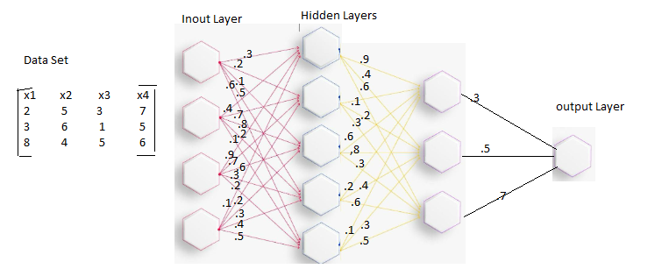

**Note: Assignment submissions must be in hard copy format and handwritten.**