**QUIZ-1**

**Introduction to Machine Learning**

**Session(2021-2025)**

Roll No.:-----------------------------------------------Name:----------------------------------------------------Section--------

Q-1What is the role of the learning rate in the gradient descent optimization algorithm?

A) It determines the number of iterations.

B) It adjusts the size of the steps taken towards the minimum.

C) It represents the slope of the cost function.

D) It is used to initialize the weights.

Q-2 which of the following quantities affect the trade-off between bias and variance?

(a) The regularization coefficient λ.

(b) The learning rate α in gradient descent

(c) The polynomial degree M in least-squares regression

(d) None of the above

Q-3 Consider the following training set of m=4 training examples:

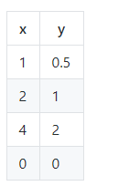

1. For the training set given above), what is the value of m?

4

1. Suppose we set θ0=−1,θ1=0.5. calculate the cost

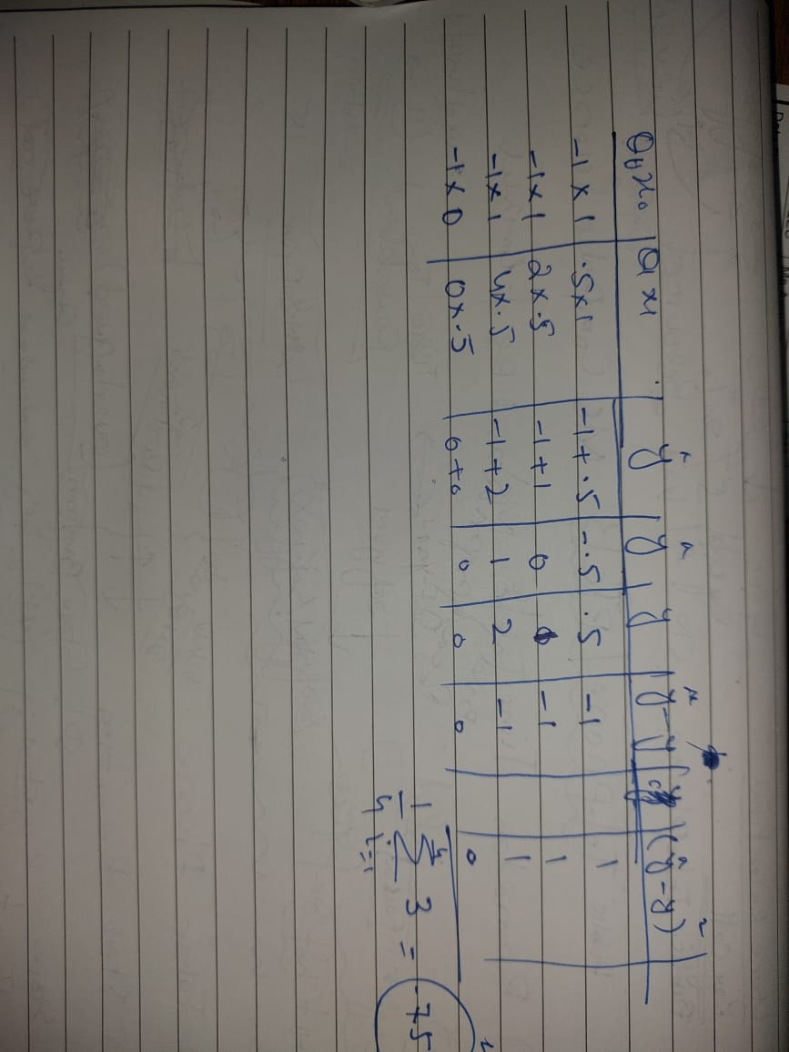

Q-5 Which of the following are true about gradient descent? (select all statements that are true.)

1. After each iteration we modify theta vector in the direction of gradient
2. We choose non variable learning rate

Question-1-4: Label the following contour plots in term Bias(Low, High) and Variance(Low, High)

|  |  |  |  |
| --- | --- | --- | --- |
|  |  |  |  |
| Low bias  Low variance | Low bais  hig variance | High bias  Low variance | High bias  High variance |