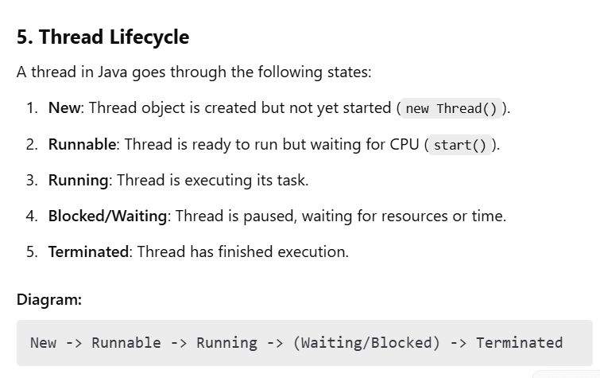

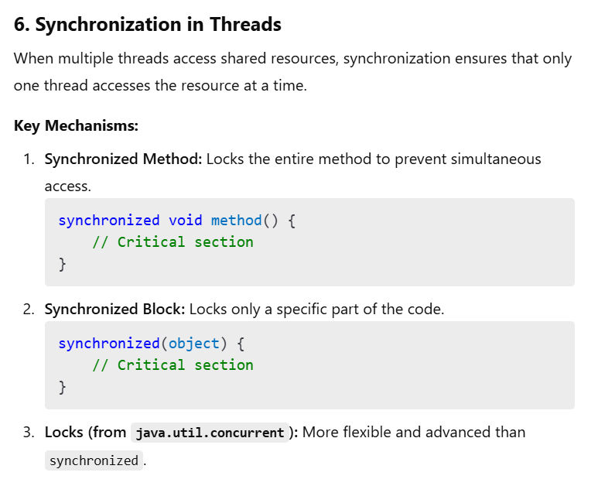

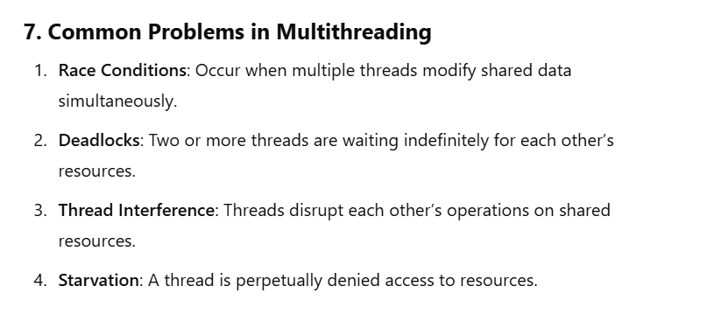

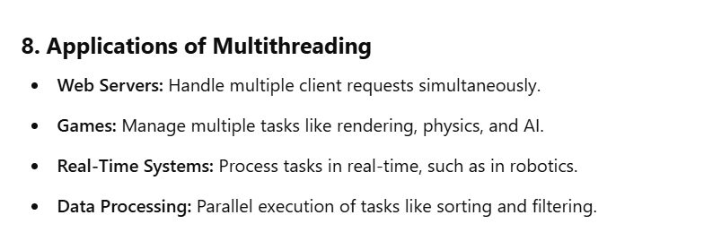

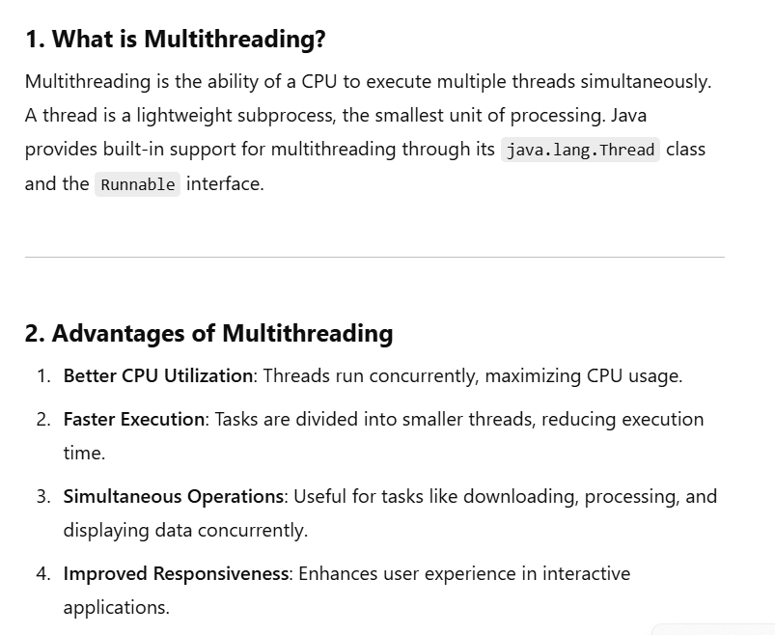

In a ticket booking system, multiple passengers try to book tickets concurrently. However, the system must maintain the correct count of available tickets and ensure that no overbooking occurs. To achieve this, we use a **synchronized method** to ensure thread safety during ticket booking.

**Scenario:**

A company needs to process multiple orders for an e-commerce platform. Each order processing task involves querying the database, updating stock, and notifying the user. To optimize resource utilization and improve performance, the company decides to use a **thread pool**.