General:

Each microservice has a start.bat to start the app.

Command to run each Microservice - **mvn spring-boot:run -DargLine="-Xmx2048m"**

User service:

User-service calls -> global-search to find Doctor , calls-> hospital-search OR doctor-speciality returns one doctor id

That doctor id is send to the Booking Request along with the user Id.

There is a REST call in Booking save method to Send Notification.

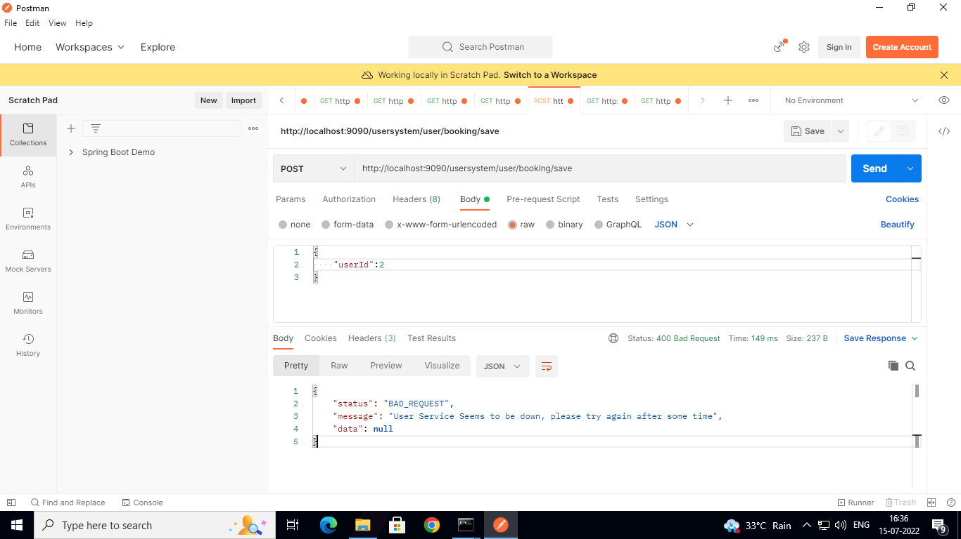

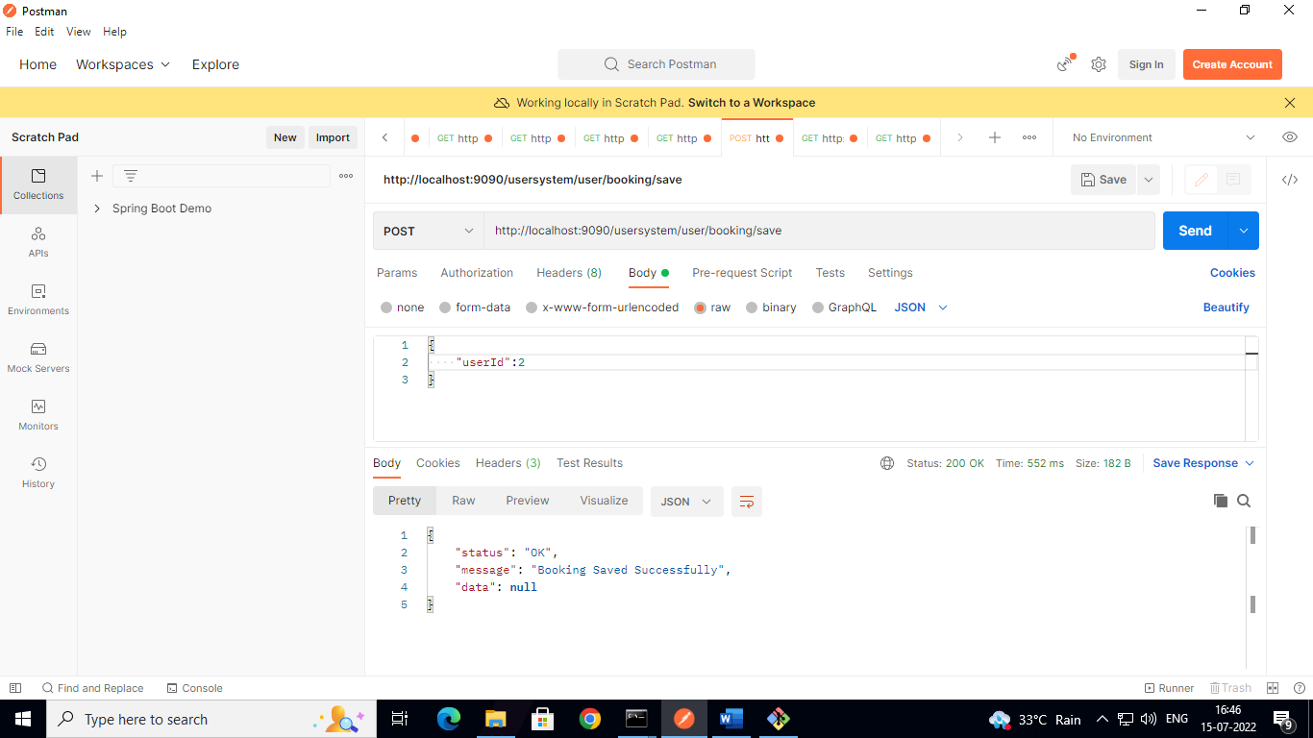

Global Search

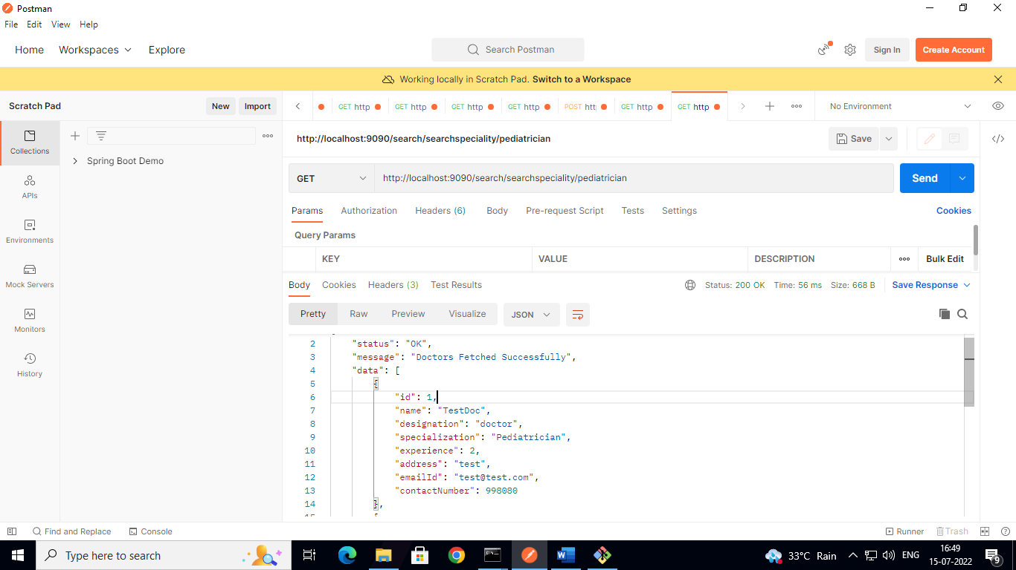

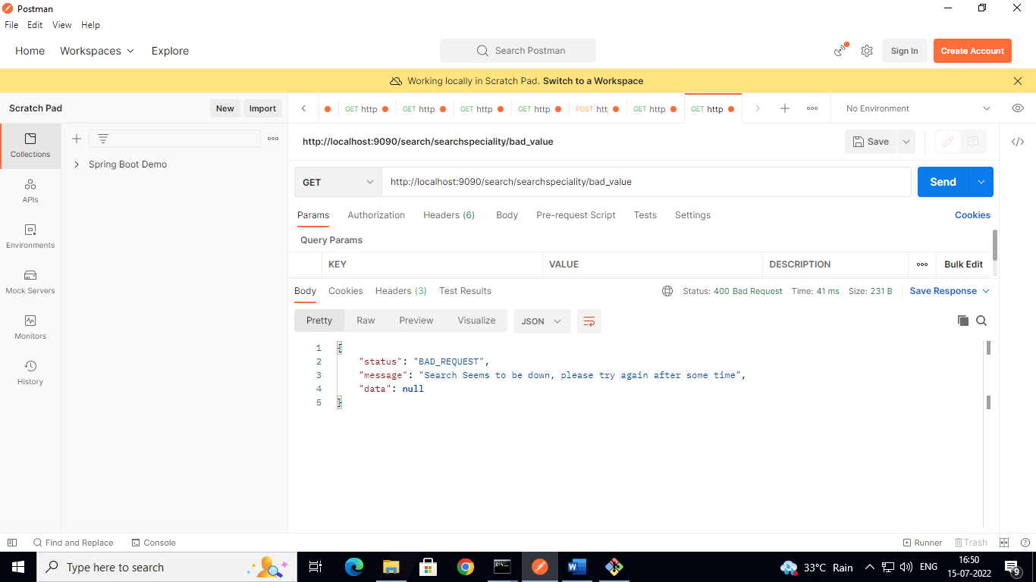

Config Server – each file has their own yml file, naming scheme is according to the application name

Eg: if a service name is notification-service then its yml will be notification-service.yml

Service name is declared in the bootstrap or application.yml of that particular Microservice

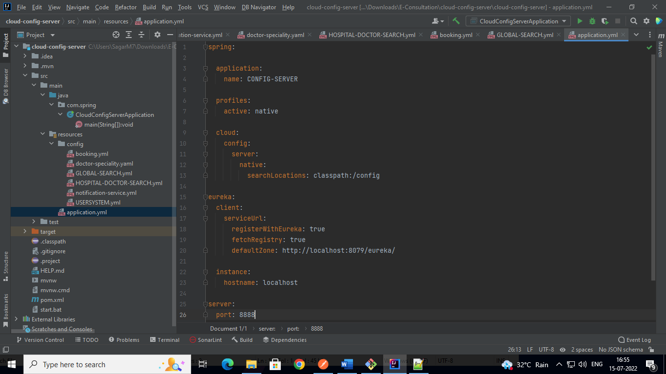

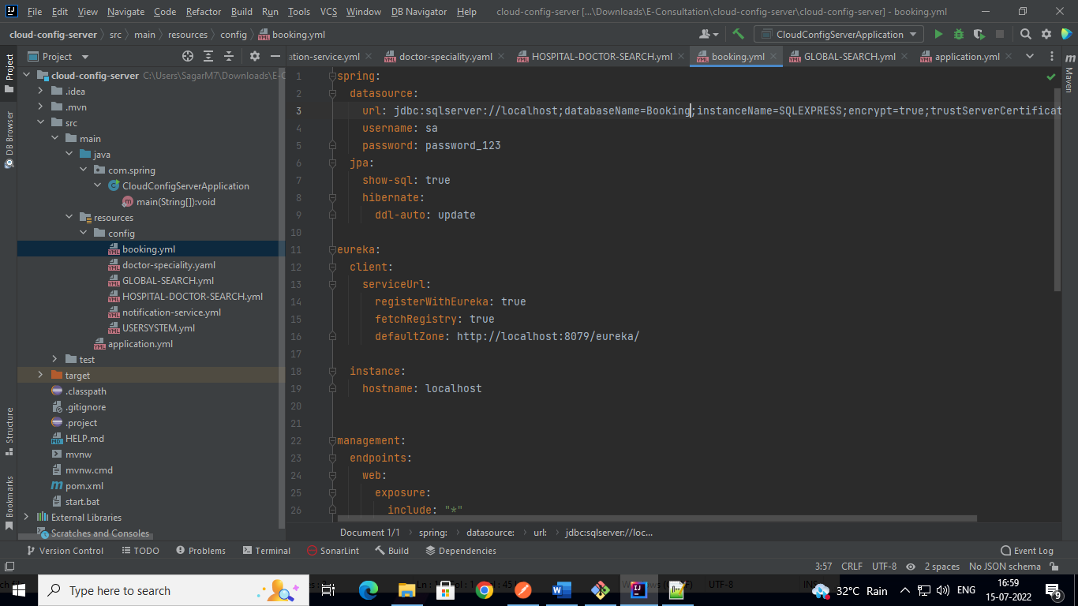

Circuit Breaker Mechanism – The annotation of @CircuitBreaker throws a callnot permitted exception, so instead of a fallback method this exception is handled in the controlle.

In each Service method which has a REST call, The circuit breaker annotation is used.

Example- UserSystem Service

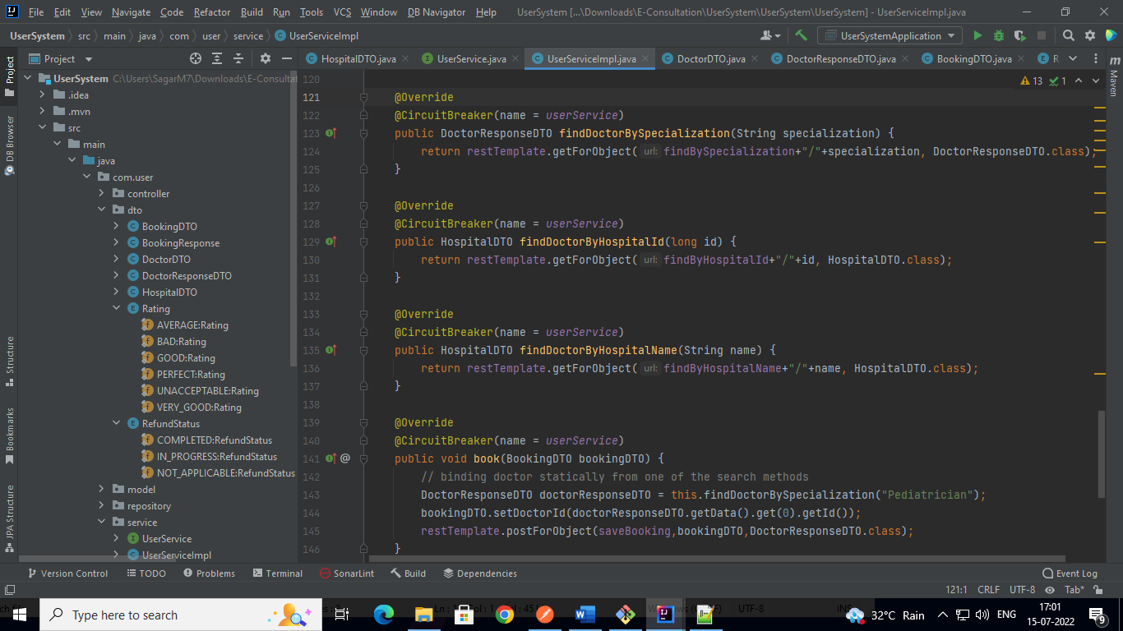

User Controller

