The Rendering Method of 2-Dimensional Vibration Presentation

for Improving Fidelity of Haptic Texture

|  |  |
| --- | --- |
| Junya Kurogi  Faculty of Engineering, Kumamoto University  2-39-1, Kurokami, chuo-ku, Kumamoto, Japan  Email: kurogi@saga-lab.org | Satoshi Saga  Faculty of Advanced Science and Technology, Kumamoto University,  2-39-1,Kurokami, Chuo-ku, Kumamoto, Japan |

*Abstract*—In recent years, touchscreens have been used all over the world, however, most of them are without realistic haptic feedback. Some of them have feedback, but most of them have vibration direction limited to one direction. Here we propose a novel rendering method for direction-controlled 2-dimensional vibration display to present texture information. In this paper, we proposed a dimension-controlled rendering method of texture information which capable of vibration control in the X and Y-axis precisely by using lateral force. Further, to improve the fidelity for large-scaled texture, we proposed to combine image features information of the textures. We held an experiment to evaluate the fidelity of the proposed method. The result shows that the proposed method can present randomized textures and periodic textures more precisely than the conventional method.

*Keywords*–*Haptic Rendering; Vibrotactile display.*

1. INTRODUCTION

In recent years, touchscreens have been used all over the world due to the spread of smartphones and the like, however many of them do not have realistic vibrotactile feedback. At the research level, several haptic devices using liquid crystal panel have been developed. For example, Chubb et al. developed a haptic device employing friction change induced by squeeze film effect [1], and Konyo et al. proposed vibration frequency control and virtual pointer [2]. Wang et al. developed a sliding system using shear force [3]. These vibration stimuli realize high reproducibility, though, the direction of the vibration is limited to one-dimension. This is because it has been found that receptors transmitting vibrational stimulus in the skin are not very good at discriminating direction of vibration[4]. For this reason, the direction of vibration has not been regarded as much importance in the tactile research so far, and most of them have employed one-dimensional vibration.

However, there is some distribution of the receptors in the skin. Thus, the input signals from multiple receptors may induce discrimination of multi-dimensional vibration. In this paper, we propose methods to reproduce triaxial acceleration information by our lateral-force-displaying device using Xaxis and Y-axis vibration information. We report the results of experiments on the reproducibility of tactile sensation by comparing the conventional method and proposed one. We propose a novel rendering method to display multi-dimensional vibration. Further, to improve the fidelity for large-scaled texture, we proposed to combine image features information of the textures. We held an experiment to evaluate the fidelity of the proposed method. The result suggest that the proposed Email: saga@saga-lab.org

method can present randomized textures and periodic textures more precisely than the conventional method.

1. PRESENTATION OF TACTILE TEXTURE INFORMATION USING VIBRATION

Many researchers are considering methods of presenting tactile texture information using vibration information from various viewpoints [5], [6]. Romano et al. proposed a method for recording texture on a tablet by recording acceleration, position, and contact force overtime when touching a texture with a dedicated tool [7].

Saga et al. proposed a simpler recording/playing method by omitting the measurement of pressure and using a compensation method when reproducing vibration [8]. They reproduce the sense of direct touch by recording vibration information with fingers and reproducing the recorded information by using the shearing force presentation device.

1. METHODS

We extend the method of Saga et al. and propose a method to accurately record the vibration information on the X and Y axes and reproduce it on our device.

# A. Recording phase

The triaxial acceleration sensor (ADXL - 335) is fixed to the finger with tape and the acceleration information is recorded from several textures.

Since Saga et al. recorded acceleration information by the audio input, it was recorded as one-dimensional data. In this research, to accurately acquire three-dimensional data, acceleration information was processed by a microcontroller, Arduino, which packs three-axis information as one packet and transmitted to a PC using serial communication. On the PC, packed vibration information was unpacked and recorded by the Processing application.

The acceleration is sampled at 1 kHz. To accurately present the recorded vibration direction and reproduce faithful vibrations, using correct vibrations which are suitable for the user ’ s movement direction is essential. Therefore, when recording vibration information, we stored vibration separately not in one direction but in X and Y-axis two directions. This makes it possible to more accurately reproduce vibrations not only for textures that give similar vibrations regardless of the direction in which the fingers are moved but also for textures with significantly different vibrations depending on the direction in which the fingers are moved.

# B. Display phase

Reproduction of vibration is carried out by using prerecorded vibrations in two directions and a shearing force presenting device. At the time of presentation, vibration patterns are generated by using the vibration information of these two directions, and this is presented.

The compensation method used by Saga et al. Resampled the acceleration by using the ratio of the moving speed of the finger during recording and playing. In our proposed method, we use a new compensation method extended the method of saga et al. in this experiment. The compensation method is described below.

First, information to be recorded and reproduced is defined

(subscript*D* = {*X,Y*} represent direction of movement, *r* and *p* represent recording and playing).

a*Dr* 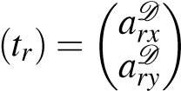 (1)

This *tr* is the time of recording. In addition, the finger position X*p* during play is obtained, and the finger movement speed is derived based on this value.

X*p*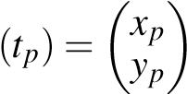 (2)

At this time, the moving speed of the finger during play( x˙p) is Calculated using the moving distance in unit time ∆*T*．

x˙p 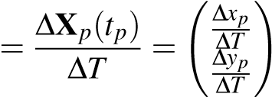 (3)

Because of the time between frames during recording and it during playing are same, the presented vibration is calculated using the ratio of the moving speed x˙r during recording and the moving speed x˙p of the finger during playing

a*D*(*tpn*+1) = ar*D*(*tpn* + |x˙p(*tpn*)|) (4) *p*

|x˙r(*tpn*)|

In this experiment, it is constant at x˙r = 5 cm/s. The vibration is presented using the appropriate a*Dp* (*tpn*+1). As shown in Figure 2, depending on the movement direction, switch the acceleration information. If α is the movement component in the X-axis direction and β is the movement component in the Y-axis direction, the accelerationa*p*(*tpn*+1) to be presented is obtained using the following formula.

a

*p*

(

*t*

*p*

*n*

+

1

)=

α

√

α

2

+

β

2

a

*X*

*r*

(

*t*

*p*

*n*

+

1

)+

β

√

α

2

+

β

2

a

*Y*

*r*

(

*t*

*p*

*n*

+

1

)

(5)

IV.

S

UPERPOSITION INFORMATION OF IMAGE FEATURES

The proposed method has a problem that tactile reproducibility decreases for a texture having a certain spatial frequency (e.g. tiled-floor). We considered that the problem can be caused by the periodicity and continuity of the presented vibration. Therefore, we propose another rendering method to resolve this problem by combining image information.

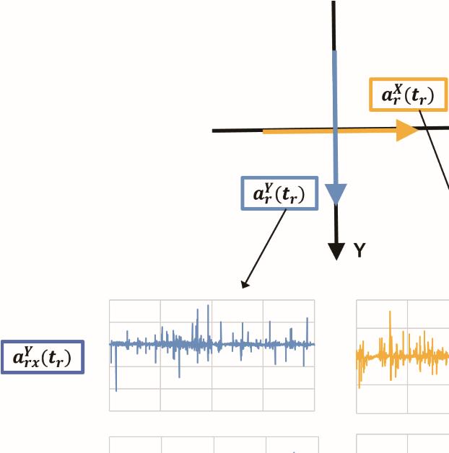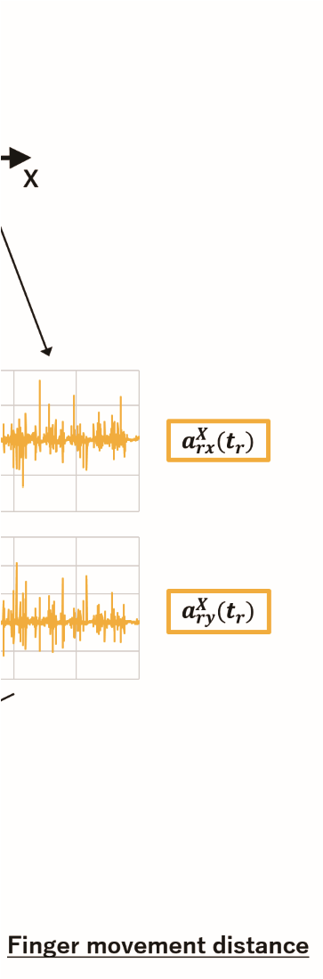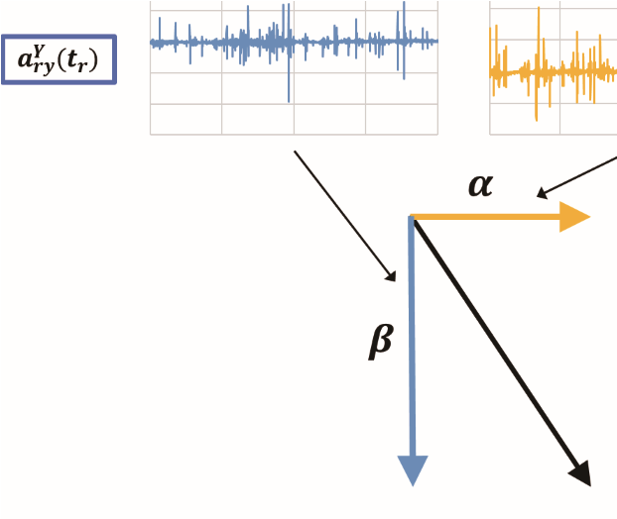

Figure 1. Presentation method of vibration according to the movement direction of the finger

# A. Recording of image features

We propose a vibration presentation method using image features. Parameters such as size and angle are stored in the image features, and these information is data representing texture features. Therefore, our method extracts the information contained in these features, processes it into a one-dimensional form that can be used for vibration presentation, and superimposes it on the vibration information to enable vibration presentation with more emphasized characteristic parts. . The procedure of presenting the actual vibration information and image information by superposition is shown below. Image processing uses OpenCV, and it processed the following four.

1. Acquire features from texture images using AKAZE
2. The size information representing the diameter of the important region around the feature is extracted.
3. Obtains one-dimensional information by averaging information in each of the x-axis and y-axis directions and then normalizing
4. Size information corresponding to the display position is superimposed on the vibration information and presented

In this section, a self-made texture of tile pattern made of PLA (polylactic acid) was used as a texture with a constant spatial frequency. Figure.?? shows the result of the feature extraction for the self-made texture used.

Image features can also be acquired for textures with other specific fixed spatial frequencies in the same way, and by superimposing image features corresponding to finger positions on texture vibration information, it is effective for textures with low tactile reproducibility vibration is presented.Figure.3

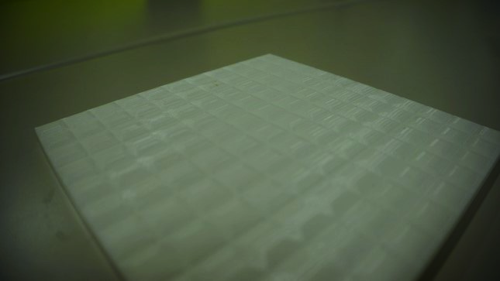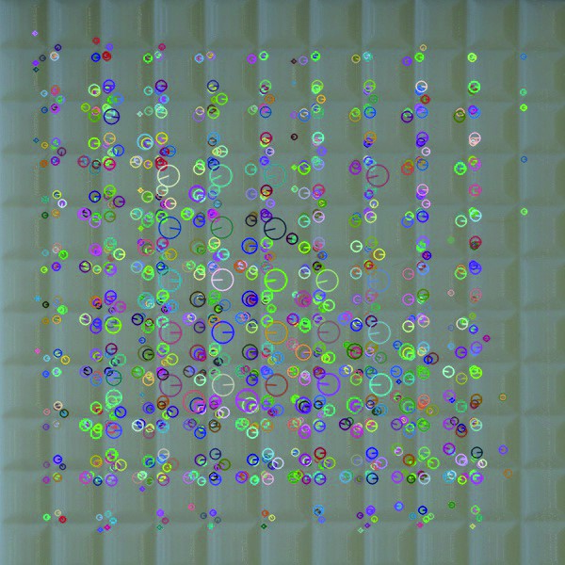

Figure 2. (left)self-made texture：(right)image future

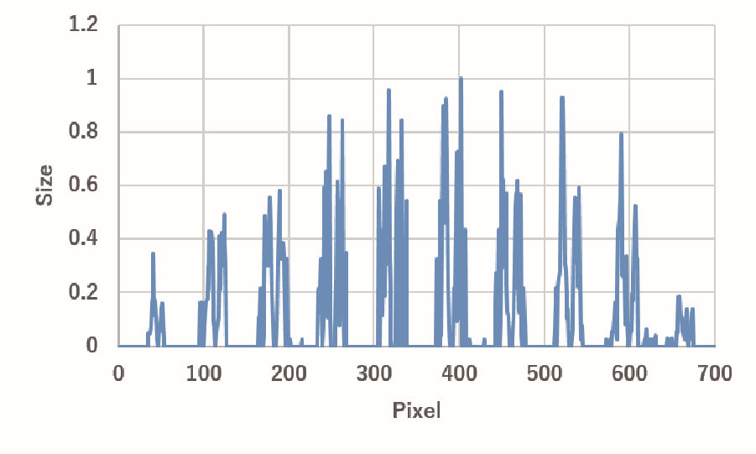

Figure 3. Image features extracted from self-made tile texture

shows a one-dimensional image feature extracted from a selfmade tile texture. In addition, in order to suppress the loss of vibration information when image features are superimposed, we also prepared a normalized one after applying a logarithmic function to the image features. The Figure.4 shows a logarithmic function applied to image features.

# B. Presentation of vibration information using image feature

The presented vibration is calculated by the following equation. *ax*, *ay* is the presentation vibration on the x-axis and y-axis, and *e* is the size information of the image feature to be superimposed.

*a*(*x,y*)= *axe*(*x*)+*aye*(*y*) (6)

By using this presentation method, it is possible to emphasize and present only the characteristic parts of the texture.

Figure.5 shows the vibration information before the image feature is superimposed, and Figure.6 shows the vibration information after the image feature is superimposed. Figure.7 shows the vibration information after the image feature to which the logarithmic function is applied is superimposed.

V. EXPERIMENT

# A. Experiment preparation

We used 10 textures for experiment (soft artificial grass1 which is close to natural grass, artificial grass2 which is harder than natural grass, stiff carpet1, soft carpet2,self-made tiled texture, 40 coarse sand Paper, three types of place mats with different feels, punched plastic plates). Figure 8 shows the image of the texture used in the experiment.

Subjects were 6 healthy men aged 22 to 24. During this experiment,they are wearing eye masks and headphones that

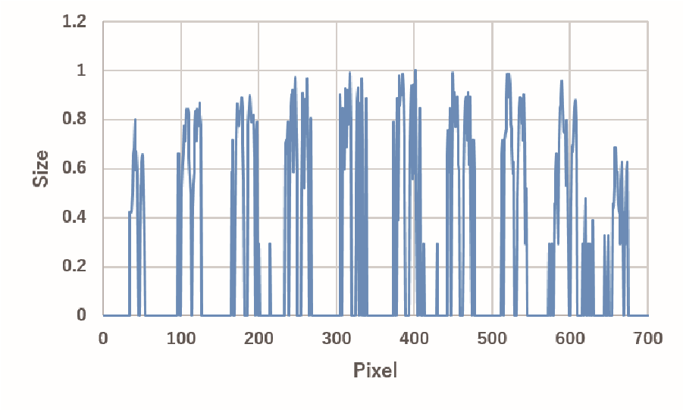

Figure 4. Image features with logarithmic function

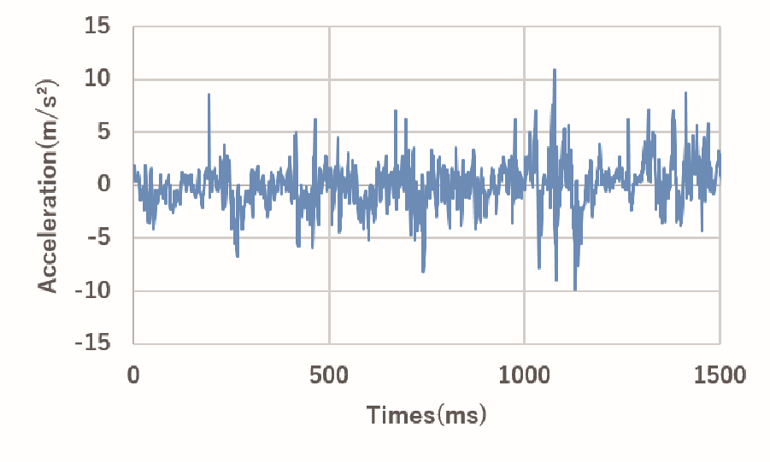

Figure 5. The vibration information before the image feature is superimposed

pink noise flowed and block external sounds. They were all right-handed, and they were touched with the right index finger.

# B. Experiment procedure

We compare each pattern of vibration presentation methods proposed. 5 stages Likert scale ware used for evaluation.

1. Ask the subject to touch the sample texture placed on the weighing scale and train them so that the pressing force is about 50 gf
2. Have they touch the real texture for 10 seconds to learn the tactile sensation
3. Ask them to touch the texture presented on the display for 10 seconds and evaluate it in five steps to see how much the real texture can be reproduced
4. Change the presentation method and have it evaluated in the same way as steps 2 and 3.
5. Only when the texture to be displayed has a specific spatial frequency, a method of superimposing image features is also used, and the user is asked to select whether to use the logarithmic function or not.
6. After completing steps 2 to 5 for all ten types of textures, finish the experiment.

To eliminate the influence of the order effect, experiments are conducted by changing the order of presenting patterns for each subject.

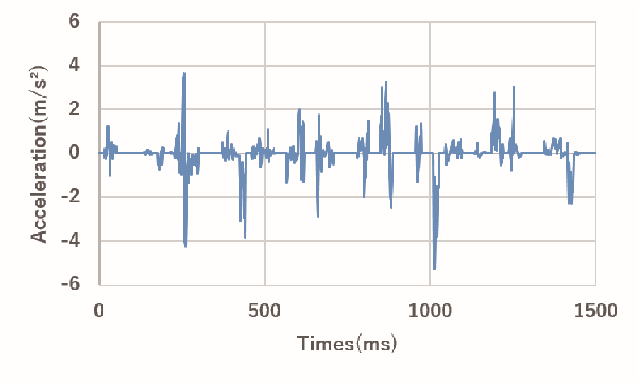

Figure 6. The vibration information after the image feature is superimposed

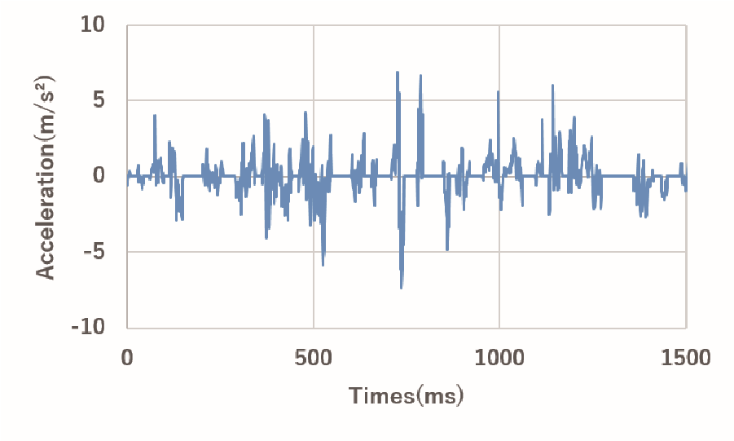

Figure 7. the vibration information after the image feature to which the logarithmic function is applied is superimposed

VI. RESULTS AND DISCUSSION

# A. Reality of virtual texture

The results of reality evaluation of the virtual texture are shown in Figure.9.

The two-dimensional vibration presentation method we proposed was evaluated higher than the one-dimensional vibration presentation in Artificial Grass2, Carpet2, Place Mat1, and Place Mat2. However, As a result of tukey’s test, no significant difference was obtained for textures other than artificial grass 2. We consider the reasons for this result. Among the textures that were highly evaluated for the two-dimensional vibration presentation, the artificial turf 2, sandpaper, and mat 2 have random spatial frequencies. In addition, although no significant difference was obtained between sandpaper and mat 2, both scores exceeded 3.0.This suggests that our two-dimensional vibration presentation method is good at presenting textures with random spatial frequencies.With soft textures such as artificial grass 1, carpet, and mat 3, there was no significant difference between the one-dimensional and two-dimensional vibration presentations. Our proposed method records vibrations in the X-axis and Y-axis directions and selects and presents vibrations in accordance with the direction of finger movement, making it easier to generate random-period vibrations than one-dimensional vibrations it is conceivable that. In particular, since the display surface is a hard material, it can be said that the evaluation of a texture having a hard random spatial frequency tends to be high. This may be related to the perception of softness due to the change in the contact area between the finger and the texture.

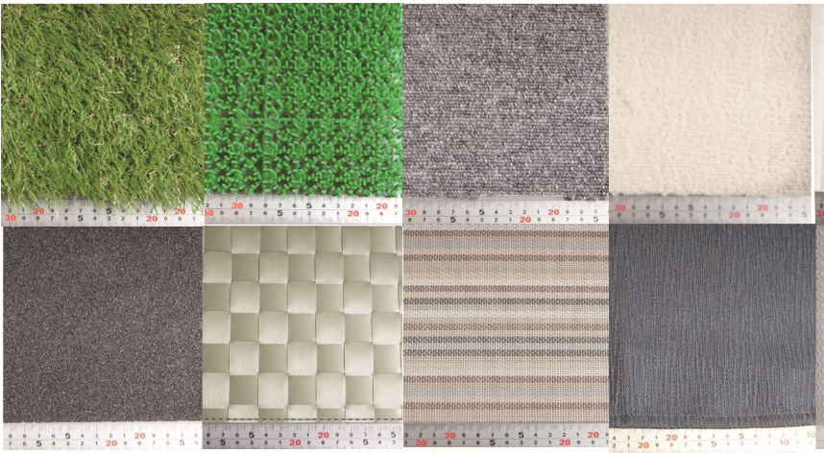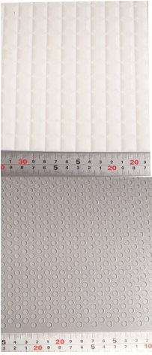

Figure 8. Texture used in experiment

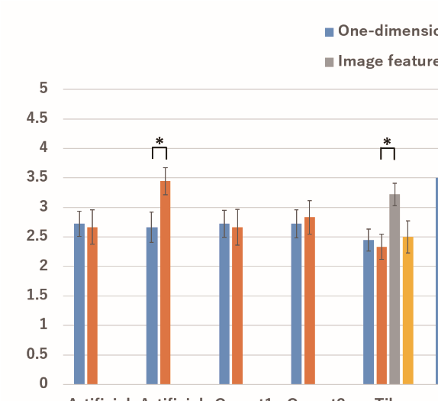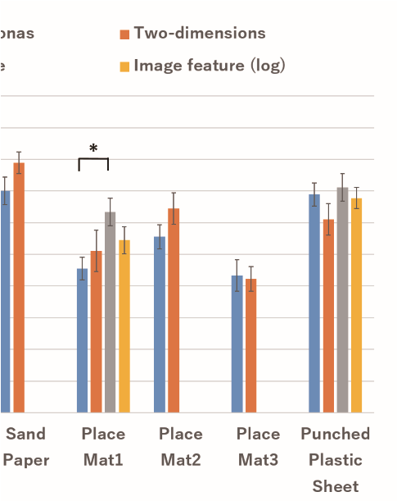

Figure 9. Result of reality evaluation

# B. Evaluation of image feature superposition method

From Figure.9 , it can be seen that for some textures, the presentation method that superimposes image features on vibration information is highly evaluated.

From the two results, the proposed method of this research is suitable for presenting materials with irregular spatial frequencies (artificial grass2, sandpaper2), which shows that it is not suitable for presenting materials with certain spatial frequencies(tile). We will discuss the reasons for this result. In the proposed method, independent vibrations are presented on the X axis and the Y axis, and it is speculated that vibrations with random periods are likely to occur, depending on the direction in which the finger is moved since the subject can freely move the finger during the experiment. For this reason, reproducibility is felt high in materials with irregular spatial frequencies, and on the contrary, reproducibility is considered to be felt in materials with constant spatial frequency. Since the texture of tiles, place mat1, and punched plastic sheet has a constant spatial frequency, it is considered difficult to reproduce it with our proposed method that generates vibrations with random spatial frequencies. Therefore, it is possible to suppress the loss of reality by using the image feature to emphasize the characteristic part of the texture.

Figure.10 shows the result of selecting the higher evaluation one of the two image feature superposition methods.

The method that did not apply the logarithmic function in all three textures received higher ratings. We consider the reason for this result. The method using a logarithmic function for image features reduced loss of vibration information but reduced feature enhancement. In particular, since Place Mat1 has

1. Y. Visell, A. Law, and J. R. Cooperstock, “Toward iconic vibrotactile information display using floor surfaces,” in EuroHaptics conference, 2009 and Symposium on Haptic Interfaces for Virtual Environment and Teleoperator Systems. World Haptics 2009. Third Joint. IEEE, 2009, pp. 267–272.

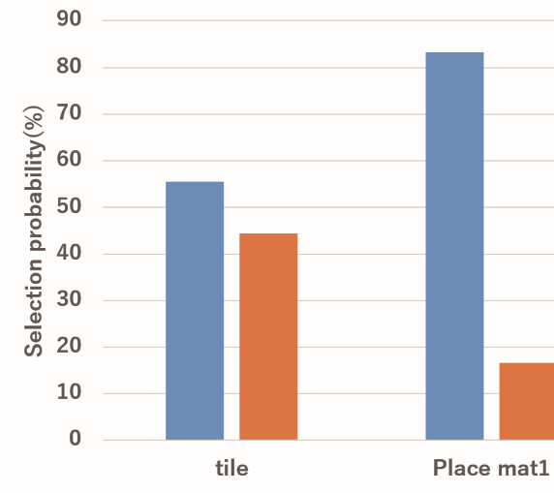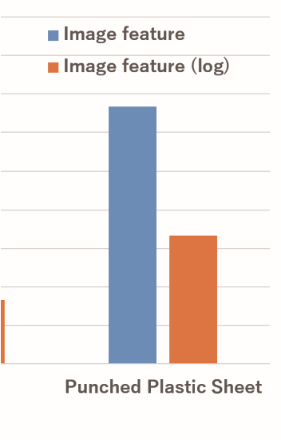

1. J. M. Romano and K. J. Kuchenbecker, “Creating realistic virtual textures from contact acceleration data,” IEEE Transactions on Haptics, vol. 5, no. 2, 2012, pp. 109–119.
2. S. Saga and R. Raskar, “Simultaneous geometry and texture display based on lateral force for touchscreen,” in World Haptics Conference (WHC), 2013. IEEE, 2013, pp. 437–442. Figure 10. Result of reality evaluation

the longest distance between features among the three textures, it is considered that the periodicity of the features contributed more to the reality than the magnitude of the vibration. Also, the score of the punched plastic sheet texture exceeds 3.0 even in the case of a two-dimensional vibration presentation, although the texture has a certain spatial frequency. This is probably because the distance between feature points of the texture is small and it is difficult to recognize a constant period. This indicates that the two-dimensional vibration presentation method is not good at presenting textures that 　 constant and large period.

VII. CONCLUSION

We proposed a method to record the vibration of a texture tracing using a three-axis acceleration sensor and reproduce it as faithfully as possible in two dimensions. Experiments show that our proposed method is suitable for displaying textures with random spatial frequencies. In addition, we proposed a presentation method that combines image features, and succeeded in improving the reproducibility of textures that are difficult to present.

ACKNOWLEDGMENT

This work was partly supported by JSPS KAKENHI 18H04104G1 (Grant-in-Aid for Scientific Research (A)) and

19K2287900 (Grant-in-Aid for challenging Exploratory Research).

REFERENCES

1. E. C. Chubb, J. E. Colgate, and M. A. Peshkin, “Shiverpad: A glass haptic surface that produces shear force on a bare finger,” IEEE Transactions on Haptics, vol. 3, no. 3, 2010, pp. 189–198.
2. M. Konyo, H. Yamada, S. Okamoto, and S. Tadokoro, “Alternative display of friction represented by tactile stimulation without tangential force,” in International Conference on Human Haptic Sensing and Touch Enabled Computer Applications. Springer, 2008, pp. 619–629.
3. D. Wang, K. Tuer, M. Rossi, and J. Shu, “Haptic overlay device for flat panel touch displays,” in Haptic Interfaces for Virtual Environment and Teleoperator Systems, 2004. HAPTICS’04. Proceedings. 12th International Symposium on. IEEE, 2004, p. 290.
4. A. Brisben, S. Hsiao, and K. Johnson, “Detection of vibration transmitted through an object grasped in the hand,” Journal of Neurophysiology, vol. 81, no. 4, 1999, pp. 1548–1558.
5. K. Minamizawa, Y. Kakehi, M. Nakatani, S. Mihara, and S. Tachi, “Techtile toolkit: a prototyping tool for design and education of haptic media,” in Proceedings of the 2012 Virtual Reality International Conference. ACM, 2012, p. 26.