Numerical Experiments of Solving Moderate-velocity Flow Field
Using a Hybrid Computational Fluid Dynamics – Molecular Dynamics Approach
Soon-Heum Ko¹, Nayong Kim^{2,*}, Shantenu Jha³, Dimitris E. Nikitopoulos⁴, and Dorel Moldovan⁴
¹ National Supercomputing Centre, Linköping University, Linköping, 584 32 Sweden
² Center for Computation and Technology, Louisiana State University, Baton Rouge, LA 70803, USA
³ Department of Electrical and Computer Engineering, Rutgers University, Piscataway, NJ 08854, USA
⁴ Department of Mechanical Engineering, Louisiana State University, Baton Rouge, LA 70803, USA
(Manuscript Received 000 0, 2012; Revised 000 0, 20121; Accepted 000 0, 2012) -please leave blank
----------------------------------------------------------------------------------------------------------------------------------------------------------------------------------------------------------------------------------------------------------------------------------------------
Abstract

We apply numerical approaches to suppress the statistical error of a hybrid computational fluid dynamics (CFD) - molecular dynamics (MD) solution due to finite sampling of molecular dynamic solution. In principle, a hybrid CFD-MD approach can provide a higher-resolution solution than traditional continuum-based simulation techniques near the solid-fluid interface with less computational cost compared to a pure particle-based method. However, applications have yet been restricted to extreme velocity conditions due to the dominance of the statistical error in the low-velocity flow simulations. Admitting the impossibility of infinitely increasing MD system size, we propose and experiment a number of numerical alternatives to suppress the excessive sampling noise in solving moderate-velocity flow field. They are the sampling of multiple replicas and linear regression of multiple spatial/temporal samples. We discuss the pros and cons of each technique in view of solution accuracy and computational cost.

Keywords: Hybrid CFD-MD Approach, Nanofluidics, Replica Sampling, Spatial Regression, Molecular Statistical Error (Molecular Sampling Noise), Temporal Regression
----------------------------------------------------------------------------------------------------------------------------------------------------------------------------------------------------------------------------------------------------------------------------------------------

1. Introduction
*Corresponding author. Tel.: +1 225 578 5486, Fax.: +1 225 578 5362
E-mail address: nykim@cct.lsu.edu
† Recommended by Editor 000 000-please leave blank
†† This paper has been revised from the proceeding at the ASME-JSME-KSME Fluids Engineering Conference 2011, whose article number is AJK2011-01021.
© KSME & Springer 2012
A hybrid CFD-MD simulation methodology [1-9] is a reliable simulation approach capable of accurately describing the flow at both molecular and macroscopic scales. In this approach the continuum and molecular domains are coupled through an overlap region that facilitates the exchange of information between them. Two descriptions are forced to match each other by constrained molecular dynamics and boundary conditions based on time and spatial averaging of relevant physical properties in the overlap region. The continuum hypothesis is adopted in capturing macroscopic flow features and a particle-based technique captures the strong intermolecular interactions near the solid obstacles. In principle, the hybrid approach provides a good balance between computational cost and atomistic details/resolution.
Despite the clear advantage over conventional CFD or MD methodology, a hybrid technique so far fails to attract scientists due to its limited possible applications. Rather artificial flow conditions are chosen in previous examples to prevent the sampling noise of molecular properties from harming the accuracy of a solution. Basically, the sampling noise due to the thermal fluctuation is the response of the locality in atomistic system. Sampling over a finite spatial/temporal scale induces this noise, which eventually diminishes by increasing sampling scales. However, temporal scale is physically bound by the characteristic time of the fluid system and spatial scale is technically bound by the computing capacity. Therefore, numerical alternatives should be devised to succeed in the hybrid simulation of moderate-velocity flow field.
In this paper, we introduce numerical approaches to suppress the sampling noise within acceptable computational cost. We start by introducing the hybrid simulation technique and its formulation in Section 2. We discuss the characteristics of the statistical error and penetrate to three numerical approaches of multiple replica sampling, linear regression of multiple consecutive spatial/temporal samples in Section 3. Numerical solutions are presented in Section 4 and concluding remarks are added in the last Section.

2. Numerical Modeling
2.1 A Hybrid CFD-MD Approach
The hybrid CFD-MD approach is a simulation method, which adopts the continuum hypothesis in capturing macroscopic features of a flow-field and details atomistic intermolecular interactions on interfaces of different materials by using the MD approach. CFD can accurately predict flow properties on conventional moderate/large size fluid domains, but is intrinsically impossible to reflect characteristics of surrounding solid materials within an interfacial region. While standard classical MD can provide atomistic level resolution of interactions between particles, it becomes computationally demanding as the size of simulated system grows. So, neither method is suitable for solving a multi-scale fluid system where the viscous effect dominates the flow characteristics but macroscopic flow variation is also important.
The best solution would be, as can be seen in Fig. 1, to carry out the hybrid CFD-MD approach where atomistic interactions between solid elements and fluid particles near the wall is simulated by MD and the macroscopic flow field is calculated by CFD. In the overlap region, computational domain can be decomposed into three interesting layers. In the bottom layer, denoted MDtoCFD, sampled molecular properties are directly imposed as the CFD boundary condition. On the other hand, continuum solution in the CFDtoMD layer is delicately imposed to MD domain, not to break up the higher degree-of-freedom (DOF) molecular motion. It demands a constrained particle dynamics to achieve consistence between two different multi-scale approaches. Finally, the external force is added in the uppermost layer to maintain the system’s ensemble.
Four coupling parameters are introduced to define the sampling condition in particle-to-continuum boundary condition layer (MDtoCFD). Sampling layer size (h) is the height of sampling layer and sampling position (H₀) is its distance from the solid obstacle. Considering the length of the computational domain is L, particles placed in L×h layer at H₀ distance above the bottom wall participate in sampling process. Sampling duration (dt_{s}) denotes how long the sampling process takes place and sampling interval (dt) defines how often the sampled data is transferred to the continuum domain. The more accurate MD sample is acquired by increasing h (along with L in case of the periodic system) and dt_{s}, while the spatial scales (L and h) are related to the computational cost of MD simulation and dt_{s} is physically bound by the hydrodynamic characteristic time for a time-dependent flow analysis. dt is designed to be longer than dt_{s}, to provide the temporal independence between each MD samples. Finally, H₀ is determined far from the solid obstacle, e.g., at least 10 σ above the bottom wall in solving the liquid argon system [3], to avoid the direct influence of stronger fluctuation near the solid-liquid interface.

2.2 Governing Equations and Numerical Schemes
2.2.1. Computational Fluid Dynamics
The in-house hydrodynamics solver simulates the incompressible laminar flow under the isothermal condition. For time-accurate unsteady simulation, dual time stepping method is adopted and it is combined with the LU-SGS (Lower-Upper Symmetric Gauss-Seidel) scheme [10] for the implicit time integration. The inviscid fluxes are upwind-differenced using Osher’s flux-difference splitting scheme [11] and the MUSCL (Monotone Upstream-centered Schemes for Conservation Laws) approach is used [12] on inviscid flux calculation for acquiring the higher-order spatial accuracy. Viscous fluxes are calculated using the conventional second-order central differencing.
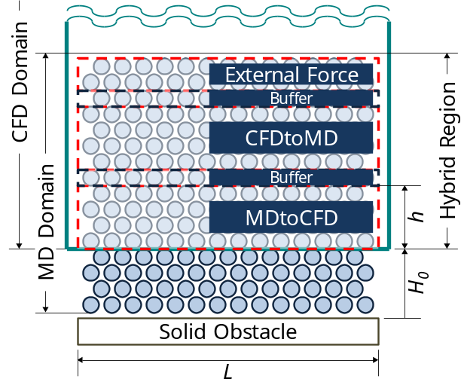
Fig. 1 Schematic diagram of the hybrid domain with detailed view of overlapping region; CFD and MD domains overlap in the middle and they construct the overall flow field. Hybrid region contains sublayers where hybrid boundary conditions are imposed on each code.

2.2.2. Molecular Dynamics
Newton’s conservation of momentum is employed at the atomic level to propagate the system’s motion through time evolution. In this work the most commonly used Lennard-Jones (12-6) intermolecular force potential model [13] is employed to calculate pair-wise interactions of particles in the system. A cut-off distance is introduced to reduce the computational cost and is set to be 2.2 magnitude of atomic characteristic length. [14] The most common velocity Verlet algorithm [13] is employed for time integration of the equations of motion of the interacting particles and to compute molecular trajectories in the simulation. In this work, the MD simulations were performed by using an appropriately modified version of the Large Atomic Molecular Massively Parallel Simulator (LAMMPS) [15]. It is a classical molecular dynamics open-source code written in C++ and developed by Sandia National Labs.

2.2.3. Hybrid Formulations and Interfaces
Hybrid simulation requires the implementation of two particle dynamics equations on MD solver. First, the external force equation acts to keep particles in the control domain so as to satisfy the conservation law. We adopt the external force function designed by Nie et al.[2].
The constrained particle dynamics equation [1] is employed to satisfy the continuity between CFD to MD domains, which can be written as:
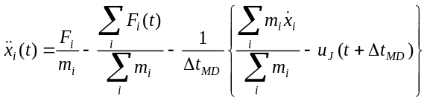 (1)
This equation accelerates/decelerates particles in the CFDtoMD layer to eventually match the mean microscopic velocity momentum to the continuum solution.
The hybrid interface is designed to transfer flow properties from the donor to the receiver. We incorporate the file-based hybrid interface which consists of a donor information sender, a monitoring function to scan the arrival of the counterpart dataset, and a hybrid boundary condition receiver. For example, the CFD code first writes the flow solution at the CFDtoMD layer, monitors the creation of MD data file and stores the molecular samples at the MDtoCFD boundary layer.

3. Hybrid Simulations of a Moderate-velocity Flow Field
Two important factors which determine the spatial accuracy of a hybrid simulation are hybrid schemes and molecular samples. Hybrid schemes/equations determine the accuracy of atomic solution and a number of works have been devoted to design/refine hybrid schemes such as alternating Schwarz method [4-6], direct flux exchange [7-9], and constrained Lagrangian dynamics [1-3,16]. On the other hand, just a few researches on sampling noise (a.k.a. statistical error) of averaged MD properties [5],[9] have been published, even though it determines the accuracy of CFD solution by means of a continuum hybrid boundary condition. In this section, we discuss how to numerically suppress the sampling noise without harming the accuracy of the hybrid solution.

3.1 Statistical Error due to the Thermal Fluctuation
Hadjiconstantinou et al. [5] introduced the statistical error of the sampled velocity as the ratio of its standard deviation compared to the average fluid velocity,
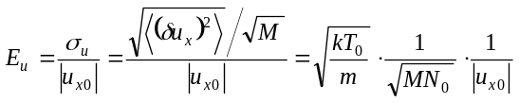 (2)
where k is the Boltzmann’s constant, T₀ refers to the average temperature, m is the particle mass. Also, M denotes the number of independent samples in time and N₀ is the average number of particles in the statistical cell. Each sample is considered “independent” if a sample satisfies the local equilibrium condition, i.e., the time interval between distinct samples is longer than the collision time τ_{col} (=0.14ρ⁻¹T^{-0.5}). Thus, M is expressed in terms of the coupling parameter as M=dt_{s}/τ_{col}. N₀ is also rewritten as ρ×L×h, where ρ is the particle number density.
The above equation explains why the sampling noise dominates the hybrid solution of a low-speed flow field. Let us consider the same fluid system with half the average velocity, i.e., 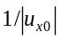 is doubled. Since the first term (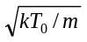) is fixed by the characteristics of the fluid particle, the number of sampled particles in space and time (MN₀) should be quadrupled to maintain the same order of statistical error. Since ρ and T are fixed in the incompressible isothermal fluid, dt_{s}×L×h should be quadrupled to satisfy the above criteria. Recalling the conditions for coupling parameters described in Sec. 2.1., dt_{s} is hard to increase since it is bound by the characteristic time of the flow field. h is limited by the opposite wall if the internal channel flow is being considered. L is fixed if the system is non-periodic. Thus, in case of internal non-periodic flow simulation, a hybrid solution is prone to suffer from a certain amount of statistical error. It concludes that additional numerical techniques are required for the suppression of the statistical error.

3.2 Numerical Approaches to Reduce the Statistical Error
We propose numerical approaches to further suppress the excessive sampling noise. We start from solving multiple replicated systems for the final solution (in Sec. 3.2.1), which is a way of virtually increasing L, to numerically increase sampling window sizes (h or dt_{s}) through the spatial regression (in Sec. 3.2.2) or the temporal regression (in Sec. 3.2.3).

3.2.1. Multiple Replica Sampling
Replica exchanging approach [17] has been in wide use in molecular dynamic simulations. Essentially, it solves multiple copies of the system with random initialization and exchanges individual configurations during the runtime. In the hybrid CFD-MD application, we run N independent replicas with different Maxwell-Boltzmann distribution of fluid particles and average those individual results to get a final solution. This averaged solution shows the same order of sampling noise as a single hybrid solution from an N-times larger domain along its periodic direction. Thus, instead of endeavouring to find the optimal domain size and/or coupling parameters for each problem, we repeat replica simulations until we acquire the non-fluctuating solution. The clear benefit of this approach is that it in principle provides the noise-free solution for any flow simulations regardless of geometric complexity. On the other hand, it does not save the computational cost since it is a way of splitting one large task into multiple smaller jobs.

3.2.2. Spatial Regression
We apply the linear regression method over multiple spatial samples to obtain the hybrid CFD boundary condition. We locate multiple statistical cells over and under the MDtoCFD layer along the non-periodic direction. Individual cell has the same dimension as the MDtoCFD layer and the same number of cells is piled over and under the MDtoCFD layer so that the CFD boundary zone is located in the middle of the stack. Other hybrid layers are shifted upward accordingly, to preserve the layer configuration.
Fig. 2 presents the simple linear regression function (i.e., the ordinary least square estimator) for the current collocated grid formulation. We allocate two additional statistical cells over and under two neighbouring CFD ghost cells. Compared to designing two distinct 5h-height MDtoCFD layers, the application of the regression function provides the same level of sampling noise with relatively less increase of computational cost.
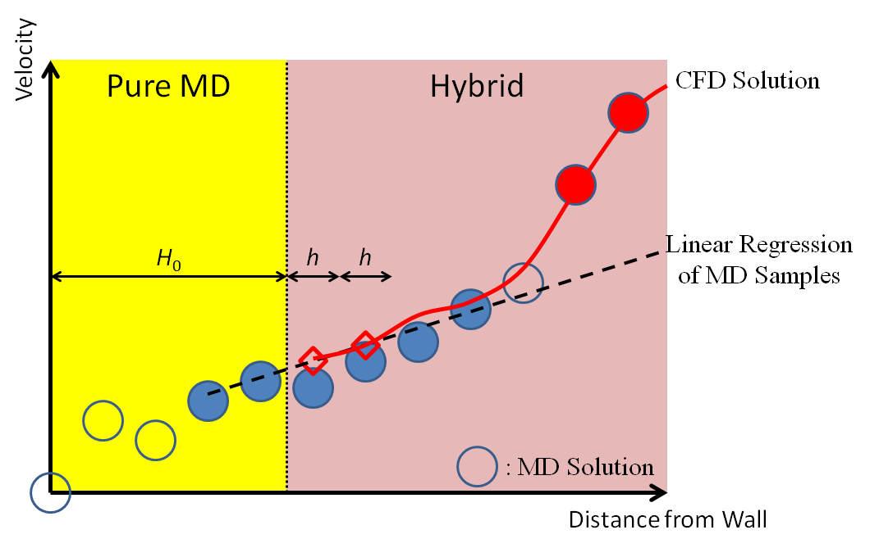
Fig. 2 Linear regression method of spatial samples; Hybrid CFD boundary condition is acquired by the regression curve from multiple samples along the wall-normal direction.

3.2.3. Temporal Regression
We apply the linear regression method over multiple spatial samples to obtain the hybrid CFD boundary condition. We locate multiple statistical cells over and under the MDtoCFD layer along the non-periodic direction. Individual cell has the same dimension as the MDtoCFD layer and the same number of cells is piled over and under the MDtoCFD layer so that the CFD boundary zone is located in the middle of the stack. Other hybrid layers are shifted upward accordingly, to preserve the layer configuration.
We apply the first-order linear regression function over previous MDtoCFD samples as seen in Fig. 3, for the purpose of virtually increasing the sampling duration dt_{s}. Considering that N previous samples from t-(N-1)dt to t participate in the regression process, a hybrid CFD boundary condition from t to t+dt is obtained as follows:
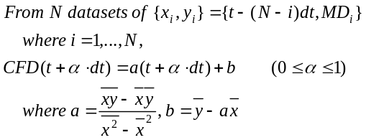
where MD_{i} denotes a sampled molecular dynamic solution at i^{th} time step.
Compared to the spatial regression, the regression of temporal profiles does not increase the computational cost at all. On the other hand, the prediction is performed outside the range of the data so that it may provide the wrong solution unless the homogeneity of variance is satisfied.
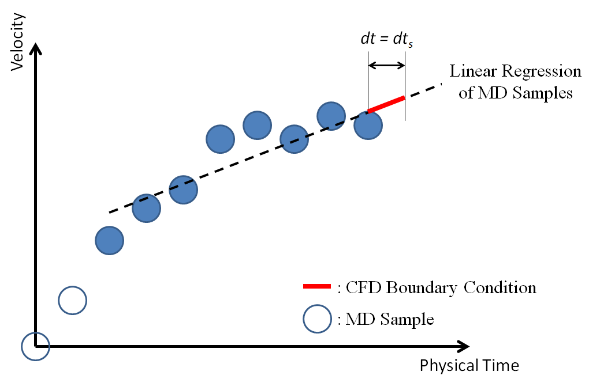
Fig. 3 Linear regression of multiple temporal samples; Hybrid CFD boundary conditions are extrapolated from the linear regression function.

4. Numerical Experiments
4.1 Problem Description and Validation
The transient Couette flow field has been simulated by a number of scientists for the validation of a hybrid CFD-MD solver. The geometric configuration is a nano-scale channel which is filled with liquid argon. Characteristic length of liquid argon is σ = 3.405×10⁻¹⁰ meter and time scale is τ =2.2 ×10⁻¹² second. Density is 0.81mσ⁻³, which means that 0.81 atoms are included in the characteristic volume. The wall material is the “frozen” argon particle whose characteristic properties are the same as liquid argon. The slip ratio between fluid and solid particles is set 0.6, to satisfy the linear velocity gradient along the vertical direction. As presented in Fig. 4, the height of the channel is 52σ. CFD mesh system is generated over the whole flow field while the pure MD region is treated as the “hole” cell and not updated. The particle lattice is constructed on the bottom half of the fluid domain. Pure MD region is 10σ in height from the bottom wall and the hybrid region is placed on the top of the pure MD region. It consists of 8 sublayers each with 2σ along the vertical direction. Two MDtoCFD layers right ahead of the pure MD region and two CFDtoMD layers from 18 to 22σ are separated by two-layer buffer zones in between. A buffer is added above the CFDtoMD layer and the external force layer is placed at the top of the hybrid region, above 24σ.
The flow is initially set at rest and the top wall starts moving by a constant velocity (1.0 σ/τ) to form the transient Couette flow profile. Fig. 5 presents a sudden-start Couette flow profile by a hybrid approach. The hybrid solution globally agrees very well with the analytic solution within the level of the thermal fluctuation. This proves that the current hybrid framework accurately analyzes the steady flow profile in nano-scaled systems.
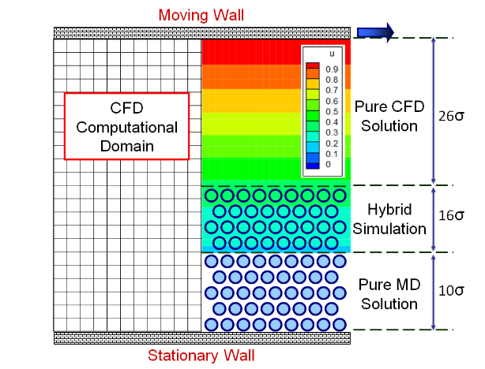
Fig. 4 Computational domain of the Couette flow simulation; The height of the fluid domain is 52σ (≈177Å). CFD mesh size is 121×27 and CFD cells at the pure MD region are not updated during the simulation. MD domain size is roughly 204σ along the principal flow direction and around 26σ along the wall-normal direction.
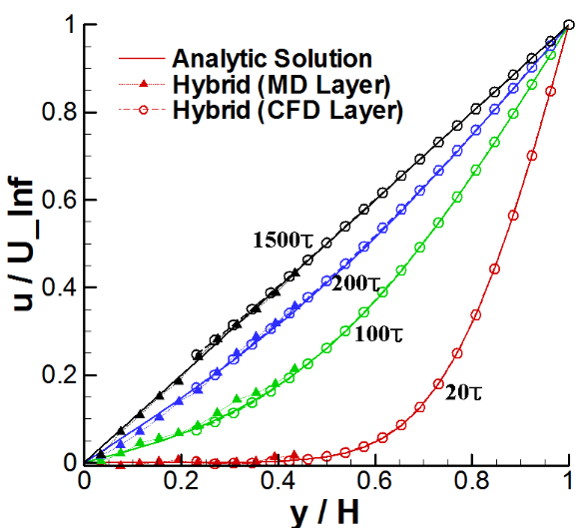
Fig. 5 A transient Couette flow; CFD solution is the instantaneous profile at each specified time and MD solution is averaged over 2σ in height and 10τ in time.

4.2 Moderate-velocity Flow simulation
The transient Couette flow profile at the upper wall velocity of 0.25σ/τ is presented in Fig. 6. All other conditions such as the fluid material, domain sizes and coupling parameters are identical to the above validation problem. As we argued in Sec. 3.1, a single solution suffers from the strong sampling noise due to the reduced mean velocity. This necessitates the implementation of numerical ideas to suppress the sampling noise for solving the moderate-velocity flow. We apply numerical ideas in Sec. 3.2 to the current application and discuss the accuracy of each approach.
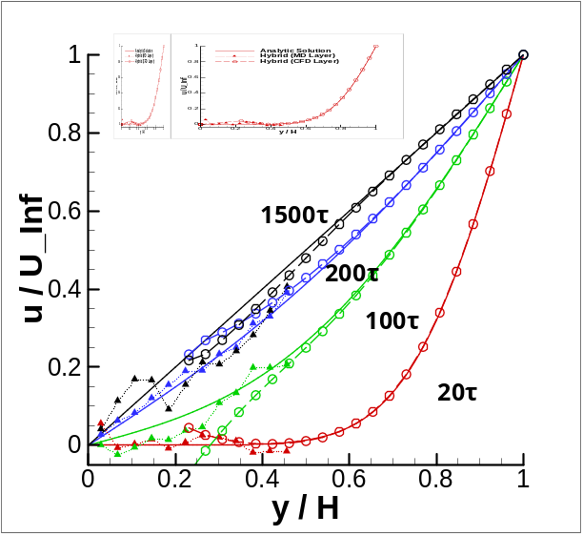
Fig. 6 Couette flow profile with the upper plate velocity of 0.25 σ/τ; The solution is very noisy because of the statistical noise of particle samples. Red lines denote the solution at 20 τ. Green, blue and black lines are solutions at 100, 200 and 1500 τ, respectively.

4.2.1. Multiple Replica Sampling
According to Sec. 3.1, solving 1/u velocity flow field requires increasing the sampling scale by u² times to maintain the same accuracy. So we perform 16 replica simulations each with the initial system size and average these solutions to numerically increase the spatial sampling scale by 16 times. We compare this result (Fig. 7) with a single solution from 16 times larger MD domain along the principal flow direction (Fig. 8) to verify the accuracy of the proposed approach.
Accuracy of two solutions are quantitatively compared by plotting the history of velocity profile in the middle of overlapping region (y = 0.3H). As are verified in Fig. 9, hybrid solutions at steady state present within 4 % of the noise (the standard deviation of samples) compared to the analytic solution. In detail, multiple sampling predicts a little faster velocity than the analytic solution, while the solution at the large-scale system is more fluctuating. Considering the similar solution accuracy between two experiments and the computational convenience of running multiple smaller jobs than a large-scale simulation, the multiple replica sampling approach can replace the increase of system size for solving moderate velocity flow.

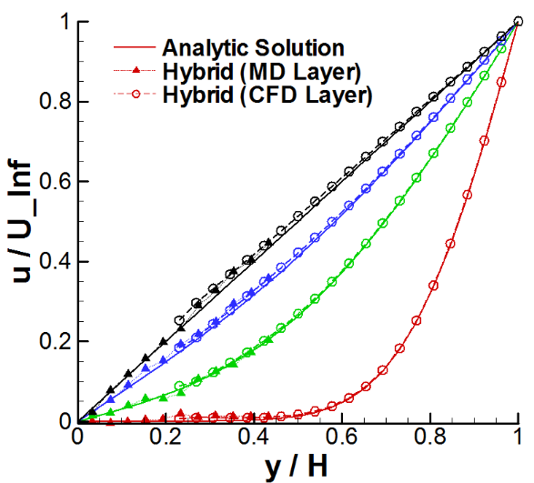
Fig. 7 16 replica samples in the upper plate velocity of 0.25 σ/τ; Solution’s accuracy is comparable to the result of system size increase.
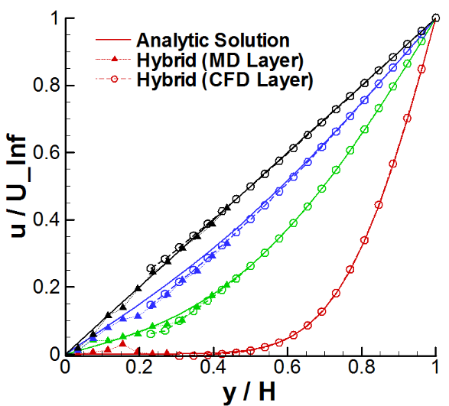
Fig. 8 Result by 16 L system length in solving 0.25 σ/τ couette flow; Sampling noise is suppressed a lot and the solution overall follows the analytic solution.
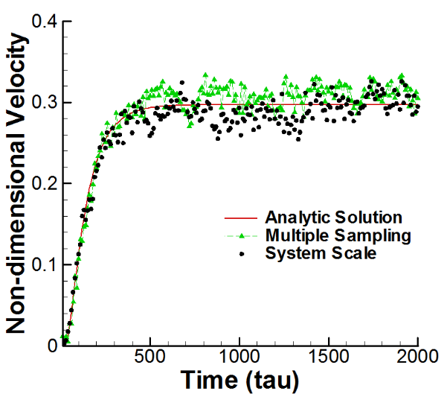
Fig. 9 Variation of the velocity in the middle of overlapping region; Solutions by multiple replica sampling and a single simulation under the increased domain present the similar strength of the statistical noise, which is around 5% of the analytic velocity profile.

4.2.2. Spatial Regression
A Couette flow profile by the spatial regression is presented in Fig. 10. In this simulation, we acquired the linear regression function from 10 vertically-consecutive layers (each with 2 σ in height) which ranges from 2 to 22 σ along the wall-normal direction, so that the hybrid CFD boundary region is placed at the same as above simulations. Since we stacked 4 additional layers on the top of MDtoCFD region, other hybrid layers (CFDtoMD, external force and buffer) are also shifted up accordingly. Individual MD profile from each layer suffers from the excessive statistical noise, while the CFD solution becomes very close to the analytic solution since the regressed MD solution is imposed as the hybrid boundary condition.
The effect of vertically increasing the sampling layer is clearly demonstrated by Fig. 11. From the history of velocity profile in the middle of overlapping region (y = 0.3h), the steady-state solution becomes less noisy with more number of samples participating in regression process. We measured the statistical error (Equation 2) of each solution after the flow is fully converged in macroscopic point of view. The error is computed as 0.1836 in case of a baseline simulation without regression. It reduces to 0.1121 when 6 vertical layers participate in regression and further reduces to 0.1040 in case of 10-layer regression. Regression of 10 layers does not show much improvement compared to 6-layer regression, because the bottom layer is located closer to the solid obstacle where stronger molecular collision takes place. It implies that the spatial regression is more or less limited in suppressing the sampling noise and should be applied in conjunction with other noise suppression technique such as the multiple replica sampling.
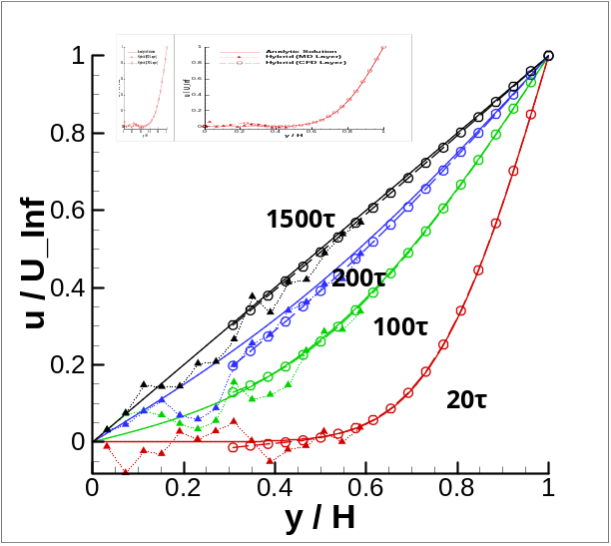
Fig. 10 Spatial sampling of 9 layers in vertical; Very noisy MD samples from individual layer are spatially averaged for the hybrid CFD boundary condition, so CFD solution becomes very close to the analytic solution.
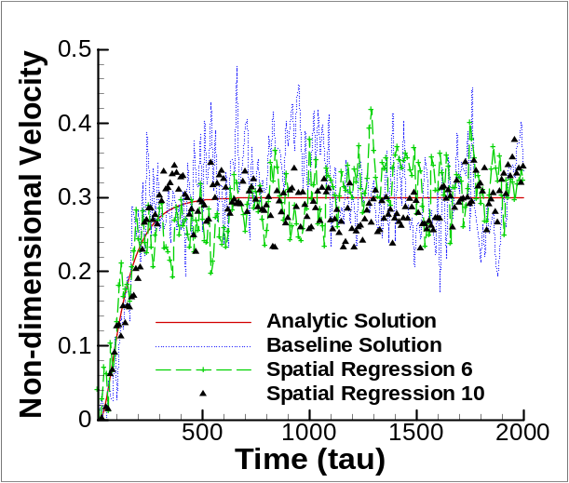
Fig. 11 Noise suppression by spatial regression; Linear regression from multiple vertical layers provide less noisy solution than the individual simulation.

4.2.3. Temporal Regression
The Couette flow solution based on linear regression of previous solutions is plotted in Fig. 12 and the history of velocity profile at the middle of hybrid region is presented in Fig. 13. Compared to the default implementation in which two sampled MD properties at t and t-dt are extrapolated to impose the hybrid CFD boundary condition from t to t+dt, the current simulation uses 10 previous-to-current sampled solutions to find the linear function and applies this function to update CFD boundary condition until the next data exchange.
The crude comparison between Fig. 10 and Fig. 12 might mislead that the spatial regression is more effective in suppressing the sampling noise: the comparison of the statistical error in the middle of hybrid layer proves the opposite. As can be expected from Fig. 13, velocity history by the imposition of temporal sampling shows less noisy pattern compared to the case of spatial regression. Quantitatively, the magnitude of the statistical error is computed as 0.0945 with 6 temporal samples and 0.0734 with 10 temporal samples. It expresses that the increase of the temporal window is more effective in reducing the sampling noise than increasing the spatial scale along the wall-normal direction. Also, the further suppression of statistical noise by increasing temporal samples from 6 to 10 is quite reasonable. According to the mathematical expression of sampling noise in Sec. 3.1, the magnitude of the noise is proportional to the square root of temporal scale: The reduction ratio (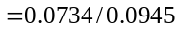) from the temporal regression is almost identical to the square root of number of temporal samples (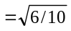). We conclude that this temporal regression can be actively applied on simulating the steady-state flow where the unfavourable time-lagging phenomenon during flow evolution is less important.
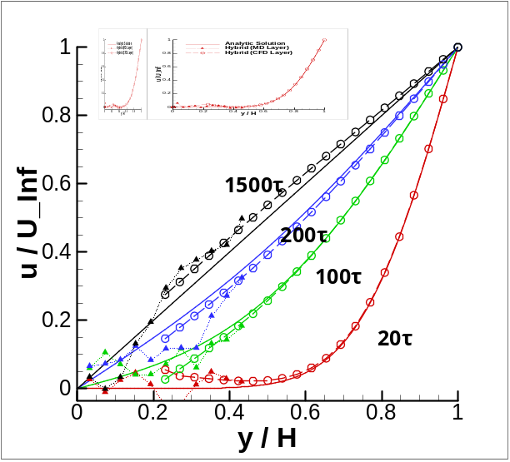
Fig. 12 Transient Couette flow profile by the temporal regression of 10 previous solutions
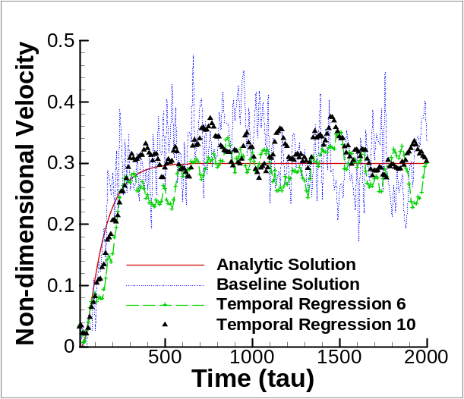
Fig. 13 Noise suppression by the linear regression of multiple temporal profiles; Compared to spatial regression, solution becomes less fluctuating and more accurate.

5. Conclusions
Numerical approaches for the accurate hybrid CFD-MD simulation of the moderate-speed flow field have been experimented. Based on reliable CFD and MD codes and a constrained Lagrangian dynamic for the imposition of continuum solution into atomistic domain, we design a number of numerical approaches to impose the accurate hybrid CFD boundary condition. Introduced approaches aim to refine the sampling noise of an individual atomistic solution in the low-speed flow regimes. Multiple replica sampling facilitates the hybrid simulation to any fluid problems, especially non-periodic problems which will suffer from the excessive statistical error due to the limited spatial and temporal sampling scale. Spatial and temporal regressions contribute in getting more accurate solutions from a single simulation run. These approaches are applied to a transient Couette flow simulation in O (10) m/s velocity field, which has not been tried much because of the excessive computational requirement for acquiring the noise-free solution. Multiple replica sampling approach is verified to provide the same order of accuracy as a single large-scale simulation of the same computational cost. Spatial/temporal regression of multiple layers provides the suppression of sampling noise than a single run. We expect that these regression methods will contribute to reducing the number of replica runs for acquiring the accurate solution.

Acknowledgment
This work has been accomplished under the Cybertools (http://cybertools.loni.org) project and was primarily funded by NSF/LEQSF (2007-10)-CyberRII-01. This work has also been made possible thanks to computer resources provided by TeraGrid TRAC TG-MCB090174 and LONI resources.

Nomenclature
dt_{s} : Sampling duration
dt : Sampling interval
h : Sampling layer size (in height)
H₀ : Position of the sampling layer in vertical direction
L, H : Length and height of the fluid domain
σ : Non-dimensional molecular length unit
τ : Non-dimensional molecular time unit
m_{i} : Non-dimensional molecular mass for i^{th} particle
F_{i} : Non-dimensional molecular force for i^{th} particle

References
- S. T. O’Connell and P. A. Thompson, Molecular Dynamics Continuum Hybrid Computations: a Tool for Studying Complex Fluid Flows, Physical Review E, 52 (1995) R5792-R5795.
- X. B. Nie, S. Y. Chen, W. N. E, and M. O. Robbins, A Continuum and Molecular Dynamics Hybrid Method for Micro- and Nano-Fluid Flow, Journal of Fluid Mechanics, 500 (2004) 55-64.
- T. H. Yen, C. Y. Soong, and P. Y. Tzeng, Hybrid Molecular Dynamics-Continuum Simulation for Nano/Mesoscale Channel Flow, Microfluidics and Nanofluidics, 3 (2007) 665-675.
- N. G. Hadjiconstantinou and A. T. Patera, Heterogeneous atomistic-continuum representations for dense fluid systems, International Journal of Modern Physics C, 8 (1997) 967-976.
- N. G. Hadjiconstantinou, A. L. Garcia, M. Z. Bazant, and G. He, Statistical Error in Particle Simulations of Hydrodynamic Phenomena, Journal of Computational Physics, 187 (2003) 274-297.
- T. Werder, J. H. Walther, and P. Koumoutsakos, Hybrid Atomistic-Continuum Method for the Simulation of Dense Fluid Flows, Journal of Computational Physics, 205 (2005) 373-390.
- E. G. Flekkoy, G. Wagner, and J. Feder, Hybrid Model for Combined Particle and Continuum Dynamics, Europhysics Letter, 52 (2000) 271-276.
- R. Delgado-Buscalioni and P. V. Coveney, Usher: An algorithm for particle insertion in dense fluids, Journal of Chemical Physics, 119 (2) (2003) 978-987.
- R. Delgado-Buscalioni and P. V. Coveney, Hybrid Molecular-Continuum Fluid Dynamics, Philosophical Transactions of the Royal Society A, 362 (2004) 1639-1654.
- S. Yoon and A. Jameson, Lower-Upper Symmetric-Gauss-Seidel Method for the Euler and Navier-Stokes Equations, AIAA Journal, 26 (1988) 1025-1026.
- M. M. Rai and S. R. Chakaravarthy, An Implicit Form of the Osher Upwind Scheme, AIAA Journal, 24 (1986) 735-743.
- B. V. Leer, Towards the Ultimate Conservative Difference Scheme. V. A Second Order Sequel to Godunov’s Methods, Journal of Computational Physics, 32 (1979) 101-136.
- M. Allen and D. Tildesley, Computer Simulation of Liquids, Oxford Science Publications (1987).
- K. Travis and K. Gubbins, Poiseuille flow of Lennard-Jones fluids in narrow slit pores, Journal of Chemical Physics, 112 (2000) 1984-1994.
- LAMMPS, http://lammps.sandia.gov.
- S.-H. Ko, N. Kim, D. E. Nikitopoulos, D. Moldovan, and S. Jha, Parametric Study of a Multiscale Fluidic System using a Hybrid CFD-MD Approach, Proc. of the 5th European Conference on Computational Fluid Dynamics (ECCOMAS CFD 2010), Lisbon, Portugal (2010).
- Y. Sugita and Y. Okamoto, Replica-exchange molecular dynamics method for protein folding, Chemical Physics Letters, 314 (1999) 141-151.


Dr. Soon-Heum Ko is a computational scientist at the Swedish National Supercomputing Center in Linkoping, Sweden. He received his Ph.D. in aerospace engineering in 2008 from Seoul National University. Later he served as a post-doctoral fellow at Louisiana State University in USA and joined the Swedish National Supercomputing Center in 2011. His research interests are in the multi-scale flow simulation and high performance computing.


Dr. Nayong Kim is a research staff in Center for Computation & Technology (CCT) and Louisiana Biomedical Research Network (LBRN) Bioinformatics / Biocomputing Core (BBC) member. He graduated with a Ph.D. in Chemical Engineering and obtained his MS in both Computer Science and Chemical Engineering from University of Southern California.

