Proceedings of ASME-JSME-KSME Joint Fluids Engineering Conference 2011
AJK2011-FED
July 24-29, 2011, Hamamatsu, Shizuoka, JAPAN
AJK2011-01021

Numerical Experiments oF Solving MODERATE-velocity Flow FIELD USING a Hybrid CFD-MD Approach

Soon-Heum Ko  National Supercomputing Centre  Linköping, Sweden | Nayong Kim  Center for Computation and Technology, LSU  Baton Rouge, LA, USA

Shantenu Jha  Center for Computation and Technology, LSU  Baton Rouge, LA, USA | Dimitris E. Nikitopoulos  Department of Mechanical Engineering, LSU  Baton Rouge, LA, USA

Dorel Moldovan
Department of Mechanical Engineering, LSU
Baton Rouge, LA, USA

Abstract
We propose numerical approaches to reduce the sampling noise of a hybrid computational fluid dynamics (CFD) - molecular dynamics (MD) solution. A hybrid CFD-MD approach provides higher-resolution solution near the solid obstacle and better efficiency than a pure particle-based simulation technique. However, applications up to now are limited to extreme velocity conditions, since the magnitude of statistical error in sampling particles' velocity is very large compared to the continuum velocity. Considering technical difficulties of infinitely increasing MD domain size, we propose and experiment a number of numerical alternatives to suppress the excessive sampling noise in solving moderate-velocity flow field. They are the sampling of multiple replicas, virtual stretching of sampling layers in space, and linear fitting of multiple temporal samples. We discuss the pros and cons of each technique in view of solution accuracy and computational cost.

1. INTRODUCTION
A hybrid CFD-MD simulation methodology [1-9] is a reliable simulation approach capable of accurately describing the flow at both molecular and macroscopic scales. In this approach the continuum and molecular domains are coupled through an overlap region that facilitates the exchange of information between them. Two descriptions are forced to match each other by constrained molecular dynamics and boundary conditions based on time and spatial averaging of relevant physical properties in the overlap region. The continuum hypothesis is adopted in capturing macroscopic flow features and a particle-based technique captures the strong intermolecular interactions near the solid obstacles. In principle, the hybrid approach provides a good balance between computational cost and atomistic details/resolution.
Despite the clear advantage over conventional CFD or MD methodology, a hybrid technique so far fails to attract scientists due to limited possible applications. Rather artificial flow conditions are chosen in previous examples to prevent the sampling noise of molecular properties from harming the accuracy of a solution. Basically, the sampling noise is the response of the locality in atomistic system. Sampling over a finite spatial/temporal scale induces this noise, which eventually diminishes by increasing sampling scales. However, temporal scale is physically bound by the characteristic time of the fluid system and spatial scale is technically bound by the computing capacity. Therefore, numerical alternatives should be devised to succeed in the hybrid simulation of moderate-velocity flow field.
In this paper, we introduce numerical approaches to suppress the sampling noise within acceptable computational cost. We start by introducing the hybrid simulation technique and its formulation in Section 2. We penetrate to three numerical approaches of multiple replica sampling, virtual increase of spatial sampling scale and fitting of multiple temporal samples in Section 3. Numerical solutions are presented in Section 4 and concluding remarks are added in the last Section.

Nomenclature
dt_{s} Sampling duration
dt Sampling interval
h Sampling layer size (in height)
H₀ Position of the sampling layer in vertical direction
L, H Length and height of the computational domain
σ Non-dimensional molecular length unit
τ Non-dimensional molecular time unit
m_{i} Non-dimensional molecular mass for i^{th} particle
F_{i} Non-dimensional molecular force for i^{th} particle

2. Numerical Modeling
2.1. A Hybrid CD-MD Approach
The hybrid CFD-MD approach is a simulation method, which adopts the continuum hypothesis in capturing macroscopic features of a flow-field and details atomistic intermolecular interactions on interfaces of different materials by using the MD approach. CFD can accurately predict flow properties on conventional moderate/large size fluid domains, but is intrinsically impossible to reflect characteristics of surrounding solid materials within an interfacial region. While standard classical MD can provide atomistic level resolution of interactions between particles, it becomes computationally demanding as the size of simulated system grows. So, neither method is suitable for solving a mesh-scale fluid system where the viscous effect dominates the flow characteristics but macroscopic features are also worth capturing efficiently. The best solution would be, as can be seen in Fig. 1, to carry out the hybrid CFD-MD approach with which atomistic interactions between solid elements and fluid particles near the wall is simulated by MD and the macroscopic flow field is calculated by CFD. In the CFD-MD hybrid overlap region, computational domain can be decomposed into three interesting regions. Applying external force region where located uppermost boundary of overlap region and in order to the momentum continuity between two approaches. The hybrid schemes have to exchange their information at the overlap region between the different approaches. The way passing the information from MD to CFD is direct since sampled molecular properties are applied to a macroscopic state of CFD. On the other hand, applying the continuum solution into MD domain requires a deep consideration not to break up the higher degree-of-freedom (DOF) molecular motion. It demands a constrained particle dynamics to achieve consistence between two different multi-scale approaches.
Four sampling parameters are introduced to define the sampling condition in particle-to-continuum boundary condition layer (denoted MDtoCFD layer). Sampling layer size (h) is the height of sampling layer and sampling position (H₀) is its distance from the solid obstacle. Considering a channel with L×H size, particles placed in L×h layer at H₀ distance above the bottom wall participate in sampling process. Sampling duration (dt_{s}) denotes how long the sampling process takes place and sampling interval (dt) defines how often the sampled data is transferred to the continuum domain. Of these parameters, h and dt_{s} defines the spatial and temporal sampling scales. dt is a factor which acts as the upper bound of sampling duration. On unsteady simulations, a short interval is preferred to frequently update temporal variation of flow field in hybrid boundary zones. Finally, H₀ is a secondary factor which can locally increase the strength of fluctuation. Conventionally, sampling layer is placed far from the solid obstacle, e.g., at least 10 σ above the bottom wall in solving the liquid argon system. [3]
2.2. Governing Equations and Numerical Schemes
2.2.1. Computational Fluid Dynamics
Two-dimensional Navier-Stokes equations are employed to solve the unsteady incompressible fluid flow. For time-accurate unsteady simulation, dual time stepping method is adopted and it is combined with the LU-SGS (Lower-Upper Symmetric Gauss-Seidel) scheme for the implicit time integration. The inviscid fluxes are upwind-differenced using Osher’s flux-difference splitting scheme. For higher-order spatial accuracy, the MUSCL (Monotone Upstream-centered Schemes for Conservation Laws) approach is used on inviscid flux calculation. Viscous fluxes are calculated using the conventional second-order central differencing.
2.2.2. Molecular Dynamics
In the molecular dynamic system, Newton’s second laws are employed to describe the atomic motion. An initial velocity is assigned using Maxwellian distribution function. To calculate a pair-wise interaction of particles in the system, the most commonly used Lennard-Jones (12-6) potential interaction model is employed. A famous Large-scale Atomic/Molecular Massively Parallel Simulator (LAMMPS; http://lammps.sandia.gov/) is modified for the hybrid simulation.
2.2.3. Hybrid Interfaces and Formulations
In the hybrid simulation, it is important to design the hybrid interface where continuum and discrete particle domains exchange their flow properties. In the current implementation, both codes exchange their flow properties in overlapping region through the file interface and apply adopted solution from its counterpart as the hybrid boundary condition.
Additional change made on CFD code is the implementation of overlapping scheme, in the same way as Chimera overset mesh. That is, pure MD region is declared as hole and MD boundary layers are treated as fringe cell.
On the other hands, MD code employs additional particle dynamics to implement hybrid scheme. First, the external force should be imposed to prevent leaving particles from the control domain and satisfy the systematic mass conservation. We adopt the external force function designed by Nie et al. [4]
To preserve continuity on CFD to MD domain, the constrained particle dynamics equation is employed with conventional equation of motion, which can be written as:

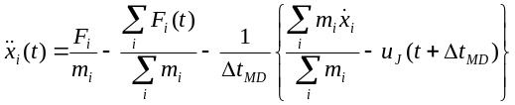
The continuum velocity and the mean microscopic velocity from MD over control domain provide the synchronization of the mass and momentum consistent with this equation.

3. sampling noise in hybrid simulations
Two important factors which determine the spatial accuracy of a hybrid simulation are hybrid schemes and sampling of molecular properties. Hybrid scheme determines the accuracy of atomic solution though the imposition of hybrid boundary condition and a number of works have been devoted to design/refine hybrid schemes such as alternating Schwarz method [4-6], direct flux exchange [7-9], and constrained Lagrangian dynamics [1-3]. On the other hand, just a few researches on sampling noise (or statistical error) of averaged MD properties have been published, even though it determines the accuracy of CFD solution by means of a continuum hybrid boundary condition. We introduce the strength of sampling noise and how to numerically suppress this noise without harming the accuracy of the solution in this section.
3.1. Strength of Sampling Noise
According to the mathematical expression in statistical error [5, 9], the sampling noise is inversely proportional to the square root of spatial layer size and temporal sampling duration. In other words, the sampling scale (=L×h×dt_{s}) shall be quadrupled to maintain the same order of accuracy in case the macroscopic flow velocity becomes halved. Unfortunately, this expression does not account for the interaction with solid obstacles and fails to present the magnitude of the sampling noise at individual sampling condition.
We measured the sampling noise of a stationary flow to verify the above expression and quantify the sampling noise in the domain of interest. Geometric conditions and flow parameters are the same as our numerical experiment, to be introduced in Section 4.1, except the velocity of top-wall is set zero. Table 1 presents the sampling noise of the pure MD solution at H₀ = 0.2 H. From this result, we can figure out,
- Noise reduction ratio by increasing spatial (h) or temporal (dt_{s}) scales is less than the expectation from the above expression. The ratio even gets worse as spatial/temporal scales increase. We argue that the interaction with the solid boundary obstructs the noise reduction.
- In case a steady Couette flow field with the top-wall speed of 1 σ/τ is of particular interest, inaccuracy of the hybrid solution at sampling conditions of (1.6σ, 16τ) is around 5%: the influence of sampling noise become higher as the macroscopic velocity slows down.
- Though not included in this paper, the relation between system length and sampling noise roughly satisfies previous numerical expression. However, increasing the system length also causes the proportional increase of computational cost.
This numerical experiment shows us two important conclusions. First, the measurement of sampling noise is necessary for determining coupling parameters. This considers the interaction with solid element and geometric configuration, thus providing the accurate amount of sampling noise. Second, other numerical ideas should be proposed to efficiently solve the moderate-velocity flow field using a hybrid approach. Sampling noise should be suppressed numerically, not by excessively increasing the computational domain.
3.2. Numerical Approaches to Reduce Statistical Error
System length (L), layer height (h) and sampling duration (dt_{s}) are important parameters to suppress the sampling noise. Of these parameters, L directly affects the computational cost. h is bound by the system’s geometry and dt_{s} is governed by the hydrodynamic characteristic time. We start from effectively increasing the system length (in Sec. 3.2.1) and advance to “virtually” increasing the layer height (in Sec. 3.2.2) or sampling duration (in Sec. 3.2.3) without increasing the computational cost a lot.
3.2.1. Sampling Multiple Replicas. Multiple replica sampling approach is schematized in Fig. 2. Instead of solving a NL×h spatial domain, we solve N replicas with L×h size and average individual results to get a final solution. In principle, computational cost itself does not change by adopting this approach: easier job allocation by smaller chunks than a single large-scale job helps in reducing waiting time on the queuing system of a computing facility. The limitation of this approach is that it is applicable to a periodic system.
3.2.2. Virtual Stretching of Sampling Layers. The next approach is to stretch the sampling layer to the non-periodic direction, as described in Fig. 3. We consider the MDtoCFD layer has h in layer height and is located at H₀ above the bottom wall. In conventional implementation, particles located within the MDtoCFD layer participate in sampling process: in the current approach, sampled region is stretched vertically from H₀-nh to H₀+nh and other hybrid layers are shifted upward by nh. Thus, the sampling noise can be effectively suppressed with relatively small increase of computational cost. Specifically in the current CFD formulation which requires two ghost zones, these two sampled zones are overlapped to further reduce the computational cost.
3.2.3. Linear Fitting of Temporal Samples. Temporal sampling scale is harder to increase compared to the spatial coupling scale because it is bound by the hydrodynamic characteristic time. So, as seen in Fig. 4, we adopt multiple previous samples from molecular domain to impose the continuum boundary conditions during the next interval. As the backward-averaged property cannot represent the solution at that instance, we conduct the linear fitting of these data for more accurate boundary condition. Considering that N previous molecular dynamic samples from t-(N-1)dt to t are used to impose a hybrid CFD boundary condition from t to t+dt, the linear least squares becomes as follows:
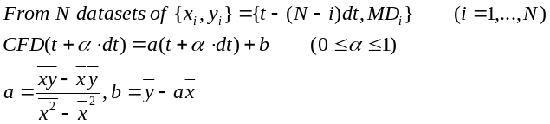

where MD_{i} denotes a sampled molecular dynamic solution.
The benefit of this approach is that it does not increase the computational cost at all. Meanwhile, the increase of the accuracy by the adoption of higher-order curve fitting methods needs further investigation.

4. numerical experiments
4.1. Problem Description and Validation
The Couette flow simulations, which have been in wide use for the validation of a fluidic system, have been conducted by a hybrid CFD-MD solver. All applications we examine are internal flow fields filled with the liquid argons. Characteristic length of liquid argon is σ = 3.405×10⁻¹⁰ and time scale is τ =2.2 ×10⁻¹². Density is 0.81mσ⁻³, which means 0.81 atoms are included in the characteristic volume. The fluid domain is a channel system, which consists of two parallel plates placed in vertical direction. Both walls have artificial properties, which is the same as those of liquid argon. The slip ratio between fluid and solid particles is set 0.6, to satisfy the linear velocity gradient along the vertical direction.
We start from the validation problem, which has 52σ distance between two parallel plates. The flow is initially set stationary and the top wall starts moving by a constant velocity (1.0 σ/τ). This physical boundary condition of the continuum domain governs the evolution of the whole flow field. Figure 6 presents a sudden-start Couette flow profile by a hybrid approach. The hybrid solution is slightly deviating from the analytic solution in the MD region, due to the locality of the particle domain. Nevertheless, the hybrid simulation succeeds in demonstrating the same flow physics as the analytic solution. This proves that the current hybrid framework accurately analyzes the steady flow profile in nano-scaled systems.
4.2. Moderate-velocity Flow Simulation
The hybrid Couette flow profile at 0.25 σ/τ of the upper wall velocity is presented in Fig. 7. Flow conditions and coupling parameters are identical to the above validation problem and the current solution suffers from the strong sampling noise. This necessitates the implementation of numerical ideas to suppress the sampling noise in solving the moderate-velocity flow. We apply numerical ideas in Sec. 3 to the current problem and discuss the accuracy of an individual approach.
4.2.1. Multiple Replicas. Roughly, solving 1/u velocity flow field requires increasing the particle domain by u² times to maintain the same accuracy. So we sample 16 replicas with the initial system size to solve a Couette flow with 0.25 σ/τ top wall velocity. This solution is compared with the single solution with 16 times larger MD domain to verify the accuracy of the proposed approach.
Solutions in Fig. 8 and Fig. 9 are the Couette flow profile by a single run at 16 times larger domain and sampled solution of 16 replicas from initial domain, respectively. At a glance, both results show globally accurate velocity profile compared to the analytic solution. This supports the above expression that u² times larger spatial sampling size (either by increasing the system domain or sampling multiple individual runs) provides the accurate hybrid simulation of 1/u velocity field.
Accuracy of two solutions are quantitatively compared by plotting the history of velocity profile in the middle of overlapping region (y = 0.3H). As are verified in Fig. 10, both solutions produce roughly about 5 % of the noise compared to the analytic solution profile. In detail, multiple sampling predicts a little faster velocity than the analytic solution, while the solution at the large-scale system is more fluctuating. Considering the similar solution accuracy between two ways and the computational convenience of running multiple smaller jobs than a large-scale simulation, the multiple replica sampling approach can replace the increase of system size for solving moderate velocity flow.
4.2.2. Spatial Stretching. A Couette flow profile by increasing the sampling layer height is described in Fig. 11. In this simulation, sampled molecular dynamic properties over 9 layers (each with 2 σ in height) surrounding the MDtoCFD boundary region are spatially averaged to impose the hybrid CFD boundary condition. So, CFD solution becomes very close to the analytic solution even though the individual molecular dynamic profile is very noisy and far variant from the analytic solution at the same position. The effect of vertically increasing the sampling layer is clearly demonstrated by Fig. 12. From the history of velocity profile in the middle of overlapping region (y = 0.3h), the solution by the spatial averaging of 9 layers is far less noisy than the default simulation and 5 layer averaging. Still, the maximal noise of an instantaneous solution goes up to 25% of the analytic solution, which implies that this approach should be applied in conjunction with other noise suppression technique such as the multiple replica sampling.
4.2.3. Linear Fitting of Temporal Samples. The Couette flow solution based on multiple temporal samples is plotted in Fig. 13 and the history of velocity profile at the middle of hybrid region is presented in Fig. 14. Compared to the default implementation in which two sampled MD properties at t and t-dt are extrapolated to impose the hybrid CFD boundary condition from t to t+dt, the current simulation uses 9 previous sampled solutions to find the linear function and applies this function to update CFD boundary condition over the same time interval. So, the hybrid boundary value from CFD site can be different from the MD solution in the same position. From Fig. 14, this approach proves that the sampling noise is suppressed by conducting the linear fitting method. Interestingly, linear fitting by 9 previous samples does not provide clearly improved solution than 5 sample fitting, which implies that this method has the limitation on increasing the accuracy. We expect that applying a higher-order curve fitting method would increase the solution accuracy. Compared to the spatially using multiple sampled data in Fig. 12, this approach shows less fluctuating pattern. Nonetheless, the maximal noise of an instantaneous solution goes up to 25% of the analytic solution, which is the same as multi-point spatial sampling.

5. further investigations
It is worth to note that the mass conservation is harder to achieve in hybrid simulations. A cost-effective classical force model [4] satisfies the global ensemble in molecular domain; however it fails to account for the local disturbance of the density field within the external force layer. [6] This causes particles to be accumulated in the external force layer and thus the local density in other regions tends to be slightly less than the initial condition. We expect that the use of more accurate force function by Werder et al. [6] can solve this problem.

conclusion
Numerical approaches for the accurate hybrid CFD-MD simulation of the moderate-speed flow field have been experimented. Based on reliable CFD and MD codes and a constrained Lagrangian dynamic for the imposition of continuum solution into atomistic domain, we design a number of numerical approaches to impose the accurate hybrid CFD boundary condition. Introduced approaches aim to refine the sampling noise of an individual atomistic solution in the low-speed flow regimes. Of the three approaches, multiple replica sampling provides the better runtime than running a single large-scale problem set through the faster job allocation in the batch queue system of a supercomputer. On the other hand, virtual stretching of sampling layer height and a linear fitting of multiple temporal solutions save the simulation runtime by reducing the computational cost. These approaches are applied to a Couette flow simulation in O (10) m/s velocity field, which has not been tried yet because of the excessive computational requirement for an accurate solution. Multiple replica sampling approach is verified to provide the same order of accuracy as a single large-scale simulation of the same computational cost. Sampling of multiple spatial/temporal data guarantees the suppression of sampling noise than a single run, though the solution still suffers from the strong noise. We argue that these approaches can provide the accurate solution with reduced computational cost by working in conjunction with the multiple replica sampling.
Acknowledgments
This work is a part of the Cybertools (http://cybertools.loni.org) project and primarily funded by NSF/LEQSF (2007-10)-CyberRII-01. This work has also been made possible thanks to computer resources provided by TeraGrid TRAC TG-MCB090174 and LONI resources.
References
[1] O'Connell, S. T., and Thompson, P. A., 1995. “Molecular dynamics continuum hybrid computations: a tool for studying complex fluid flows”. Phys. Rev. E, 52, pp. R5792-R5795.
[2] Nie, X. B., Chen, S. Y., E, W. N., and Robbins, M. O., 2004. “A continuum and molecular dynamics hybrid method for micro- and nano- fluid flow”. J. Fluid Mech., 500, pp. 55-64.
[3] Yen, T. H., Soong, C. Y., and Tzeng, P. Y., 2007. “Hybrid molecular dynamics continuum simulation for nano/mesoscale channel flow”. Micro-fluid Nano fluid, 3, pp.665-675.
[4] Hadjiconstantinou, N. G., and Patera, A. T., 1997. “Heterogeneous atomistic continuum representations for dense fluid systems”. Comput. Phys. Commun., 4, pp.967-976.
[5] Hadjiconstantinou, N. G., Garcia, A. L., Bazant, M. Z., and He, G., 2003. “Statistical error in particle simulations of hydrodynamic phenomena”. J. Comput. Phys., 187, pp.274-297.
[6] Werder, T., Walther, J. H., and Koumoutsakos, P., 2005. “Hybrid atomistic-continuum method for the simulation of dense fluid flows”. J. Comput. Phys., 205, pp.373-390.
[7] Flekkoy, E. G., Wagner, G., and Feder, J., 2000. “Hybrid model for combined particle and continuum dynamics”. Europhys. Lett., 52, pp.271-276.
[8] Delgado-Buscalioni, R., and Coveney, P. V., 2003. “Usher: An algorithm for particle insertion in dense fluids”. J. Chem. Phys., 119(2), pp.978-987.
[9] Delgado-Buscalioni, R., and Coveney, P. V., 2004. “Hybrid molecular-continuum fluid dynamics”. Phil. Trans. R. Soc. Lond. A, 362, pp.1639-1654.

TABLE 1. SAMPLING NOISE IN A STATIONARY FLOW;
A PURE MD SIMULATION ON 140×52 (σ²) CHANNEL
SYSTEM IS CONDUCTED. THE UNIT IS 1/1000 OF
NON-DIMENSIONAL MD VELOCITY (1.0 σ/τ).

dt_{s}  h | 1 τ | 4 τ | 16 τ | 64 τ
0.1 σ | 30.578 | 19.228 | 13.238 | 9.308
0.4 σ | 23.158 | 16.965 | 10.759 | 8.355
1.6 σ | 15.966 | 13.486 | 9.944 | 8.034
6.4 σ | 10.243 | 9.860 | 9.189 | 8.117

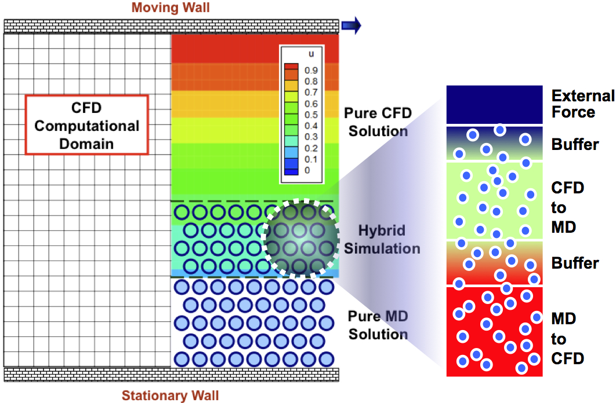
FIGURE 1. SCHEMATIC DIAGRAM OF THE HYBRID DOMAIN WITH DETAILED VIEW OF OVERLAPPING ZONE; CFD AND MD DOMAINS OVERLAP IN THE MIDDLE AND THEY CONSTRUCT THE OVERALL FLOW FIELD. HYBIRD REGION CONTAINS SUBLAYERS WHERE HYBRID BOUNDARY CONDITIONS ARE IMPOSED ON EACH CODE.

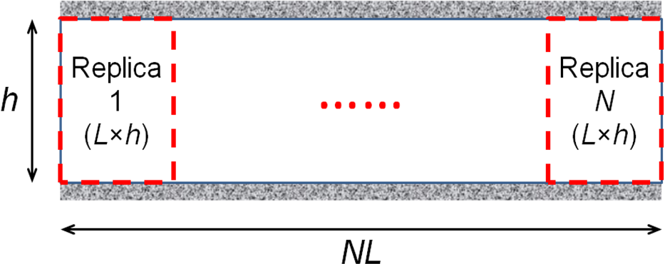
FIGURE 2. MULTIPLE REPLICA SAMPLING APPROACH; SOLUTIONS OF N REPLICAS AT L×h DOMAIN ARE SAMPLED TO REPRESENT A NL×h SYSTEM

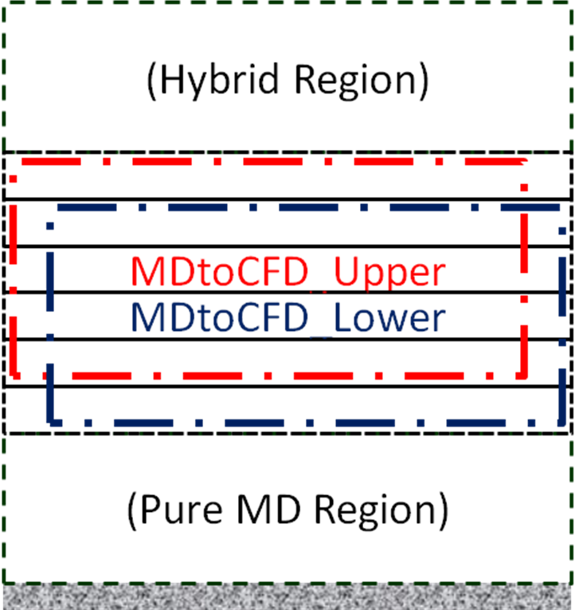
FIGURE 3. STRETCHING OF SAMPLING LAYER; SAMPLING LAYER IS STRETCHED TO A NON-PERIODIC DIRECTION TO REDUCE THE SAMPLING NOISE.

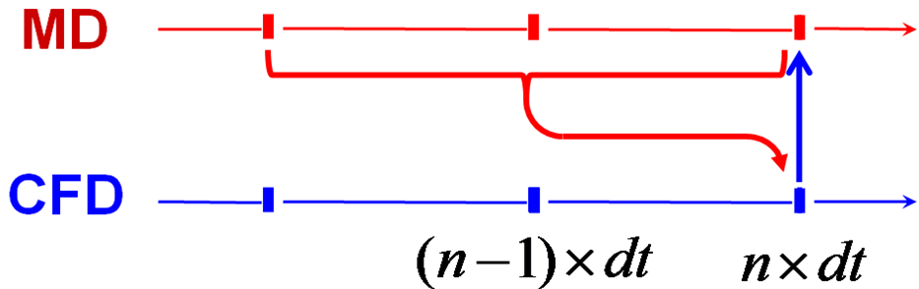

FIGURE 4. LINEAR FITTING OF MULTIPLE TEMPORAL SAMPLES; MULTIPLE PREVIOUS SAMPLES ARE LINEARLY FITTED AND IMPOSED AS THE CONTINUUM BOUNDARY CONDITION DURING THE NEXT INTERVAL.

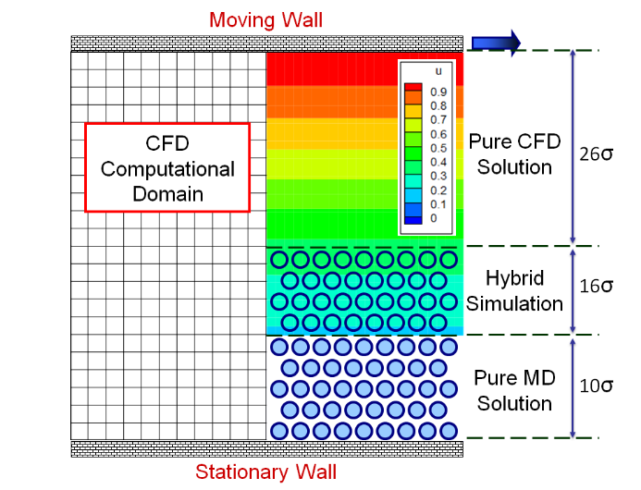
FIGURE 5. COMPUTATIONAL DOMAIN OF COUETTE FLOW SIMULATION; THE HEIGHT OF THE FLUID DOMAIN IS 52σ (≈177Å). CFD MESH SIZE IS 71×27 AND CFD CELLS AT THE PURE MD REGION ARE TREATED AS HOLES. MD DOMAIN SIZE IS ABOUT 140σ IN THE X-DIRECTION AND AROUND 26σ IN THE Y-DIRECTION.

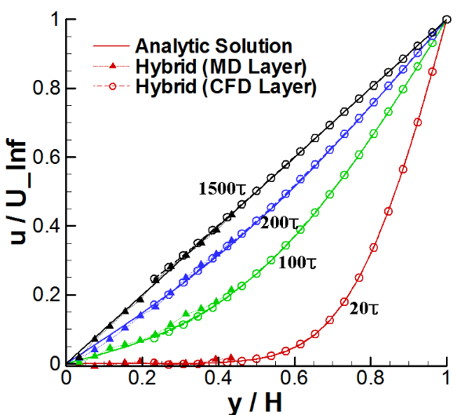
FIGURE 6. A SUDDEN-START COUETTE FLOW; CFD SOLUTION IS THE INSTANTANEOUS PROFILE AT SPECIFIED TIME AND MD SOLUTION IS AVERAGED OVER 2σ IN HEIGHT AND 10τ IN TIME.

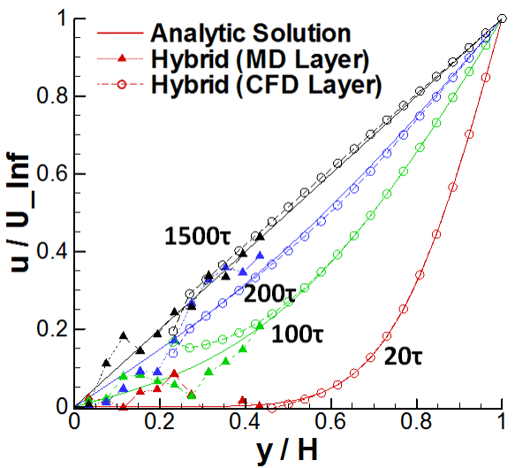
FIGURE 7. COUETTE FLOW PROFILE WITH THE UPPER PLATE VELOCITY OF 0.25 σ/τ; THE SOLUTION IS VERY NOISY BECAUSE OF THE SAMPLING NOISE IN PARTICLE DOMAIN. RED LINES DENOTE THE SOLUTION AT 20 τ. GREEN, BLUE AND BLACK LINES ARE SOLUTIONS AT 100, 200 AND 1500 τ, RESPECTIVELY.

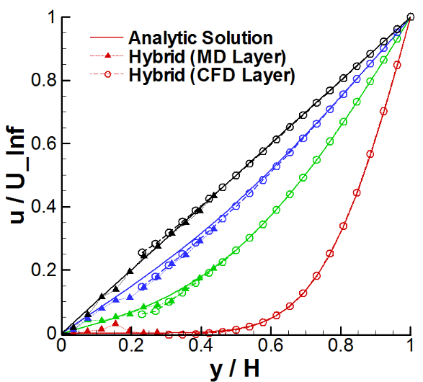
FIGURE 8. RESULT BY 16L SYSTEM LENGTH IN SOLVING 0.25 σ/τ COUETTE FLOW; SAMPLING NOISE IS SUPRESSED A LOT AND THE SOLUTION OVERALL FOLLOWS THE ANALYTIC SOLUTION.

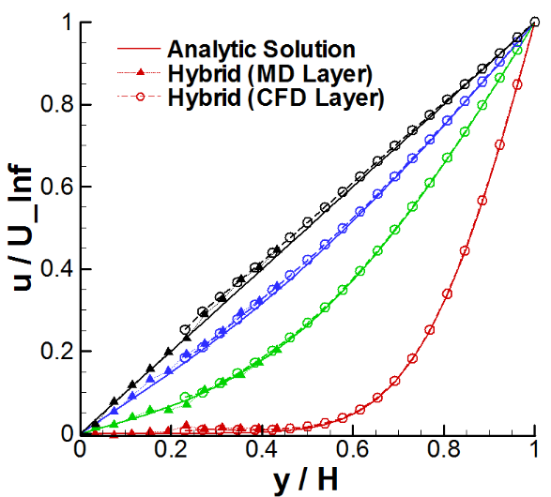
FIGURE 9. 16 REPLICA SAMPLES IN THE UPPER PLATE VELOCITY OF 0.25 σ/τ; SOLUTION’S ACCURACY IS COMPARABLE TO THE RESULT OF SYSTEM SIZE INCREASE.

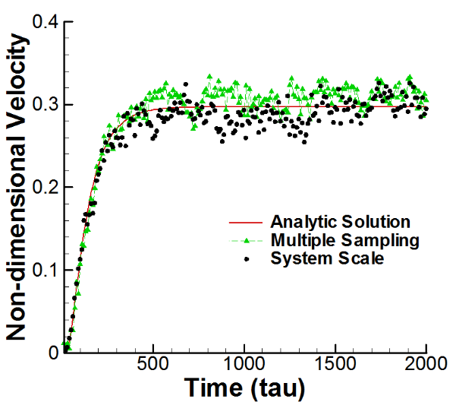
FIGURE 10. VARIATION OF THE VELOCITY IN THE MIDDLE OF OVERLAPPING REGION; SOLUTIONS BY MULTIPLE SAMPLING AND INCREASING THE SYSTEM CONTAIN THE SIMILAR STRENGTH OF THE NOISE IN THE SOLUTION, WHICH IS AROUND 5% OF THE ANALYTIC VELOCITY PROFILE.

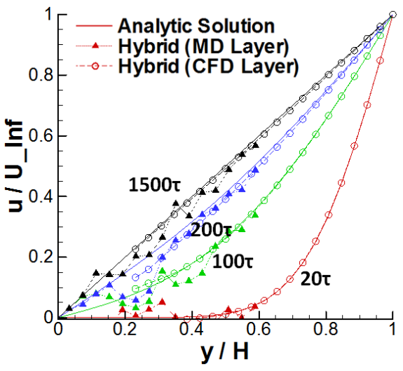
FIGURE 11. SPATIAL SAMPLING OF 9 LAYERS IN VERTICAL; VERY NOISY MOLECULAR DYNAMIC PROPERTIES ARE SPATIALLY AVERAGED FOR THE HYBRID CFD BOUNDARY CONDITION, SO CFD SOLUTION BECOMES VERY CLOSE TO THE ANALYTIC SOLUTION.

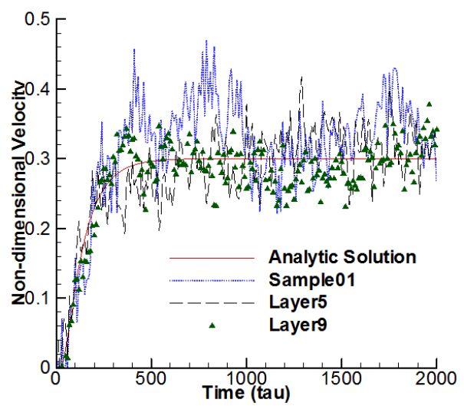
FIGURE 12. NOISE SUPRESSION BY MULTI-LAYER SAMPLING. AVERAGING MULTIPLE VERTICAL LAYERS PROVIDE LESS NOISY SOLUTION THAN THE DEFAULT SIMULATION (SAMPLING A SINGLE LAYER).

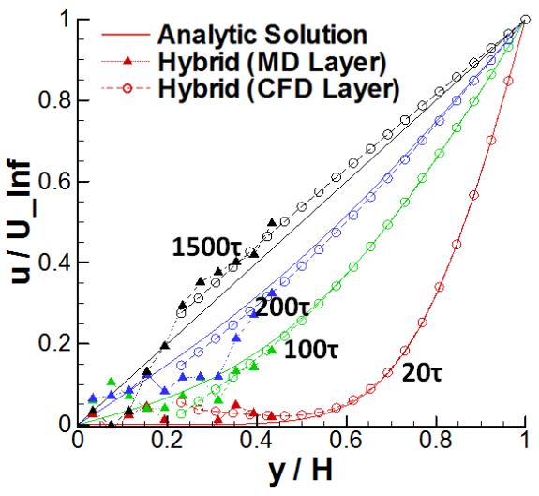
FIGURE 13. BOUNDARY VALUE PREDICTION BY 10 PREVIOUS SOLUTIONS; LINEAR-FITTED FUNCTION IS APPLIED TO IMPOSE A HYBRID CFD BOUNDARY CONDITION.

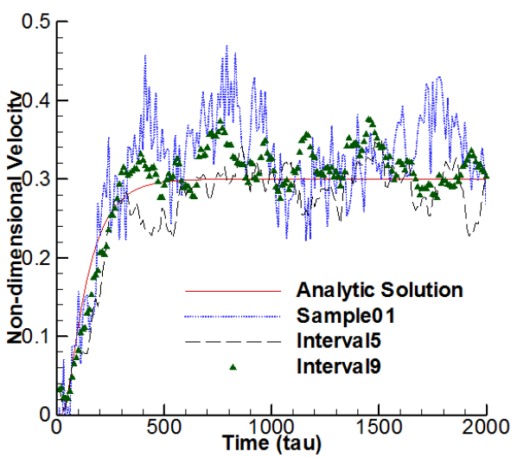
FIGURE 14. NOISE SUPRESSION BY THE LINEAR-FITTING OF MULTIPLE TEMPORAL PROFILE. COMPARED TO SPATIALLY SAMPLING MULTIPLE LAYERS, SOLUTION BECOMES LESS FLUCTUATING AND MORE ACCURATE.

