XSEDE Federation and Interoperation Use Cases

<03 December 2012>

Version <0.1>

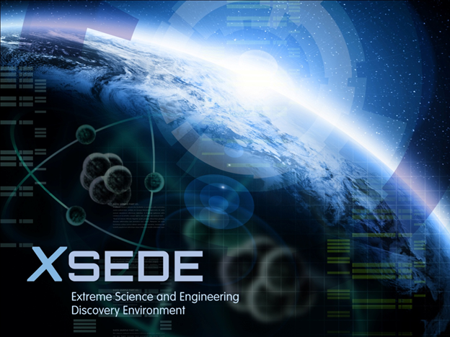

Table of Contents

A. Document History 3

B. Document Scope 2

C. High Performance Computing Use Cases 4

# Document History

Overall Document Authors:

Altaf Hossain, PSC altaf@psc.edu

Shantenu Jha, Ole Weidner

RADICAL, Rutgers University

|  |  |  |  |  |
| --- | --- | --- | --- | --- |
|  | Version | Date | Changes | Author |
| First use case draft | 0.1 | 09/09/2012 | Document created | Sanielevici |
| Draft 2 use cases based on feedback | 0.2 | 10/05/2012 | List of 4 use cases; glossary; draft development of first 2 use cases | Sanielevici |
|  |  |  |  |  |
|  |  |  |  |  |
|  |  |  |  |  |

# Document Scope

This document is one component of a process that generates at least the following documents, some of which are user-facing, some are as of now intended to be internal working documents:

* ***This document*** - A description of use cases [User facing]
* A binary mapping of use cases to Requirements in DOORS (a binary mapping – for each use case a “yes” or “no” flag indicating whether a particular requirement within the full list of requirements is or is not required to enable a particular use case
* A set of level 3 decomposition documents, which include:
  + Quality Attributes descriptions
  + Connections diagram in UML

The use cases are presented here using the following format, derived from the Malan and Bredemeyer white paper1 as follows:

|  |  |
| --- | --- |
| Use Case | Use case identifier and reference number and modification history |
| *Description* | Interoperation of XSEDE Resources and Federation with non-XSEDE Resources |
| *References* | References and citations relevant to use case |
| *Actors* | End-Scientists (e.g., Chemists, climate-scientist) trying to utilize as many resources as possible |
| *Prerequisites (Dependencies) & Assumptions* | User has allocation on multiple systems. |
| *Steps* | See UML Actor Diagram |
| *Variations (optional)* | The user may want to use not only existing XSEDE resources but also OSG, EGI or PRACE resources. |
| *Quality Attributes* | Overall Time-to-completion is one critical component. Other quality metrics could be the number of tasks completed. |
| *Non-functional (optional)* | Simplicity |
| *Issues* | List of issues that remain to be resolved |

# Glossary

Federation: The aggregation of resources via common policies in allocation, accounting, authentication and identity management. Resources within a given “domain” are generally considered federated. Resources between different domains are federated using different models.

Interoperation: The ability to utilize distinct heterogeneous resources for a common application or user-defined goal.

Resources within XSEDE should be deemed to be already federated but are not a priori interoperable.

# Federation and Interoperation Use Cases

<using the template table above draft your use cases>



Use Case Diagram: A graphical representation of the use case.