Assignment 1 – Data Visualization
  - BIOL 520/820 Statistical Methods in Life Sciences, Fall 2026
Group X: [member names]
October 2026
Table of Contents

Introduction
Graphs are the first step of any data analysis: they show the distribution of a variable, differences between groups, relationships between variables and whether the assumptions of a statistical test are reasonable. In this assignment we present four graphical methods that we consider essential for the biological sciences and apply each of them to two biomedical datasets from Kaggle: a gene-expression dataset of breast tumours (dataset 1) and a clinical dataset of liver patients (dataset 2). For each of the eight graphs we explain why that type of graph was chosen and what it shows. All graphs were made in R with the ggplot2 package; the scripts, the figures (PDF and PNG) and this report are in the group’s GitHub repository (Section 6).

Four essential graphical methods

Histogram (with density curve)
A histogram divides the range of a continuous variable into bins and shows how many observations fall in each bin. It is the simplest way to see the shape of a distribution: whether it is symmetric or skewed, whether it has one peak or several, and where the centre and the spread are. Adding the mean and median as vertical lines shows directly how skewness pulls the mean away from the median, and a kernel density curve gives a smooth version of the histogram. Histograms belong to the descriptive statistics introduced in week 2 and are the first graph we draw to decide whether a variable can be treated as normally distributed or needs a transformation (week 4).

Box plot
The box plot (Tukey, 1977) summarises a distribution with five numbers: the median (thick line), the first and third quartiles (the box, whose height is the inter-quartile range, IQR) and the whiskers, which extend to the most extreme values within 1.5 IQR of the box; observations beyond the whiskers are drawn individually as outliers. Placing several box plots side by side is the standard way to compare a measurement between groups (treatments, genotypes, disease groups) and to spot outliers. We overlay the individual data points where the groups are small so that the sample size is visible, as recommended for biological data (Weissgerber et al., 2015).

Scatter plot with a regression line
A scatter plot shows every observation as a point with one variable on each axis. It is the graph behind correlation and simple linear regression (weeks 5 and 6): the direction and tightness of the cloud of points correspond to the sign and size of the Pearson correlation coefficient r, and the least-squares line y = a + bx summarises the linear relationship. We print r, the regression equation and the coefficient of determination R² on the graph, draw the 95 percent confidence band of the line, and use colour for a grouping variable so that the reader can see whether the relationship holds within groups.

Normal quantile-quantile (Q-Q) plot
The Q-Q plot (Wilk & Gnanadesikan, 1968) checks the assumption of normality (week 4) more precisely than a histogram. The sorted observations (sample quantiles) are plotted against the values expected for a normal distribution with the same mean and standard deviation (theoretical quantiles). If the data are normal the points lie on the straight line; a curved or S-shaped pattern shows skewness, heavy tails or several modes. We report the Shapiro-Wilk test next to each Q-Q plot, as in Practical 5, and we use the Q-Q plot to judge whether a log transformation makes a variable closer to normal.

Dataset 1: breast cancer gene expression (CuMiDa, GSE45827)

Description of the dataset
Source. Kaggle dataset Breast Cancer Gene Expression - CuMiDa (https://www.kaggle.com/datasets/brunogrisci/breast-cancer-gene-expression-cumida), file Breast_GSE45827.csv. CuMiDa (Feltes et al., 2019) is a collection of curated cancer microarray datasets from the NCBI Gene Expression Omnibus. This one is GEO series GSE45827 (Gruosso et al., 2016): breast tissue samples profiled on the Affymetrix HG-U133 Plus 2.0 array, background-corrected, normalised and log2-transformed by CuMiDa.
Data frame. 151 rows (samples) and 54,677 columns: samples (a sample number), type (the class) and 54,675 numeric columns, one per probe set, containing log2 expression values. The six classes are the molecular subtypes of breast cancer (Perou et al., 2000) plus normal tissue and cell lines (Table 1). Because the full matrix is far too large to plot, we selected four genes that every breast cancer biologist knows: ESR1 (oestrogen receptor), GATA3 (a transcription factor co-expressed with ESR1), ERBB2 (the HER2 receptor) and PGR (progesterone receptor); the probe identifiers were taken from the GEO annotation of the array. Table 2 shows the first rows of the resulting data frame and Table 3 its descriptive statistics.
Classes of the CuMiDa GSE45827 dataset.
Class | n | Meaning
Normal | 7 | Histologically normal breast tissue
Luminal A | 29 | Oestrogen-receptor-positive tumours, low proliferation
Luminal B | 30 | Oestrogen-receptor-positive tumours, higher proliferation
HER2-enriched | 30 | HER2 (ERBB2)-amplified tumours
Basal-like | 41 | Triple-negative tumours
Cell line | 14 | Breast cancer cell lines grown in culture

First six rows of the data frame used for dataset 1 (151 rows, 6 columns).
sample | subtype | ESR1 | GATA3 | ERBB2 | PGR
84 | Basal-like | 6.17 | 6.89 | 8.72 | 4.18
85 | Basal-like | 4.41 | 7.71 | 6.73 | 3.77
87 | Basal-like | 5.76 | 5.31 | 7.86 | 4.11
90 | Basal-like | 5.82 | 5.43 | 8.62 | 4.80
91 | Basal-like | 5.42 | 8.20 | 9.47 | 4.23
92 | Basal-like | 4.32 | 2.83 | 7.27 | 3.83

Descriptive statistics of the four genes over all 151 samples (log2 expression).
Gene | n | Mean | SD | Median | Q1 | Q3 | Min | Max
ERBB2 | 151 | 10.73 | 2.07 | 10.13 | 9.10 | 12.97 | 6.73 | 14.15
ESR1 | 151 | 8.06 | 2.94 | 7.71 | 5.29 | 11.14 | 3.57 | 13.43
GATA3 | 151 | 8.66 | 2.18 | 9.00 | 7.19 | 10.37 | 2.83 | 12.24
PGR | 151 | 6.17 | 2.57 | 4.75 | 4.29 | 8.13 | 3.77 | 13.42

Figure 1 - Histogram of ESR1 expression
Why this graph. The oestrogen receptor is the single most important marker in breast cancer, and the first question about any variable is what its distribution looks like. A histogram of ESR1 over all 151 samples answers that question, and colouring the bars by class shows which samples form each part of the distribution.
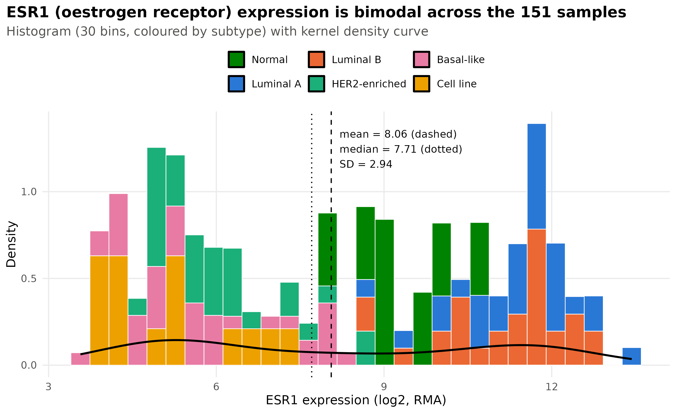
Histogram of ESR1 expression in the 151 samples, coloured by class, with the kernel density curve, the mean (dashed) and the median (dotted).
What it shows. ESR1 expression is clearly bimodal: one peak around 5-6 (log2 units) and a second around 11-12, with few samples in between. The mean (8.06) and median (7.71) fall in the gap between the two peaks, so neither describes a typical sample, and the standard deviation (2.94) is large because it mixes the two groups. The colours explain the shape: the low peak is made of basal-like, HER2-enriched tumours and cell lines (the oestrogen-receptor-negative classes), the high peak of luminal A and luminal B tumours (the oestrogen-receptor-positive classes), and the normal tissues sit in between. This is a good example of a variable whose distribution should not be summarised by a single mean, and it already suggests that the normality assumption will fail for the whole sample (Figure 4).

Figure 2 - Box plots of ESR1 and ERBB2 by subtype
Why this graph. Figure 1 suggests that the classes differ; box plots compare the six classes directly and show, for each one, the median, the spread and the outliers. We add ERBB2 as a second panel because it defines the HER2-enriched class, and we overlay the individual samples because some classes are small (7 normal samples, 14 cell lines).
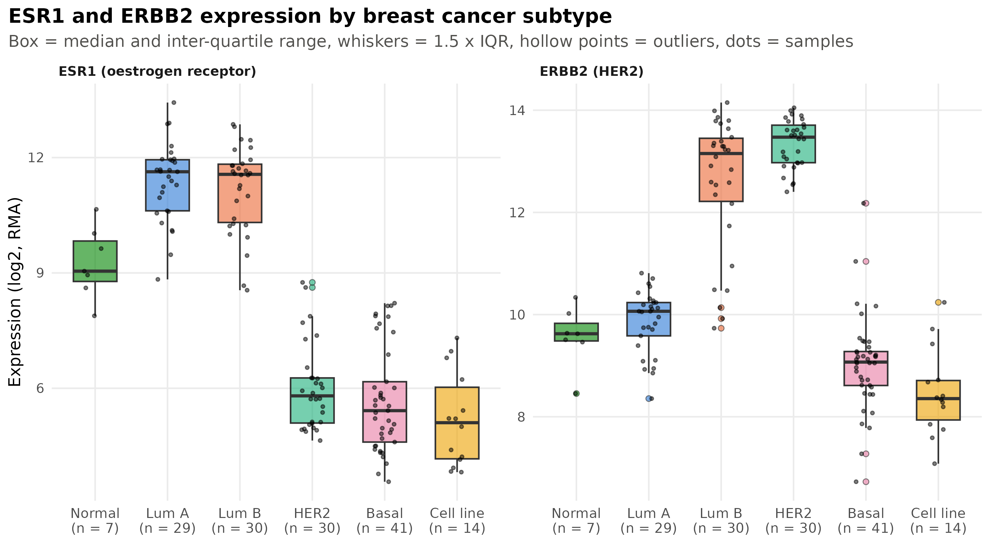
Box plots of ESR1 and ERBB2 expression in the six classes, with individual samples overlaid.
What it shows. ESR1 separates the classes into two clear groups: luminal A and luminal B tumours have medians around 11.6, normal tissue is intermediate (median 9.0) and the HER2-enriched, basal-like and cell-line classes have medians of 5.1-5.8, with no overlap of the boxes between the two groups. ERBB2 tells a different story: it is very high and tightly distributed in the HER2-enriched class (median 13.5, SD 0.47), around 9-10 in the other classes, and strikingly variable in luminal B, whose box spans from 12.2 to 13.4 with several outliers near 10. This means that roughly half of the luminal B tumours also carry high ERBB2 expression, which is exactly what is known clinically (some luminal B tumours are HER2-positive). The plot also illustrates how box plots reveal outliers: two HER2-enriched samples with unusually high ESR1, and two basal-like samples with high ERBB2.

Figure 3 - Scatter plot of ESR1 versus GATA3 with the regression line
Why this graph. GATA3 is a transcription factor that works together with the oestrogen receptor, so a positive relationship is expected. A scatter plot with the least-squares line is the standard way to display and quantify such a relationship; the Pearson correlation and R² are printed on the graph and the points are coloured by class to see where each class sits along the line.
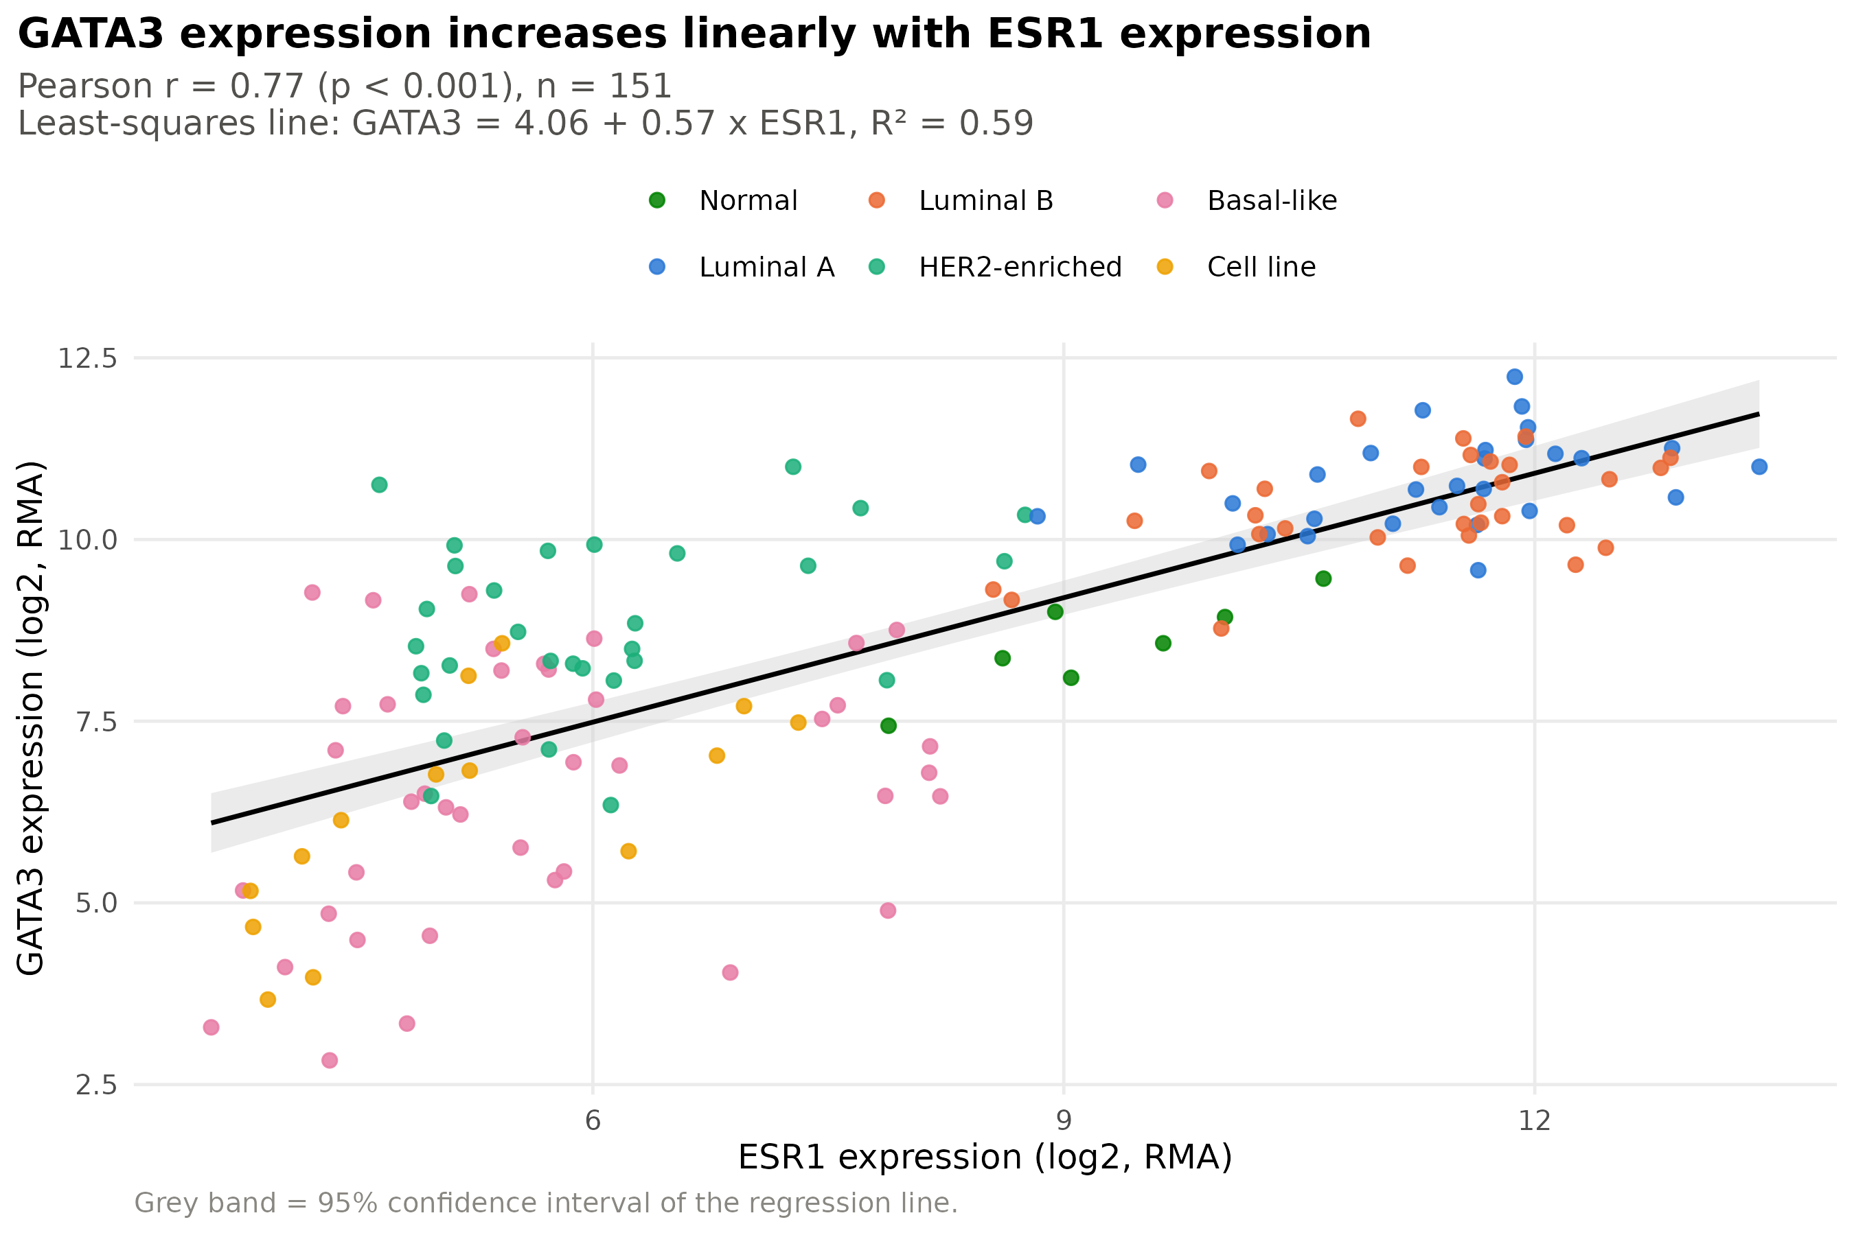
Scatter plot of GATA3 against ESR1 expression (n = 151) with the least-squares regression line and its 95 percent confidence band. Points are coloured by class.
What it shows. The relationship is positive, approximately linear and strong: Pearson r = 0.77 (95 percent CI 0.70 to 0.83, t = 14.7, df = 149, p < 0.001). The fitted line is GATA3 = 4.06 + 0.57 x ESR1: a one-unit increase in log2 ESR1 is associated on average with a 0.57-unit increase in log2 GATA3, and the line explains R² = 0.59, i.e. about 59 percent of the variation in GATA3. The colours show that the correlation is largely driven by the difference between the oestrogen-receptor-negative classes (bottom left) and the luminal classes (top right); within the luminal cluster the points are more scattered, and several HER2-enriched tumours lie above the line (high GATA3 despite low ESR1). This is a useful reminder from week 6: a strong correlation across the whole sample can be produced by group differences, so one should always look at the scatter plot and not only at r.

Figure 4 - Normal Q-Q plots of ESR1 expression
Why this graph. Many of the tests we will use later (t-tests, ANOVA, regression) assume normally distributed data within groups. The Q-Q plot checks this assumption; we draw it twice, for all samples together and for the luminal A class alone, to show that the answer depends on which group is examined.
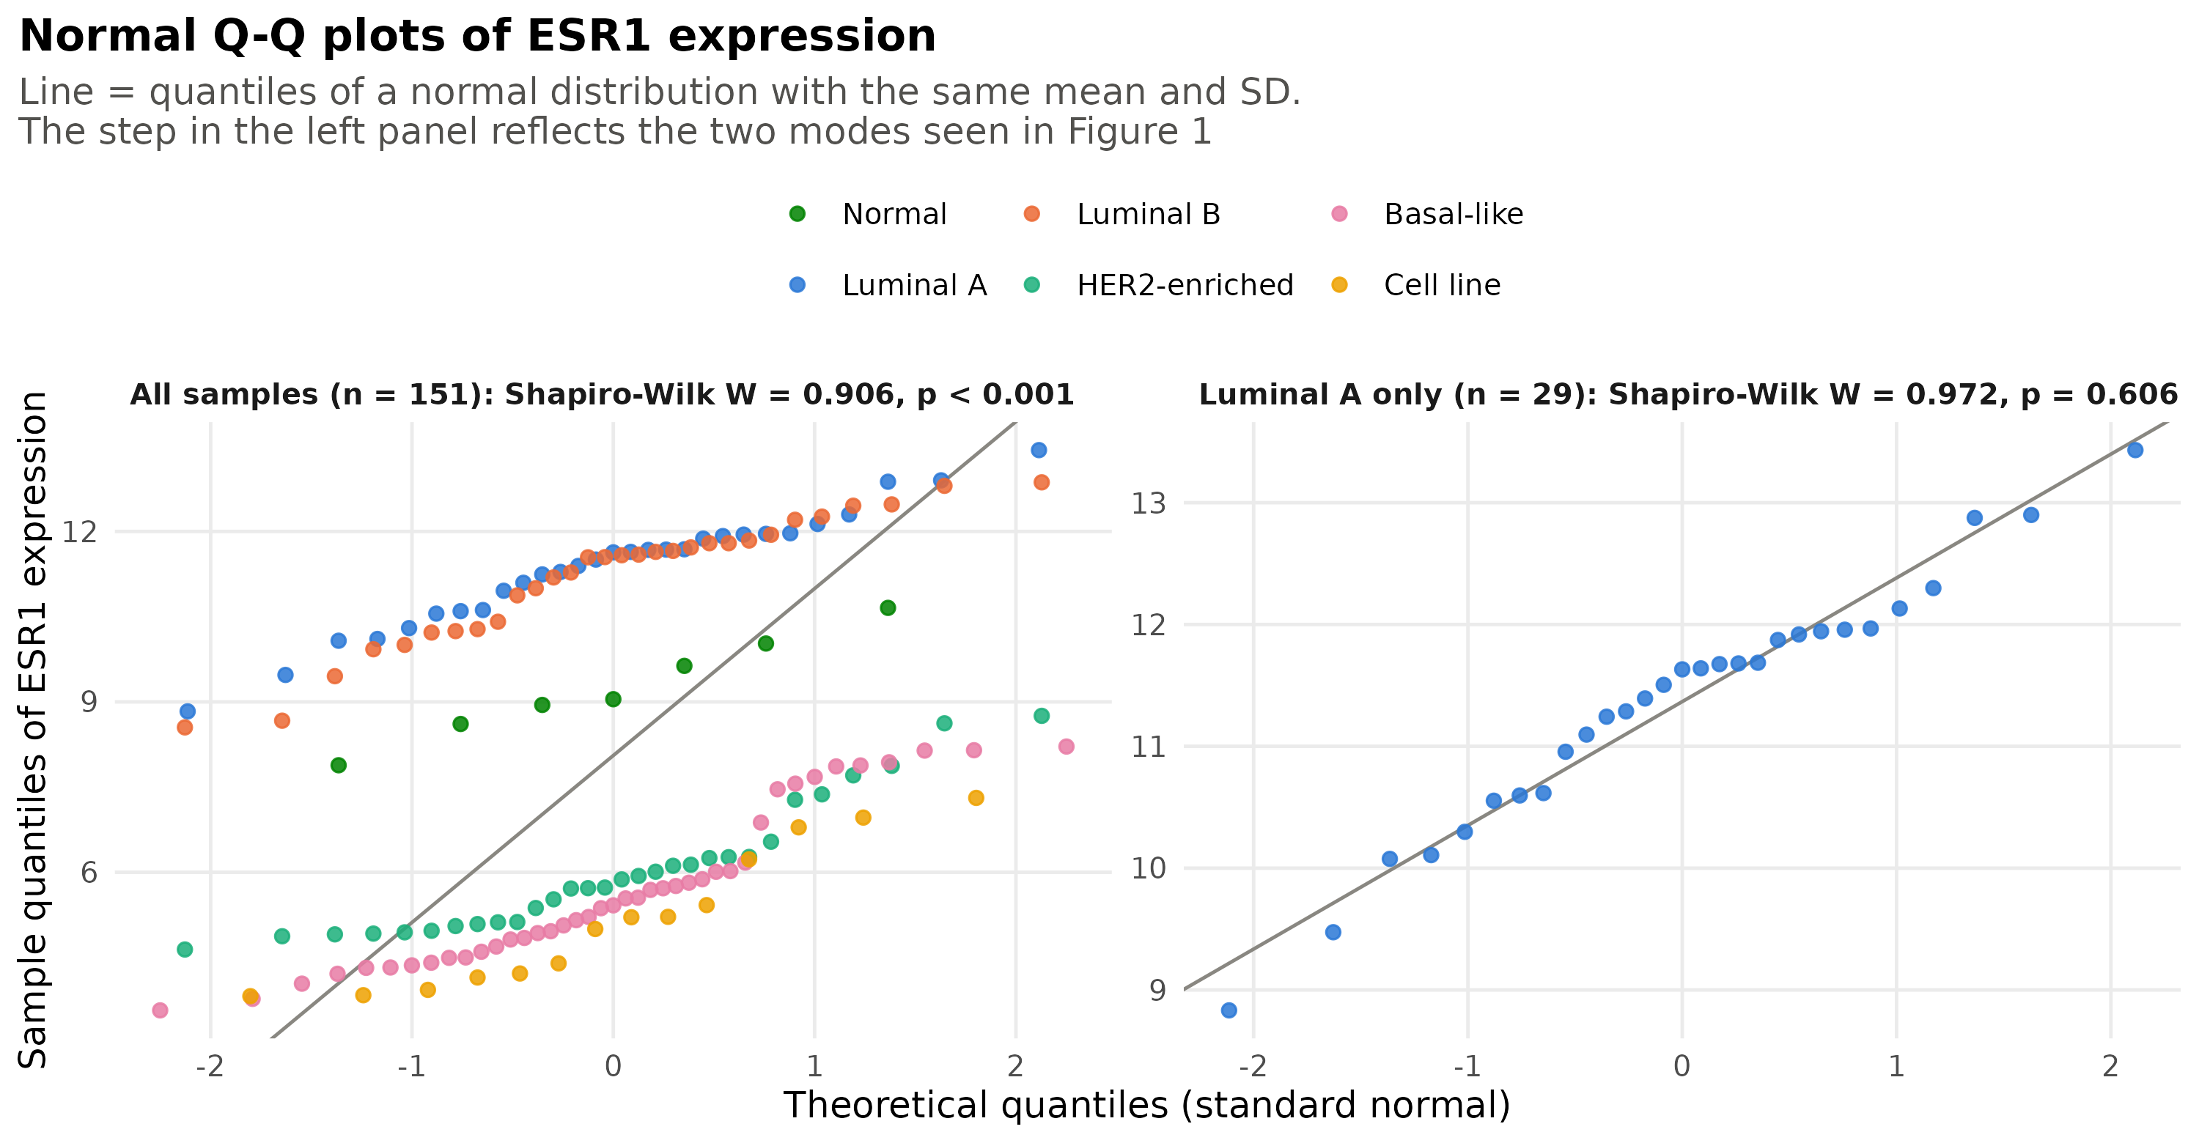
Normal Q-Q plots of ESR1 expression for all 151 samples (left) and for the 29 luminal A tumours only (right), with the Shapiro-Wilk test in the panel titles.
What it shows. For all samples together the points form a step rather than a line: the low-ESR1 classes lie below the line and the luminal classes above it, which is the Q-Q signature of a bimodal distribution, and the Shapiro-Wilk test rejects normality (W = 0.906, p < 0.001). Within the luminal A class alone the points follow the line closely and the test gives no evidence against normality (W = 0.972, p = 0.61). The lesson is that normality should be checked within groups, and that the apparent non-normality of the whole sample simply reflects the mixture of biologically different classes.

Dataset 2: Indian Liver Patient Records

Description of the dataset
Source. Kaggle dataset Indian Liver Patient Records (uploaded by Md. Faysal Mahmud), file indian_liver_patient.csv. It is the Indian Liver Patient Dataset (ILPD) collected in Andhra Pradesh, India, and deposited in the UCI Machine Learning Repository (Ramana et al., 2012); the same file is also on Kaggle as uciml/indian-liver-patient-records.
Data frame. 583 rows (patients) and 11 columns: age, gender, eight blood-test results and the diagnosis (Dataset: 1 = liver patient, 2 = no liver disease). Table 4 lists the variables, Table 5 shows the first rows and Table 6 gives descriptive statistics by diagnosis. There are 416 liver patients and 167 patients without liver disease; 441 patients are men and 142 are women. Four values of the albumin/globulin ratio are missing; no other values are missing.
Variables of the Indian Liver Patient Records dataset (column names as in the file).
Variable | Type | Description
Age | numeric | Age in years
Gender | categorical | Female or Male
Total_Bilirubin | numeric | Total bilirubin (mg/dL)
Direct_Bilirubin | numeric | Direct bilirubin (mg/dL)
Alkaline_Phosphotase | numeric | Alkaline phosphatase (IU/L)
Alamine_Aminotransferase | numeric | Alanine aminotransferase, ALT (IU/L)
Aspartate_Aminotransferase | numeric | Aspartate aminotransferase, AST (IU/L)
Total_Protiens | numeric | Total protein (g/dL)
Albumin | numeric | Albumin (g/dL)
Albumin_and_Globulin_Ratio | numeric | Albumin / globulin ratio
Dataset | categorical | 1 = liver patient, 2 = no liver disease

First six rows of the data frame (583 rows, 11 columns; column names abbreviated).
Age | Gender | TB | DB | ALP | ALT | AST | TP | ALB | A/G | Dataset
65 | Female | 0.7 | 0.1 | 187 | 16 | 18 | 6.8 | 3.3 | 0.90 | 1
62 | Male | 10.9 | 5.5 | 699 | 64 | 100 | 7.5 | 3.2 | 0.74 | 1
62 | Male | 7.3 | 4.1 | 490 | 60 | 68 | 7.0 | 3.3 | 0.89 | 1
58 | Male | 1.0 | 0.4 | 182 | 14 | 20 | 6.8 | 3.4 | 1.00 | 1
72 | Male | 3.9 | 2.0 | 195 | 27 | 59 | 7.3 | 2.4 | 0.40 | 1
46 | Male | 1.8 | 0.7 | 208 | 19 | 14 | 7.6 | 4.4 | 1.30 | 1

Descriptive statistics by diagnosis.
Variable | Group | n | Mean (SD) | Median [Q1, Q3]
Age (years) | Liver patient | 416 | 46.2 (15.7) | 46.0 [34.0, 58.0]
Age (years) | No liver disease | 167 | 41.2 (17.0) | 40.0 [28.0, 55.0]
Total bilirubin | Liver patient | 416 | 4.2 (7.1) | 1.4 [0.8, 3.6]
Total bilirubin | No liver disease | 167 | 1.1 (1.0) | 0.8 [0.7, 1.1]
Direct bilirubin | Liver patient | 416 | 1.9 (3.2) | 0.5 [0.2, 1.8]
Direct bilirubin | No liver disease | 167 | 0.4 (0.5) | 0.2 [0.2, 0.3]
Alkaline phosphatase | Liver patient | 416 | 319.0 (268.3) | 229.0 [186.0, 315.2]
Alkaline phosphatase | No liver disease | 167 | 219.8 (141.0) | 186.0 [161.5, 213.0]
ALT | Liver patient | 416 | 99.6 (212.8) | 41.0 [25.0, 76.5]
ALT | No liver disease | 167 | 33.7 (25.1) | 27.0 [20.0, 37.5]
AST | Liver patient | 416 | 137.7 (337.4) | 52.5 [29.8, 108.8]
AST | No liver disease | 167 | 40.7 (36.4) | 29.0 [21.0, 43.5]
Total protein | Liver patient | 416 | 6.5 (1.1) | 6.5 [5.7, 7.2]
Total protein | No liver disease | 167 | 6.5 (1.1) | 6.6 [5.9, 7.3]
Albumin | Liver patient | 416 | 3.1 (0.8) | 3.0 [2.5, 3.6]
Albumin | No liver disease | 167 | 3.3 (0.8) | 3.4 [2.9, 4.0]
Albumin/globulin ratio | Liver patient | 414 | 0.9 (0.3) | 0.9 [0.7, 1.1]
Albumin/globulin ratio | No liver disease | 165 | 1.0 (0.3) | 1.0 [0.9, 1.2]

Figure 5 - Histogram of total bilirubin, raw and log-transformed
Why this graph. Blood-test results are often strongly skewed, and total bilirubin is a typical case. A histogram of the raw values next to a histogram of the log10-transformed values shows the skew, the effect of the transformation, and why the mean and median disagree (week 4, handling violations of assumptions).
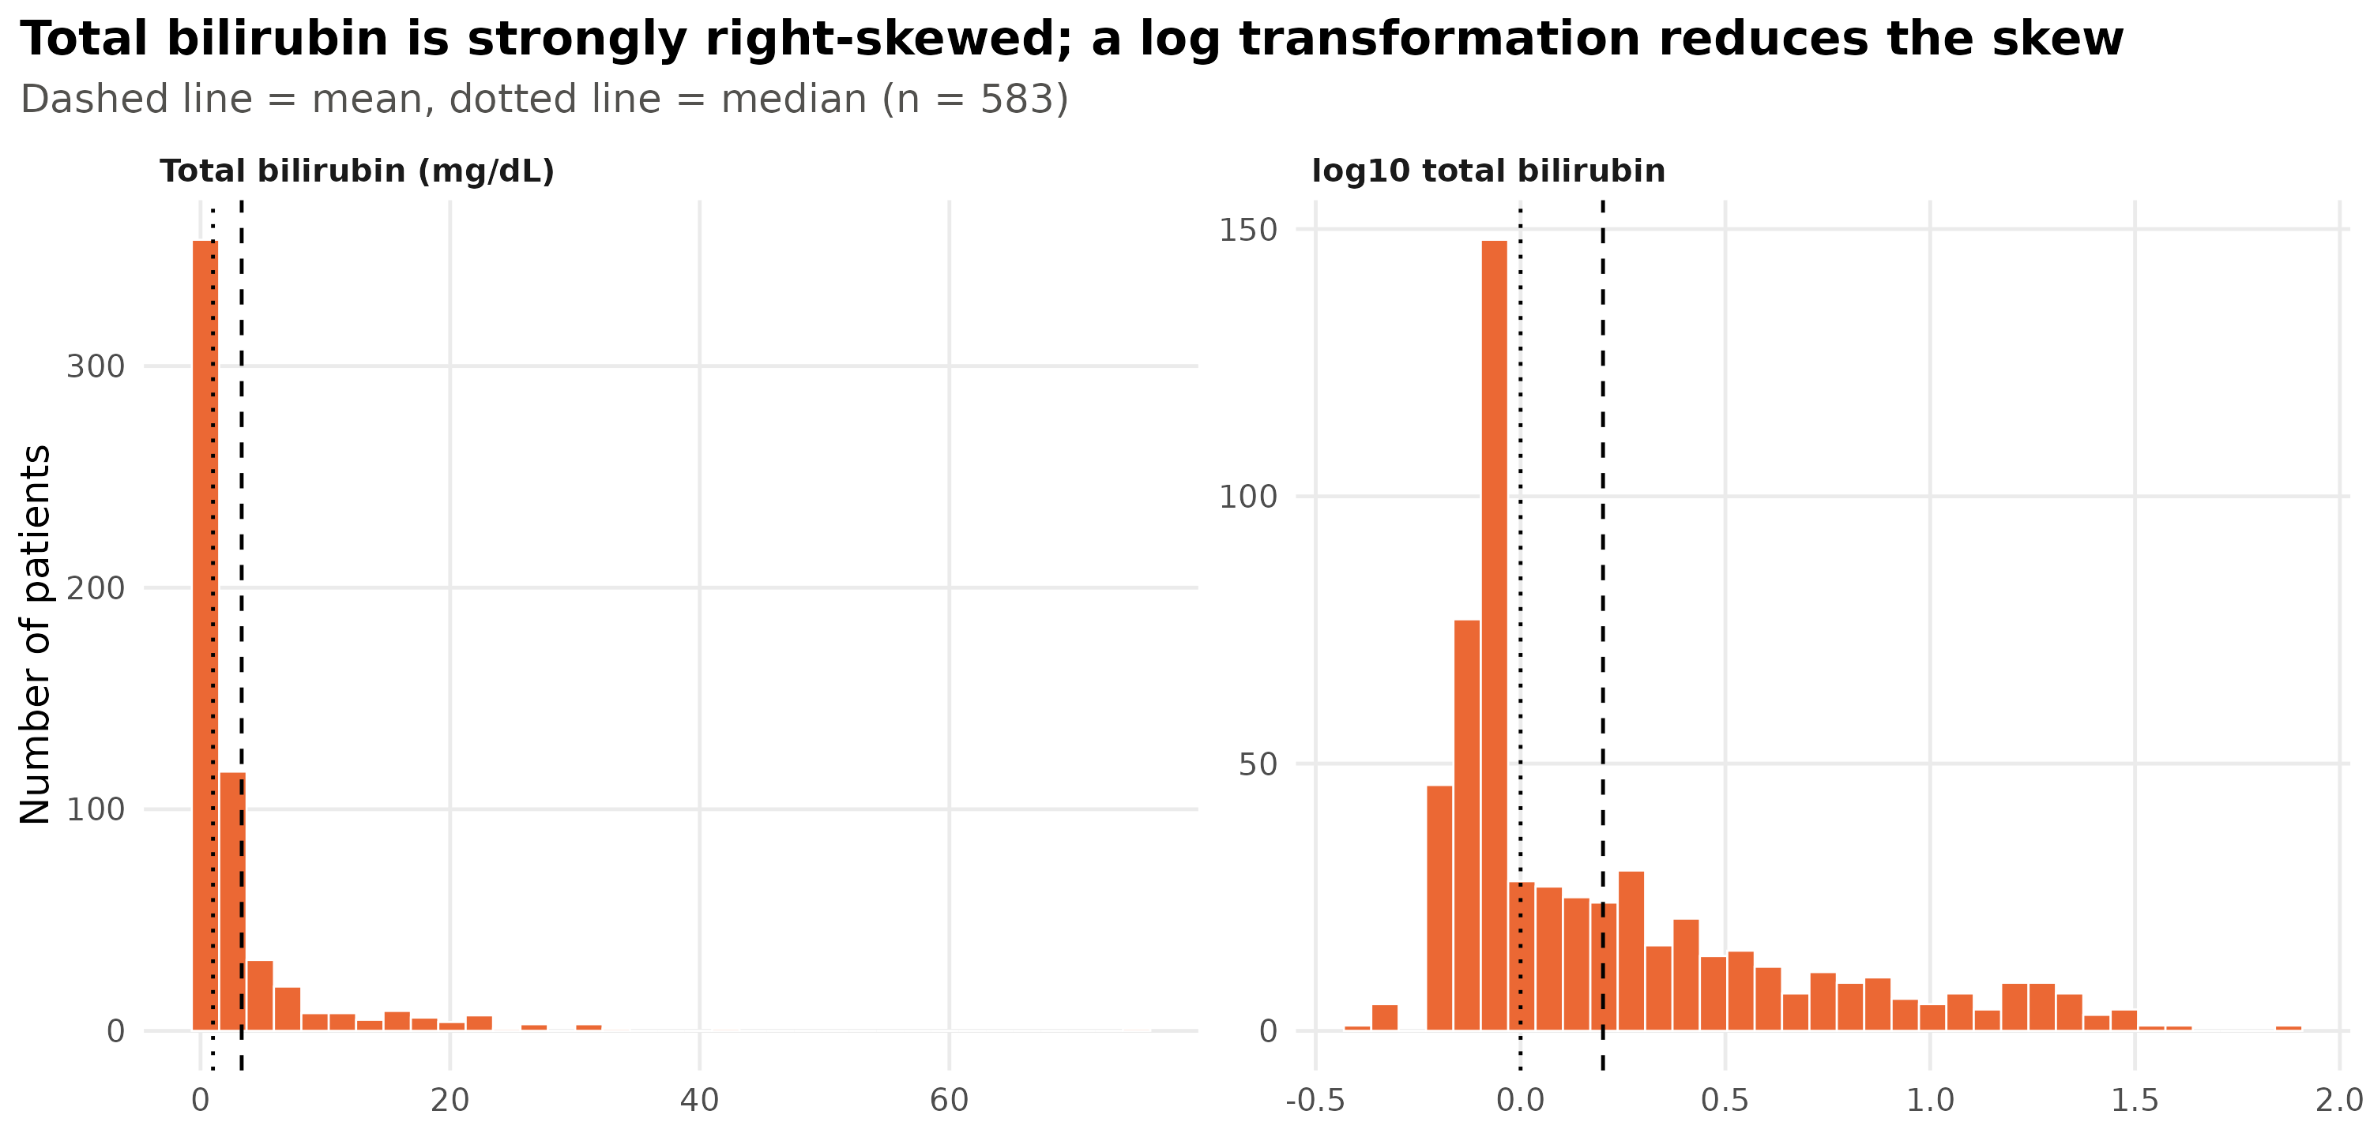
Histograms of total bilirubin for the 583 patients on the original scale (left) and after log10 transformation (right), with mean (dashed) and median (dotted).
What it shows. On the original scale almost all patients are in the first two bins (below 4 mg/dL) while a long tail reaches 75 mg/dL; the mean (3.30 mg/dL) is more than three times the median (1.00 mg/dL), which is the classic sign of strong right skew. After the log10 transformation the distribution is much less skewed and the mean and median come closer together, although a spike at the normal value (about 0.7-0.8 mg/dL, i.e. log10 close to -0.1) and a long shoulder towards high values remain. The transformation therefore helps, but it does not make bilirubin normal: a large fraction of patients have healthy values and the rest form a wide spread of abnormal values.

Figure 6 - Box plots of five liver tests by diagnosis
Why this graph. The key question of the dataset is how liver patients differ from patients without liver disease. Side-by-side box plots of the main liver-function tests show the medians, spreads and outliers of the two groups on one page. Because the enzymes and bilirubin are right-skewed (Figure 5), they are plotted on a log10 scale so that the boxes are not squeezed by extreme values.
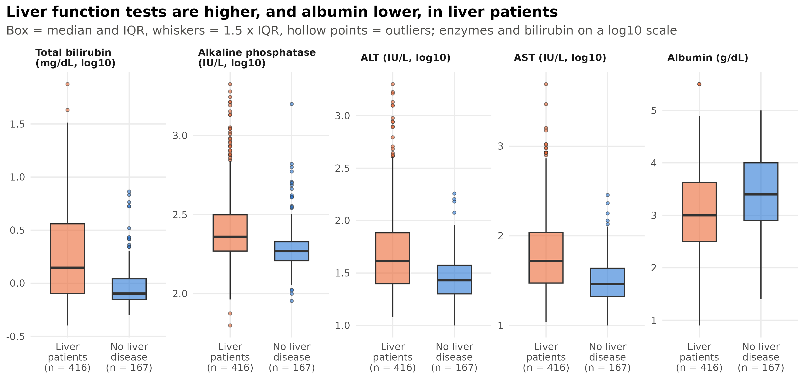
Box plots of total bilirubin, alkaline phosphatase, ALT, AST (all log10) and albumin by diagnosis (416 liver patients, 167 without liver disease).
What it shows. Liver patients have higher values of all four liver-damage markers: the median total bilirubin is 1.4 versus 0.8 mg/dL, alkaline phosphatase 229 versus 186 IU/L, ALT 41 versus 27 IU/L and AST 52.5 versus 29 IU/L, and in each case the box of the liver patients is wider and has a long upper tail of outliers, reflecting patients with severe disease. Albumin, which the liver produces, goes the other way: the median is 3.0 g/dL in liver patients versus 3.4 g/dL in the other group. The boxes overlap considerably, however, so none of these tests separates the two groups on its own; this is why the diagnosis in practice relies on several tests together. The graph also shows unequal spread between the groups (the liver patients are far more variable), which would need to be considered before a t-test.

Figure 7 - Scatter plot of total protein versus albumin with the regression line
Why this graph. Albumin is the main component of serum protein, so a linear relationship between the two is expected and provides a clean example of correlation and simple linear regression. The points are coloured by diagnosis to see whether the relationship differs between the groups.
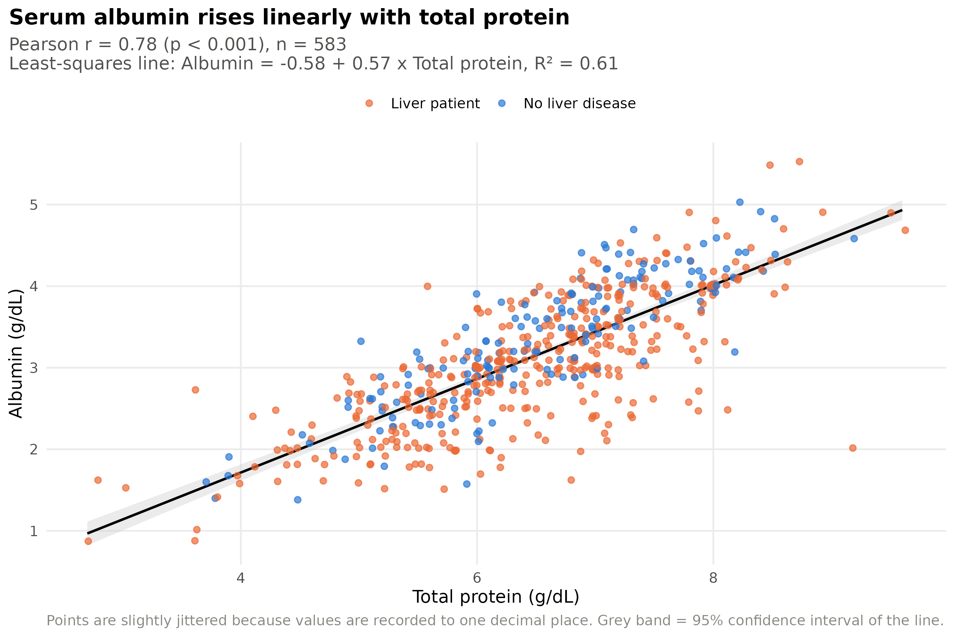
Scatter plot of albumin against total protein for the 583 patients, coloured by diagnosis, with the least-squares regression line and its 95 percent confidence band.
What it shows. The cloud of points is tight and linear: Pearson r = 0.78 (95 percent CI 0.75 to 0.81, p < 0.001). The fitted line Albumin = -0.58 + 0.57 x Total protein means that each additional g/dL of total protein corresponds on average to 0.57 g/dL more albumin, and the line explains R² = 0.61 of the variance of albumin. Liver patients and patients without liver disease follow the same line, so the relationship between the two proteins is not altered by the disease; liver patients simply tend to sit at lower values of both. A few points lie far below the line (for example a patient with total protein 9.2 g/dL but albumin 2.0 g/dL): these are patients whose high total protein is due to globulins rather than albumin, and they are the kind of outliers that regression diagnostics would flag.

Figure 8 - Normal Q-Q plots of ALT, raw and log-transformed
Why this graph. Before comparing an enzyme such as ALT between groups with a parametric test, one must check whether it is close to normal. Q-Q plots of the raw and log10-transformed values show how far the data are from normality and how much the transformation helps, more precisely than the histograms of Figure 5.
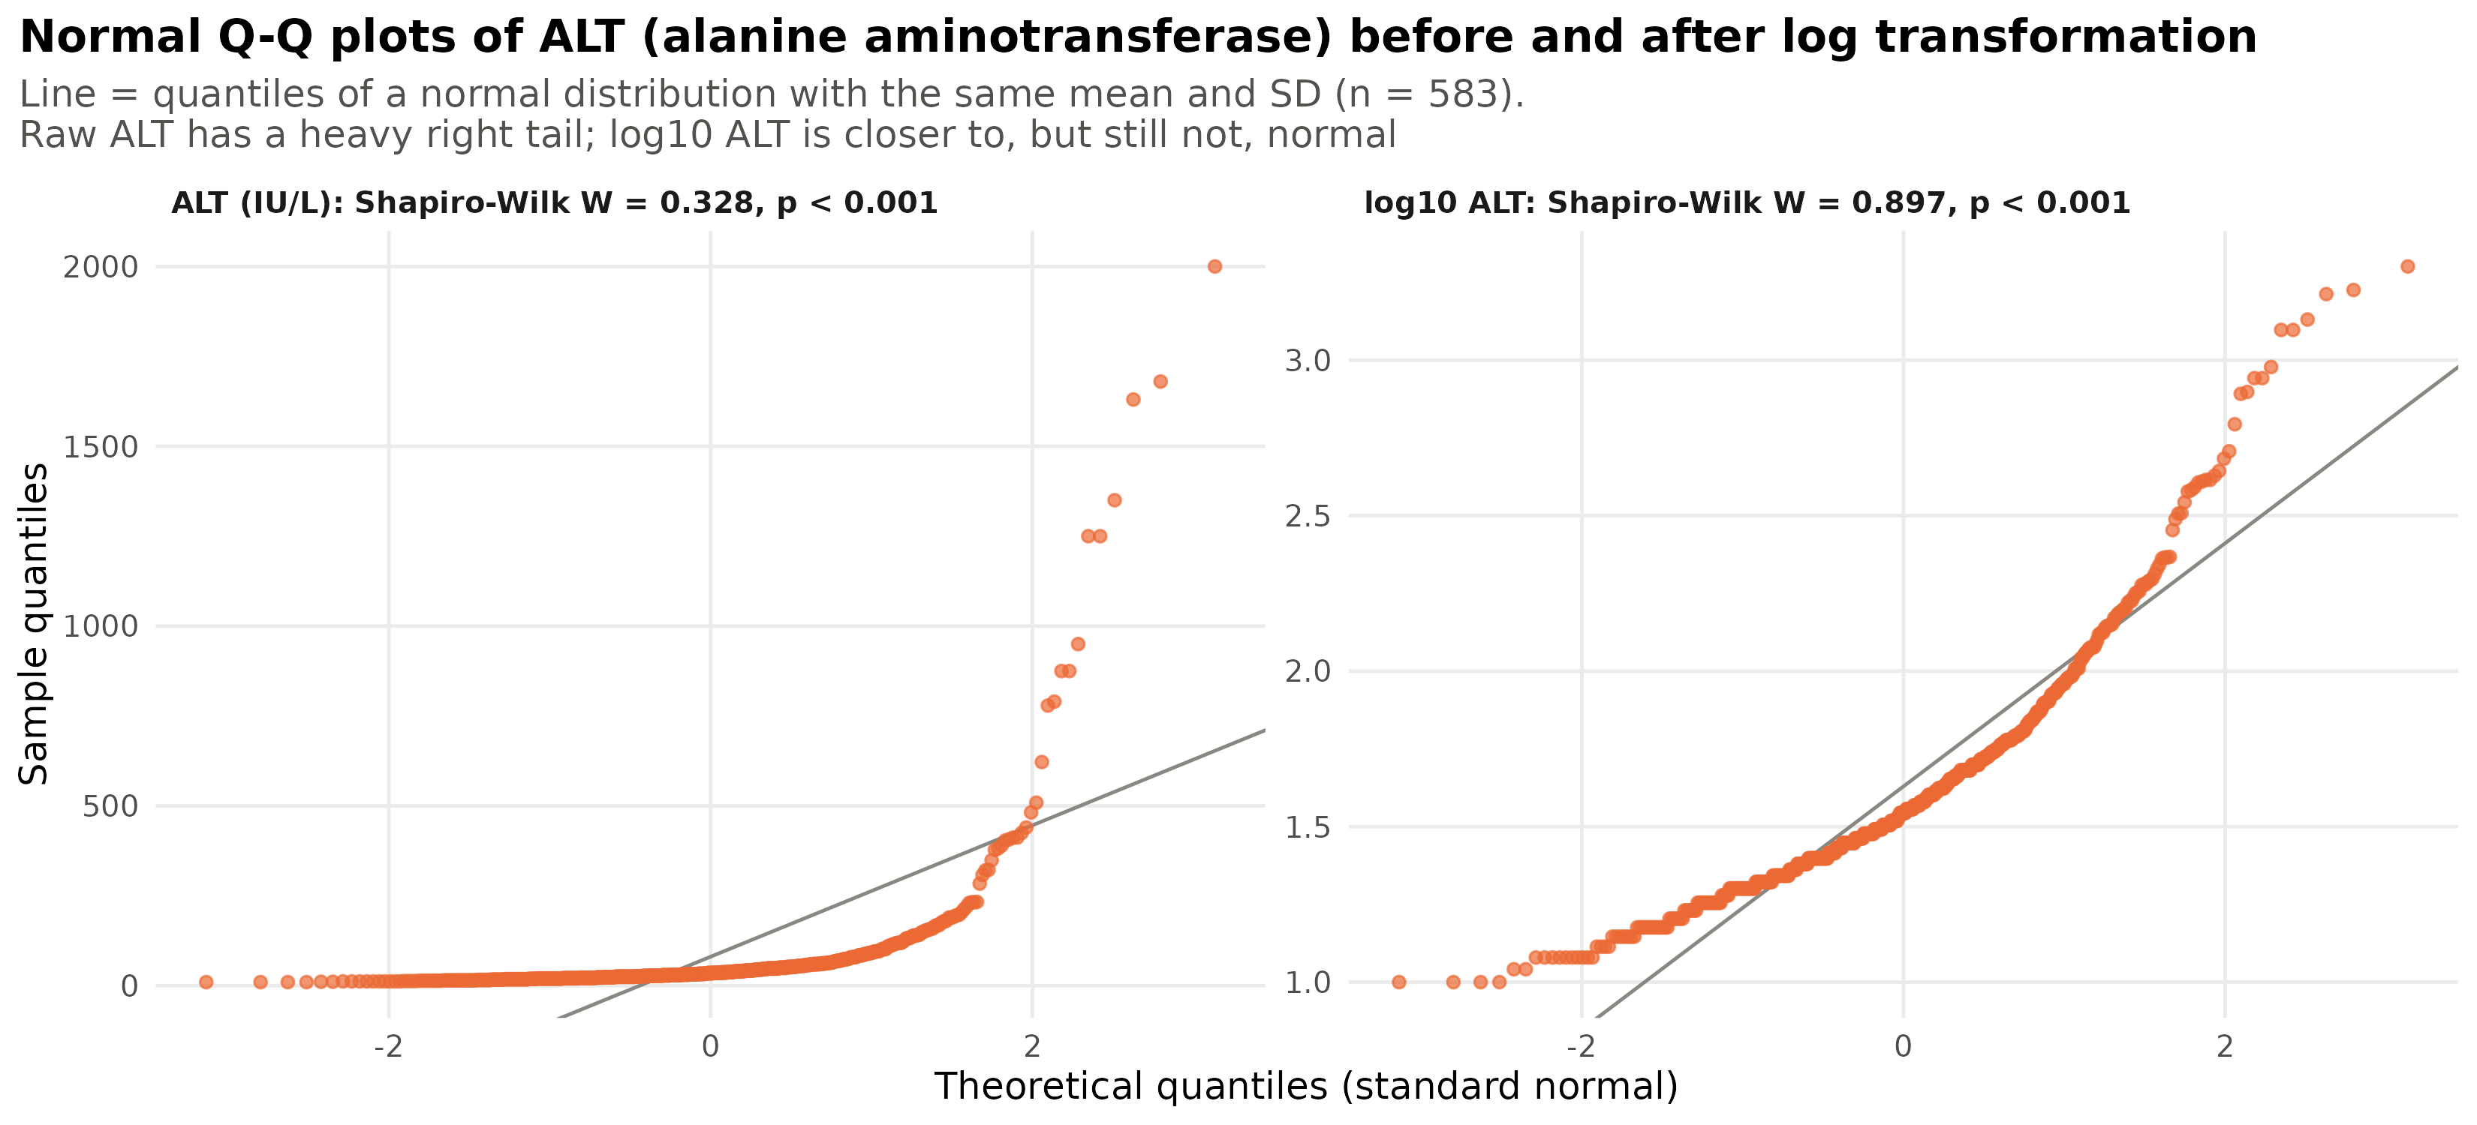
Normal Q-Q plots of alanine aminotransferase (ALT) before (left) and after (right) log10 transformation, with Shapiro-Wilk tests, n = 583.
What it shows. The raw ALT values depart dramatically from the line: the points are flat on the left and shoot upwards on the right, the typical pattern of a heavy right tail, and the Shapiro-Wilk statistic is extremely low (W = 0.328, p < 0.001). After the log10 transformation the points follow the line much more closely over most of the range (W = 0.897), but they still bend upwards at the top and the test still rejects normality (p < 0.001), partly because with 583 observations even small departures are detected. The practical conclusion is that ALT should be analysed on the log scale, and that a non-parametric comparison (or a large-sample argument) would be the safer choice for group comparisons, exactly the kind of decision discussed in week 4.

Conclusions
Four basic graphs were enough to explore two very different biomedical datasets. Histograms revealed a bimodal gene (ESR1) and a strongly skewed blood test (bilirubin); box plots compared groups and exposed outliers (ERBB2 in luminal B tumours, enzyme values in liver patients); scatter plots with regression lines quantified two strong linear relationships (ESR1-GATA3, r = 0.77; total protein-albumin, r = 0.78); and Q-Q plots showed when the normality assumption holds (ESR1 within luminal A tumours), when it fails because of a mixture of groups, and when a log transformation helps (ALT, bilirubin). In every case the choice of graph followed from the question asked - distribution, comparison, relationship or assumption - and reading the graph before running a test prevented misleading summaries such as the mean of a bimodal variable.

Software and reproducibility
All graphs were produced in R 4.4.2 (R Core Team, 2024) with ggplot2 (Wickham, 2016), dplyr, tidyr and data.table; the Shapiro-Wilk tests, correlations and regressions used the base R functions shapiro.test(), cor.test() and lm(). This report was written in R Markdown and knitted to Word and PDF. The download script, the two analysis scripts, the figures and the result tables are in the group’s GitHub repository: https://github.com/sagadinov/biol820-assignment1-dataviz.

References
Feltes, B. C., Chandelier, E. B., Grisci, B. I., & Dorn, M. (2019). CuMiDa: An extensively curated microarray database for benchmarking and testing of machine learning approaches in cancer research. Journal of Computational Biology, 26(4), 376-386.
Gruosso, T., Mieulet, V., Cardon, M., et al. (2016). Chronic oxidative stress promotes H2AX protein degradation and enhances chemosensitivity in breast cancer patients. EMBO Molecular Medicine, 8(5), 527-549. (GEO accession GSE45827.)
Perou, C. M., Sørlie, T., Eisen, M. B., et al. (2000). Molecular portraits of human breast tumours. Nature, 406, 747-752.
R Core Team. (2024). R: A language and environment for statistical computing. R Foundation for Statistical Computing. https://www.R-project.org/
Ramana, B. V., Babu, M. S. P., & Venkateswarlu, N. B. (2012). A critical comparative study of liver patients from USA and India: An exploratory analysis. International Journal of Computer Science Issues, 9(3), 506-516. (ILPD dataset, UCI Machine Learning Repository.)
Shapiro, S. S., & Wilk, M. B. (1965). An analysis of variance test for normality (complete samples). Biometrika, 52(3-4), 591-611.
Tukey, J. W. (1977). Exploratory data analysis. Addison-Wesley.
Weissgerber, T. L., Milic, N. M., Winham, S. J., & Garovic, V. D. (2015). Beyond bar and line graphs: Time for a new data presentation paradigm. PLoS Biology, 13(4), e1002128.
Whitlock, M. C., & Schluter, D. (2015). The analysis of biological data (2nd ed.). Roberts and Company.
Wickham, H. (2016). ggplot2: Elegant graphics for data analysis. Springer.
Wilk, M. B., & Gnanadesikan, R. (1968). Probability plotting methods for the analysis of data. Biometrika, 55(1), 1-17.

