

**Synopsis on INT-213 Project**

**TITLE: Price Estimation of Used Bikes**

|  |  |  |  |  |
| --- | --- | --- | --- | --- |
| **Sr. No** | **Reg. No** | **Name** | **Roll No** | **Section** |
| **1** | **11911216** | **Sachin Bisht** | **45** | **K19KY** |
| **2** | **11915752** | **Sagar Chauhan** | **68** | **K19KY** |
| **3** | **11911390** | **Sahil Aggarwal** | **60** | **K19KY** |

**Under the Guidance of**

**(Dr. Moin Hasan)**

**School of Computer Science and Engineering**

**Lovely Professional University**

**Phagwara, Punjab (India) – 144411**

**October 2020**

**Abstract**

This project is aimed to developing an online Used Bike Price Estimation Software. If some person wants to sell or purchase the used bike so he/she can use this software and can get a rough idea of the price of the vehicle on various parameters as an input to program and on the basis of the input, the software tells the approx. price on which he/she can sell or purchase the vehicle. We give user the three price on the basis of the condition of bike good, fair & bad.

The estimation is based upon historical data which is collected by some other organization we just download it from internet. We have used Tkinter for developing the eye-catching user interface. All code are working fine and providing comparable performance.

**Acknowledgement**

I would like to express my special thanks of gratitude to my teacher Dr. Moin Hasan who gave us the golden opportunity to do this wonderful project on the topic Used Bike Price Estimation Software, which also helped us doing a lot of research and we came to know so many new things and helped to understand topics deeply.

We are really thankful to them.

Secondly, we would also like to thank friends who helped us a lot finishing this project within the time limit.

We are making this project not only for marks but to also increase our knowledge and to learn about many topics deeply.

THANKS AGAIN TO ALL WHO HELPED US.

**Abbreviations Used**

* GUI: Graphical User Interface
* SQL: Structured Query Language
* GFG: Geeks for Geeks

**Contents**

|  |  |  |
| --- | --- | --- |
| **Sr. No** | **TITLE** | **Page. No** |
| 1 | Abstract | 2 |
| 2 | Acknowledgement | 3 |
| 3 | Abbreviations Used | 4 |
| 4 | List of Tables | 6 |
| 5 | Introduction | 7 |
| 6 | Review of Literature | 8-11 |
| 7 | Project Contribution   1. Materials and Methods 2. Results/Conclusion 3. Discussion | 12 |
| 8 | References | 13 |

**List of Tables**

|  |  |
| --- | --- |
| Welcome Page | Check |
| Exit |
|  |

|  |  |
| --- | --- |
| Details for proper Evaluation | |
| Purchase Price | Int |
| Brand Selection | Drop Down Menu () |
| Year of Purchase | Drop Down Menu () |
| State | Drop down Menu () |
| Km’s Driven | integer |

**Introduction**

Estimating the resale value of a used bike is not a simple task. It is trite knowledge that the value of used bikes depends on a number of factors. The most important ones are usually the Brand of the bike, Year of manufacturing, State from which the bike is purchased, the condition of the bike and most important how much KMs the bike is driven.

So, here is the software which can easily estimate the price of the used bike. You just have to enter some basic details and in couple of seconds, you can see the price of the bike.

As a buyer, you should not do the deal on guesswork but rather on market price. UBPE with its algorithmic pricing engine will provide a fair market value of used bikes. As a seller, you should stop thinking of your bike as the most expensive model in the world. Thus, stop pulling imaginary numbers out of the hat. Use this software and get fair and realistic value of your used bike.

This software can help both during buying as well as selling process. Knowing the fair price range helps a user to make an informed decision.

**Review of Literature**

This software has many pages such as:

1. **Welcome**: This interface appears at the starting of the software. It has Check Price and Exit option.

A person can select the suitable option according to their choice and can further navigate to the other forms.

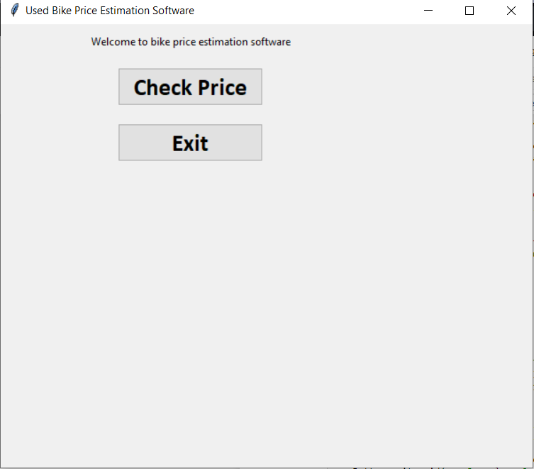

1. **Check Price:** It takes all the information from the user such as Enter Purchase Price, Select Brand, Year of Purchase, State and Kilometers driven for proper evaluation of Best Price.

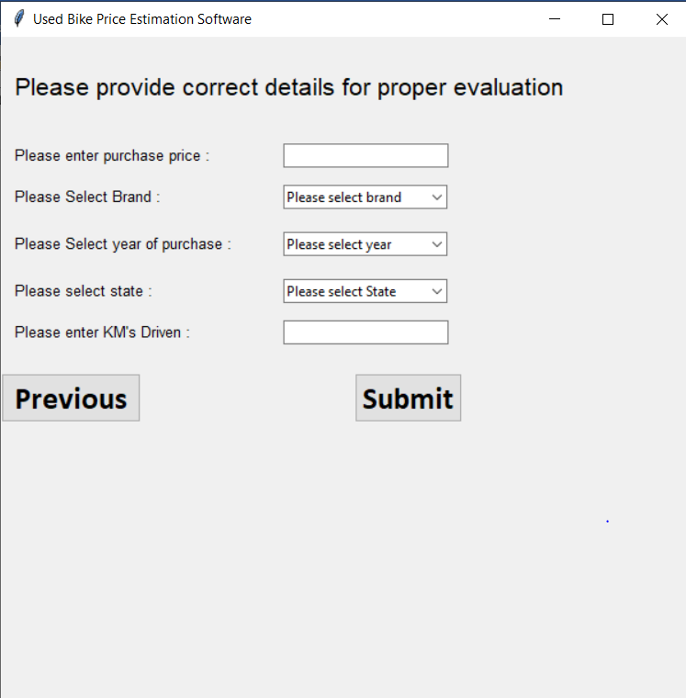

If the user enters or select the wrong input or detail then the software generate the prompt like *Wrong input and *Wong selection.

Because of this, the user will not be able to submit the details and have to change the details.

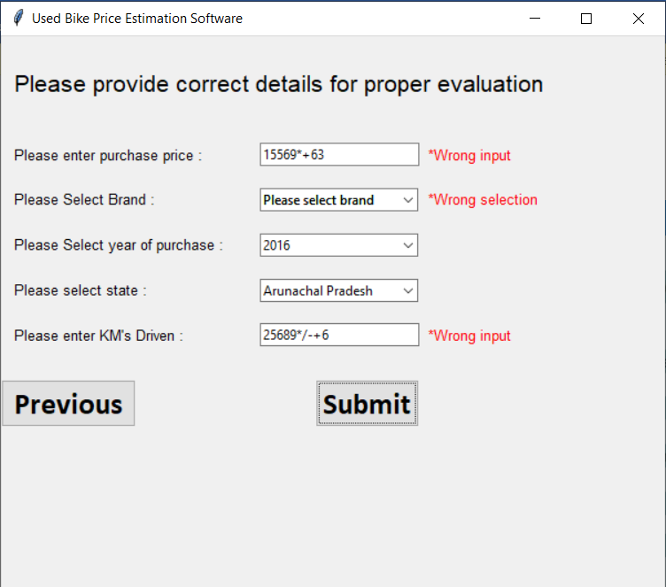.

This interface appears when the user inputs the correct details. In this the price estimation of bike is visible to the user. The user can choose the price according to the condition of the vehicle and if the user want to view price of the other vehicle so, they can click on previous button.

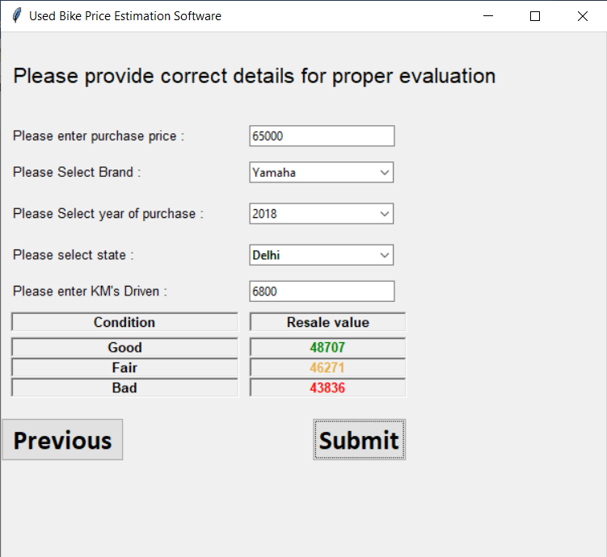

**Project Contribution**

* **Material and Methods:**

Technical stack used for our project includes:

* Frontend (GUI): Tkinter (Python library)
* Databases: MySQL – MySQL.connector
* **Results / Conclusion**

By this, we can conclude that thousands of people sell or purchase their bike on daily basis without knowing the actual price of the vehicle that they could get or give. People just sell or purchase bikes at the cost which third party decide. But now with the help of this software they can estimate the resale value of the bike and can bargain with the buyer so seller so that they can get the best price out of it.

**Discussion**

**Recommendations:** We can work more on improving GUI to make it more efficient, user friendly and interactive. We can also add more factors that will affect the resale price like mileage of bike, Engine CC, Type of engine and many other specifications of Bikes. If we will add bike models then it would be more better for user

**References**

* Geeks for Geeks
* Python Documentation
* Python.com
* https://orangebookvalue.com/used-bikes
* You Tube