E-Commerce Revenue Diagnostic & Operations Overview
Project Overview & Business Problem
This project evaluates retail sales, pricing efficiency, and fulfillment logistics across 5,000 retail transactions across four geographical regions. The primary business goal is to diagnose hidden margin leakage caused by steep promotional discounting, monitor logistics SLA performance, and identify customer value concentration to drive higher business profitability.
Dataset Architecture & Data Quality
- Volume: 5,000 complete customer purchase orders.
- Features: 12 raw columns tracking transactions, product categories, prices, discounts, delivery timelines, ratings, and payment channels.
- Data Hygiene: 0 null values and 0 duplicate rows detected across the entire transactional schema.
- Key Dimensions: Transaction dates, unique customer identifiers, regional sectors, unit quantities, and delivery lead times.
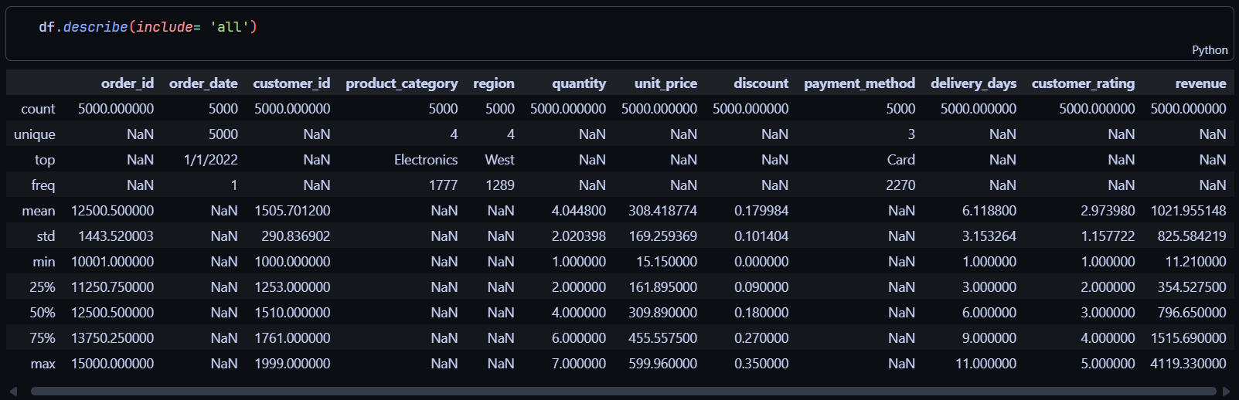
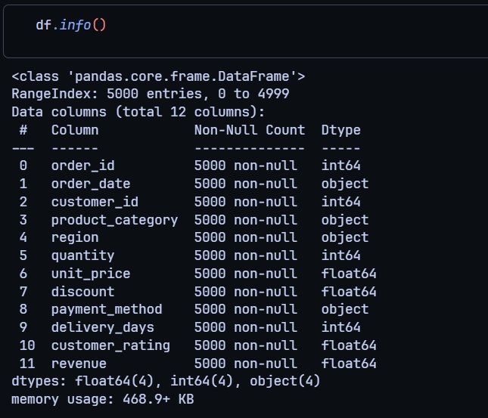
Data Engineering & Pipeline Automation
- Schema Validation & Cleaning: Parsed timestamps into proper datetime format and converted transaction and customer IDs to string keys in Python using Pandas.
- Feature Engineering: Calculated gross price (quantity * unit_price) and validated net discounted revenue against original unit values.
- Relational Database Ingestion: Automated table creation and direct database loading into a MySQL database instance via SQLAlchemy and PyMySQL.
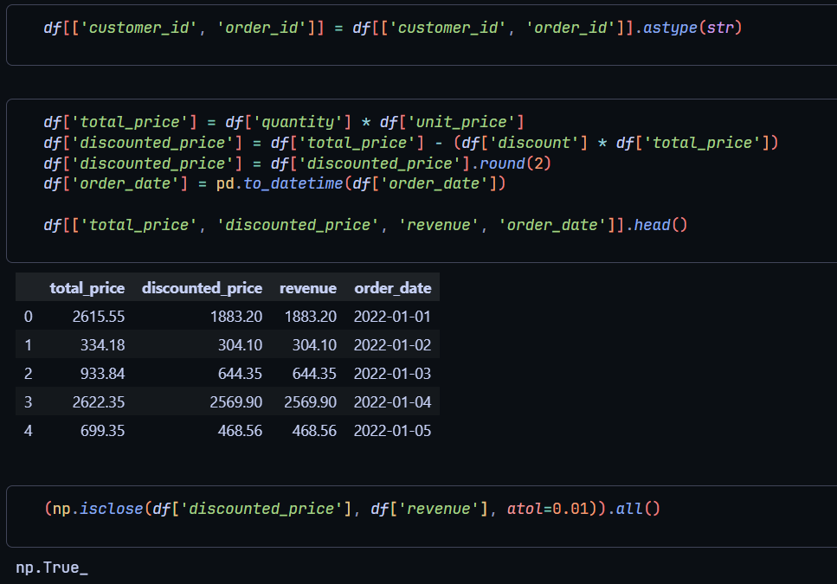
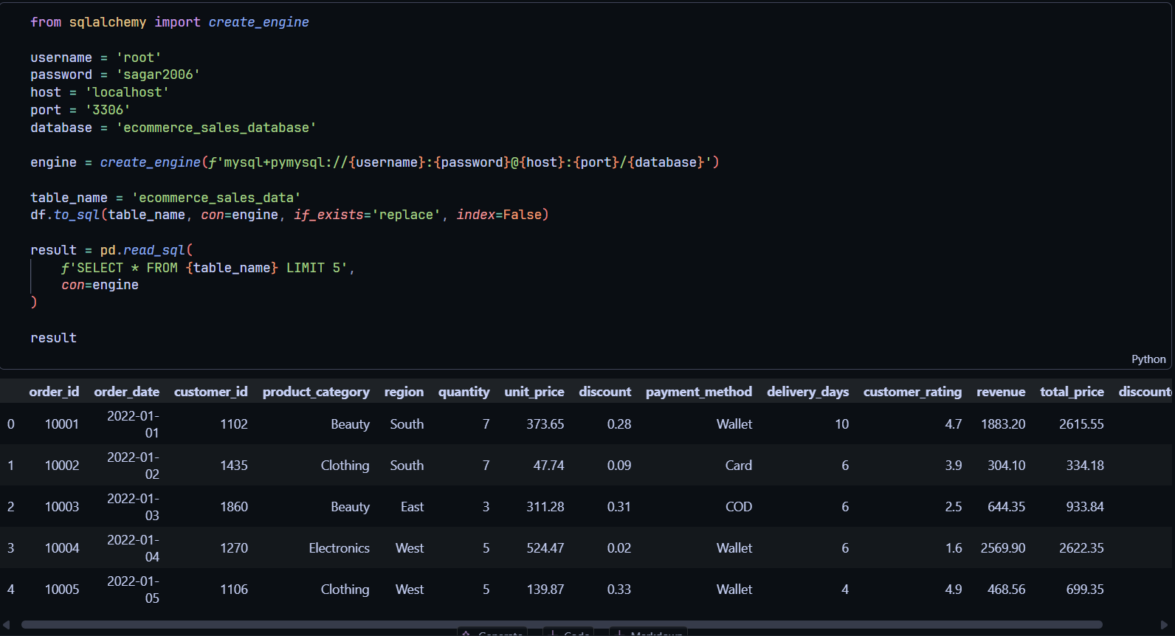
Diagnostic SQL Analytics: Discounting Inefficiency
- No Quantity Elasticity: Grouping transactions by promotional tiers reveals that order basket sizes remain completely flat at approximately 4.0 units per purchase across all discount levels.
- Severe Revenue Leakage: Average realized revenue drops from $1,175.15 on low discounts down to $853.74 on heavy discounts—a 27.3% decline in ticket value without driving additional sales volume.
- Customer Review Invariance: Customer satisfaction scores stay invariant between 2.94 and 3.03 stars, proving that deep discounts fail to lift customer sentiment.
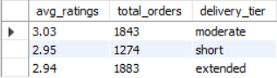
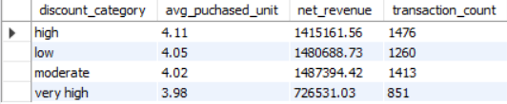
Operations, Fulfillment SLAs & Customer Value
- Critical Logistics Drift: 37.66% of all processed orders breach the standard 7-day fulfillment threshold, with lead times averaging 6.1 days company-wide.
- Silent Churn Risk: Shipping delays show virtually zero correlation with customer review ratings, showing that logistics dissatisfaction remains latent rather than visible in standard feedback scores.
- Revenue Concentration (Pareto Principle): SQL window ranking (NTILE(5)) demonstrates that the top 20% of buyers generate 37.4% of total net sales, highlighting high dependence on a core VIP customer segment.
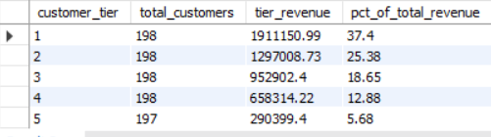
Executive Power BI Dashboard
- Interactive Single-Page Report: Directly connected Power BI to the MySQL warehouse to report on $5.11M in total net revenue, 5,000 orders, and a company-wide 2.97 average rating.
- Dynamic DAX Measures: Programmed operational measures including SLA Breach Rate, Total Net Revenue, and Revenue Lost to Discounts.
- Fulfillment & Commercial Views: Visualized category breakdowns (Electronics leading at 36%), payment methods (Cards leading at 46%), and side-by-side performance charts for delivery statuses and discount tiers.
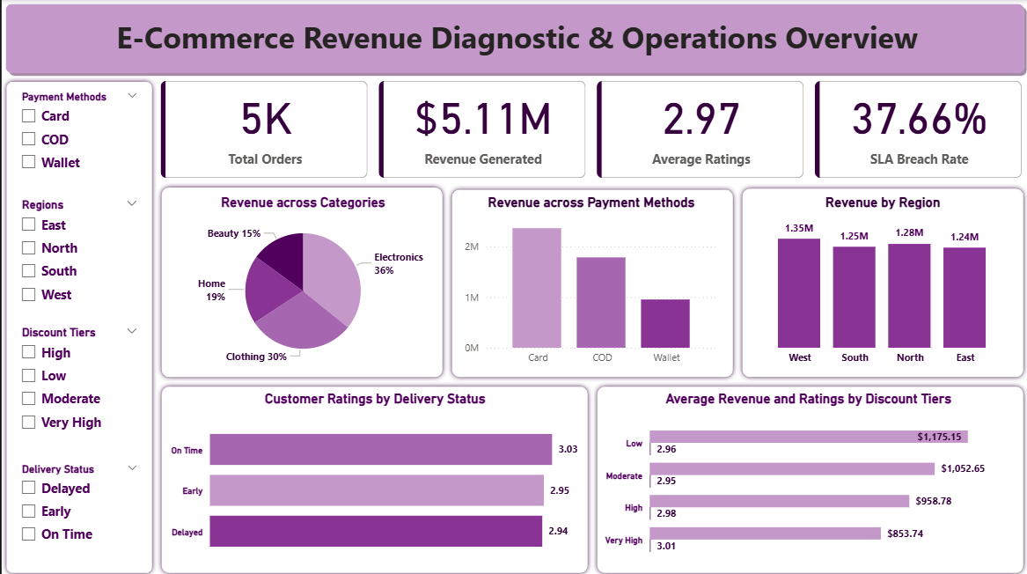
Strategic Action Plan & Business Impact
- Enforce a 15% Promotional Cap: Restrict non-targeted blanket promotions to protect transactional margins, as customers naturally purchase ~4 units without steep price cuts.
- Reallocate Capital to VIP Retention: Pivot budget away from broad discounts toward loyalty programs tailored to the top 20% revenue-generating customer segment.
- Logistics Route Remediation: Restructure supply chain routes to target the 37.7% late delivery breach rate and establish tighter delivery schedules.
- Track Behavioral Churn: Replace reliance on post-delivery review ratings with repeat purchase cycle tracking to monitor long-term retention risk accurately.

