1) Find the average ride distance for each vehicle type

i)copy vehical_type column and dusre jagah paste kar do

ii)clean the vehical_type column and select vehical_type column -> go to **Data** and click on **remove Duplicates ->press ok**

iii)make another column name **Avg. Distance** , write formula in one row, =AVERAGEIF(F:F, F2, Q:Q)

F:F ->column of **vehicle_type ,** F2 ->prime sedan cell , Q:Q->**Ride_Distance** column

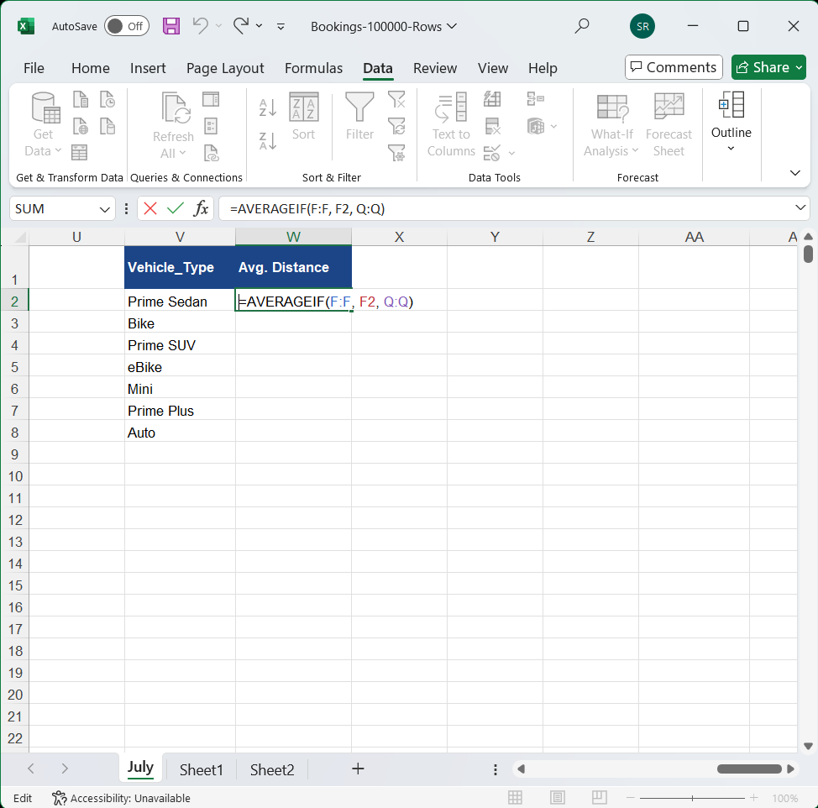

niche wala squre and ctrl press karke ,fir mujhe sabka average distance show ho jayega.

