**PIZZA SALES SQL QUERY**

1. **KPI’’s**

1. **Total Revenue:**

SELECT SUM(total_price) AS total_revenue FROM pizza_sales;

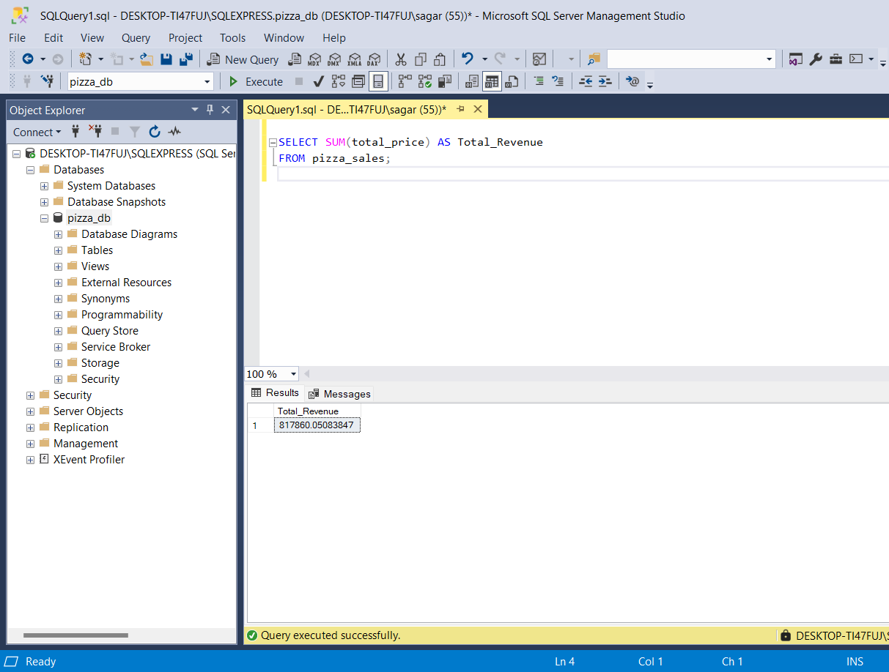

2) **Average Order Value**

SELECT SUM(total_price)/COUNT(DISTINCT order_id) AS Average_Order_Value from pizza_sales

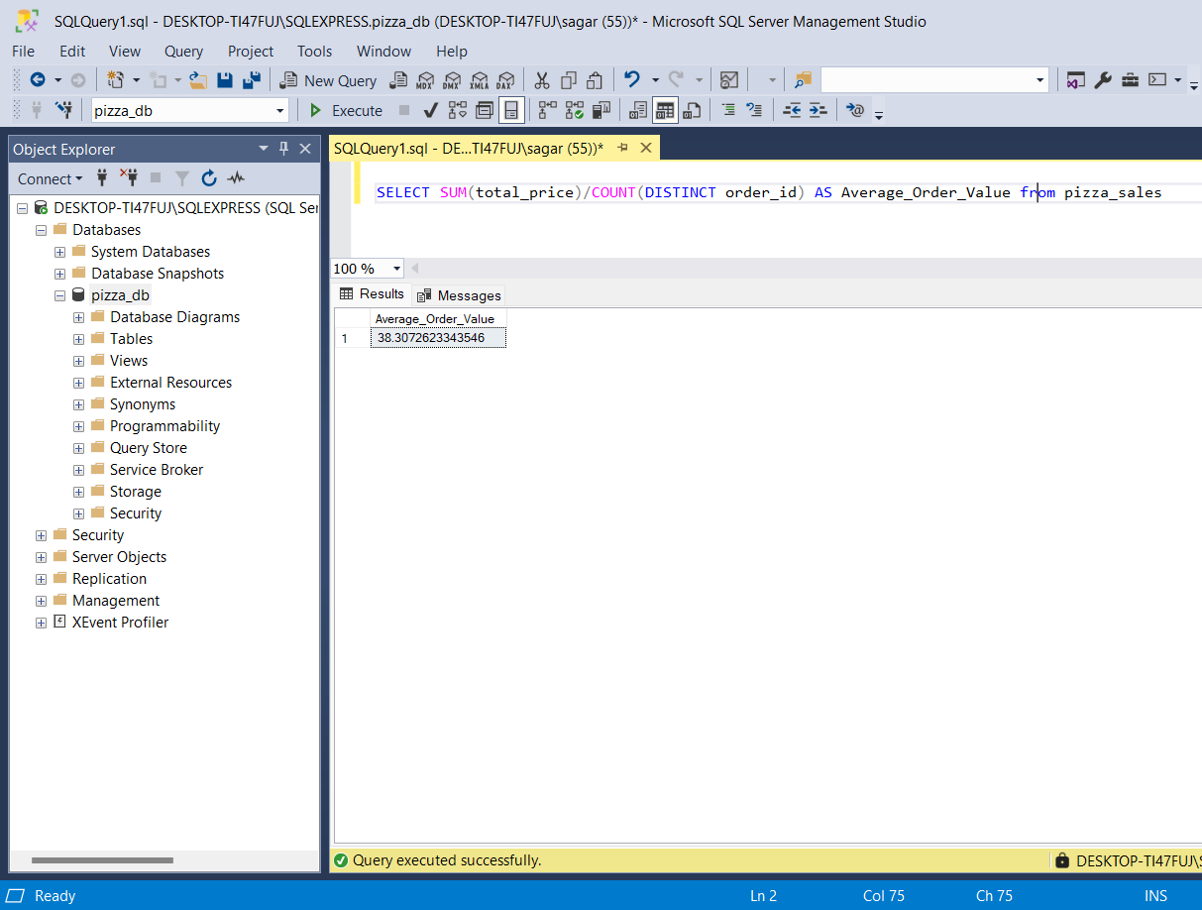

iii. **Total Pizzas Sold**

SELECT SUM(quantity) AS Total_pizza_sold from pizza_sales