**PIZZA SALES SQL QUERY**

1. **KPI’’s**

1. **Total Revenue:**

SELECT SUM(total_price) AS total_revenue FROM pizza_sales;

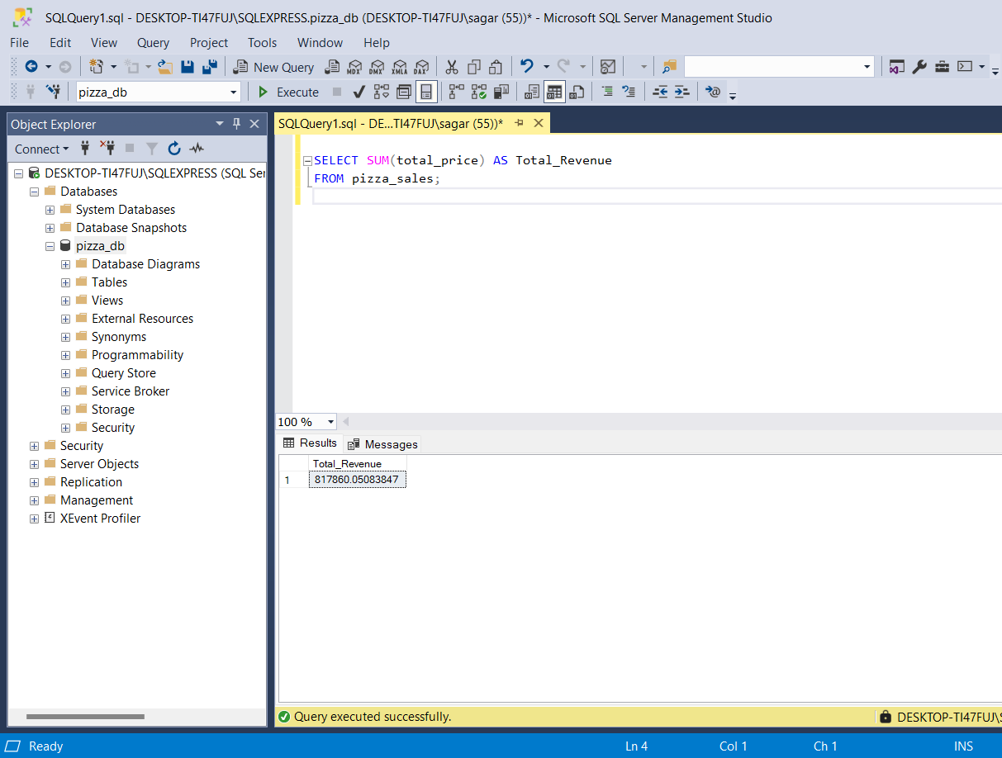

2) **Average Order Value**

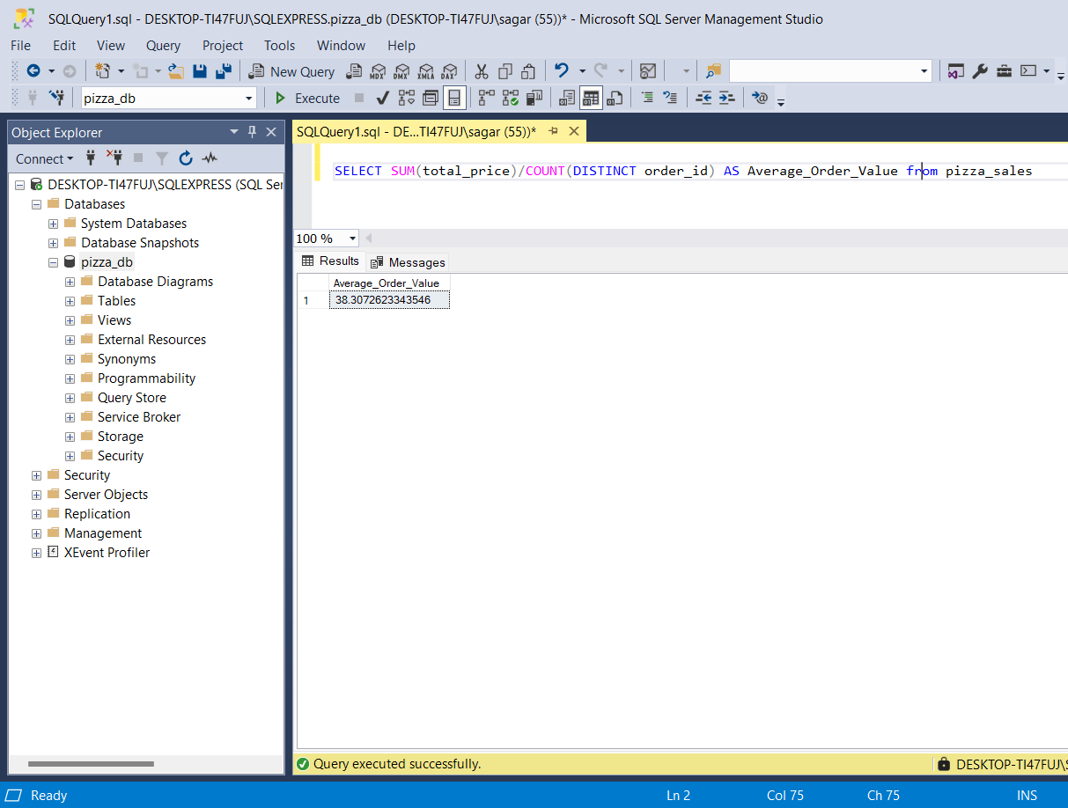

iii. **Total Pizzas Sold**

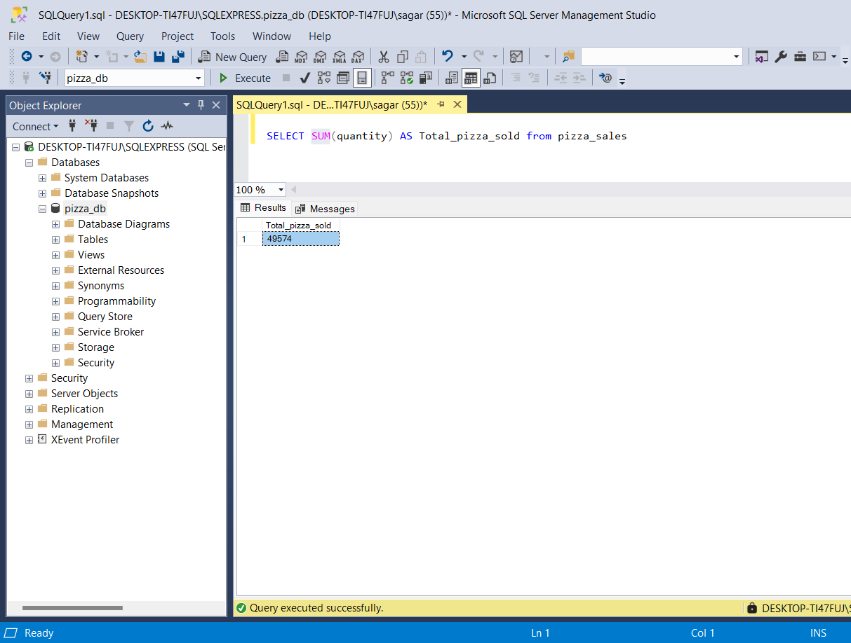

**iv. Total Orders**

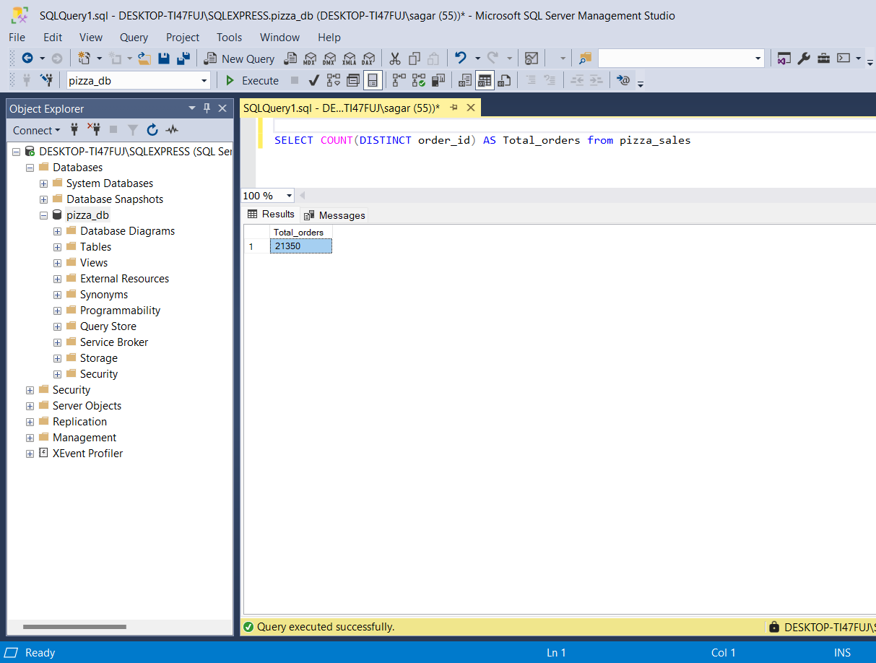

**v. Average Pizzas Per Order:**

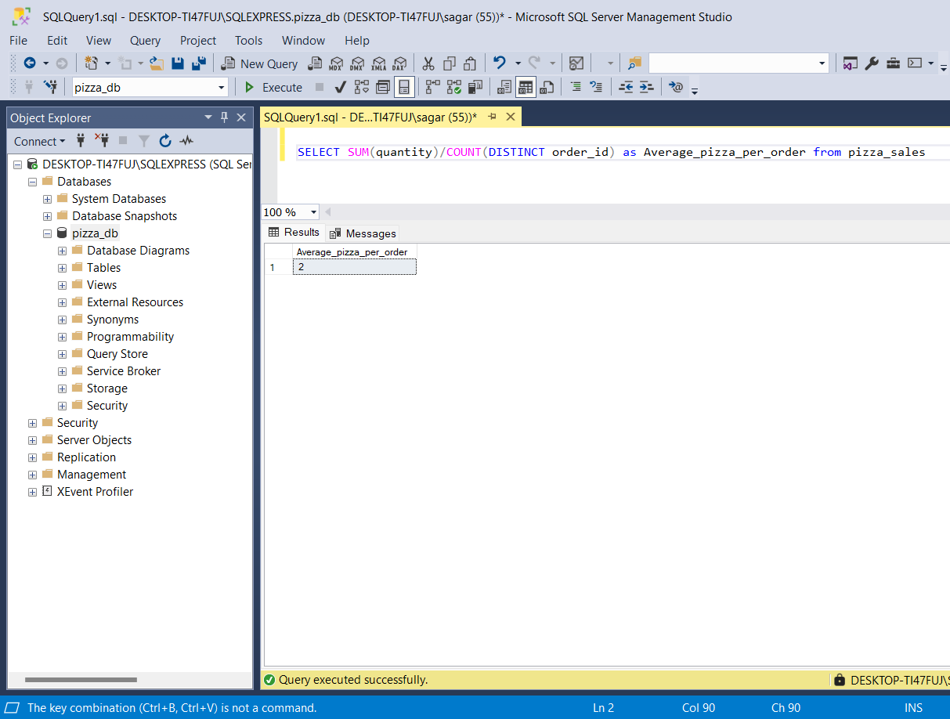

**CHARTS**

**i) Number of orders per day (Daily Trends)**

kis weekday pe sabse jyada order hota h. (i,e. peak day kon sa h)

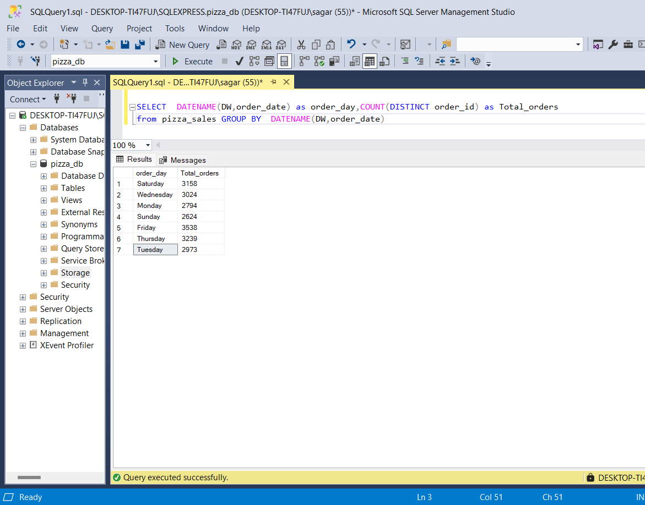

note: DW ->Weekday ka name return karega (e.g., Sunday, Monday)

order_date ->column name

DATENAME ek function hai jo kisi **date** ka specified **part ka name** return karta hai.(like month name, weekday name ..)

ii) **Number of orders per Hour (Daily Trends)**

Daily kis time pe sabse jyada order hota h. (i,e. peak hour kon sa h)

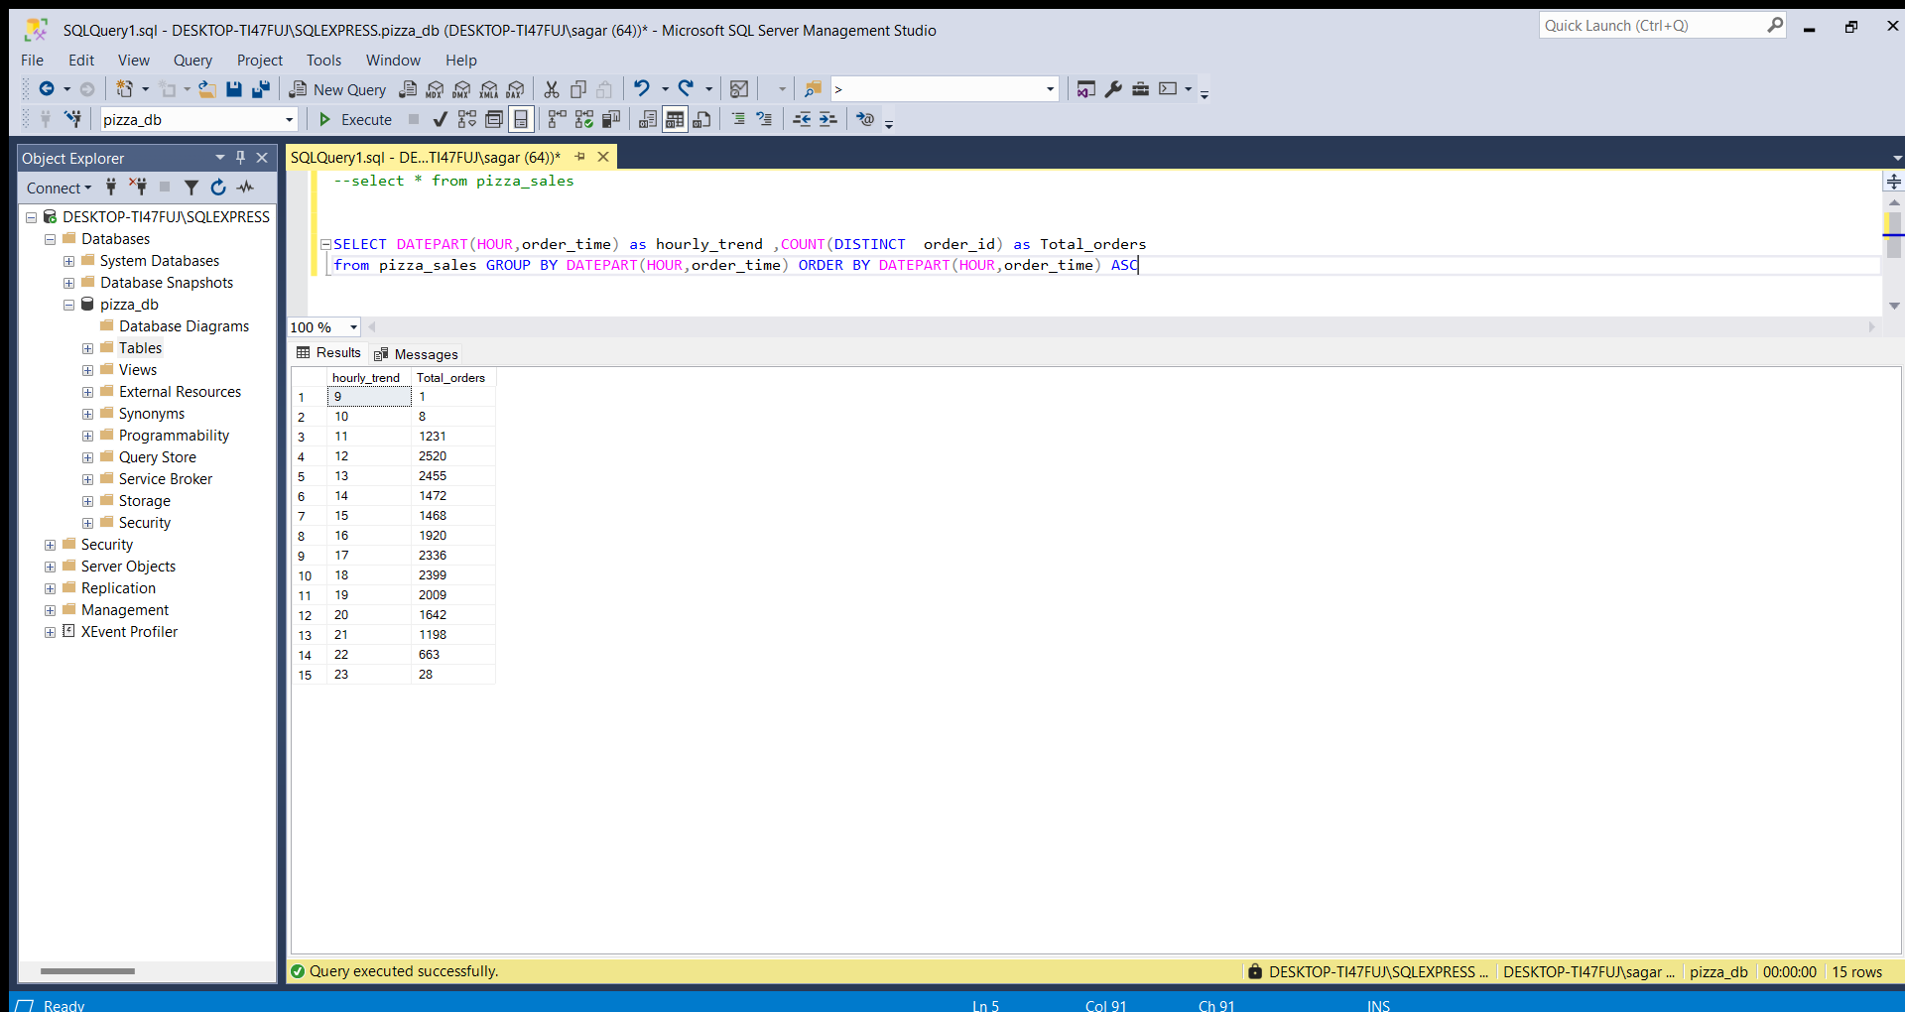

**iii)percentage of sales by pizza category (which pizza is sold maximum)**