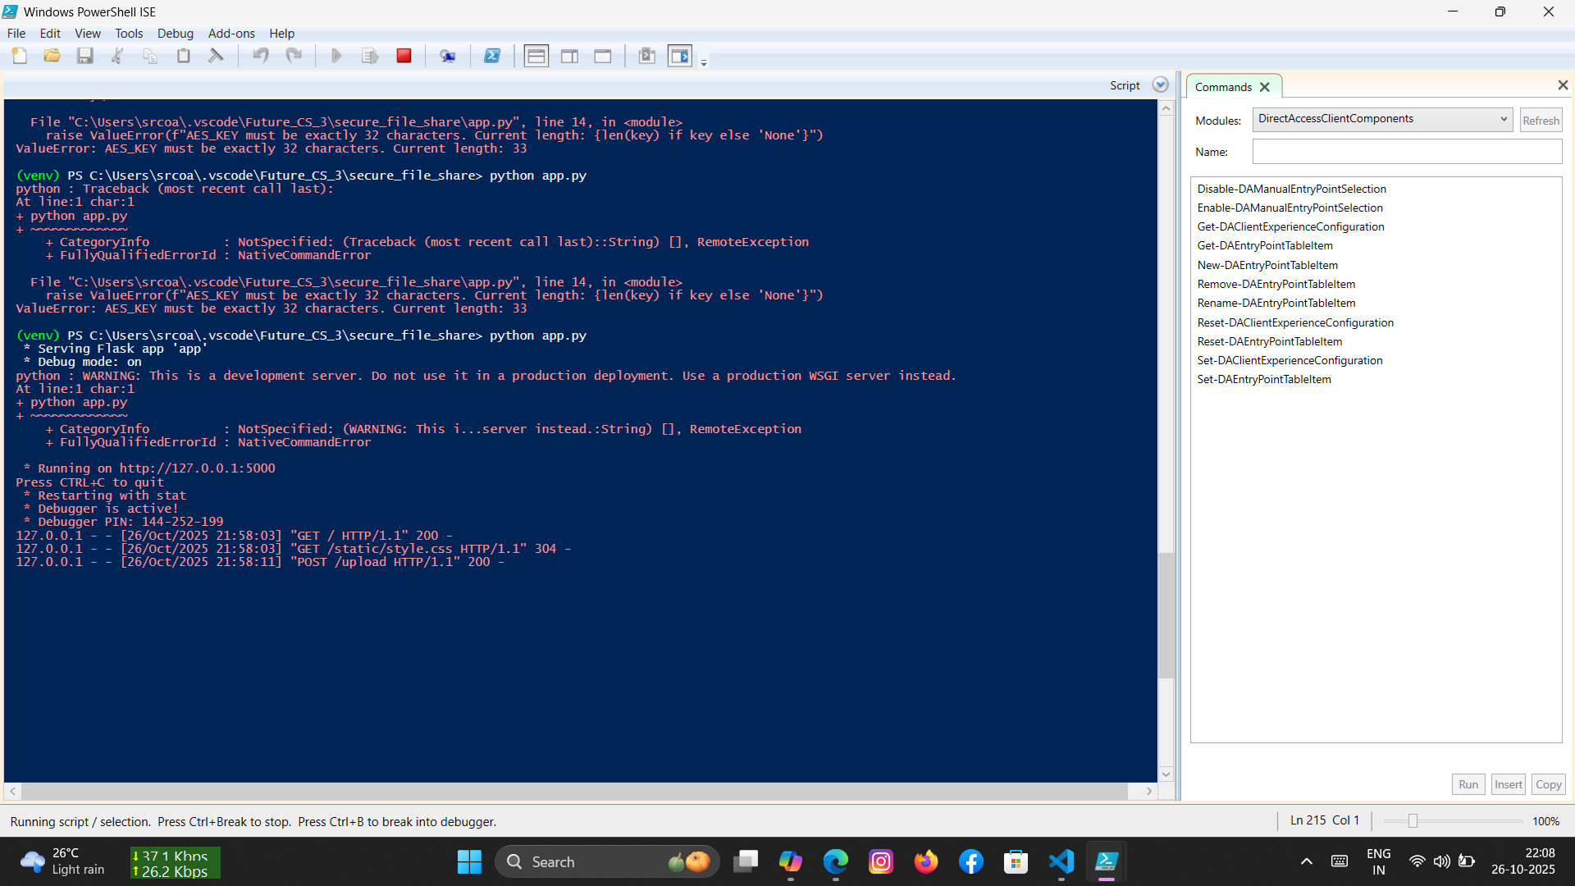

Screenshot 1: Setup .venv environment on PowerShell

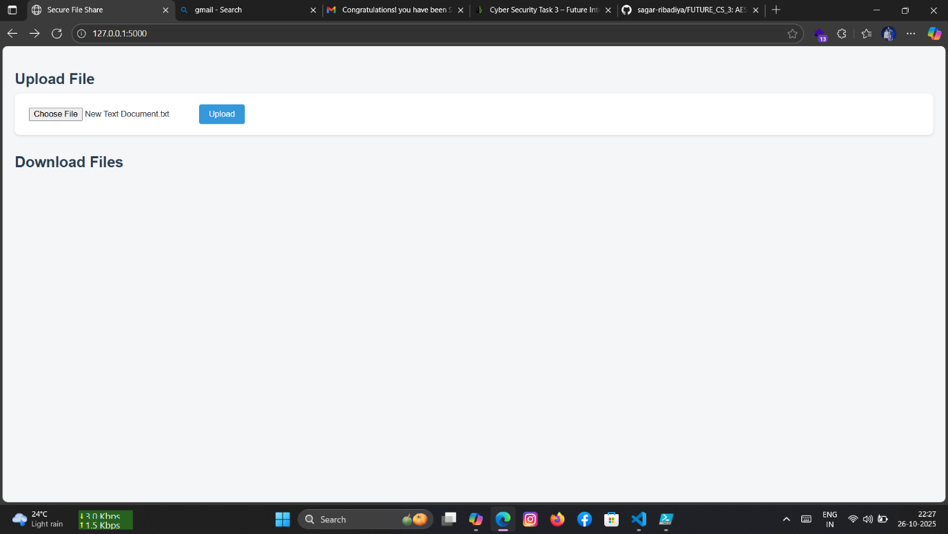

Screenshot 2: upload txt file which we have to encrypt

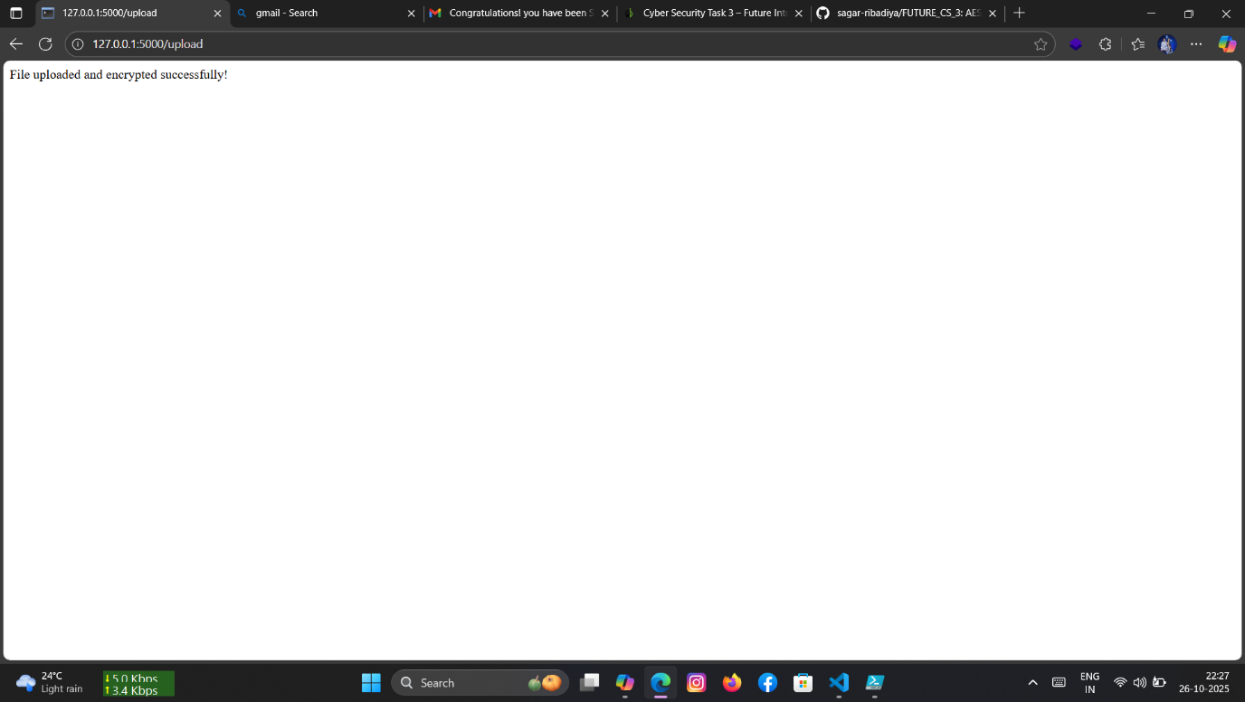

Screenshot 3: our file is successfully encrypt on browser

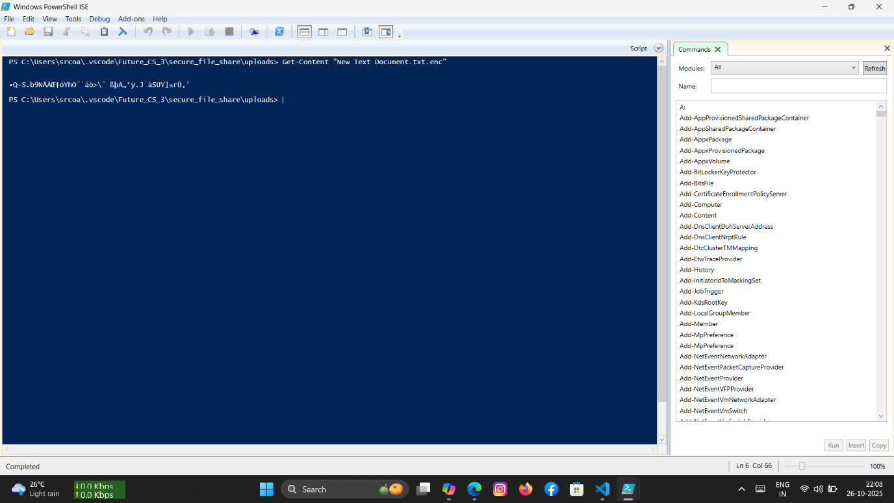

Screenshot 4: show encrypted file output on PowerShell

**Activity Report: Secure File Sharing App**

**Project Title**

Secure File Sharing System Using AES Encryption and Flask

**Objective**

To build a secure web-based file sharing system that encrypts uploaded files using AES-256 encryption and allows safe download through a simple Flask interface.

**Technologies Used**

• Flask (Web framework)

• PyCryptodome (AES encryption)

• Python-dotenv (Environment variable management)

• HTML/CSS (Frontend interface)

• Git & GitHub (Version control and deployment)

**Completed Tasks**

| Task | Description | Status |

|------|-------------|--------|

| Environment Setup | Created virtual environment and installed dependencies | Completed |

| Flask App Development | Built routes for upload, download, and file listing | Completed |

| AES Encryption Logic | Implemented AES-256 EAX mode for secure file encryption | Completed |

| Key Management | Stored encryption key securely in `. env` file | Completed |

| File Upload & Save | Uploaded files are encrypted and stored in `uploads/` folder | Completed |

| File Download & Decryption | Encrypted files are decrypted and served for download | Completed |

| Debugging & Testing | Resolved key length errors, verified encryption/decryption | Completed |

| GitHub Deployment | Pushed full project to GitHub with commit history | Completed |

**Folder Structure**

secure_file_share/

├app.py # Flask app

├utils.py # AES encryption functions

├. env # Stores AES key

├ uploads/ # Encrypted files

├ templates/

│ └ index.html # Upload & download UI

├ static/

│ └── style.css # Basic styling

**Key Features**

• AES-256 encryption using EAX mode for confidentiality + integrity

• Secure upload and download via browser

• Environment-based key management

• Simple UI with file listing