1. **Designers should be able to create new project**

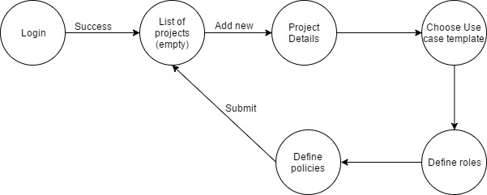

* The designer logs in to the application with correct credentials and is redirected to the list of projects page which is empty.
* The designer clicks on add new button. He then must fill the project details, choose a use case template, define roles and define policies.
* On clicking the submit button, the designer is redirected to the list of projects page where he can view his project added to the list.

1. **Designer should be able to view existing projects**

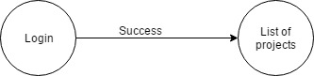

* The designer logs in to the application with correct credentials and is redirected to the list of projects page.
* Here the designer can view the projects created by him, ordered by the date of creation and the active ones are highlighted.

1. **Create new use case for existing projects**

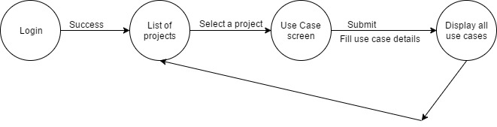

* The designer logs in to the application with correct credentials and is redirected to the list of projects page.
* Now the designer selects a project in which he wants to create a new use case. He is then redirected to a page where a use case details have to be filled based on the template previously selected.
* Once the details are submitted, the designer can see the use case added to the list of use cases under a project.

1. **Designer should be able to view all use cases for an existing project**

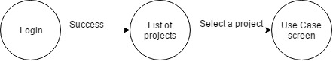

* The designer logs in to the application with correct credentials and is redirected to the list of projects page.
* Now the designer has to select a project and click on the view use cases button which will display all the use cases.
* The use cases are ordered by the date of creation and the active ones are highlighted.

1. **Non-designer should be able to view existing projects**



* The non-designer logs in to the application with correct credentials and is redirected to the list of projects page.
* Here the person can view the projects created by him, ordered by the date of creation and the active ones are highlighted.

1. **Non-designer should be able to view all use cases for an existing project**



* The non-designer logs in to the application with correct credentials and is redirected to the list of projects page.
* Now the person has to select a project and click on the view use cases button which will display all the use cases.
* The use cases are ordered by the date of creation and the active ones are highlighted.

1. **Edit Use Case for first time.**

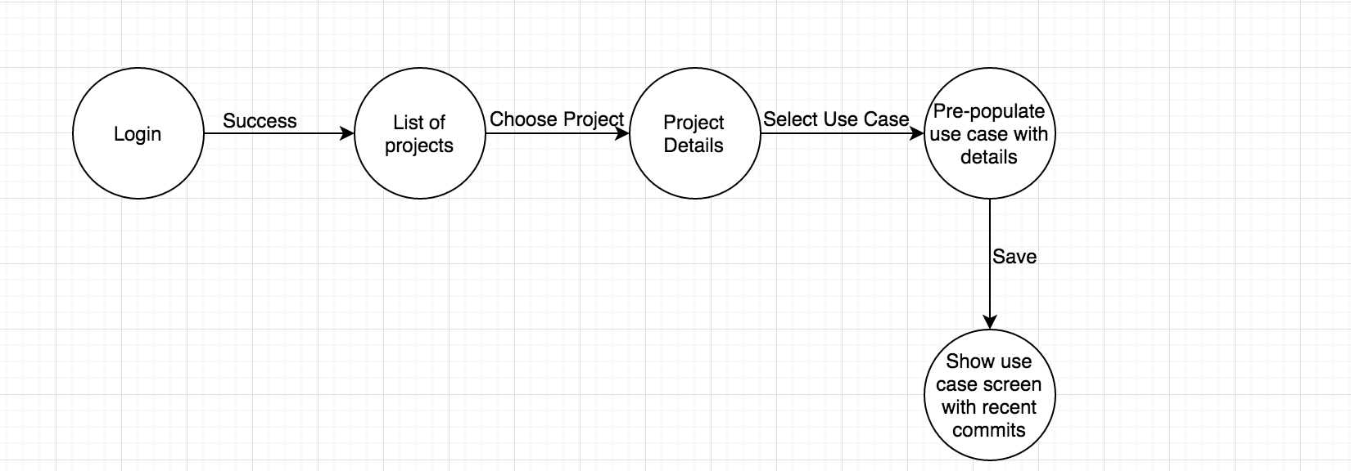

* A user logs in to the application with correct credentials and is redirected to the list of projects page.
* Now the person has to select a project and click on the view use cases button which will display all the use cases.
* Now the user selects the use case he wants to edit and a pre-populated use case is displayed. After making the necessary changes, the user clicks on save and the use case screen is displayed with all the recent commits.

1. **Users able to view recent commits for use case.**

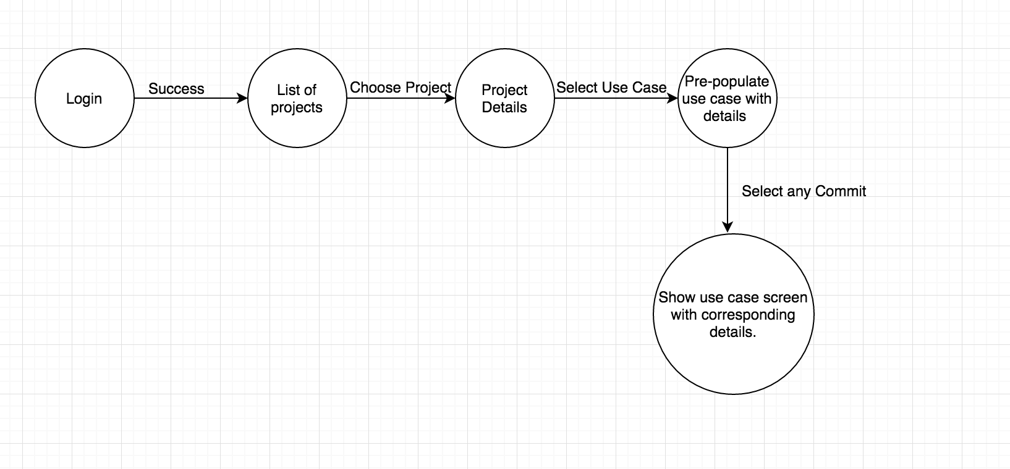

* The same flow as the previous case is followed here.

1. **Compare two Use case versions.**

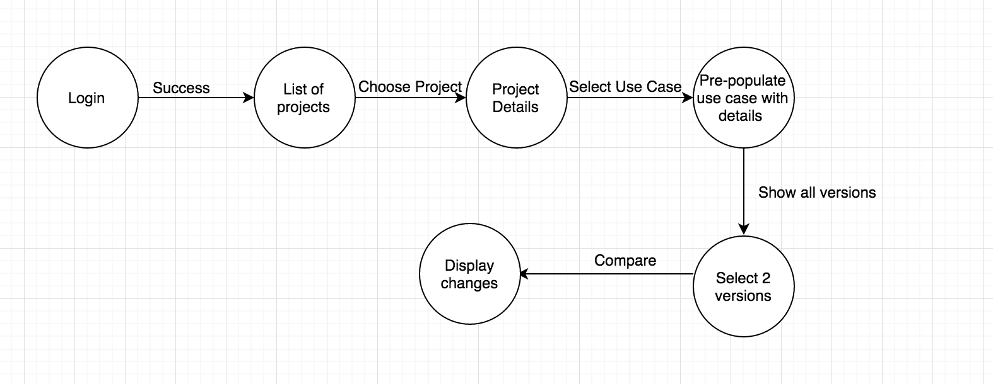

10. Designer can create a new Use Case Template.

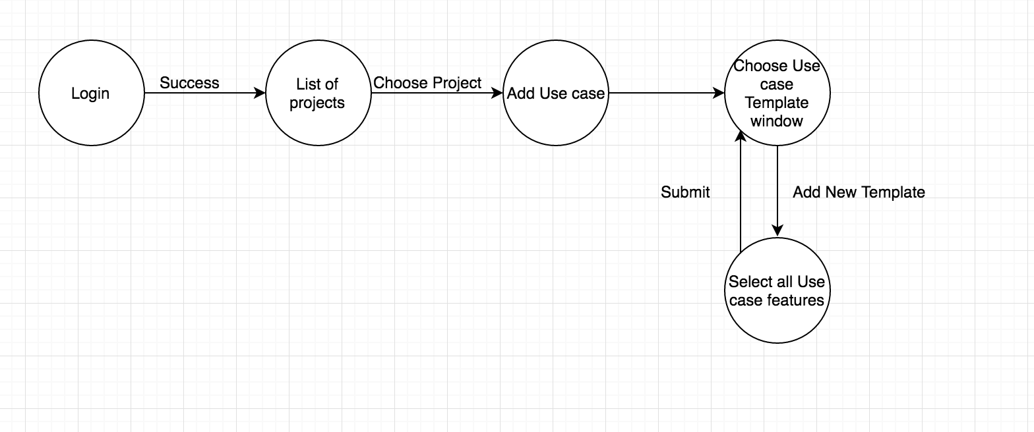

11.Designer creates customized policy.

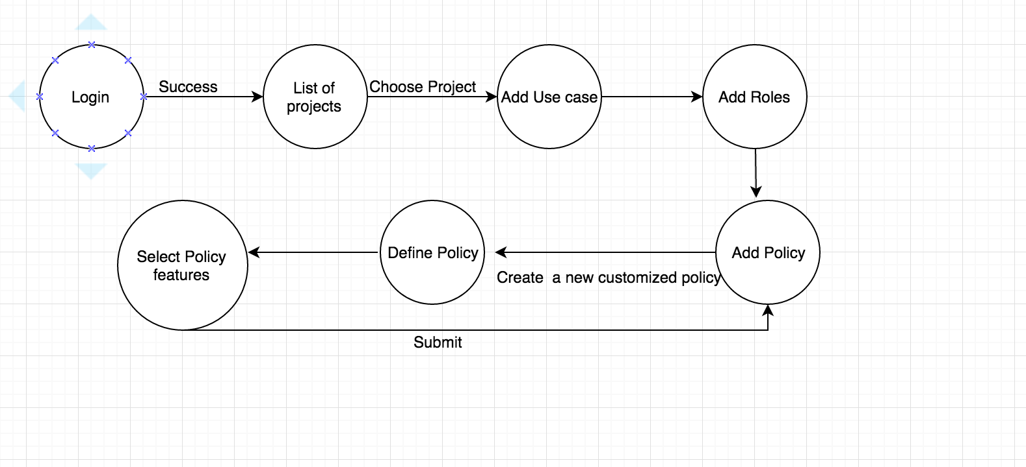

12.Designer should be able to close a use case.

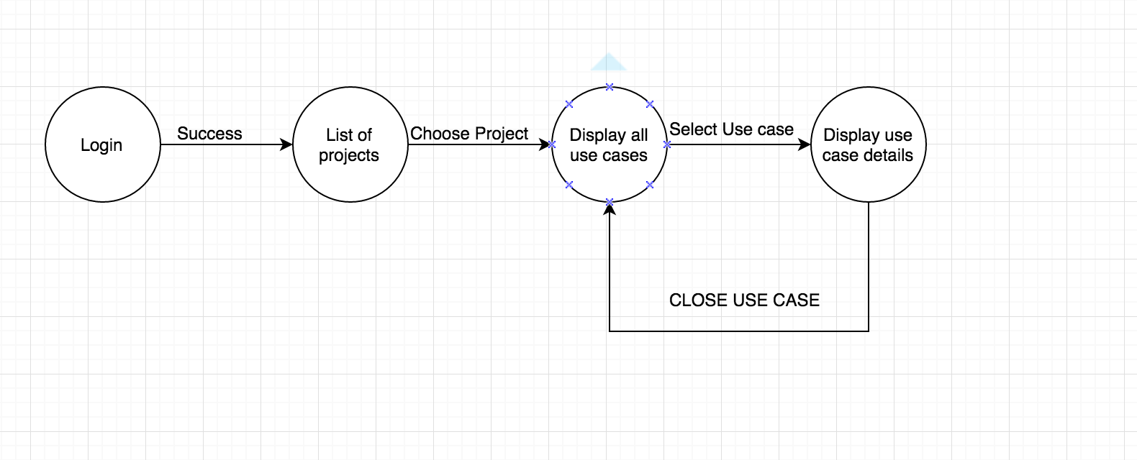

13.Designer should be able to close a Project.

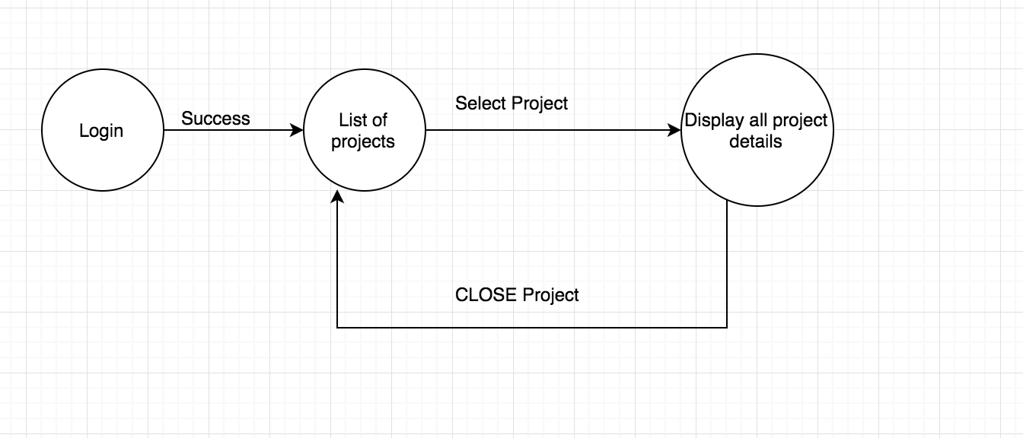

14.User should be able to login with his/her role.

