**Workflow for designer:** The below diagram shows the workflow for a designer while using the collaborative design tool.

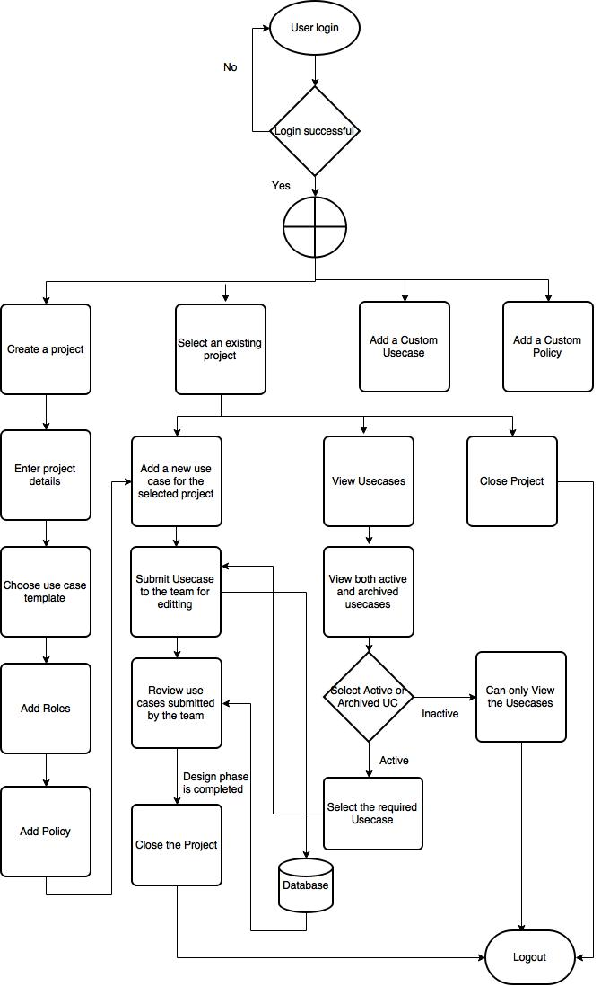

**Workflow for non-designers:** The diagram below shows the workflow for non-designers (development manager, solution manager, architect, QA) while using the collaborative design tool.