1. create database collaborative_design_tool;
2. create table collaborative_design_tool.user( email varchar(40), password varchar(16) not null, role varchar(20) not null, primary key (email));
3. insert into collaborative_design_tool.user values(“John_Doe@collabDesign.com”, “abcd1234”, “designer”);

insert into collaborative_design_tool.user values("Jack_Forth@collabDesign.com", "abcd1234", "development-manager");

insert into collaborative_design_tool.user values("Tim_Kevin@collabDesign.com", "abcd1234", "solution-manager");

insert into collaborative_design_tool.user values("Tom_Smith@collabDesign.com ", "abcd1234", "architect");

insert into collaborative_design_tool.user values("Adam_Johnson@collabDesign.com", "abcd1234", "qa");

insert into collaborative_design_tool.user values("Jones_Brown@collabDesign.com", "abcd1234", "development-manager ");

insert into collaborative_design_tool.user values("Jones_Brown@collabDesign.com", "abcd1234", "development-manager ");

insert into collaborative_design_tool.user values("Harris_Williams@collabDesign.com", "abcd1234", "architect");

insert into collaborative_design_tool.user values("Jenkins_Perry@collabDesign.com", "abcd1234", "solution-manager");

insert into collaborative_design_tool.user values("Taylor_Anderson@collabDesign.com", "abcd1234", "qa");

insert into collaborative_design_tool.user values("Scott_Hill@collabDesign.com", "abcd1234", "designer");

insert into collaborative_design_tool.user values("Ward_Washington@collabDesign.com", "abcd1234", "development-manager");

insert into collaborative_design_tool.user values("Tom_Mitchell@collabDesign.com", "abcd1234", "solution-manager");

insert into collaborative_design_tool.user values("Davis_Wilson@collabDesign.com", "abcd1234", "architect");

insert into collaborative_design_tool.user values("Robert_Peterson@collabDesign.com", "abcd1234", "qa");

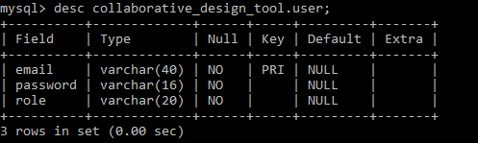

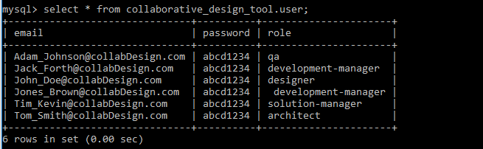

1. create table collaborative_design_tool.policy(name varchar(20), description varchar(100), primary key(name));
2. create table collaborative_design_tool.projects(name varchar(20), description varchar(40), created_by varchar(40) not null, use_case_template varchar(20) not null, policy_name varchar(20) not null, dev_mgr_duration int, soln_mgr_duration int, arch_duration int, qa_duration int, primary key (name), foreign key (created_by) references collaborative_design_tool.user(email), foreign key (policy_name) references collaborative_design_tool.policy(name));

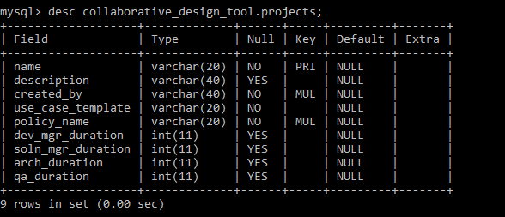

1. insert into collaborative_design_tool.policy values(“StartToFinish”, “This is a user defined policy”);

insert into collaborative_design_tool.policy values(“FinishToStart”, “The predecessor team has to finish before successor team starts”);

insert into collaborative_design_tool.policy values(“StartToStart”, “﻿﻿﻿﻿﻿All the teams can start working simultaneously”);

1. insert into collaborative_design_tool.projects values(“Wires”, “This is a wires project”, “John_Doe@collabDesign.com”, “template1”, “StartToFinish”, 7, 6, 5, 4);
2. create table collaborative_design_tool.assigned(name varchar(20) not null, assigned_to varchar(40) not null, foreign key(assigned_to) references collaborative_design_tool.user(email));
3. insert into collaborative_design_tool.assigned values(“Wires”, “Jack_Forth@collabDesign.com”);

insert into collaborative_design_tool.assigned values(“Wires”, “Tim_Kevin@collabDesign.com”);

insert into collaborative_design_tool.assigned values(“Wires”, “Tom_Smith@collabDesign.com”);

insert into collaborative_design_tool.assigned values(“Wires”, “Adam_Johnson@collabDesign.com”);

insert into collaborative_design_tool.assigned values(“Wires”, “Jones_Brown@collabDesign.com”);

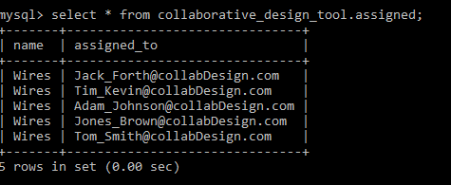

1. select name from collaborative_design_tool.projects where created_by= “Jones_Brown@collabDesign.com” union select name from collaborative_design_tool.assigned where assigned_to= “Jones_Brown@collabDesign.com”;
2. select p.name, description, created_by, use_case_template, policy_name, assigned_to, role from projects p, assigned a, user u where p.name=a.name and a.assigned_to=u.email and p.name in (select name from projects where created_by=? union select name from assigned where assigned_to=?);
3. select p.name, description, created_by, use_case_template, policy_name, assigned_to, role from collaborative_design_tool.projects p, collaborative_design_tool.assigned a, collaborative_design_tool.user u where p.name=a.name and a.assigned_to=u.email and p.name in (select name from collaborative_design_tool.projects where created_by=”Jones_Brown@collabDesign.com” union select name from collaborative_design_tool.assigned where assigned_to=”Jones_Brown@collabDesign.com”);

select p.name, description, created_by, use_case_template, policy_name, assigned_to, role from collaborative_design_tool.projects p, collaborative_design_tool.assigned a, collaborative_design_tool.user u where p.name=a.name and a.assigned_to=u.email and p.name in (select name from collaborative_design_tool.projects where created_by=”John_Doe@collabDesign.com” union select name from collaborative_design_tool.assigned where assigned_to=”John_Doe@collabDesign.com”);

1. select p.name, description, created_by, use_case_template, policy_name, assigned_to, role from collaborative_design_tool.projects p, collaborative_design_tool.assigned a, collaborative_design_tool.user u where p.name=a.name and a.assigned_to=u.email and p.name in (select name from collaborative_design_tool.projects where created_by=”John_Doe@collabDesign.com” union select name from collaborative_design_tool.assigned where assigned_to=”John_Doe@collabDesign.com”);