**LAB - 3**

1. Create a superclass Person with attributes name and age, and a method display(). Create a subclass Student that adds an attribute studentID. Write a program to create a Student object and display all its attributes.

Code:-

// Superclass Person

class Person {

// Attributes

String name;

int age;

// Constructor

public Person(String name, int age) {

this.name = name;

this.age = age;

}

// Method to display information

public void display() {

System.out.println("Name: " + name);

System.out.println("Age: " + age);

}

}

// Subclass Student inheriting from Person

class Student extends Person {

// Additional attribute

int studentID;

// Constructor

public Student(String name, int age, int studentID) {

super(name, age);

this.studentID = studentID;

}

// Method to display student information

public void displayStudentInfo() {

// Utilizing superclass's display method

super.display();

System.out.println("Student ID: " + studentID);

}

}

// Main class

public class Main {

public static void main(String[] args) {

// Creating a Student object

Student student1 = new Student("John Doe", 20, 123456);

// Displaying all attributes of the student

student1.displayStudentInfo();

}

}

Output:-

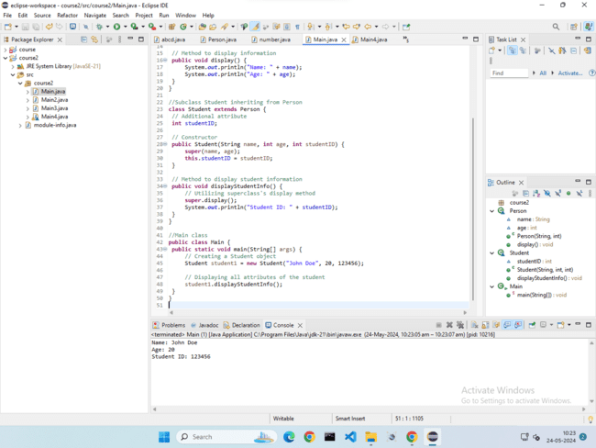

1. Create a superclass Calculator with a method add(int a, int b). Create a subclass AdvancedCalculator that overloads the add method to handle three integers.

Code:-

**package** course2;

//SuperClass Calculator

**class** Calculator {

**public** **int** add(**int** a , **int** b) {

**return** a+b;

}

}

//SubClass AdvancedCalculator

**class** AdvancedCalculator **extends** Calculator{

//Overloading the add method to handle three integers

**public** **int** add(**int** a, **int** b, **int** c) {

**return** a+b+c;

}

}

**public** **class** Main{

**public** **static** **void** main(String[] args) {

Calculator basicCalc = **new** Calculator();

AdvancedCalculator advCalc = **new** AdvancedCalculator();

//Using the add method of Calculator class

**int** sum1 = basicCalc.add(5, 3);

System.***out***.println("Sum using basic Calculator: "+sum1);

//Using the overloaded add method of AdvancedCalculator class

**int** sum2 = advCalc.add(5, 3, 2);

System.***out***.println("Sum using advanced calculator: "+sum2);

}

}

Output:-

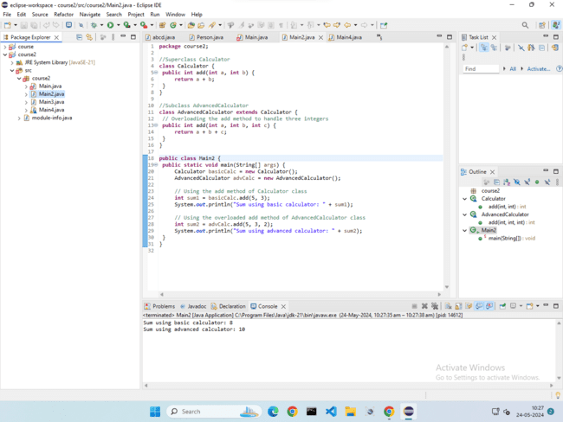

1. Create a superclass Vehicle with a method move(). Create subclasses Car and Bike that inherit from Vehicle. Write a program to create objects of Car and Bike and call the move() method on each.

Code:-

// Superclass Vehicle

class Vehicle {

// Method to move

public void move() {

System.out.println("Vehicle is moving.");

}

}

// Subclass Car inheriting from Vehicle

class Car extends Vehicle {

// Additional methods and attributes specific to Car can be added here

}

// Subclass Bike inheriting from Vehicle

class Bike extends Vehicle {

// Additional methods and attributes specific to Bike can be added here

}

// Main class

public class Main {

public static void main(String[] args) {

// Creating objects of Car and Bike

Car car = new Car();

Bike bike = new Bike();

// Calling the move() method on each object

car.move();

bike.move();

}

}

Output:-

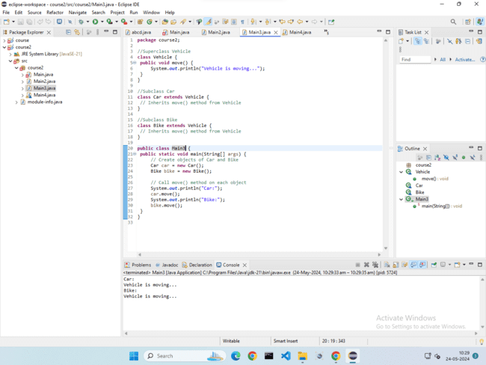

1. Create an class Employee with an abstract method calculatePay(). Create subclasses SalariedEmployee and HourlyEmployee that implement the calculatePay() method. Write a program to create objects of both subclasses and call the calculatePay() method.

Code:-

// Abstract superclass Employee

abstract class Employee {

// Abstract method calculatePay

public abstract double calculatePay();

}

// Subclass SalariedEmployee inheriting from Employee

class SalariedEmployee extends Employee {

private double salary;

// Constructor

public SalariedEmployee(double salary) {

this.salary = salary;

}

// Implementing calculatePay method for SalariedEmployee

@Override

public double calculatePay() {

// For simplicity, assume monthly salary

return salary;

}

}

// Subclass HourlyEmployee inheriting from Employee

class HourlyEmployee extends Employee {

private double hourlyRate;

private double hoursWorked;

// Constructor

public HourlyEmployee(double hourlyRate, double hoursWorked) {

this.hourlyRate = hourlyRate;

this.hoursWorked = hoursWorked;

}

// Implementing calculatePay method for HourlyEmployee

@Override

public double calculatePay() {

// For simplicity, assume no overtime calculation

return hourlyRate * hoursWorked;

}

}

// Main class

public class Main {

public static void main(String[] args) {

// Creating objects of both subclasses

SalariedEmployee salariedEmp = new SalariedEmployee(5000);

HourlyEmployee hourlyEmp = new HourlyEmployee(15, 40);

// Calling calculatePay method on each object

System.out.println("Salaried Employee Pay: $" + salariedEmp.calculatePay());

System.out.println("Hourly Employee Pay: $" + hourlyEmp.calculatePay());

}

}

Output:-

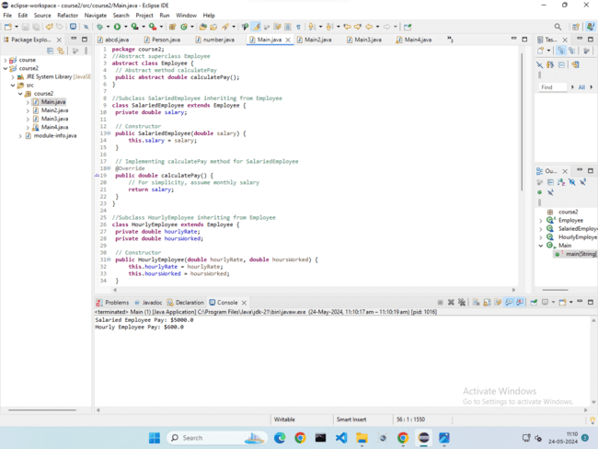

1. Create an class Document with an method void open(). Implement subclasses WordDocument, PDFDocument, and SpreadsheetDocument that extend Document and provide implementations for open(). Write a main class to demonstrate opening different types of documents.(implement complile time- polymorphism).

Code:-

// Superclass Document

class Document {

// Method to open document

public void open() {

System.out.println("Opening a generic document.");

}

}

// Subclass WordDocument inheriting from Document

class WordDocument extends Document {

// Implementing open method for WordDocument

@Override

public void open() {

System.out.println("Opening a Word document.");

}

}

// Subclass PDFDocument inheriting from Document

class PDFDocument extends Document {

// Implementing open method for PDFDocument

@Override

public void open() {

System.out.println("Opening a PDF document.");

}

}

// Subclass SpreadsheetDocument inheriting from Document

class SpreadsheetDocument extends Document {

// Implementing open method for SpreadsheetDocument

@Override

public void open() {

System.out.println("Opening a Spreadsheet document.");

}

}

// Main class

public class Main {

public static void main(String[] args) {

// Demonstrating compile-time polymorphism

Document doc1 = new WordDocument();

Document doc2 = new PDFDocument();

Document doc3 = new SpreadsheetDocument();

// Opening different types of documents

doc1.open();

doc2.open();

doc3.open();

}

}

Output:-

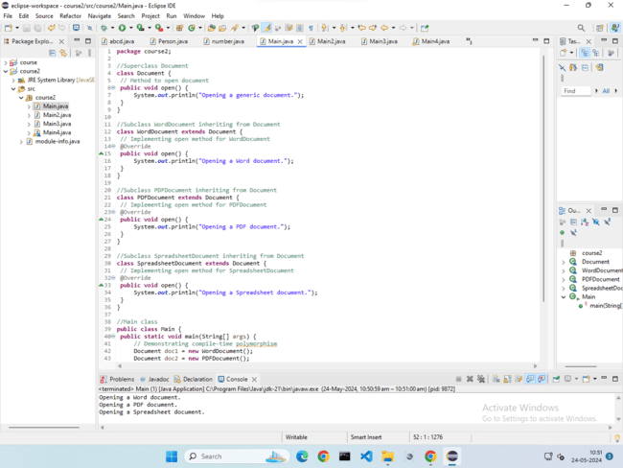

1. Create a class Calculator with overloaded methods add() that take different numbers and types of parameters: int add(int a, int b),double add(double a, double b) ,int add(int a, int b, int c) Write a main class to demonstrate the usage of these methods.

Code:-

**package** course2;

**import** java.util.*;

**class** Calculator {

// Method to add two integers

**public** **int** add(**int** a, **int** b) {

**return** a + b;

}

// Method to add two doubles

**public** **double** add(**double** a, **double** b) {

**return** a + b;

}

// Method to add three integers

**public** **int** add(**int** a, **int** b, **int** c) {

**return** a + b + c;

}

}

**public** **class** Main {

**public** **static** **void** main(String[] args) {

Scanner sc = **new** Scanner(System.***in***);

System.***out***.println("Enter three integers: ");

**int** a = sc.nextInt();

**int** b = sc.nextInt();

**int** e = sc.nextInt();

System.***out***.println("Enter two decimal integers: ");

**double** c = sc.nextDouble();

**double** d = sc.nextDouble();

Calculator calculator = **new** Calculator();

// Using the overloaded methods

**int** sum1 = calculator.add(a, b);

**double** sum2 = calculator.add(c, d);

**int** sum3 = calculator.add(a, b, e);

// Displaying the results

System.***out***.println("Sum of integers (1st + 2nd): " + sum1);

System.***out***.println("Sum of doubles (1st + 2nd): " + sum2);

System.***out***.println("Sum of three integers (1st + 2nd + 3rd): " + sum3);

}

}

Output:-

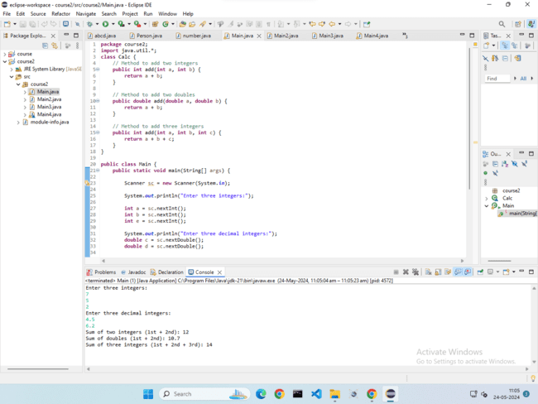

1. Create a [JavaBean](https://aln.anudip.org/mod/resource/view.php?id=12692) class Person with properties firstName, lastName, age, and email. Implement the required no-argument constructor, getter and setter methods for each property. Write a main class to create an instance of Person, set its properties, and print them out.

Code:-

// JavaBean class Person

public class Person {

// Properties

private String firstName;

private String lastName;

private int age;

private String email;

// No-argument constructor

public Person() {

// Default constructor

}

// Getter and Setter methods for firstName

public String getFirstName() {

return firstName;

}

public void setFirstName(String firstName) {

this.firstName = firstName;

}

// Getter and Setter methods for lastName

public String getLastName() {

return lastName;

}

public void setLastName(String lastName) {

this.lastName = lastName;

}

// Getter and Setter methods for age

public int getAge() {

return age;

}

public void setAge(int age) {

this.age = age;

}

// Getter and Setter methods for email

public String getEmail() {

return email;

}

public void setEmail(String email) {

this.email = email;

}

}

// Main class to demonstrate usage

public class Main {

public static void main(String[] args) {

// Creating an instance of Person

Person person = new Person();

// Setting properties

person.setFirstName("John");

person.setLastName("Doe");

person.setAge(30);

person.setEmail("john.doe@example.com");

// Printing out properties

System.out.println("First Name: " + person.getFirstName());

System.out.println("Last Name: " + person.getLastName());

System.out.println("Age: " + person.getAge());

System.out.println("Email: " + person.getEmail());

}

}

Output:-

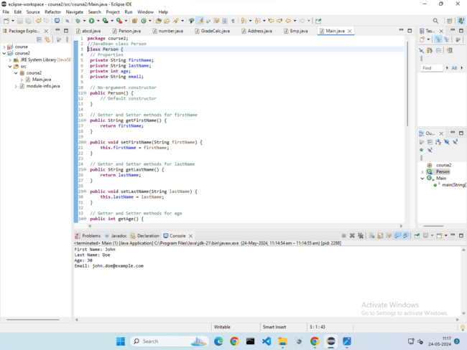

1. Create a [JavaBean](https://aln.anudip.org/mod/resource/view.php?id=12692) class Car with properties make, model, year, and color. Implement the required no-argument constructor, getter and setter methods for each property. Write a main class to create an instance of Car, set its properties, and print the car details.

Code:-

// JavaBean class Car

public class Car {

// Properties

private String make;

private String model;

private int year;

private String color;

// No-argument constructor

public Car() {

// Default constructor

}

// Getter and Setter methods for make

public String getMake() {

return make;

}

public void setMake(String make) {

this.make = make;

}

// Getter and Setter methods for model

public String getModel() {

return model;

}

public void setModel(String model) {

this.model = model;

}

// Getter and Setter methods for year

public int getYear() {

return year;

}

public void setYear(int year) {

this.year = year;

}

// Getter and Setter methods for color

public String getColor() {

return color;

}

public void setColor(String color) {

this.color = color;

}

}

// Main class to demonstrate usage

public class Main {

public static void main(String[] args) {

// Creating an instance of Car

Car car = new Car();

// Setting properties

car.setMake("Toyota");

car.setModel("Camry");

car.setYear(2020);

car.setColor("Silver");

// Printing out car details

System.out.println("Make: " + car.getMake());

System.out.println("Model: " + car.getModel());

System.out.println("Year: " + car.getYear());

System.out.println("Color: " + car.getColor());

}

}

Output:-

