URBAN | INTEGRATED MUNICIPAL ERP | PRODUCT
Technical Architecture
High-level and low-level design for the build team, all four phases
Hake Technologies | Version 0.1 draft | October 2026 | Based on product SRS v0.35 | Reference deployment: GWMC, Telangana

Contents

If page numbers are missing, right-click the contents and choose Update Field.

Document control
Item | Detail
Document | Urban Integrated Municipal ERP: Technical Architecture (HLD and LLD)
Version | 0.1 draft for the build team, 22 October 2026
Prepared by | Hake Technologies
Inputs | Urban ERP product SRS v0.35 (19 modules, 432 module requirements, PLT-FR-001 to 036, NFR-001 to 024, interfaces I-01 to I-43, external systems E-01 to E-60); Solution Architecture v0.1; GWMC Deployment SRS v0.28
Audience | Solution and technical architects, module tech leads, developers, DevOps and SRE, security, QA
Status of choices | Technology choices are recommendations recorded as decisions (section 4). Changes go through the decision log, and this document is then updated

1. Introduction
This document turns the Urban product SRS into a buildable technical architecture. Part A (high-level design) covers the context, containers, services, data, integration, security, platform services, deployment and engineering practices. Part B (low-level design) defines the conventions every team follows and the platform services. It then has one chapter per rollout phase, separated by section breaks, giving each module its service design, data model, APIs, events, state model, jobs, configuration and adapters.
The SRS remains the source of the requirements. Process IDs (for example PTX-P05), requirement IDs and interface IDs (I-xx) are used throughout, so every design element can be traced back to it.

Scope of the build
- One product release serving any ULB in any state: product core, state packs, ULB configuration (single- or multi-tenant)
- 19 domain services, about 14 platform services, channels (citizen portal and app, staff console, offline field app, WhatsApp, IVRS, chatbot) and an adapter hub for 60 external systems
- Deployment on premises, in a State Data Centre or in MeitY-empanelled cloud from the same containers and Helm charts, including an offline installer
- Phased rollout as in the SRS: Phase 1 (1, 2, 3, 4, 9), Phase 2 (5, 6, 11, 13, 18), Phase 3 (7, 10, 12, 14, 17), Phase 4 (8, 15, 16, 19)

2. Architecture drivers

Quality attributes from the SRS
Driver | Target (SRS) | Architectural consequence
Performance (NFR-001) | Screens and search within 3 s at the 95th percentile | Read models and caching, search index, paginated APIs, async heavy work
Peak capacity (NFR-002) | 5,000 citizens and 1,000 staff concurrently (GWMC) | Stateless services scaled horizontally; queue-backed payment and demand runs
Integration (NFR-003) | Events within 1 minute, at least once, idempotent consumers | Kafka with transactional outbox, inbox de-duplication, dead-letter topics
Availability and recovery (NFR-004, 005) | 99.5% monthly; RPO 15 min, RTO 4 h | HA pairs for data, 3-node Kafka and Kubernetes control plane, async DR replica
Security (NFR-006, 019 to 024) | TLS 1.2+, AES-256, ASVS L2 (L3 for identity, payments, signing, admin), MFA for all staff, CERT-In | Central identity, step-up OTP, HSM, SIEM, secure SDLC with scans in CI
Privacy (NFR-008) | DPDP Act 2023, Aadhaar masking | Aadhaar Data Vault, consent records, purpose tags on personal data
Portability (NFR-011, 013) | India hosting; no proprietary cloud services | Open-source components on any Kubernetes; S3-compatible storage abstraction
Multi-tenancy (NFR-014, PLT-FR-020) | No cross-tenant reads | tenant_id on every row with PostgreSQL row-level security; per-tenant keys
Upgrades and onboarding (NFR-016, 017) | Zero-downtime minor upgrades; tenant live in 1 day | Backward-compatible migrations, versioned APIs and events, tenant bootstrap tooling
Languages (PLT-FR-021, 025) | English and 22 Indian languages | i18n bundles, Unicode end to end, Bhashini adapter, RTL support
Offline field work (PLT-FR-013) | Field app works without network | Local SQLite store, sync protocol with conflict rules

Constraints
- Data stays in India (State Data Centre or MeitY-empanelled cloud); ICT logs kept 180 days in India (CERT-In)
- Open-source, licence-safe components only; no lock-in to a cloud provider's proprietary services
- Integrate-or-full per module: state systems such as CDMA, TG-bPASS and the state fire service may stay as the system of record
- Aadhaar numbers only in the Aadhaar Data Vault; OTP SMS through TRAI DLT-registered templates

3. Architecture principles
- One product, configured not forked: state and ULB differences sit in state packs, rules (DMN) and configuration with effective dates
- Service per module, modular inside: each module is one deployable service with its own schema. It is split further only when load or team size requires it
- Own your data: a service writes only its own schema. Other services read through its API or react to its events. No cross-schema joins
- Events for facts, APIs for questions: state changes are published as events; lookups (ULPIN, dues, availability) are synchronous APIs
- ULPIN as the spine: every property-related record carries ULPIN and ward; spatial data in PostGIS with EPSG:4326 storage
- Secure by default: zero-trust between services (mTLS), least privilege, step-up OTP for money and master changes, audit everything
- Idempotent and replayable: every command carries an idempotency key and every consumer de-duplicates
- Observable: OpenTelemetry traces, metrics and logs with tenant and module labels from day one
- Accessible and multilingual: GIGW 3.0 / WCAG 2.1 AA, Unicode and translation keys, never hard-coded text

4. Key architecture decisions
Each decision gets a full ADR in the repository (docs/adr). The summary below is the baseline for Phase 1.
ADR | Decision | Rationale | Alternatives considered
ADR-001 | One deployable service per module (19) plus platform services | Matches SRS modules and teams; manageable operations | Fine-grained microservices; single monolith
ADR-002 | Node.js 22 LTS with TypeScript and NestJS for domain services | SRS stack; one language across teams; strong typing | Java Spring Boot, Go
ADR-003 | PostgreSQL 16 with PostGIS, schema per service, row-level security for tenancy | Spatial plus relational; open source; RLS isolation | Database per tenant
ADR-004 | Apache Kafka (KRaft) as event bus, CloudEvents JSON, Apicurio schema registry | Durable replayable log; ordering by key (ULPIN) | RabbitMQ, NATS
ADR-005 | Transactional outbox and inbox for every event producer and consumer | Exactly-once effect over at-least-once delivery | Dual writes
ADR-006 | Flowable (BPMN and DMN) as workflow and rules engine | Apache 2.0 licence; BPMN for workflows, DMN for fees and taxes | Camunda 7 CE (end of life), custom engine
ADR-007 | Keycloak for identity with custom OTP, step-up and CAPTCHA extensions | OIDC standard; MFA, passkeys, brokering to Meri Pehchaan | Custom identity service
ADR-008 | Apache APISIX as API gateway | Apache 2.0; rate limits, JWT, mTLS plug-ins | Kong OSS, NGINX
ADR-009 | S3-compatible object storage abstraction (Ceph RGW on premises; provider S3 in cloud) | Portability; licence-safe | MinIO (AGPL)
ADR-010 | OpenSearch for full-text, document content and cross-module search | Indic analysers, highlights, open source | PostgreSQL full-text only
ADR-011 | Valkey for cache, sessions, rate counters and OTP state | BSD licence fork of Redis | Redis (licence change)
ADR-012 | GeoServer for OGC services, vector tiles via PostGIS, CesiumJS 3D Tiles for 3D | Standards; mature | MapServer
ADR-013 | React + TypeScript web, Flutter for citizen and field apps | SRS stack; offline-first field app | Native apps
ADR-014 | Kubernetes (RKE2 or managed) with Helm and Argo CD (GitOps) | Same release everywhere; offline installer | VM deployment
ADR-015 | OpenBao (or HSM-backed KMS) for secrets; network HSM for signing and the Aadhaar vault | Licence-safe; FIPS 140-2 L3 for the vault | HashiCorp Vault (BSL)
ADR-016 | Warehouse on PostgreSQL (ClickHouse for the large tier) with Apache Superset | Cross-module MIS refreshed daily or faster | Proprietary BI

5. System context
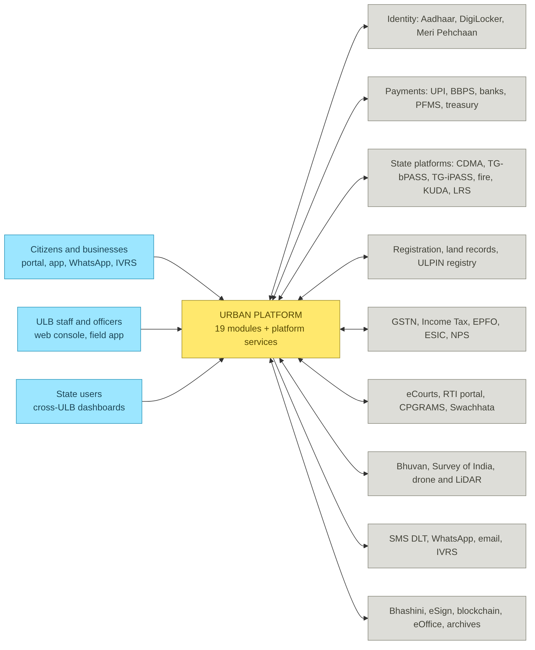
Figure 1. System context: actors and external system groups

External system groups
Group | External systems (SRS IDs) | Integration style
Identity and documents | E-01, E-02, E-35, E-36, E-37 | Adapter in the integration hub; REST/SOAP/SFTP per provider; retries, circuit breaker, audit
Payments and finance | E-03, E-04, E-08, E-26, E-27, E-28, E-57, E-58, E-59 | Adapter in the integration hub; REST/SOAP/SFTP per provider; retries, circuit breaker, audit
State platforms and authorities | E-05, E-06, E-07, E-18, E-31, E-40, E-42 to E-53 | Adapter in the integration hub; REST/SOAP/SFTP per provider; retries, circuit breaker, audit
Land, registration and GIS | E-11, E-16, E-17 | Adapter in the integration hub; REST/SOAP/SFTP per provider; retries, circuit breaker, audit
Utilities and IoT | E-13, E-14, E-15, E-19, E-20, E-49 | Adapter in the integration hub; REST/SOAP/SFTP per provider; retries, circuit breaker, audit
Citizen channels and grievance | E-12, E-21 to E-25 | Adapter in the integration hub; REST/SOAP/SFTP per provider; retries, circuit breaker, audit
Courts and legal | E-09 | Adapter in the integration hub; REST/SOAP/SFTP per provider; retries, circuit breaker, audit
Language and trust | E-38, E-39 | Adapter in the integration hub; REST/SOAP/SFTP per provider; retries, circuit breaker, audit
Business, schemes and others | E-10, E-29, E-30, E-32, E-33, E-34, E-41, E-54 to E-56, E-60 | Adapter in the integration hub; REST/SOAP/SFTP per provider; retries, circuit breaker, audit

6. Container view
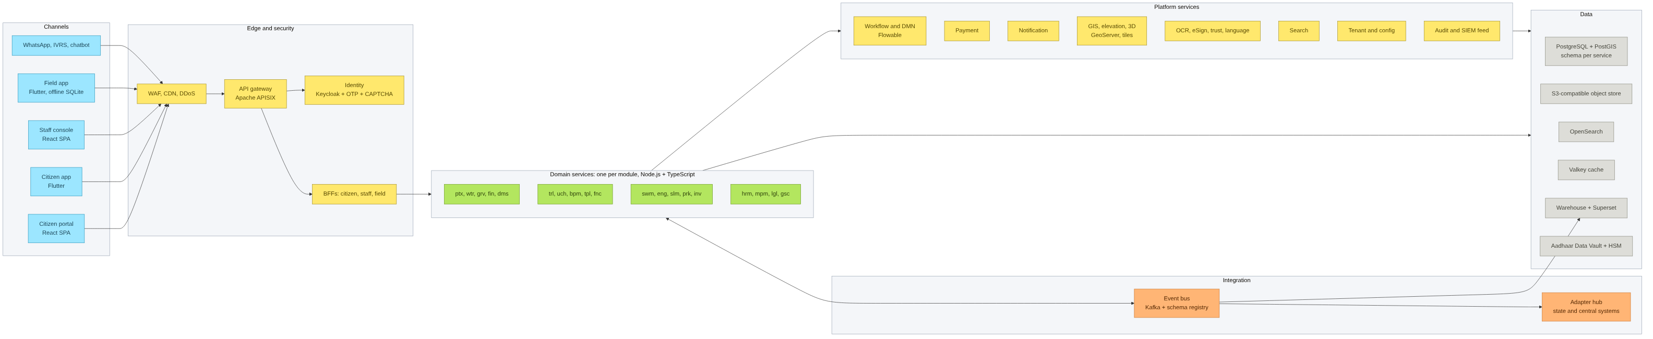
Figure 2. Containers: channels, edge, domain services, platform services, integration and data

Container | Technology | Responsibility
Citizen portal and app | React SPA / Flutter | Public services, payments, applications, citizen account (e.g. MyGWMC); white-labelled per ULB
Staff console | React SPA | All module work queues, maps, dashboards, configuration console
Field app | Flutter + SQLite | Offline tasks for inspections, surveys, readings, scans, attendance; plug-in per module
WAF and CDN | ModSecurity CRS / provider WAF | OWASP filtering, bot rules, DDoS protection, static assets
API gateway | Apache APISIX | Routing, JWT validation, rate limits, request size limits, mTLS to services
Identity | Keycloak + extensions | Citizen OTP login, staff MFA, passkeys, step-up, CAPTCHA, Meri Pehchaan brokering
BFFs | NestJS | Channel-shaped APIs that aggregate several services; no business rules
Domain services (19) | NestJS, PostgreSQL schema each | Module logic, own data, publish and consume events
Workflow and rules | Flowable | BPMN processes with SLA timers, delegation from HR org; DMN tables for fees, taxes, eligibility
Platform services | NestJS / Python workers | Payment, notification, GIS, document pipeline, search, tenant and config, audit
Event bus | Kafka + Apicurio | Domain events, CDC from outbox, dead-letter topics
Adapter hub | NestJS adapters | State and central systems behind stable internal contracts
Data stores | PostgreSQL/PostGIS, object store, OpenSearch, Valkey, warehouse | Operational, document, search, cache and analytics data

7. Service decomposition
Domain services map one-to-one to SRS modules. Interfaces are counted as provided and consumed from the SRS interface catalogue.
Service | Module | Schema | Phase | Processes | Requirements | Interfaces out / in
ptx-service | 1 Property Tax & Revenue Management | ptx | P1 | 33 | 38 | 7 / 12
wtr-service | 2 Water, Sewerage & Utility Billing | wtr | P1 | 32 | 35 | 7 / 13
grv-service | 3 Citizen Service Desk, Grievance & RTI | grv | P1 | 30 | 30 | 4 / 4
fin-service | 4 Finance & Accounting | fin | P1 | 30 | 30 | 3 / 10
dms-service | 9 Document Management System | dms | P1 | 30 | 31 | 2 / 4
trl-service | 5 Trade Licence Management | trl | P2 | 26 | 26 | 5 / 8
uch-service | 6 User Charges Management | uch | P2 | 23 | 22 | 5 / 10
bpm-service | 11 Building Permission Management / Integration | bpm | P2 | 22 | 25 | 9 / 8
tpl-service | 13 Town Planning | tpl | P2 | 23 | 24 | 8 / 6
fnc-service | 18 Fire NOC Management | fnc | P2 | 17 | 18 | 5 / 9
swm-service | 7 Solid Waste Management | swm | P3 | 17 | 19 | 6 / 10
eng-service | 10 Engineering Project Management System | eng | P3 | 20 | 21 | 7 / 5
slm-service | 12 Street Light Management | slm | P3 | 12 | 13 | 5 / 6
prk-service | 14 Parks & Horticulture Management | prk | P3 | 18 | 18 | 4 / 5
inv-service | 17 Inventory & Stores Management | inv | P3 | 17 | 17 | 3 / 3
hrm-service | 8 Payroll & HR Management | hrm | P4 | 19 | 19 | 5 / 2
mpm-service | 15 Municipal Property Management | mpm | P4 | 15 | 15 | 6 / 9
lgl-service | 16 Legal Case Management | lgl | P4 | 17 | 17 | 4 / 3
gsc-service | 19 Government Schemes Management | gsc | P4 | 14 | 14 | 5 / 3

Platform services
Service | SRS requirements | Notes
identity (Keycloak) | PLT-FR-001, 026, 028 to 032 | Realms per tenant or shared realm with tenant claim
otp-service | PLT-FR-029, 030 | OTP issue and verify, DLT templates, fallback channels
captcha-service | PLT-FR-031 | Self-hosted, risk-based, multilingual, accessible
workflow (Flowable) | PLT-FR-003, 004 | BPMN and DMN, task lists, SLA timers
tenant-config-service | PLT-FR-015 to 018, 022 | Tenants, boundaries, state packs, module enablement, branding
payment-service | PLT-FR-008 | Intents, gateway and UPI, BBPS biller, reconciliation
notification-service | PLT-FR-007 | SMS, WhatsApp, email, push, IVRS templates in many languages
gis-service | PLT-FR-005, 036 | Layers, geocoding, spatial analysis, elevation and 3D
document pipeline (in dms-service) | PLT-FR-006, 025, 027 | Virus scan, OCR, translation, signing, anchoring
search-service | PLT-FR-014 | Cross-module index with access filtering
audit-service | PLT-FR-012, 035 | Immutable audit log, SIEM feed
field-sync-service | PLT-FR-013 | Offline sync for the field app
reporting (warehouse) | PLT-FR-011 | ELT from events, Superset dashboards
adapter-hub | PLT-FR-019 | External system adapters

8. Data architecture
The ULPIN hierarchy is the spine of the data model. Property Tax owns parcels, buildings, units and segments; other modules hold references (ULPIN, unit number) and read through the ptx API or the owner-change events.
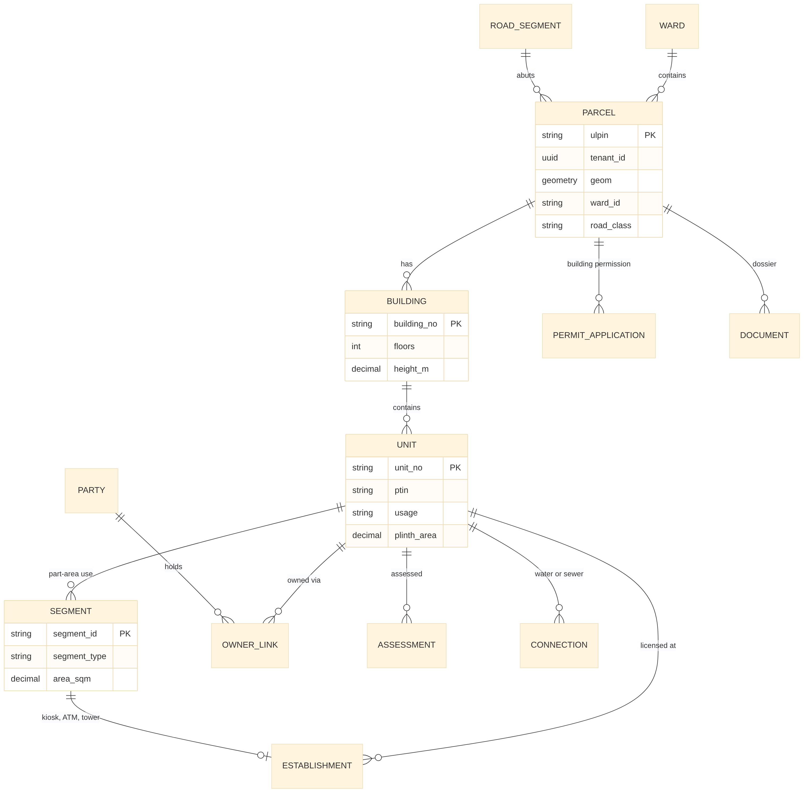
Figure 3. Core property data model (ULPIN spine) and the main records that reference it

Master data ownership
Master | Owner service | Consumers and mechanism
Parcel, building, unit, segment (ULPIN) | ptx-service | All property-related modules via I-27 API and owner-change events
Citizen and consumer profile | identity + tenant-config | All citizen-facing modules via token claims and profile API
Employee and org hierarchy | hrm-service (interim: tenant-config until Phase 4) | Workflow engine approver lookup; rosters I-15
Boundaries and planning layers | tpl-service (interim: gis-service in Phase 1) | OGC services I-20
Road register | eng-service (interim: gis-service in Phase 1) | I-32 API and layer
Establishments | trl-service | I-22 events
Assets | mpm-service (interim: fin fixed asset schedule) | I-42 events
Account heads and budget | fin-service | I-24 events, posting API
Documents | dms-service | I-16 API, I-29 dossier

Tenancy and isolation
- Every table carries tenant_id; PostgreSQL row-level security policies filter on the session variable app.tenant_id set by the service from the token
- Object storage paths and OpenSearch indices are prefixed by tenant; encryption keys per tenant in the KMS
- A single-tenant installation uses the same schema with one tenant row, so the code path is identical
- Backups and exports per tenant (PLT-FR-020, 023); cross-tenant dashboards only through the warehouse for authorised state users

Data lifecycle and classification
Class | Examples | Controls
Public | Ward maps, permit register, published lists | Cached, CDN
Internal | Workflow notes, inspection reports | Role and ward access
Personal | Names, mobile, address, bank details | Field encryption for bank details, masking in UI and logs, DPDP consent and purpose tags
Sensitive | Aadhaar number | Only in the Aadhaar Data Vault (HSM keys); services keep the reference key
Financial and legal | Receipts, journals, case files | Immutable records, corrections by reversal; legal hold; long retention as per state rules

Analytics: events and CDC feed the warehouse (staging, then conformed dimensions such as ward, ULPIN, module and date, then marts per module). Superset dashboards read the marts, and personal data is pseudonymised there.

9. Integration architecture

Patterns
Need | Pattern | Notes
Lookup another module's data | Synchronous REST through the service mesh | Timeouts 2 s, retries with jitter, circuit breaker; cache with short TTL where safe
Notify a state change | Domain event on Kafka via transactional outbox | Key = business key (ULPIN, application no.) for ordering
Long-running cross-module process | Choreography by events; BPMN orchestration only inside a module | Each step idempotent; compensation events where needed
Bulk or nightly exchange | Batch event or file over the adapter hub | Control totals reconciled (e.g. I-09 daily totals)
External system | Adapter in the hub with an anti-corruption layer | Mapping, retries, dead letters, audit of every call
Interim arrangement (phase crossing) | Stub consumer or manual entry screen behind the same contract | Swapped for the real provider at cut-over without consumer change

Event naming and envelope
Topics are named urban.<service>.<entity>.<event>.v<major>, for example urban.bpm.occupancy-certificate.issued.v1. Every event uses the CloudEvents 1.0 JSON envelope with a registered JSON Schema.
{
"specversion": "1.0",
"id": "01JBX4T7V9Q2S6M8N3K5R1W0YZ",
"source": "urban/bpm-service",
"type": "urban.bpm.occupancy-certificate.issued.v1",
"time": "2026-10-22T10:15:00+05:30",
"subject": "ULPIN TS-WGL-0012345",
"tenantid": "gwmc",
"traceparent": "00-4bf92f3577b34da6a3ce929d0e0e4736-00f067aa0ba902b7-01",
"datacontenttype": "application/json",
"data": { "ocNo": "OC/2026/00123", "ulpin": "TS-WGL-0012345", "units": [ { "unitNo": "TS-WGL-0012345-B01-U0001", "usage": "residential", "plinthAreaSqm": 112.5 } ] }
}
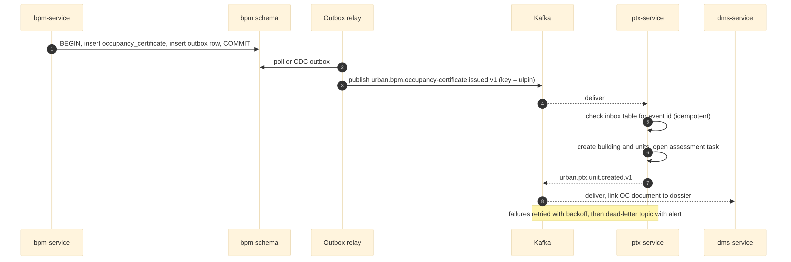
Figure 4. Occupancy certificate to Property Tax (I-03): outbox, Kafka, idempotent consumer

10. Security architecture
Area | Design | SRS reference
Citizen and business login | Mobile OTP (DLT SMS, WhatsApp fallback), Meri Pehchaan brokering, DigiLocker and Entity Locker linking | PLT-FR-026, 028, 030
Staff and admin login | Keycloak MFA: TOTP authenticator or passkey (WebAuthn); SMS only as fallback; passkeys mandatory for admins | PLT-FR-028, NFR-020
Step-up OTP | Transaction-bound OTP or TOTP; token exchange issues short-lived acr=stepup token bound to a transaction hash (amount, payee) | PLT-FR-029
Authorisation | RBAC roles from Keycloak plus ABAC scope (tenant, ward, department, confidentiality) enforced in services by a policy library | PLT-FR-002
Segregation of duties | Maker-checker on money, demand and masters; time-bound delegation; just-in-time privileged access; logged break-glass | PLT-FR-033
Bot protection | Risk-based self-hosted CAPTCHA on public forms and OTP requests; gateway rate limits per IP, device and mobile | PLT-FR-031, NFR-021
Sessions | Idle and absolute timeouts, concurrent session limits for staff, new-device alerts | PLT-FR-032
Service-to-service | mTLS (service mesh), workload identities, network policies default-deny | NFR-006
Data protection | TLS 1.2+; AES-256 at rest; field encryption for bank details; Aadhaar Data Vault with HSM keys | NFR-006, 024, PLT-FR-034
Secrets and keys | OpenBao with HSM auto-unseal; keys rotated yearly; signing keys in HSM | NFR-024
Audit and monitoring | Audit service (append-only, hash-chained), SIEM (Wazuh) with alert rules for brute force, OTP abuse, mass download, privilege change; logs 180 days in India; NTP to NIC/NPL | PLT-FR-012, 035, NFR-022
Secure SDLC | Threat model per module, SAST, dependency and container scans, DAST, VAPT by CERT-In empanelled auditor before each phase | NFR-019, 023

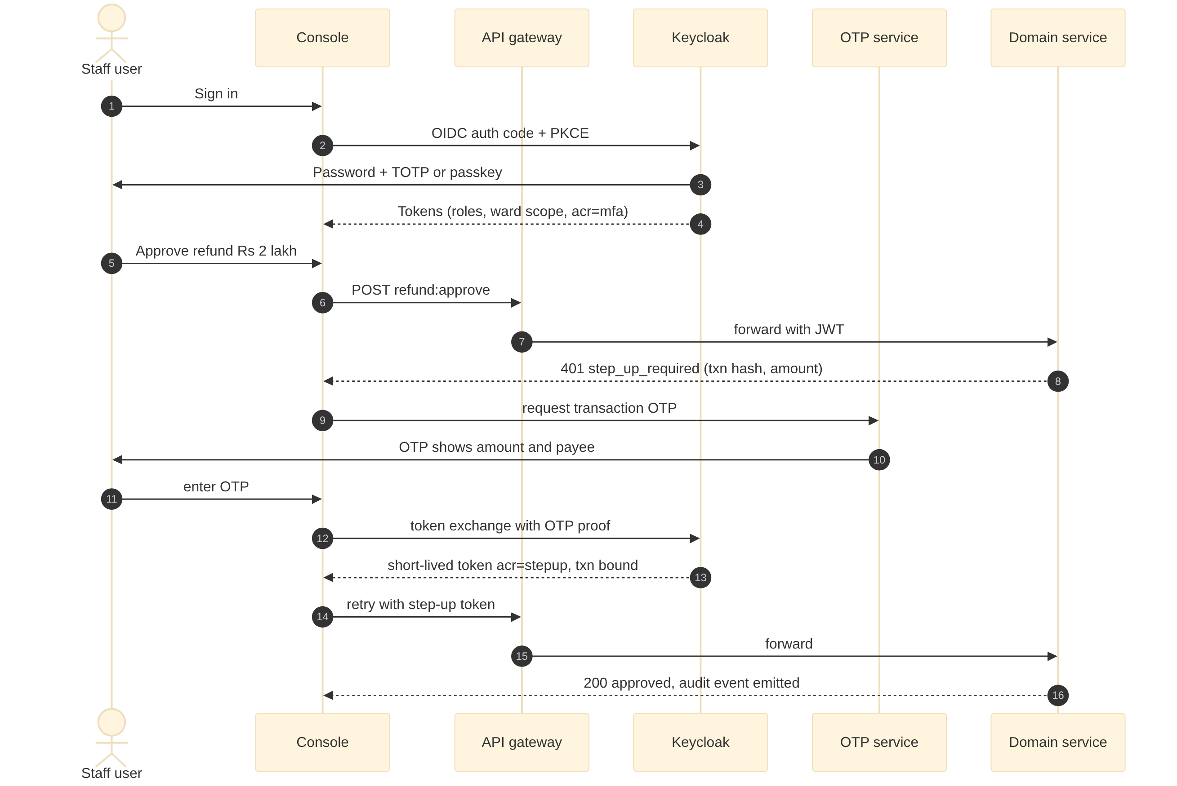
Figure 5. Staff sign-in and step-up OTP for a high-risk action

11. Platform services (HLD)
Service | Design summary
Workflow and rules | Flowable runs BPMN per module process (for example the assessment approval) with SLA timers and escalation; approvers are resolved through hrm org API (tenant-config in Phase 1). DMN tables hold taxes, fees, tariffs, penalties and eligibility, versioned with effective dates and edited in the configuration console with maker-checker.
GIS, elevation and 3D | PostGIS stores geometries (EPSG:4326, area computed in local UTM 44N for Telangana); GeoServer publishes WMS/WFS and vector tiles; base map and imagery tiles cached; elevation rasters (DTM, DSM, nDSM) as Cloud Optimised GeoTIFFs with analysis endpoints (slope, inundation, height); 3D buildings as 3D Tiles for CesiumJS (PLT-FR-036).
Document pipeline | Upload to object storage through pre-signed URLs, then virus scan, OCR with language detection (Indic models via Bhashini or on-premises), searchable PDF/A, indexing in OpenSearch, eSign or DSC, Merkle-batched hash anchoring on a permissioned ledger, and DigiLocker issue.
Payment | Payment intents with idempotency keys; gateway and UPI adapters with signed webhooks and server-side status checks; BBPS biller; daily settlement and bank reconciliation with Finance.
Notification | Template store with language variants; channel routing (SMS DLT, WhatsApp, email, push, IVRS); preference and quiet hours; delivery receipts; OTP traffic on a priority lane.
Search | Per-module projections indexed in OpenSearch with access attributes (tenant, ward, confidentiality); queries filtered by the caller's scope; transliteration and fuzzy matching.
Tenant and configuration | Tenant bootstrap (boundaries, departments, branding, enabled modules, integrate or full mode), state pack loader, configuration with versions and effective dates, feature flags.
Field sync | Task packages downloaded per user and area; local SQLite; changes uploaded as commands with client IDs; server resolves conflicts by rule (server wins for masters, last-writer with audit for observations); photos uploaded separately with geo-tags.
Reporting | ELT from events and CDC into the warehouse every 15 minutes; dashboards for Commissioner and modules; scheduled reports; state cross-tenant views.

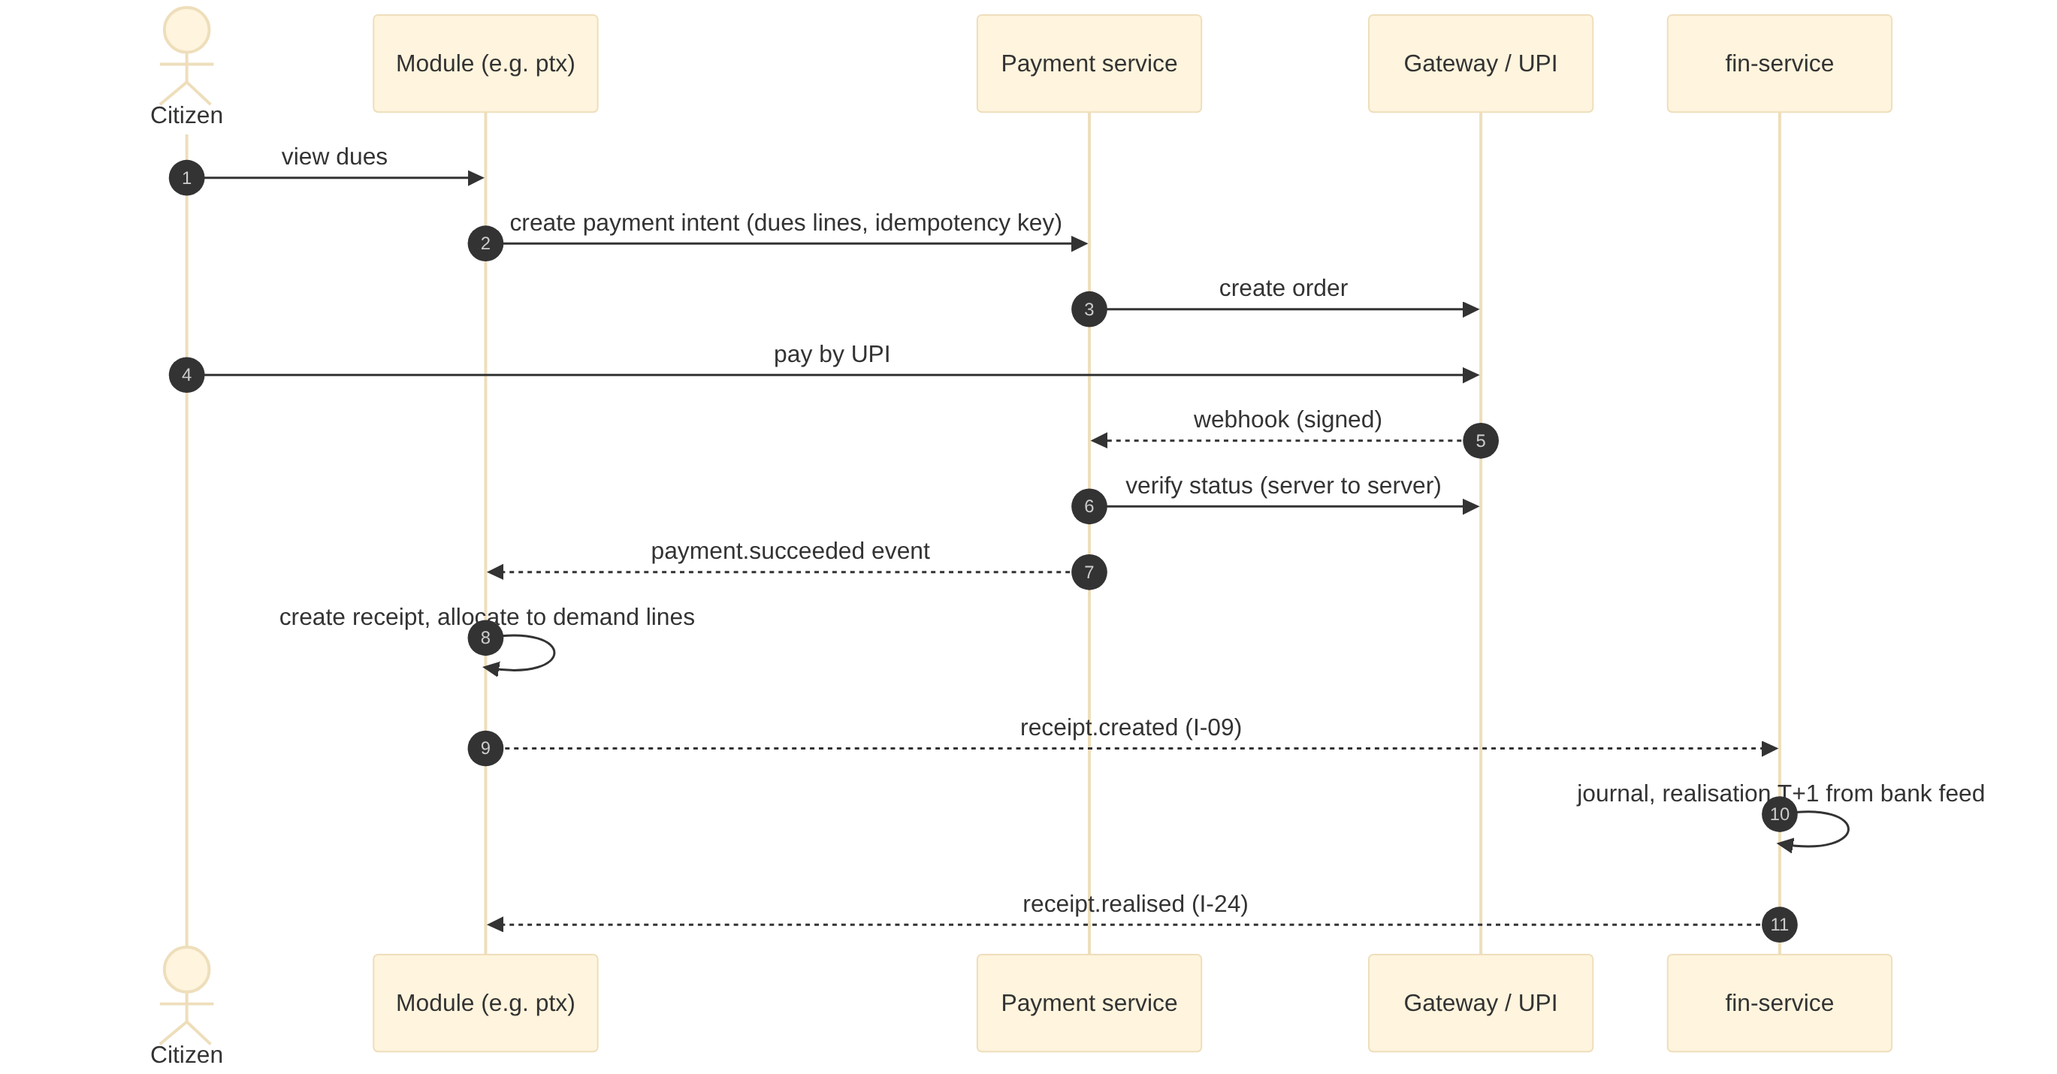
Figure 6. Citizen payment from dues to realisation (payment service, module, Finance)

12. Deployment architecture
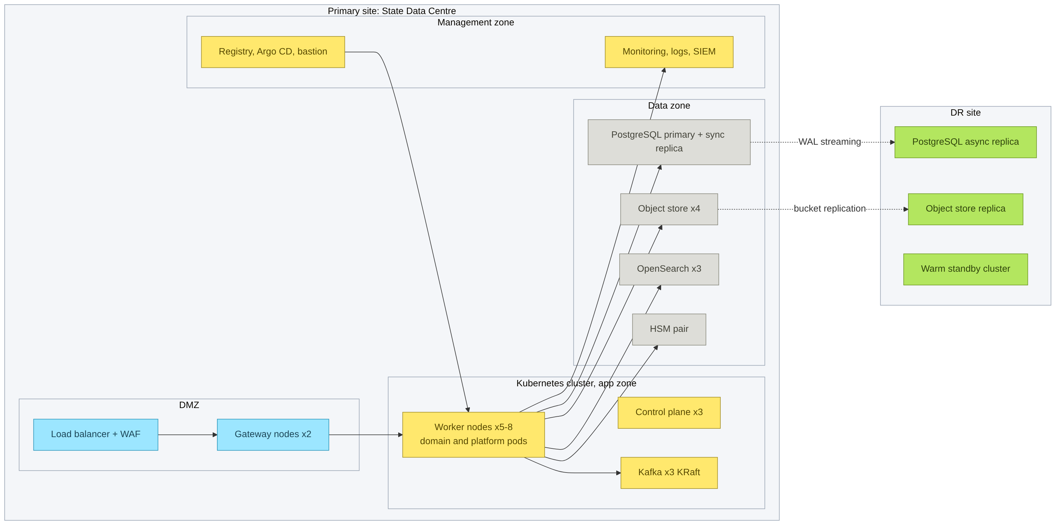
Figure 7. Reference deployment in a State Data Centre with DR site

Environments
Environment | Purpose | Data
Dev | Continuous deployment from main | Synthetic
Test / QA | Integration, contract, DAST, performance | Synthetic and masked
UAT | Business acceptance per phase | Masked copy of migrated data
Training | User training | Synthetic
Production | Live | Live
DR | Warm standby | Replicated live

Sizing tiers (indicative, confirmed by performance tests)
Tier | ULB size | Kubernetes workers | Database | Other
Small | Up to 25,000 properties | 3 nodes (8 vCPU, 32 GB) | 1 primary + 1 replica (8 vCPU, 32 GB) | Shared or 3-node Kafka, 1 OpenSearch
Medium (GWMC) | 25,000 to 2 lakh properties | 5 to 8 nodes (16 vCPU, 64 GB) | Primary + sync replica (16 vCPU, 128 GB, NVMe) | 3 Kafka, 3 OpenSearch, 4 object store nodes, HSM pair
Large | Above 2 lakh, metros | 12+ nodes, autoscaling | Primary + replicas, read pools; ClickHouse warehouse | Dedicated GIS and OCR node pools

Resilience, backup and DR
- Synchronous replica in the primary site; asynchronous WAL streaming to DR (RPO 15 minutes or better); PITR backups with 35-day retention, immutable copies
- Object storage replicated to DR; OpenSearch rebuilt from source or snapshot; Kafka mirrored for audit topics
- DR runbook tested every six months; RTO 4 hours (NFR-005)
- Pod disruption budgets, readiness and liveness probes, horizontal autoscaling on CPU and queue depth

13. NFR realisation
NFR | Requirement | Design measures | Verification
NFR-001 | 3 s response | Read models, caching, indexes, pagination, async jobs | Load test at peak profile
NFR-002 | Peak users | Horizontal scaling, queue-backed payment and demand | Soak and spike tests
NFR-003 | Events within 1 minute | Outbox relay under 5 s, consumer lag alerts | Lag dashboards, contract tests
NFR-004/005 | 99.5%; RPO/RTO | HA, DR replica, runbooks | DR drills
NFR-006/024 | Encryption and keys | TLS, AES-256, HSM, rotation | Configuration audit
NFR-007/023 | Audits and VAPT | Secure SDLC, scans, fix SLAs | CERT-In empanelled audit per phase
NFR-008 | DPDP | Consent, purpose tags, masking, deletion workflows | Privacy review
NFR-010 | Accessibility | Design system with accessible components | Automated and manual audits
NFR-012 | Versioning | URI major versions, event schema compatibility rules | Schema registry checks in CI
NFR-013 | Portability | Open-source stack, S3 abstraction | Install on two platforms
NFR-014 | Tenant isolation | RLS, per-tenant keys | Penetration test
NFR-016/017 | Upgrades and onboarding | Expand-and-contract migrations, tenant bootstrap | Upgrade rehearsals
NFR-018 | Observability | OpenTelemetry, Prometheus, Grafana, Loki, Tempo | SLO dashboards
NFR-019/020/021/022 | Security controls | Section 10 | Security test cases per release

14. Engineering practices

Figure 8. Delivery pipeline from merge request to production and offline bundle

Testing strategy
Level | Scope | Tooling
Unit | Domain logic, rules adapters | Jest
Component | Service with real PostgreSQL and Kafka (containers) | Testcontainers
Contract | APIs (OpenAPI) and events (JSON Schema) between providers and consumers | Pact / schema registry compatibility
End to end | SRS E2E scenarios (E2E-01 to 39) per phase | Playwright, API suites
Performance | NFR-001/002 profiles | k6
Security | SAST, DAST, dependency, container, IaC | Semgrep, ZAP, Trivy
Accessibility | Citizen screens | axe, manual audit

Observability
- OpenTelemetry SDK in every service; trace context carried in HTTP headers and CloudEvents traceparent
- Golden signals per service and tenant; SLOs with error budgets; alert routing to on-call
- Structured JSON logs without personal data; correlation IDs; 180-day retention for ICT logs

15. Technology stack
Layer | Choice | Licence
Web UI | React 18, TypeScript, design system with accessibility, MapLibre GL, CesiumJS | MIT / Apache 2.0
Mobile and field | Flutter, SQLite, background sync | BSD / public domain
Services | Node.js 22 LTS, NestJS, Prisma or TypeORM, Zod | MIT
Workflow and rules | Flowable 7 (BPMN, DMN) | Apache 2.0
Identity | Keycloak | Apache 2.0
Gateway | Apache APISIX | Apache 2.0
Messaging | Apache Kafka (KRaft), Apicurio Registry | Apache 2.0
Databases | PostgreSQL 16, PostGIS 3 | PostgreSQL / GPL (PostGIS, server-side)
Search | OpenSearch | Apache 2.0
Cache | Valkey | BSD
Object storage | Ceph RGW or provider S3 | LGPL
GIS | GeoServer, GDAL, TiTiler | GPL (server) / MIT
OCR and language | Tesseract and Indic OCR models, Bhashini APIs | Apache 2.0 / government service
Platform | Kubernetes (RKE2), Helm, Argo CD, Harbor | Apache 2.0
Observability and SIEM | OpenTelemetry, Prometheus, Grafana, Loki, Tempo, Wazuh | Apache 2.0 / AGPL (Grafana stack, self-hosted) / GPL
Secrets | OpenBao, network HSM | MPL 2.0
Analytics | PostgreSQL or ClickHouse, Apache Superset | Apache 2.0

PART B

Low-level design
Conventions, platform services and one chapter per rollout phase
16. LLD conventions
17. Platform services
18 to 21. Phase 1 to Phase 4 module designs

16. LLD conventions

Service structure
Every domain service follows the same hexagonal layout so developers can move between teams.
services/ptx-service/
src/
api/ # controllers, DTOs (Zod), OpenAPI decorators
application/ # use cases (commands, queries), transactions
domain/ # entities, value objects, domain events, rules ports
infra/
db/ # repositories, migrations (expand-and-contract)
events/ # outbox writer, inbox consumer, schema bindings
clients/ # typed clients for other services and adapters
workflow/ # Flowable task handlers
test/ # unit, component (Testcontainers), contract
openapi.yaml # published contract, versioned
events/ # JSON Schemas for published events
helm/ # chart values per tier

API conventions
- Base path /<service-code>/v<major>/..., plural resources, kebab-case; actions as POST /resource/{id}:action (submit, approve, reject)
- JSON, camelCase fields, ISO 8601 times with +05:30, money as integer paise with currency, areas in square metres
- Pagination by cursor (limit, nextCursor); filtering with explicit query parameters; sorting whitelisted
- Idempotency-Key header on every POST that creates or pays; stored 24 hours
- Optimistic concurrency with ETag / If-Match on updates
- Errors as RFC 9457 problem details with a stable code and translation key
HTTP/1.1 422 Unprocessable Content
Content-Type: application/problem+json
{
"type": "https://urban.example/problems/ptx.assessment.area-mismatch",
"title": "Plinth area exceeds GIS footprint by more than the allowed tolerance",
"status": 422,
"code": "PTX-ASM-012",
"i18nKey": "ptx.assessment.areaMismatch",
"traceId": "4bf92f3577b34da6a3ce929d0e0e4736",
"errors": [ { "field": "plinthAreaSqm", "reason": "exceedsFootprint", "limit": 118.4 } ]
}

Database conventions
- Primary keys are ULIDs (sortable). Business keys (ULPIN, PTIN, application numbers) are unique per tenant
- Common columns: id, tenant_id, created_at, created_by, updated_at, updated_by, version, deleted_at (soft delete where the SRS allows deletion)
- Money columns bigint paise; geometry columns typed (Point, MultiPolygon, LineString) with SRID 4326 and GiST indexes
- Financial and demand rows are immutable; corrections by reversal or adjustment rows
- Every schema has outbox and inbox tables; migrations are backward compatible for one release
CREATE TABLE ptx.unit (
id char(26) PRIMARY KEY,
tenant_id text NOT NULL,
unit_no text NOT NULL, -- ULPIN-Bnn-Unnnn
ptin text, -- state assessment number
building_id char(26) NOT NULL REFERENCES ptx.building(id),
usage text NOT NULL,
plinth_area numeric(10,2) NOT NULL,
created_at timestamptz NOT NULL DEFAULT now(), created_by text NOT NULL,
updated_at timestamptz, updated_by text, version int NOT NULL DEFAULT 0,
UNIQUE (tenant_id, unit_no)
);
ALTER TABLE ptx.unit ENABLE ROW LEVEL SECURITY;
CREATE POLICY tenant_isolation ON ptx.unit
USING (tenant_id = current_setting('app.tenant_id'));

CREATE TABLE ptx.outbox (
id char(26) PRIMARY KEY, tenant_id text NOT NULL, topic text NOT NULL,
event_key text NOT NULL, payload jsonb NOT NULL, created_at timestamptz DEFAULT now(),
published_at timestamptz
);

Events, workflow and configuration
- Producers write the business change and the outbox row in one transaction; a relay (Debezium CDC or poller) publishes to Kafka
- Consumers record the event id in the inbox in the same transaction as their change; duplicates are ignored; poison messages go to <topic>.dlq with an alert
- Schema evolution is backward compatible within a major version (add optional fields only). A breaking change creates .v2 and both run for 6 months (NFR-012)
- BPMN process keys are named <service>.<process> (for example ptx.assessment-approval). User tasks carry the ward and role, and the service exposes task completion as API actions
- DMN decisions are named <service>.<decision> (for example ptx.arv-calculation) and evaluated with the effective date of the transaction
- Text shown to users comes from translation keys; notices are generated from templates per language and stored in DMS

17. Platform services (LLD)
Service | Design | Key APIs | Key tables | Events
Identity and OTP | Keycloak realm 'urban' with tenant attribute; custom authenticators: mobile-OTP, step-up (transaction-bound), CAPTCHA gate; identity brokering to Meri Pehchaan (OIDC) | POST /otp/v1/challenges, POST /otp/v1/challenges/{id}:verify, POST /auth/stepup | otp_challenge (hash, purpose, txn_hash, attempts, expires_at), device, consent | urban.identity.login.succeeded|failed.v1, urban.identity.stepup.used.v1
Workflow and rules | Flowable engine with REST; task service in staff console; SLA timers raise escalations; DMN deployed per tenant and version | POST /wf/v1/process-instances, GET /wf/v1/tasks?assignee=, POST /wf/v1/tasks/{id}:complete, POST /rules/v1/decisions/{key}:evaluate | Flowable tables (own schema), decision_version (key, tenant, effective_from, approved_by) | urban.wf.task.created|completed|escalated.v1
Tenant and configuration | Tenants, boundaries (ward polygons), departments, enabled modules and modes, state pack versions, feature flags; config cached in Valkey | GET /cfg/v1/tenants/{id}, GET /cfg/v1/config/{module}?at=, PUT /cfg/v1/config/{module} (maker-checker) | tenant, boundary, module_setting, config_version, state_pack | urban.cfg.config.changed.v1
Payment | Payment intent per dues set; gateway adapters; webhook verification; BBPS fetch and pay; settlement files | POST /pay/v1/intents, POST /pay/v1/webhooks/{provider}, GET /pay/v1/intents/{id} | payment_intent, payment_attempt, settlement, refund | urban.pay.payment.succeeded|failed|refunded.v1
Notification | Template rendering with language fallback; channel adapters (DLT SMS, WhatsApp BSP, email, FCM, IVRS); rate limits | POST /ntf/v1/messages, GET /ntf/v1/messages/{id} | template, message, delivery_receipt, preference | urban.ntf.message.delivered|failed.v1
GIS, elevation and 3D | Layer catalogue, geocoder (address, ULPIN, door number), spatial queries, elevation analysis, 3D tile builder | GET /gis/v1/geocode, POST /gis/v1/analysis/{op}, /gis/ows (OGC), /tiles/{layer}/{z}/{x}/{y} | layer, layer_version, raster_asset, building_3d | urban.gis.layer.published.v1
Search | Indexers subscribe to module events and build projections; query API applies access filter | GET /search/v1?q=&types= | OpenSearch indices per tenant and type | -
Audit | Append-only, hash-chained audit records; export to SIEM | POST /audit/v1/records (internal), GET /audit/v1/records?entity= | audit_record (actor, action, entity, before, after, hash, prev_hash) | urban.audit.record.created.v1
Field sync | Task packages, delta sync, conflict rules, media upload | GET /sync/v1/packages, POST /sync/v1/changes | device, sync_cursor, change_log | -
Adapter hub | One adapter per external system with mapping, retries, circuit breaker, call audit | Internal REST per adapter, for example POST /adapters/cdma/v1/demands | adapter_call_log, mapping_table | urban.adapter.call.failed.v1
Aadhaar Data Vault | Separate service and database; HSM-wrapped keys; returns reference keys; strict access by two services | POST /adv/v1/references, POST /adv/v1/references/{ref}:resolve (restricted) | vault_entry (ref_key, cipher, key_version) | -

PART B | PHASE 1 | MONTHS 0 TO 6

18. Phase 1 LLD: Foundation and revenue core
5 services: ptx-service, wtr-service, grv-service, fin-service, dms-service
1 Property Tax & Revenue Management
2 Water, Sewerage & Utility Billing
3 Citizen Service Desk, Grievance & RTI
4 Finance & Accounting
9 Document Management System

18.0 Phase 1 build notes
- Build the platform services first: identity and OTP, tenant and config, workflow and DMN, payment, notification, GIS base, document pipeline, search, audit, adapter hub
- Interim masters: org hierarchy in tenant-config until hrm-service (Phase 4); ward and road layers in gis-service until tpl-service and eng-service
- Stub consumers for later providers (Building Permission OC, schemes concessions, Legal) behind the final contracts
- Adapters needed: CDMA (integrate mode), IGRS, land records, payment gateway and BBPS, banks, PFMS, SMS DLT, WhatsApp, DigiLocker, eSign, Bhashini, blockchain

18.1 1 Property Tax & Revenue Management (ptx-service)
Item | Design
Service and schema | ptx-service, PostgreSQL schema ptx, base path /ptx/v1
Scope | ULPIN, assessment, mutation, demand, collection, state platform sync
Primary users | Citizen; Bill Collector; Cashier; Revenue Inspector; Revenue Officer; GIS cell; Commissioner
Requirements realised | 38 (PTX-FR-001 to PTX-FR-038), 33 processes (PTX-*)
Interfaces | Provides I-05, I-09, I-16, I-17, I-27, I-28, I-33; consumes I-03, I-08, I-20, I-22, I-23, I-24, I-29, I-30, I-32, I-34, I-37, I-40

Data model
Table | Key columns | Notes
parcel | ulpin (PK, business key), provisional_flag, survey_no, ward_id, locality_id, geom (MultiPolygon, 4326), road_id, road_class, corner_plot | One per land parcel; ULPIN from state registry or provisional
building | building_no (ULPIN-Bnn), parcel_id, floors, height_m, footprint geom, dsm_height_m, oc_ref | Height cross-checked with nDSM
unit | ptin, unit_no (ULPIN-Bnn-Unnnn), building_id, usage, occupancy, plinth_area, carpet_area, legacy_no[] | Assessable unit; PTIN from state platform
segment | unit_id, segment_type (ATM, kiosk, tower, hoarding), area_sqm, licence_ref | Part-area use taxed on its own area
owner_link | unit_id, party_id, share_pct, from_date, to_date, source (deed, mutation) | Ownership history; party in citizen master
assessment | unit_id, type (new, re, back, self, revision), arv, tax_rates_version, effective_from, status, workflow_id | Calculated by rules engine DMN
demand | unit_id, period (H1/H2 yyyy), head (tax, cess, penalty, interest, arrear), amount, rebate, due_date, status | Immutable lines; corrections by adjustment
receipt / adjustment | receipt_no, payment_ref, lines[{demand_id, amount}], channel, realised_at / adj_type, reason, approver | Maker-checker on adjustments
notice / petition | notice_type, served_at, served_by, geo_point / petition_no, grounds, lgl_case_ref | Petitions become Legal cases (I-17)

APIs
Endpoint | Purpose | Processes
GET /ptx/v1/parcels/{ulpin} | ULPIN lookup with buildings, units, owners (I-27) | PTX-P01
POST /ptx/v1/parcels | Register parcel; provisional ULPIN when state ID absent | PTX-P01, PTX-P03
POST /ptx/v1/assessments | Create assessment draft (new, re, back, apartment, vacant land) | PTX-P05, PTX-P07-P09, PTX-P11
POST /ptx/v1/assessments/self | Citizen self-assessment with documents and CAPTCHA | PTX-P06
POST /ptx/v1/assessments/{id}:submit|approve|reject | Workflow transitions; approve needs maker-checker | PTX-P05-P13
POST /ptx/v1/mutations | Mutation by application; auto-mutation via IGRS adapter | PTX-P14, PTX-P15
POST /ptx/v1/demand-runs | Start half-yearly demand generation (batch, idempotent by period) | PTX-P18
GET /ptx/v1/units/{ptin}/dues | Outstanding dues for payment and BBPS fetch | PTX-P21
POST /ptx/v1/adjustments | Bill amendment, rebate, write-off (step-up OTP above threshold) | PTX-P19, PTX-P26, PTX-P27
GET /ptx/v1/certificates/{type} | No-dues, assessment extract (signed via DMS, QR) | PTX-P28

Events and interfaces
Direction | Interface | Counterpart | Topic or endpoint
Provides | I-05 | 2 Water & Sewerage | GET /ptx/v1/units/{ulpin}
Provides | I-09 | 4 Finance & Accounting | urban.<module>.demand.raised.v1, urban.<module>.receipt.created.v1
Provides | I-16 | 9 Document Management | POST /dms/v1/documents, GET /dms/v1/documents/{id}
Provides | I-17 | 16 Legal Cases | POST /lgl/v1/cases
Provides | I-27 | 2 Water & Sewerage, 5 Trade Licence, 6 User Charges, 7 Solid Waste, 11 Building Permission, 15 Municipal Property, 18 Fire NOC, 19 Government Schemes | GET /ptx/v1/parcels/{ulpin}
Provides | I-28 | 13 Town Planning | urban.ptx.setback-deviation.referred.v1 / urban.tpl.regularisation.decided.v1
Provides | I-33 | 3 Citizen Desk & RTI | urban.<module>.service-event.v1
Consumes | I-03 | 11 Building Permission | urban.bpm.occupancy-certificate.issued.v1
Consumes | I-08 | 3 Citizen Desk & RTI | urban.grv.service-request.routed.v1 / urban.<module>.service-request.updated.v1
Consumes | I-20 | 13 Town Planning | OGC WMS/WFS/Vector tiles /gis/ows
Consumes | I-22 | 5 Trade Licence | urban.trl.establishment.changed.v1
Consumes | I-23 | 19 Government Schemes | GET /gsc/v1/concessions?ulpin=
Consumes | I-24 | 4 Finance & Accounting | urban.fin.receipt.realised.v1
Consumes | I-29 | 9 Document Management | GET /dms/v1/dossiers/{ulpin}
Consumes | I-30 | 16 Legal Cases | urban.lgl.case.status-changed.v1
Consumes | I-32 | 10 Engineering Projects | GET /eng/v1/roads?bbox=, OGC layer roads
Consumes | I-34 | 3 Citizen Desk & RTI | urban.grv.rti.requested.v1 / urban.<module>.rti.replied.v1
Consumes | I-37 | 13 Town Planning | urban.tpl.layout.approved.v1, urban.tpl.door-number.assigned.v1
Consumes | I-40 | 11 Building Permission | urban.bpm.rwh-certificate.changed.v1

State model: Assessment lifecycle
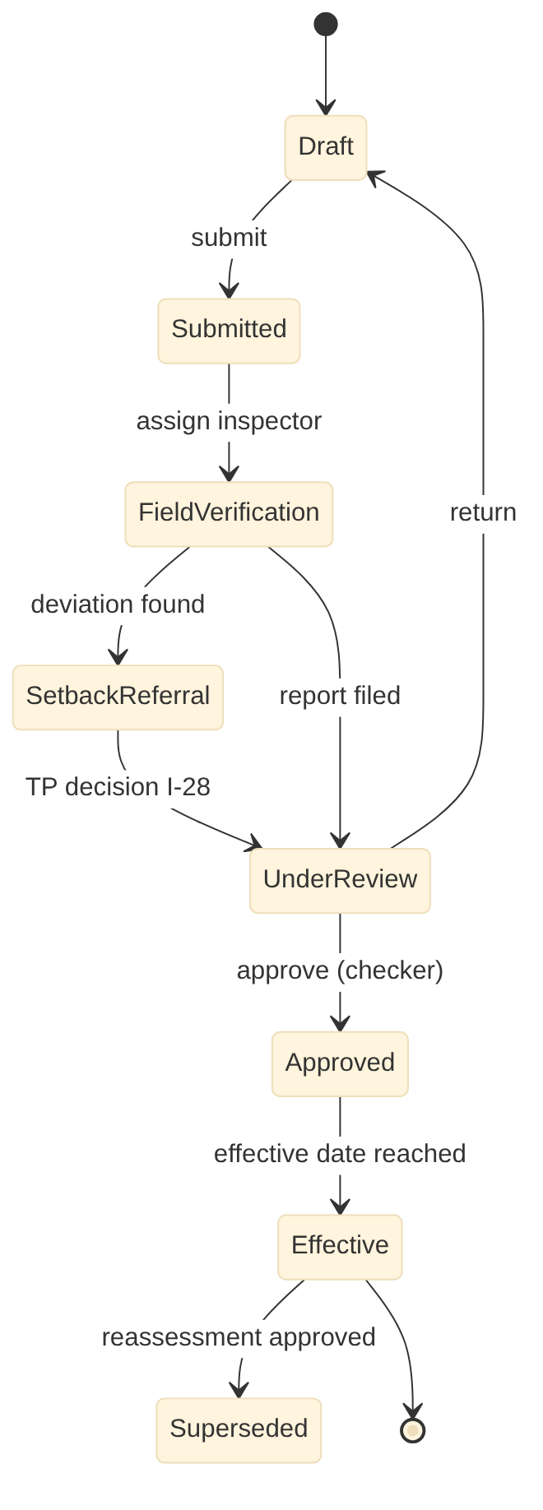
Figure 9. Property Tax & Revenue Management: assessment lifecycle states

Scheduled jobs
Job | Schedule | Purpose
demand-run | 1 April and 1 October 00:30 (per state pack) | Generate half-yearly demand by ward partitions
interest-accrual | Monthly, 1st 01:00 | Penalty and interest per rules
cdma-sync | Every 5 min | Two-way sync with state tax platform (integrate mode)
gis-reconcile | Weekly | Footprint vs assessed area, nDSM height vs floors

Configuration and rules
Item | Mechanism | Example
Tax method and rates | DMN decision table (state pack) | Telangana ARV by zone, usage, construction type
Rebates and penalties | DMN | Early payment rebate, interest per month
Demand cycle | Config | Half-yearly, due dates
Thresholds for step-up OTP | Config | Adjustments above Rs 10,000

External adapters
ID | System | Purpose
E-03 | Payment gateway, UPI, BBPS | Online payments and bill presentment
E-07 | State municipal portals (Telangana: CDMA) | State reporting and service catalogues
E-11 | Bhuvan (incl. CartoDEM), Survey of India (incl. high-resolution DEM), drone and LiDAR surveys | Base maps, imagery, elevation models and survey data
E-16 | State registration department (Telangana: Registration & Stamps / IGRS) | Deed data and mutation fee for auto-mutation (GO Ms No 155) and apartment unit split
E-17 | State land records / ULPIN registry | ULPIN and land parcel data
E-18 | State municipal tax platform adapter (Telangana: CDMA eMunicipal by CGG) | Two-way sync of assessments, state assessment numbers, demand, receipts, mutations where the state platform is system of record
E-29 | Online accommodation listings and tourism/police registrations (where data sharing exists) | Detect unlicensed or undeclared paying guest, homestay and short-term rental use
E-39 | Permissioned blockchain (National Blockchain Framework / Vishvasya on NIC, state ledger, or product-hosted) | Anchoring and verification of document and record hashes

Security notes: all endpoints require a tenant-scoped token. Ward scope is applied to staff queries. Money, demand and master changes need maker-checker, and step-up OTP above the configured thresholds. Personal data fields are masked in list views and logs.

18.2 2 Water, Sewerage & Utility Billing (wtr-service)
Item | Design
Service and schema | wtr-service, PostgreSQL schema wtr, base path /wtr/v1
Scope | Connections, metering, billing, NRW, tankers, call for service
Primary users | Citizen / consumer; Meter reader; Field crew and licensed plumber; Dispatcher; AE (Water); Chemist; Tanker and desludging operators; Commissioner
Requirements realised | 35 (WTR-FR-001 to WTR-FR-035), 32 processes (WTR-*)
Interfaces | Provides I-09, I-14, I-16, I-17, I-31, I-33, I-39; consumes I-05, I-08, I-15, I-20, I-23, I-24, I-27, I-29, I-30, I-32, I-34, I-36, I-40

Data model
Table | Key columns | Notes
connection | consumer_no, unit_id (ULPIN), category, pipe_size_mm, status, metered, dma_id, geom point | Water or sewer connection
application | app_no, type (new, transfer, change, disconnect), status, workflow_id, road_cut_ref | One table for all service applications
meter | meter_no, make, size, install_date, last_test, amr_id, status | Replacements kept as history
reading | connection_id, reading_date, value, source (spot, AMR, estimated), photo_ref, flag | Spot billing from field app
bill / bill_line | bill_no, period, consumption_kl, tariff_version, amount, due_date / head, amount | Tariff via DMN
service_request | sr_no, type (leak, no water, tanker, desludging), geom, priority, crew_id, sla_due, status | Call for service
dma_balance | dma_id, month, inflow_kl, billed_kl, nrw_pct | NRW by district metered area
quality_sample | sample_point, taken_at, params jsonb, result, action | Contamination response

APIs
Endpoint | Purpose | Processes
POST /wtr/v1/applications | New connection, transfer, change, disconnection | WTR-W01-W10
POST /wtr/v1/applications/{id}:approve|reject | Workflow transitions | WTR-W01-W10
POST /wtr/v1/readings:batch | Upload readings from field app or AMR head-end | WTR-W12, WTR-W13
POST /wtr/v1/billing-runs | Bill generation per cycle and zone | WTR-W16
GET /wtr/v1/connections/{consumerNo}/dues | Dues for payment and BBPS | WTR-W19
POST /wtr/v1/service-requests | Leak, no-water, tanker, desludging request | WTR-W27-W30
PATCH /wtr/v1/service-requests/{id} | Dispatch, update, close with geo-tagged evidence | WTR-W30
GET /wtr/v1/hydrants | Hydrants and pressure zones (I-39) | -
GET /wtr/v1/dma/{id}/balance | NRW report | WTR-W23

Events and interfaces
Direction | Interface | Counterpart | Topic or endpoint
Provides | I-09 | 4 Finance & Accounting | urban.<module>.demand.raised.v1, urban.<module>.receipt.created.v1
Provides | I-14 | 17 Inventory & Stores | POST /inv/v1/indents
Provides | I-16 | 9 Document Management | POST /dms/v1/documents, GET /dms/v1/documents/{id}
Provides | I-17 | 16 Legal Cases | POST /lgl/v1/cases
Provides | I-31 | 10 Engineering Projects | urban.wtr.road-cut.requested.v1 / urban.eng.road-cut.restored.v1
Provides | I-33 | 3 Citizen Desk & RTI | urban.<module>.service-event.v1
Provides | I-39 | 18 Fire NOC | OGC layer hydrants, GET /wtr/v1/hydrants?bbox=
Consumes | I-05 | 1 Property Tax & Revenue | GET /ptx/v1/units/{ulpin}
Consumes | I-08 | 3 Citizen Desk & RTI | urban.grv.service-request.routed.v1 / urban.<module>.service-request.updated.v1
Consumes | I-15 | 8 Payroll & HR | urban.hrm.roster.published.v1 / urban.<module>.attendance.captured.v1
Consumes | I-20 | 13 Town Planning | OGC WMS/WFS/Vector tiles /gis/ows
Consumes | I-23 | 19 Government Schemes | GET /gsc/v1/concessions?ulpin=
Consumes | I-24 | 4 Finance & Accounting | urban.fin.receipt.realised.v1
Consumes | I-27 | 1 Property Tax & Revenue | GET /ptx/v1/parcels/{ulpin}
Consumes | I-29 | 9 Document Management | GET /dms/v1/dossiers/{ulpin}
Consumes | I-30 | 16 Legal Cases | urban.lgl.case.status-changed.v1
Consumes | I-32 | 10 Engineering Projects | GET /eng/v1/roads?bbox=, OGC layer roads
Consumes | I-34 | 3 Citizen Desk & RTI | urban.grv.rti.requested.v1 / urban.<module>.rti.replied.v1
Consumes | I-36 | 6 User Charges | urban.uch.event-service-order.issued.v1
Consumes | I-40 | 11 Building Permission | urban.bpm.rwh-certificate.changed.v1

State model: Connection application
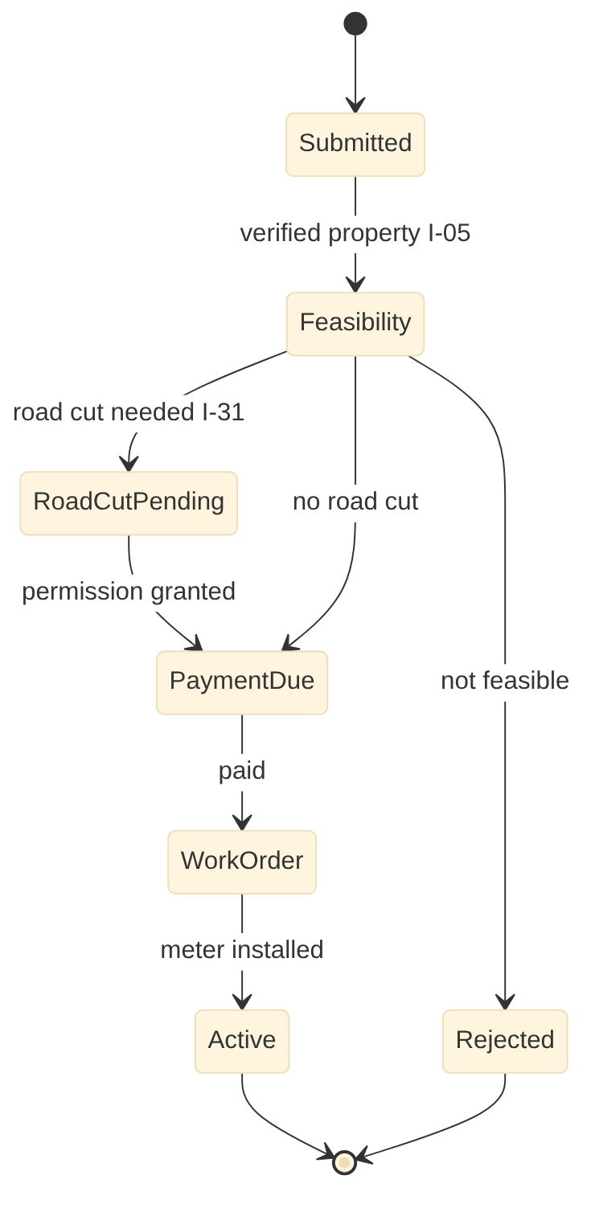
Figure 10. Water, Sewerage & Utility Billing: connection application states

Scheduled jobs
Job | Schedule | Purpose
billing-run | Per cycle and zone | Generate bills
amr-ingest | Every 15 min | Pull AMR readings and alarms
nrw-balance | Monthly | DMA water balance
arrears-notice | Daily | Disconnection notices after notice period

Configuration and rules
Item | Mechanism | Example
Tariff | DMN | Slabs by category and consumption
SLA per request type | Config | Tanker 48 h, desludging 3 days
Average billing rule | Config | Faulty meter: last 3 cycles

External adapters
ID | System | Purpose
E-03 | Payment gateway, UPI, BBPS | Online payments and bill presentment
E-11 | Bhuvan (incl. CartoDEM), Survey of India (incl. high-resolution DEM), drone and LiDAR surveys | Base maps, imagery, elevation models and survey data
E-15 | Vehicle GPS / AVLS provider | Vehicle tracking for SWM fleet, water tankers and desludging vehicles
E-18 | State municipal tax platform adapter (Telangana: CDMA eMunicipal by CGG) | Two-way sync of assessments, state assessment numbers, demand, receipts, mutations where the state platform is system of record
E-19 | Bulk water supplier meters / SCADA (Telangana: Mission Bhagiratha) | Bulk inflow readings per zone or DMA for water balance
E-20 | AMR / smart water meter head-end | Automatic meter readings and alarms

Security notes: all endpoints require a tenant-scoped token. Ward scope is applied to staff queries. Money, demand and master changes need maker-checker, and step-up OTP above the configured thresholds. Personal data fields are masked in list views and logs.

18.3 3 Citizen Service Desk, Grievance & RTI (grv-service)
Item | Design
Service and schema | grv-service, PostgreSQL schema grv, base path /grv/v1
Scope | Grievance on every channel, SLA routing, RTI, happiness index
Primary users | Citizen; Call-centre agent; Social media cell; Ward clerk; GRO and department officers; PIO, APIO and First Appellate Authority; Audit cell; Commissioner and Mayor
Requirements realised | 30 (GRV-FR-001 to GRV-FR-030), 30 processes (GRV-*)
Interfaces | Provides I-08, I-16, I-17, I-34; consumes I-20, I-29, I-30, I-33

Data model
Table | Key columns | Notes
service_request | sr_no, channel, category_id, description, geom, ward_id, citizen_id, owner_module, owner_ref, status, sla_due, priority | Every complaint or request
category | code, name_i18n, owner_module, sla_hours, escalation_matrix_id, call_for_service flag | Taxonomy shared by all modules
assignment | sr_id, org_unit, user_id, assigned_at, transferred_from, reason | Transfer and reassign history
evidence | sr_id, stage, document_id, geom, captured_at | Before and after photos
feedback | sr_id, rating, comment, reopened flag | Happiness rating
rti_application | rti_no, applicant, subject, pio_id, due_date, fee_status, status, third_party flag | RTI register
rti_appeal | rti_id, level (first, second), filed_at, hearing_date, order | Appeals
channel_message | channel (WhatsApp, IVRS, social, Swachhata, CPGRAMS), external_id, payload, sr_id | Inbound raw messages

APIs
Endpoint | Purpose | Processes
POST /grv/v1/service-requests | Create request from any channel; duplicate check | GRV-G01-G08, GRV-G10
GET /grv/v1/service-requests/{srNo} | Status for citizen view | GRV-G25
POST /grv/v1/service-requests/{id}:route|transfer|resolve|reopen|close | Lifecycle actions | GRV-G11, GRV-G12, GRV-G16, GRV-G18
POST /grv/v1/service-requests/{id}/feedback | Citizen confirmation and rating | GRV-G17
POST /grv/v1/rti | RTI application | GRV-G20
POST /grv/v1/rti/{id}:assign|reply|appeal | RTI lifecycle | GRV-G21-G23
POST /grv/v1/channels/{channel}/webhook | Inbound adapters (WhatsApp, Swachhata, CPGRAMS, social) | GRV-G01-G06
GET /grv/v1/dashboards/governance | Good governance and happiness index | GRV-G29, GRV-G30

Events and interfaces
Direction | Interface | Counterpart | Topic or endpoint
Provides | I-08 | 1 Property Tax & Revenue, 2 Water & Sewerage, 5 Trade Licence, 6 User Charges, 7 Solid Waste, 10 Engineering Projects, 11 Building Permission, 12 Street Lights, 13 Town Planning, 14 Parks & Horticulture, 15 Municipal Property, 18 Fire NOC, 19 Government Schemes | urban.grv.service-request.routed.v1 / urban.<module>.service-request.updated.v1
Provides | I-16 | 9 Document Management | POST /dms/v1/documents, GET /dms/v1/documents/{id}
Provides | I-17 | 16 Legal Cases | POST /lgl/v1/cases
Provides | I-34 | All modules | urban.grv.rti.requested.v1 / urban.<module>.rti.replied.v1
Consumes | I-20 | 13 Town Planning | OGC WMS/WFS/Vector tiles /gis/ows
Consumes | I-29 | 9 Document Management | GET /dms/v1/dossiers/{ulpin}
Consumes | I-30 | 16 Legal Cases | urban.lgl.case.status-changed.v1
Consumes | I-33 | All modules | urban.<module>.service-event.v1

State model: Service request
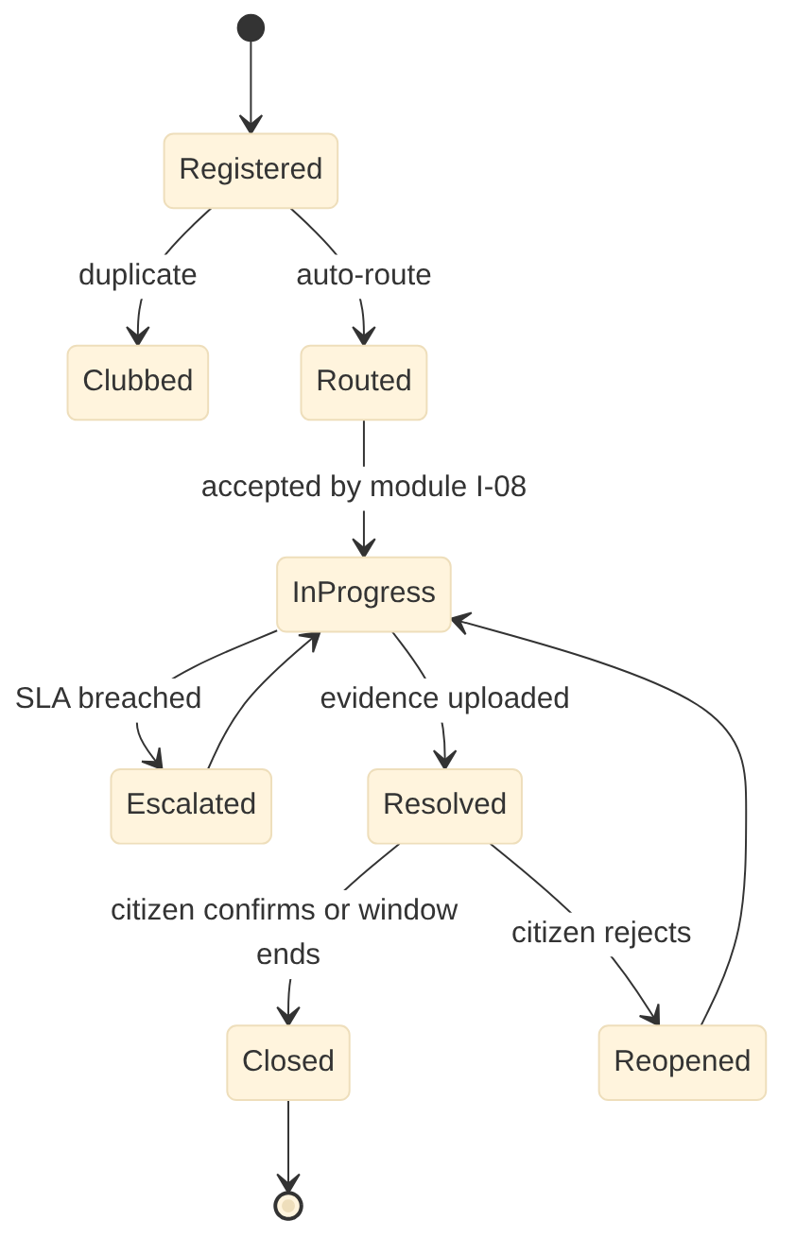
Figure 11. Citizen Service Desk, Grievance & RTI: service request states

Scheduled jobs
Job | Schedule | Purpose
sla-escalation | Every 5 min | Escalate breached requests
auto-close | Hourly | Close resolved requests after confirmation window
rti-due-alerts | Daily 08:00 | Alerts 7, 3, 1 days before due
hotspot-analysis | Daily | Cluster complaints by location and category

Configuration and rules
Item | Mechanism | Example
Category taxonomy and SLAs | Config | Garbage 12 h, street light 48 h
Escalation matrix | Config | Ward officer, AC, Commissioner
Reopen window | Config | 5 days

External adapters
ID | System | Purpose
E-07 | State municipal portals (Telangana: CDMA) | State reporting and service catalogues
E-21 | MoHUA Swachhata app / SBM-U | Swachh Bharat complaints in, resolution status and photos out; citizen feedback
E-22 | State and national grievance portals (Telangana: Prajavani; CPGRAMS) | Inbound grievances, status and action-taken reports
E-23 | Social media platforms / listening tool | Mentions and messages in, replies out
E-24 | State RTI portal and State Information Commission | Online RTI applications; appeal and hearing information
E-25 | Call centre telephony and IVRS (Telangana: CDMA call centre, if used) | Caller identification, IVRS, recording, call-backs
E-38 | Bhashini (National Language Translation Mission) or on-premises Indian language models | Translation, transliteration, speech (IVRS, chatbot) and OCR for Indian languages

Security notes: all endpoints require a tenant-scoped token. Ward scope is applied to staff queries. Money, demand and master changes need maker-checker, and step-up OTP above the configured thresholds. Personal data fields are masked in list views and logs.

18.4 4 Finance & Accounting (fin-service)
Item | Design
Service and schema | fin-service, PostgreSQL schema fin, base path /fin/v1
Scope | Ledger, budget, GST, payments, close, audit, bonds
Primary users | Accountant; Accounts Officer; Cashier; Department bill raisers; Internal auditor; Commissioner; Standing Committee and Council; Rating agency; Merchant banker and debenture trustee
Requirements realised | 30 (FIN-FR-001 to FIN-FR-030), 30 processes (FIN-*)
Interfaces | Provides I-16, I-24, I-33; consumes I-09, I-10, I-11, I-12, I-13, I-18, I-19, I-25, I-34, I-42

Data model
Table | Key columns | Notes
account_head | code (NMAM / state), name, type, function, functionary, fund | Chart of accounts
budget_line | fy, head_id, function, original, revised, committed, actual | Budget control
journal / journal_line | voucher_no, date, source_module, source_ref, status / head_id, dr, cr, function, ward | Double entry; source idempotency key
bill | bill_no, type (works, supply, salary, advocate, refund), vendor_id, gross, deductions jsonb, net, status | Bills with statutory deductions
payment | payment_no, bill_id, mode (PFMS, treasury, bank), utr, paid_at, status | Payment and confirmation
receipt_realisation | receipt_ref, module, bank_txn_id, realised_at, account_head_id | T+1 realisation
bank_statement_line | bank_account, txn_date, amount, ref, matched_to | Auto reconciliation
gst_invoice | invoice_no, gstin_buyer, taxable, cgst, sgst, igst, irn | Output tax and e-invoice
fixed_asset_schedule | asset_ref, cost, dep_method, accumulated_dep | Interim until Module 15

APIs
Endpoint | Purpose | Processes
POST /fin/v1/postings | Idempotent posting endpoint behind event consumers (I-09, I-10, I-13, I-19, I-42) | FIN-F07
POST /fin/v1/commitments | Budget check and commitment (I-11) | FIN-F05
POST /fin/v1/bills | Create bill; deductions computed | FIN-F11, FIN-F12
POST /fin/v1/bills/{id}:pass|pay | Pass and pay; step-up OTP for payment approval | FIN-F13
POST /fin/v1/bank-statements:import | Import bank feed for reconciliation | FIN-F22
POST /fin/v1/periods/{yyyymm}:close | Month-end close with checks | FIN-F23
GET /fin/v1/reports/{name} | Trial balance, receipts and payments, balance sheet | FIN-F25
POST /fin/v1/gst/returns/{period} | Prepare GSTR files via GSP adapter | FIN-F21

Events and interfaces
Direction | Interface | Counterpart | Topic or endpoint
Provides | I-16 | 9 Document Management | POST /dms/v1/documents, GET /dms/v1/documents/{id}
Provides | I-24 | 1 Property Tax & Revenue, 2 Water & Sewerage, 5 Trade Licence, 6 User Charges, 15 Municipal Property | urban.fin.receipt.realised.v1
Provides | I-33 | 3 Citizen Desk & RTI | urban.<module>.service-event.v1
Consumes | I-09 | 1 Property Tax & Revenue, 2 Water & Sewerage, 5 Trade Licence, 6 User Charges, 7 Solid Waste, 15 Municipal Property | urban.<module>.demand.raised.v1, urban.<module>.receipt.created.v1
Consumes | I-10 | 11 Building Permission, 13 Town Planning, 18 Fire NOC | urban.<module>.fee.paid.v1
Consumes | I-11 | 10 Engineering Projects | POST /fin/v1/commitments, POST /fin/v1/bills
Consumes | I-12 | 8 Payroll & HR | urban.hrm.payroll.approved.v1 / urban.fin.payment.confirmed.v1
Consumes | I-13 | 17 Inventory & Stores | urban.inv.grn.valued.v1, urban.inv.issue.costed.v1
Consumes | I-18 | 16 Legal Cases | urban.lgl.payment.ordered.v1
Consumes | I-19 | 19 Government Schemes | urban.gsc.disbursement.made.v1
Consumes | I-25 | 12 Street Lights | urban.slm.energy.verified.v1
Consumes | I-34 | 3 Citizen Desk & RTI | urban.grv.rti.requested.v1 / urban.<module>.rti.replied.v1
Consumes | I-42 | 15 Municipal Property | urban.mpm.asset.capitalised.v1, urban.mpm.depreciation.posted.v1

State model: Bill
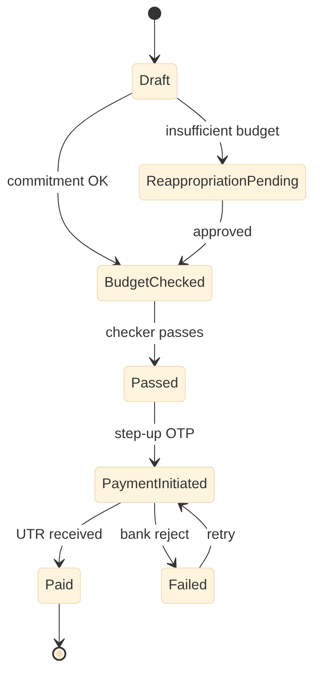
Figure 12. Finance & Accounting: bill states

Scheduled jobs
Job | Schedule | Purpose
daily-control-totals | Daily 23:30 | Compare module totals with ledger (I-09 batch)
bank-recon | Daily 06:00 | Match bank lines to receipts and payments
gst-tds | Monthly | GST TDS on supplier payments
period-close-check | Monthly by 7th | Unposted and suspense items

Configuration and rules
Item | Mechanism | Example
Chart of accounts and mappings | Config (state pack) | NMAM codes, module head mapping
Deduction rules | DMN | TDS, GST TDS 2%, BOCW cess 1%, security deposit
Delegation of financial powers | Config | Approval limits by role

External adapters
ID | System | Purpose
E-04 | Banks | Statement feeds for auto-reconciliation
E-07 | State municipal portals (Telangana: CDMA) | State reporting and service catalogues
E-08 | Treasury, IFMIS, PFMS | Grants, DBT disbursement, treasury reporting
E-13 | Electricity distribution company (Telangana: TGNPDCL) | Energy readings per service connection
E-26 | GST Network (via GST Suvidha Provider) | GSTIN validation, e-invoices, GST and GST TDS returns
E-27 | Income Tax (TRACES / TIN) | TDS returns, certificates and PAN validation
E-28 | Credit rating agencies, stock exchange and debenture trustee | Rating surveillance, bond listing, disclosures and investor servicing
E-39 | Permissioned blockchain (National Blockchain Framework / Vishvasya on NIC, state ledger, or product-hosted) | Anchoring and verification of document and record hashes
E-45 | Building and Other Construction Workers Welfare Board | Labour cess remittance
E-54 | Scheme MIS portals (AMRUT 2.0, Smart Cities Mission, SBM-U, PMAY-U, DAY-NULM, Finance Commission grants) | Physical and financial progress and utilisation reporting
E-56 | Authorised recyclers, RDF buyers, processors and common biomedical waste facilities | Hand-over and sale records for recyclables, RDF, special and biomedical waste
E-57 | MSTC / GeM forward auction | E-auction of surplus, obsolete and scrap items

Security notes: all endpoints require a tenant-scoped token. Ward scope is applied to staff queries. Money, demand and master changes need maker-checker, and step-up OTP above the configured thresholds. Personal data fields are masked in list views and logs.

18.5 9 Document Management System (dms-service)
Item | Design
Service and schema | dms-service, PostgreSQL schema dms, base path /dms/v1
Scope | Multilingual OCR, e-File, eSign, blockchain, DigiLocker
Primary users | All staff; Inward and dispatch clerks; Records clerk; Records officer; Public information officer; Data protection officer; Scanning agency; IT administrator; Citizen
Requirements realised | 31 (DMS-FR-001 to DMS-FR-031), 30 processes (DMS-*)
Interfaces | Provides I-29, I-33; consumes I-16, I-20, I-30, I-34

Data model
Table | Key columns | Notes
document | doc_no, type_id, title, language[], classification, owner_module, owner_ref, ulpin, current_version_id, legal_hold, retention_until | Metadata only; content in object storage
document_version | document_id, version_no, object_key, sha256, mime, pages, ocr_status, signed flag | Immutable versions
ocr_text | version_id, page_no, lang, text, confidence, bbox jsonb | Indexed in OpenSearch
file (e-File) | file_no, subject, section, current_holder, status, priority | Noting and approvals
note | file_id, seq, author, text, signed_at | Green sheet notes
anchor | batch_id, merkle_root, tx_id, chain, anchored_at; doc_hash -> batch | Blockchain anchoring
digilocker_issue | document_id, uri, doc_type, issued_at, status | Issuer push records
retention_rule | type_id, years, trigger, disposal_action | Retention schedule

APIs
Endpoint | Purpose | Processes
POST /dms/v1/documents | Upload with metadata (multipart or pre-signed URL) | DMS-D01, DMS-D02
GET /dms/v1/documents/{id} | Metadata, versions, signed URL to content | DMS-D10
GET /dms/v1/search?q=&lang=&within= | Search across and inside documents with highlights | DMS-D10, DMS-D28
POST /dms/v1/documents/{id}:sign | eSign or DSC; then hash anchoring | DMS-D12, DMS-D29
GET /dms/v1/verify/{hash} | Public verification page (QR) | DMS-D13, DMS-D29
POST /dms/v1/documents/{id}:translate | Translated copy in target language, marked unofficial | DMS-D30
POST /dms/v1/files, POST /dms/v1/files/{id}/notes | e-File and notes | DMS-D11
POST /dms/v1/documents/{id}:legal-hold | Set or release legal hold (I-30) | DMS-D19
GET /dms/v1/dossiers/{ulpin} | Property dossier and ownership chain (I-29) | DMS-D07

Events and interfaces
Direction | Interface | Counterpart | Topic or endpoint
Provides | I-29 | 1 Property Tax & Revenue, 2 Water & Sewerage, 3 Citizen Desk & RTI, 16 Legal Cases | GET /dms/v1/dossiers/{ulpin}
Provides | I-33 | 3 Citizen Desk & RTI | urban.<module>.service-event.v1
Consumes | I-16 | All modules | POST /dms/v1/documents, GET /dms/v1/documents/{id}
Consumes | I-20 | 13 Town Planning | OGC WMS/WFS/Vector tiles /gis/ows
Consumes | I-30 | 16 Legal Cases | urban.lgl.case.status-changed.v1
Consumes | I-34 | 3 Citizen Desk & RTI | urban.grv.rti.requested.v1 / urban.<module>.rti.replied.v1

State model: Document version
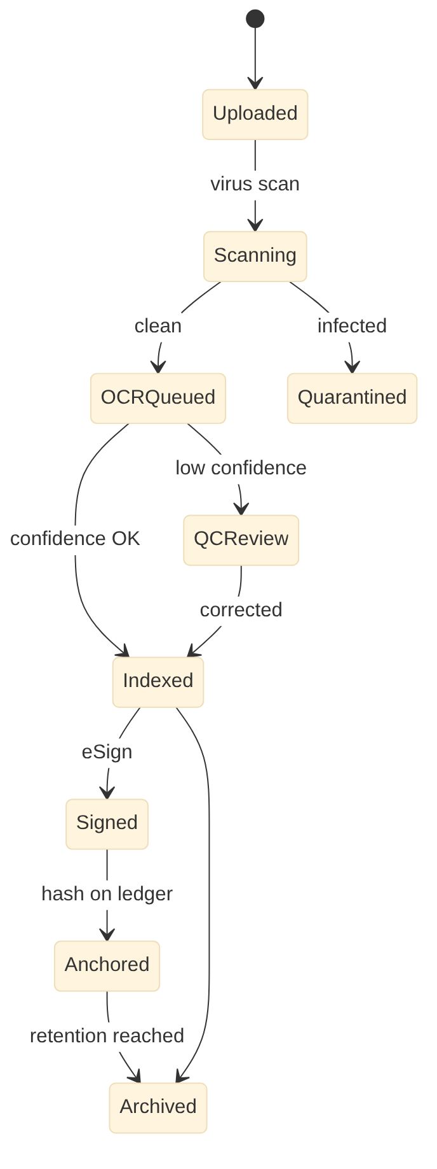
Figure 13. Document Management System: document version states

Scheduled jobs
Job | Schedule | Purpose
ocr-workers | Continuous (queue) | OCR with language detection
anchor-batch | Every 5 min | Merkle batch to blockchain
retention-review | Annual | Weeding list for approval
digilocker-sync | Event driven | Status sync on cancellation

Configuration and rules
Item | Mechanism | Example
Document types | Config | Type, classification, retention, issuer doc type
OCR languages | Config | Per tenant active languages
Anchoring chain | Config | NBF / hosted Fabric endpoint

External adapters
ID | System | Purpose
E-02 | DigiLocker (issuer, requester, Entity Locker, Meri Pehchaan) | Issue and update certificates and licences; fetch citizen and business documents with consent; national login
E-35 | eSign service providers and DSC (CCA-licensed) | Digital signatures, timestamps and validation
E-36 | State or NIC eOffice | e-File exchange where the state mandates eOffice
E-37 | State archives | Transfer of records of archival value
E-38 | Bhashini (National Language Translation Mission) or on-premises Indian language models | Translation, transliteration, speech (IVRS, chatbot) and OCR for Indian languages
E-39 | Permissioned blockchain (National Blockchain Framework / Vishvasya on NIC, state ledger, or product-hosted) | Anchoring and verification of document and record hashes

Security notes: all endpoints require a tenant-scoped token. Ward scope is applied to staff queries. Money, demand and master changes need maker-checker, and step-up OTP above the configured thresholds. Personal data fields are masked in list views and logs.

PART B | PHASE 2 | MONTHS 4 TO 10

19. Phase 2 LLD: Regulation and licensing
5 services: trl-service, uch-service, bpm-service, tpl-service, fnc-service
5 Trade Licence Management
6 User Charges Management
11 Building Permission Management / Integration
13 Town Planning
18 Fire NOC Management

19.0 Phase 2 build notes
- Hand over ward and planning layers from gis-service to tpl-service; migrate data and switch I-20 provider
- Replace the Property Tax OC stub with the real I-03 consumer; reconcile assessments created manually from paper OCs
- Adapters: TG-bPASS, TG-iPASS, state fire service, KUDA/DTCP, LRS/BRS, AAI NOCAS, RERA, Parivesh, police, VAHAN, PM SVANidhi

19.1 5 Trade Licence Management (trl-service)
Item | Design
Service and schema | trl-service, PostgreSQL schema trl, base path /trl/v1
Scope | Licences, MSME and industry, street vending, food trucks
Primary users | Trader / operator / host; Entrepreneur; Street vendor; Town Vending Committee; Licensing inspector; Licensing officer (Health Officer); Verification team; Commissioner
Requirements realised | 26 (TRL-FR-001 to TRL-FR-026), 26 processes (TRL-*)
Interfaces | Provides I-09, I-16, I-17, I-22, I-33; consumes I-04, I-08, I-20, I-24, I-27, I-30, I-32, I-34

Data model
Table | Key columns | Notes
establishment | est_no, name, unit_id, segment_id, area_sqm, trade_category, risk_class, gstin, udyam_no, geom | Published via I-22
licence | licence_no, est_id, type (permanent, temporary, seasonal, PG, homestay), valid_from, valid_to, fee, status, qr | Signed and pushed to DigiLocker
application | app_no, type (new, renew, change, shift, surrender), status, workflow_id | All licence applications
inspection | est_id, type (risk, drive), checklist jsonb, findings, photos, geom | Field app
vendor | vendor_id, survey_ref, category, zone_id, cov_no, id_card_no, svanidhi_ref | Street vendors and food trucks
vending_zone | zone_id, type (free, restricted, no-vending), capacity, geom, tvc_resolution | Vending plan
fee_schedule_ref | rule_version, category, road_class, area_band | Rules live in DMN

APIs
Endpoint | Purpose | Processes
POST /trl/v1/applications | New, renewal, change, shift, surrender | TRL-T01-T11, TRL-T21
POST /trl/v1/applications/{id}:approve|reject | Workflow; checks Fire NOC (I-04) for risk classes | TRL-T01, TRL-T16
GET /trl/v1/licences/{no} | Licence and status (verification by QR) | TRL-T18
POST /trl/v1/inspections | Inspection and drive results | TRL-T12-T14
POST /trl/v1/vendors | Register surveyed vendor; issue certificate of vending | TRL-T22-T24
GET /trl/v1/vending-zones | Zones with capacity for map | TRL-T23

Events and interfaces
Direction | Interface | Counterpart | Topic or endpoint
Provides | I-09 | 4 Finance & Accounting | urban.<module>.demand.raised.v1, urban.<module>.receipt.created.v1
Provides | I-16 | 9 Document Management | POST /dms/v1/documents, GET /dms/v1/documents/{id}
Provides | I-17 | 16 Legal Cases | POST /lgl/v1/cases
Provides | I-22 | 1 Property Tax & Revenue, 6 User Charges, 7 Solid Waste, 18 Fire NOC | urban.trl.establishment.changed.v1
Provides | I-33 | 3 Citizen Desk & RTI | urban.<module>.service-event.v1
Consumes | I-04 | 18 Fire NOC | GET /fnc/v1/nocs/verify?ulpin=&use=
Consumes | I-08 | 3 Citizen Desk & RTI | urban.grv.service-request.routed.v1 / urban.<module>.service-request.updated.v1
Consumes | I-20 | 13 Town Planning | OGC WMS/WFS/Vector tiles /gis/ows
Consumes | I-24 | 4 Finance & Accounting | urban.fin.receipt.realised.v1
Consumes | I-27 | 1 Property Tax & Revenue | GET /ptx/v1/parcels/{ulpin}
Consumes | I-30 | 16 Legal Cases | urban.lgl.case.status-changed.v1
Consumes | I-32 | 10 Engineering Projects | GET /eng/v1/roads?bbox=, OGC layer roads
Consumes | I-34 | 3 Citizen Desk & RTI | urban.grv.rti.requested.v1 / urban.<module>.rti.replied.v1

State model: Licence
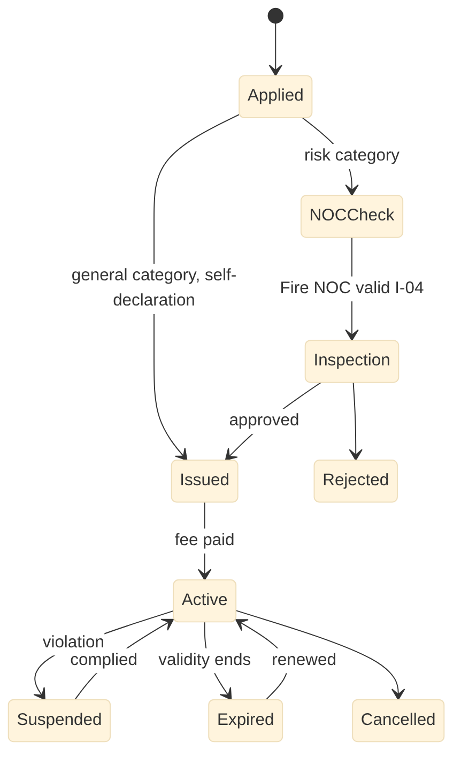
Figure 14. Trade Licence Management: licence states

Scheduled jobs
Job | Schedule | Purpose
renewal-reminders | Daily | Reminders 30 and 7 days before expiry
expiry | Daily 00:10 | Expire and notify
unlicensed-detection | Monthly | Match property usage, GST and complaints

Configuration and rules
Item | Mechanism | Example
Fee rules | DMN | Category x area band x road class
Risk classes needing NOC | Config | Dangerous and offensive trades list
Vending fees | DMN | By zone and vendor type

External adapters
ID | System | Purpose
E-02 | DigiLocker (issuer, requester, Entity Locker, Meri Pehchaan) | Issue and update certificates and licences; fetch citizen and business documents with consent; national login
E-03 | Payment gateway, UPI, BBPS | Online payments and bill presentment
E-18 | State municipal tax platform adapter (Telangana: CDMA eMunicipal by CGG) | Two-way sync of assessments, state assessment numbers, demand, receipts, mutations where the state platform is system of record
E-29 | Online accommodation listings and tourism/police registrations (where data sharing exists) | Detect unlicensed or undeclared paying guest, homestay and short-term rental use
E-30 | Udyam (MSME) and Startup India recognition | Verify MSME and startup status for concessions
E-31 | State industrial single window (Telangana: TG-iPASS) | Industry applications and status for municipal licences
E-32 | PM SVANidhi portal | Street vendor credit and digital-payment status
E-39 | Permissioned blockchain (National Blockchain Framework / Vishvasya on NIC, state ledger, or product-hosted) | Anchoring and verification of document and record hashes

Security notes: all endpoints require a tenant-scoped token. Ward scope is applied to staff queries. Money, demand and master changes need maker-checker, and step-up OTP above the configured thresholds. Personal data fields are masked in list views and logs.

19.2 6 User Charges Management (uch-service)
Item | Design
Service and schema | uch-service, PostgreSQL schema uch, base path /uch/v1
Scope | SWM charges, parking, park bookings, events, processions
Primary users | Citizen / business / organiser; Motorist and fleet operator; Parking contractor; Sanitary inspector; Sanitation staff; Revenue officer; Commissioner
Requirements realised | 22 (UCH-FR-001 to UCH-FR-022), 23 processes (UCH-*)
Interfaces | Provides I-09, I-16, I-17, I-33, I-36; consumes I-06, I-08, I-20, I-22, I-24, I-27, I-30, I-32, I-34, I-35

Data model
Table | Key columns | Notes
charge_account | account_no, payer (unit, establishment, BWG, vendor), category, rate_ref, status | One per payer and charge type
charge_demand | account_id, period, amount, basis (flat, service-linked), status | Monthly or combined bill
booking | booking_no, venue_ref (park, ground, hall, lot, road stretch), purpose, from_ts, to_ts, fee, deposit, status | Parks, grounds, processions
procession_route | booking_id, route geom (LineString), police_noc, traffic_noc, fire_noc | Religious processions
parking_permit | permit_no, vehicle_no (VAHAN-verified), lot_id, type (daily, monthly), valid_to | Parking
service_order | booking_id, module (2, 7, 10, 12), order_type, status | I-36
spot_fine | fine_no, offence, amount, geom, photo, officer | Spot fines
deposit | booking_id, amount, held_in_fin_ref, refund_status | Refundable deposits

APIs
Endpoint | Purpose | Processes
POST /uch/v1/accounts | Auto-registration from property, licence, BWG events | UCH-U01-U03
POST /uch/v1/demand-runs | Generate charges | UCH-U05, UCH-U06
GET /uch/v1/accounts/{no}/dues | Dues for payment | UCH-U08
POST /uch/v1/bookings | Booking with availability check (I-35) and NOCs | UCH-U19, UCH-U22
POST /uch/v1/bookings/{id}:confirm|inspect|refund | Lifecycle | UCH-U19, UCH-U23
POST /uch/v1/parking-permits | Parking permit with VAHAN check | UCH-U21
POST /uch/v1/spot-fines | Field fine with photo | UCH-U09

Events and interfaces
Direction | Interface | Counterpart | Topic or endpoint
Provides | I-09 | 4 Finance & Accounting | urban.<module>.demand.raised.v1, urban.<module>.receipt.created.v1
Provides | I-16 | 9 Document Management | POST /dms/v1/documents, GET /dms/v1/documents/{id}
Provides | I-17 | 16 Legal Cases | POST /lgl/v1/cases
Provides | I-33 | 3 Citizen Desk & RTI | urban.<module>.service-event.v1
Provides | I-36 | 2 Water & Sewerage, 7 Solid Waste, 10 Engineering Projects, 12 Street Lights | urban.uch.event-service-order.issued.v1
Consumes | I-06 | 7 Solid Waste | urban.swm.collection.daily-status.v1
Consumes | I-08 | 3 Citizen Desk & RTI | urban.grv.service-request.routed.v1 / urban.<module>.service-request.updated.v1
Consumes | I-20 | 13 Town Planning | OGC WMS/WFS/Vector tiles /gis/ows
Consumes | I-22 | 5 Trade Licence | urban.trl.establishment.changed.v1
Consumes | I-24 | 4 Finance & Accounting | urban.fin.receipt.realised.v1
Consumes | I-27 | 1 Property Tax & Revenue | GET /ptx/v1/parcels/{ulpin}
Consumes | I-30 | 16 Legal Cases | urban.lgl.case.status-changed.v1
Consumes | I-32 | 10 Engineering Projects | GET /eng/v1/roads?bbox=, OGC layer roads
Consumes | I-34 | 3 Citizen Desk & RTI | urban.grv.rti.requested.v1 / urban.<module>.rti.replied.v1
Consumes | I-35 | 14 Parks & Horticulture, 15 Municipal Property | GET /prk/v1/venues/availability, GET /mpm/v1/venues/availability

State model: Booking
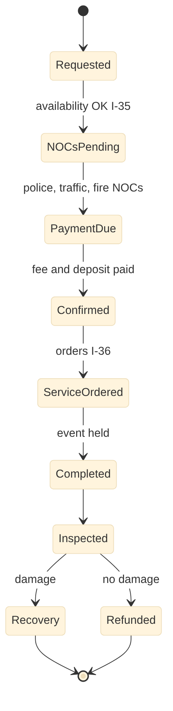
Figure 15. User Charges Management: booking states

Scheduled jobs
Job | Schedule | Purpose
demand-run | Monthly | Service-linked and flat charges
swm-status-ingest | Nightly | Consume I-06 batch
deposit-refund | Daily | Refund after clean inspection

Configuration and rules
Item | Mechanism | Example
Charge rates | DMN | By category, generator type, waste quantity
Venue rules | Config | Capacity, blackout dates, festival windows
Parking tariffs | DMN | By lot, vehicle type, duration

External adapters
ID | System | Purpose
E-02 | DigiLocker (issuer, requester, Entity Locker, Meri Pehchaan) | Issue and update certificates and licences; fetch citizen and business documents with consent; national login
E-03 | Payment gateway, UPI, BBPS | Online payments and bill presentment
E-32 | PM SVANidhi portal | Street vendor credit and digital-payment status
E-33 | VAHAN vehicle registry and traffic police e-challan / towing | Vehicle details for parking passes and fines; towing and clamping records
E-34 | Police permission and NOC systems (Telangana: TSCOP / police portal) | Police, traffic and fire NOCs for processions, festivals and gatherings

Security notes: all endpoints require a tenant-scoped token. Ward scope is applied to staff queries. Money, demand and master changes need maker-checker, and step-up OTP above the configured thresholds. Personal data fields are masked in list views and logs.

19.3 11 Building Permission Management / Integration (bpm-service)
Item | Design
Service and schema | bpm-service, PostgreSQL schema bpm, base path /bpm/v1
Scope | eDCR, buffer-zone NOCs, permits, RWH, occupancy
Primary users | Applicant / owner; Licensed technical person (architect, engineer); Building overseer; Third-party inspector; Town Planning Officer; Commissioner; NOC agencies
Requirements realised | 25 (BPM-FR-001 to BPM-FR-025), 22 processes (BPM-*)
Interfaces | Provides I-02, I-03, I-10, I-16, I-17, I-21, I-33, I-40, I-41; consumes I-01, I-08, I-20, I-27, I-30, I-32, I-34, I-43

Data model
Table | Key columns | Notes
application | app_no, ulpin, category (registration, instant, single window, high-rise), plot_area, height_m, floors, status, mode (full, integrate), state_ref | TG-bPASS reference in integrate mode
drawing_set | app_id, version, dxf_object_key, edcr_report jsonb, result | eDCR scrutiny
noc_request | app_id, authority (fire, lake, airport, forest, heritage, groundwater, railways), status, ref_no, decided_at | Parallel NOCs
fee_line | app_id, head (permit, betterment, cess, impact, TDR), amount, paid | Fees and cess
mortgage | app_id, unit_ref (10% built-up), deed_ref, released_at | Release at OC
inspection | app_id, stage (pre, plinth, slab, completion), findings, photos, geom | Field app
permit | permit_no, app_id, valid_to, deemed flag, conditions | Signed and anchored
rwh_certificate | app_id, capacity, inspected_at, status (issued, lapsed, failed) | I-40
occupancy_certificate | oc_no, app_id, units jsonb, issued_at | Triggers I-03

APIs
Endpoint | Purpose | Processes
POST /bpm/v1/pre-checks | Pre-application check and fee estimate | BPM-B02
POST /bpm/v1/applications | Submit application with drawings | BPM-B03, BPM-B04
POST /bpm/v1/applications/{id}/drawings:scrutinise | Run eDCR scrutiny | BPM-B05
POST /bpm/v1/applications/{id}/nocs | Raise parallel NOC requests | BPM-B06, BPM-B21, BPM-B22
POST /bpm/v1/applications/{id}:approve|shortfall|reject | Decision; deemed approval timer | BPM-B10, BPM-B11
POST /bpm/v1/applications/{id}/inspections | Stage inspections | BPM-B08, BPM-B12
POST /bpm/v1/applications/{id}/occupancy | Issue OC; publishes I-03 | BPM-B15, BPM-B16
POST /bpm/v1/applications/{id}/rwh-certificate | RWH certificate | BPM-B20

Events and interfaces
Direction | Interface | Counterpart | Topic or endpoint
Provides | I-02 | 18 Fire NOC | urban.bpm.fire-noc.requested.v1 / urban.fnc.noc.decided.v1
Provides | I-03 | 1 Property Tax & Revenue | urban.bpm.occupancy-certificate.issued.v1
Provides | I-10 | 4 Finance & Accounting | urban.<module>.fee.paid.v1
Provides | I-16 | 9 Document Management | POST /dms/v1/documents, GET /dms/v1/documents/{id}
Provides | I-17 | 16 Legal Cases | POST /lgl/v1/cases
Provides | I-21 | 13 Town Planning | urban.bpm.unauthorised-construction.detected.v1
Provides | I-33 | 3 Citizen Desk & RTI | urban.<module>.service-event.v1
Provides | I-40 | 1 Property Tax & Revenue, 2 Water & Sewerage | urban.bpm.rwh-certificate.changed.v1
Provides | I-41 | 7 Solid Waste | urban.bpm.cnd-plan.approved.v1, urban.eng.cnd-plan.approved.v1
Consumes | I-01 | 13 Town Planning | GET /tpl/v1/plots/{ulpin}/development-control
Consumes | I-08 | 3 Citizen Desk & RTI | urban.grv.service-request.routed.v1 / urban.<module>.service-request.updated.v1
Consumes | I-20 | 13 Town Planning | OGC WMS/WFS/Vector tiles /gis/ows
Consumes | I-27 | 1 Property Tax & Revenue | GET /ptx/v1/parcels/{ulpin}
Consumes | I-30 | 16 Legal Cases | urban.lgl.case.status-changed.v1
Consumes | I-32 | 10 Engineering Projects | GET /eng/v1/roads?bbox=, OGC layer roads
Consumes | I-34 | 3 Citizen Desk & RTI | urban.grv.rti.requested.v1 / urban.<module>.rti.replied.v1
Consumes | I-43 | 19 Government Schemes | urban.gsc.housing-permission.requested.v1 / urban.bpm.permit.issued.v1

State model: Building permission application
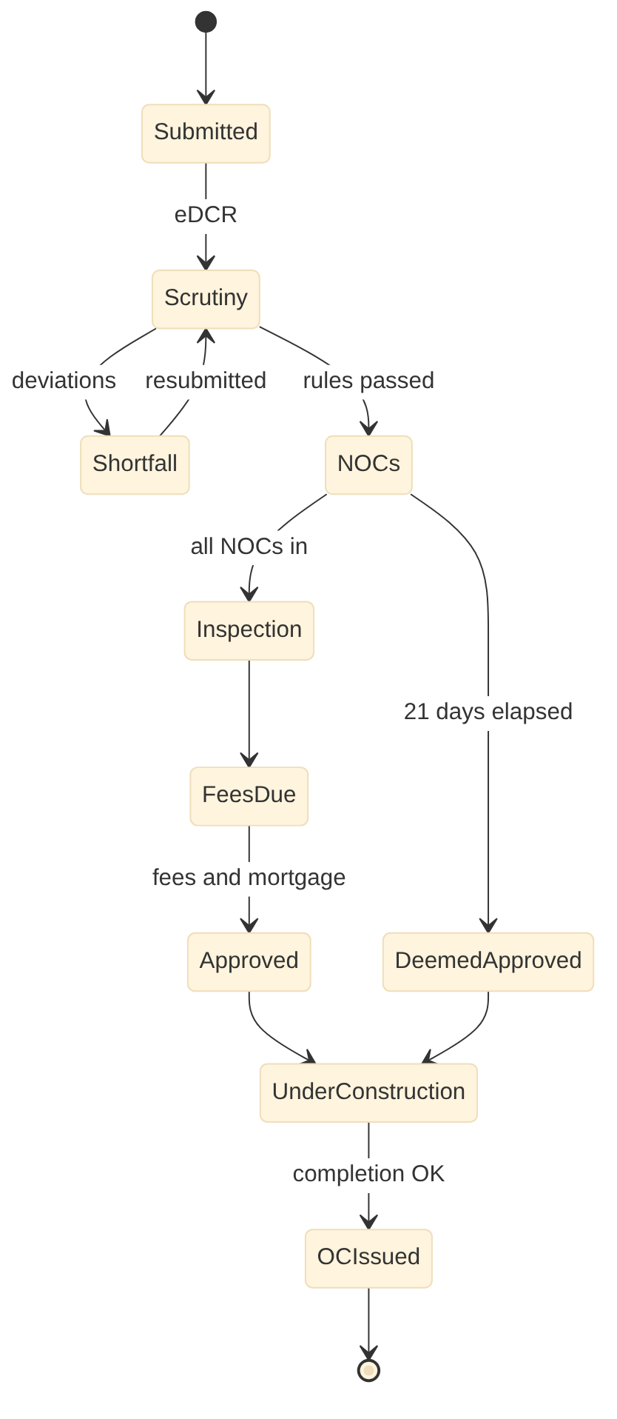
Figure 16. Building Permission Management / Integration: building permission application states

Scheduled jobs
Job | Schedule | Purpose
deemed-approval-timer | Hourly | Flag and issue deemed approvals per state rule
tgbpass-sync | Every 5 min | Integrate mode sync
imagery-change | Per survey | Compare imagery with permits (I-21)

Configuration and rules
Item | Mechanism | Example
Category thresholds | Config (state pack) | 75 sq yd, 600 sq yd / 10 m, high-rise
Development control rules for eDCR | Rule set | Setbacks, FAR, parking, height
Fee and cess rules | DMN | Permit fee, BOCW cess 1%

External adapters
ID | System | Purpose
E-02 | DigiLocker (issuer, requester, Entity Locker, Meri Pehchaan) | Issue and update certificates and licences; fetch citizen and business documents with consent; national login
E-03 | Payment gateway, UPI, BBPS | Online payments and bill presentment
E-05 | State building permission system (Telangana: TG-bPASS) | Building permission data or workflow
E-11 | Bhuvan (incl. CartoDEM), Survey of India (incl. high-resolution DEM), drone and LiDAR surveys | Base maps, imagery, elevation models and survey data
E-31 | State industrial single window (Telangana: TG-iPASS) | Industry applications and status for municipal licences
E-39 | Permissioned blockchain (National Blockchain Framework / Vishvasya on NIC, state ledger, or product-hosted) | Anchoring and verification of document and record hashes
E-40 | Urban development authority and state town planning department (Telangana: KUDA, DTCP) | Master plan layers, variations and layout or permission referrals
E-43 | Airports Authority of India NOCAS | Height clearance near airports
E-44 | State RERA | Project registration and permit details
E-45 | Building and Other Construction Workers Welfare Board | Labour cess remittance
E-46 | Parivesh / SEIAA environmental clearance | Clearance status for large projects
E-47 | Council of Architecture and state engineer registers | Licensed professional verification
E-50 | State irrigation, revenue and water resources departments / lake protection authority / wetland authority (Telangana: Irrigation & CAD; HYDRAA in Hyderabad) | Certified FTL, river, drain, wetland and flood zone boundaries; NOCs
E-51 | State forest department and tree authority (Telangana: Forest Department; WALTA) | Forest, urban forest park and eco-sensitive zone boundaries; tree felling permissions
E-52 | Central Ground Water Authority / state groundwater department | Groundwater NOCs for large projects
E-53 | Other buffer-zone authorities (railways, NHAI and state roads, power utilities, pipeline operators, Local Military Authority, pollution control board) | Zone boundaries and NOCs for plots in their buffers

Security notes: all endpoints require a tenant-scoped token. Ward scope is applied to staff queries. Money, demand and master changes need maker-checker, and step-up OTP above the configured thresholds. Personal data fields are masked in list views and logs.

19.4 13 Town Planning (tpl-service)
Item | Design
Service and schema | tpl-service, PostgreSQL schema tpl, base path /tpl/v1
Scope | Zoning, layouts, LRS and BRS, TDR, enforcement
Primary users | Town Planning Officer; Building overseer / enforcement team; GIS cell; Developer and licensed technical person; Applicant / owner; Advertising agency; Telecom operator; Council
Requirements realised | 24 (TPL-FR-001 to TPL-FR-024), 23 processes (TPL-*)
Interfaces | Provides I-01, I-10, I-16, I-17, I-20, I-33, I-37, I-38; consumes I-08, I-21, I-28, I-30, I-32, I-34

Data model
Table | Key columns | Notes
plan_layer | layer_code (master plan, zoning, buffer), version, effective_from, source_go, geom | Versioned planning layers
dc_rule | rule_set_version, zone, use, parameter, value | Development control rules
layout | layout_no, applicant, area, plots_count, status, geom | Layout permissions
plot | layout_id, plot_no, area, use, geom, ulpin_ref | Published via I-37
open_space | layout_id, area, deed_ref, handed_to (14, 15), geom | I-38
enforcement_case | case_no, ulpin, violation, detected_by, notice_at, status, lgl_case_ref | Unauthorised construction
regularisation | scheme (LRS, BRS), app_no, ulpin, penalty, status | LRS and BRS
tdr_certificate | tdr_no, origin_ulpin, area, utilised jsonb, balance | TDR bank
hoarding / tower | permit_no, location geom, size, fee, valid_to | Advertisements and towers

APIs
Endpoint | Purpose | Processes
GET /tpl/v1/plots/{ulpin}/development-control | Zoning, buffers, widening line, TDR for scrutiny (I-01) | TPL-P03
POST /tpl/v1/land-use-certificates | Zoning check and certificate | TPL-P03
POST /tpl/v1/layouts | Layout application | TPL-P07
POST /tpl/v1/layouts/{id}:approve|final-approve | Approval; final approval publishes I-37, I-38 | TPL-P07-P09
POST /tpl/v1/enforcement-cases | Open case from imagery, complaint or referral | TPL-P13, TPL-P14
POST /tpl/v1/regularisations | LRS or BRS application | TPL-P11, TPL-P12
POST /tpl/v1/tdr | Issue and utilise TDR | TPL-P15

Events and interfaces
Direction | Interface | Counterpart | Topic or endpoint
Provides | I-01 | 11 Building Permission | GET /tpl/v1/plots/{ulpin}/development-control
Provides | I-10 | 4 Finance & Accounting | urban.<module>.fee.paid.v1
Provides | I-16 | 9 Document Management | POST /dms/v1/documents, GET /dms/v1/documents/{id}
Provides | I-17 | 16 Legal Cases | POST /lgl/v1/cases
Provides | I-20 | 1 Property Tax & Revenue, 2 Water & Sewerage, 3 Citizen Desk & RTI, 5 Trade Licence, 6 User Charges, 7 Solid Waste, 9 Document Management, 10 Engineering Projects, 11 Building Permission, 12 Street Lights, 14 Parks & Horticulture, 15 Municipal Property, 18 Fire NOC | OGC WMS/WFS/Vector tiles /gis/ows
Provides | I-33 | 3 Citizen Desk & RTI | urban.<module>.service-event.v1
Provides | I-37 | 1 Property Tax & Revenue | urban.tpl.layout.approved.v1, urban.tpl.door-number.assigned.v1
Provides | I-38 | 14 Parks & Horticulture, 15 Municipal Property | urban.tpl.open-space.handed-over.v1
Consumes | I-08 | 3 Citizen Desk & RTI | urban.grv.service-request.routed.v1 / urban.<module>.service-request.updated.v1
Consumes | I-21 | 11 Building Permission | urban.bpm.unauthorised-construction.detected.v1
Consumes | I-28 | 1 Property Tax & Revenue | urban.ptx.setback-deviation.referred.v1 / urban.tpl.regularisation.decided.v1
Consumes | I-30 | 16 Legal Cases | urban.lgl.case.status-changed.v1
Consumes | I-32 | 10 Engineering Projects | GET /eng/v1/roads?bbox=, OGC layer roads
Consumes | I-34 | 3 Citizen Desk & RTI | urban.grv.rti.requested.v1 / urban.<module>.rti.replied.v1

State model: Enforcement case
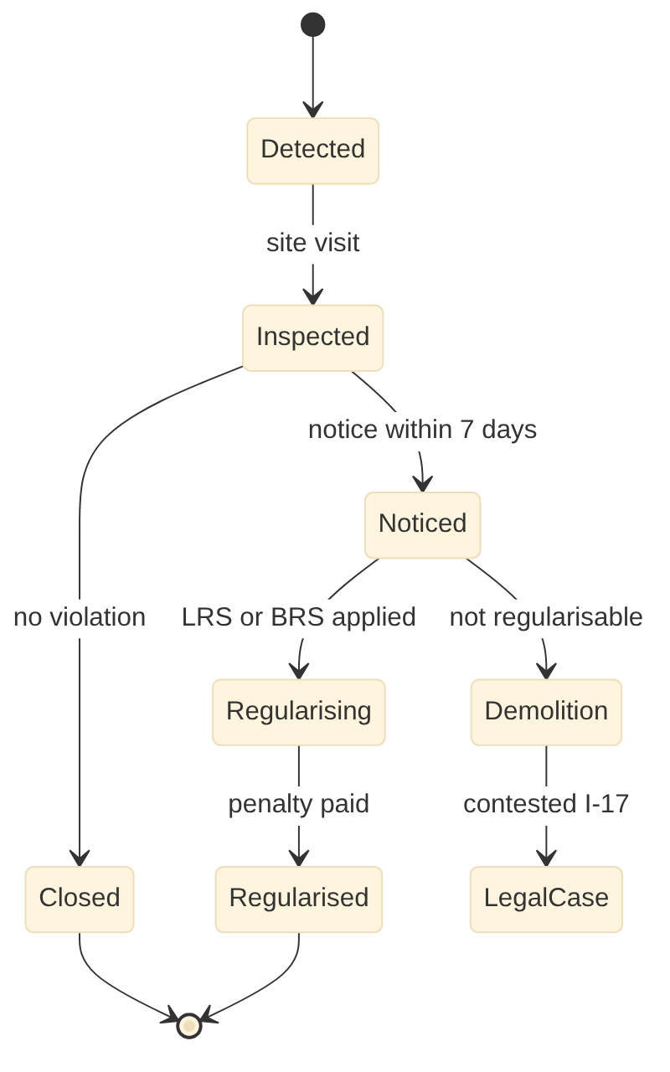
Figure 17. Town Planning: enforcement case states

Scheduled jobs
Job | Schedule | Purpose
layer-publish | On approval | Publish layers to GeoServer
buffer-recompute | On layer change | Recompute buffer polygons
notice-timer | Daily | Notice due within 7 days

Configuration and rules
Item | Mechanism | Example
DC rules | Rule set (state pack) | Telangana building rules
Buffer catalogue | Config | FTL 30 m / 9 m, rivers 50 m, nalas
Charges | DMN | Development, impact, open space charges

External adapters
ID | System | Purpose
E-11 | Bhuvan (incl. CartoDEM), Survey of India (incl. high-resolution DEM), drone and LiDAR surveys | Base maps, imagery, elevation models and survey data
E-17 | State land records / ULPIN registry | ULPIN and land parcel data
E-40 | Urban development authority and state town planning department (Telangana: KUDA, DTCP) | Master plan layers, variations and layout or permission referrals
E-41 | GatiShakti Sanchar (telecom right-of-way portal) | Tower, pole and cable right-of-way applications
E-42 | State layout and building regularisation portal (Telangana: LRS / BRS) | Regularisation applications and registration intimations
E-50 | State irrigation, revenue and water resources departments / lake protection authority / wetland authority (Telangana: Irrigation & CAD; HYDRAA in Hyderabad) | Certified FTL, river, drain, wetland and flood zone boundaries; NOCs
E-51 | State forest department and tree authority (Telangana: Forest Department; WALTA) | Forest, urban forest park and eco-sensitive zone boundaries; tree felling permissions
E-53 | Other buffer-zone authorities (railways, NHAI and state roads, power utilities, pipeline operators, Local Military Authority, pollution control board) | Zone boundaries and NOCs for plots in their buffers

Security notes: all endpoints require a tenant-scoped token. Ward scope is applied to staff queries. Money, demand and master changes need maker-checker, and step-up OTP above the configured thresholds. Personal data fields are masked in list views and logs.

19.5 18 Fire NOC Management (fnc-service)
Item | Design
Service and schema | fnc-service, PostgreSQL schema fnc, base path /fnc/v1
Scope | Provisional and final NOC, audits, fire-risk map
Primary users | Applicant / owner / RWA; Architect and fire consultant; Inspection committee; Fire officer (DFO, RFO, DG); Empanelled auditor; Organiser or trader
Requirements realised | 18 (FNC-FR-001 to FNC-FR-018), 17 processes (FNC-*)
Interfaces | Provides I-04, I-10, I-16, I-17, I-33; consumes I-02, I-08, I-20, I-22, I-27, I-30, I-32, I-34, I-39

Data model
Table | Key columns | Notes
noc_application | app_no, type (provisional, final, renewal, establishment, temporary), ulpin, height_m, occupancy_class, status, state_ref | Integrate mode with state fire service
applicability_rule | version, occupancy, height_from, area_from, required flag | Telangana residential from 24 m
inspection | app_id, checklist jsonb, deficiencies jsonb, inspector, geom, photos | Checklist by occupancy
noc | noc_no, app_id, valid_to, conditions, status | Register and verification (I-04)
audit_report | noc_id, auditor, date, findings | Third-party audits
iot_device | noc_id, device_type, last_seen, status | Optional IoT monitoring
incident | incident_no, ulpin, date, cause, loss, review | Fire incidents

APIs
Endpoint | Purpose | Processes
POST /fnc/v1/applications | NOC application (from BPM event or direct) | FNC-N03-N06, FNC-N12
GET /fnc/v1/applicability?height=&use=&area= | Applicability check | FNC-N02
POST /fnc/v1/applications/{id}/inspections | Inspection with checklist | FNC-N07, FNC-N08
POST /fnc/v1/applications/{id}:issue|reject | Issue or reject NOC | FNC-N04
GET /fnc/v1/nocs/verify | Verification for Trade Licence (I-04) | FNC-N14
GET /fnc/v1/risk-map | Fire-risk layer | FNC-N15

Events and interfaces
Direction | Interface | Counterpart | Topic or endpoint
Provides | I-04 | 5 Trade Licence | GET /fnc/v1/nocs/verify?ulpin=&use=
Provides | I-10 | 4 Finance & Accounting | urban.<module>.fee.paid.v1
Provides | I-16 | 9 Document Management | POST /dms/v1/documents, GET /dms/v1/documents/{id}
Provides | I-17 | 16 Legal Cases | POST /lgl/v1/cases
Provides | I-33 | 3 Citizen Desk & RTI | urban.<module>.service-event.v1
Consumes | I-02 | 11 Building Permission | urban.bpm.fire-noc.requested.v1 / urban.fnc.noc.decided.v1
Consumes | I-08 | 3 Citizen Desk & RTI | urban.grv.service-request.routed.v1 / urban.<module>.service-request.updated.v1
Consumes | I-20 | 13 Town Planning | OGC WMS/WFS/Vector tiles /gis/ows
Consumes | I-22 | 5 Trade Licence | urban.trl.establishment.changed.v1
Consumes | I-27 | 1 Property Tax & Revenue | GET /ptx/v1/parcels/{ulpin}
Consumes | I-30 | 16 Legal Cases | urban.lgl.case.status-changed.v1
Consumes | I-32 | 10 Engineering Projects | GET /eng/v1/roads?bbox=, OGC layer roads
Consumes | I-34 | 3 Citizen Desk & RTI | urban.grv.rti.requested.v1 / urban.<module>.rti.replied.v1
Consumes | I-39 | 2 Water & Sewerage | OGC layer hydrants, GET /wtr/v1/hydrants?bbox=

State model: Fire NOC application
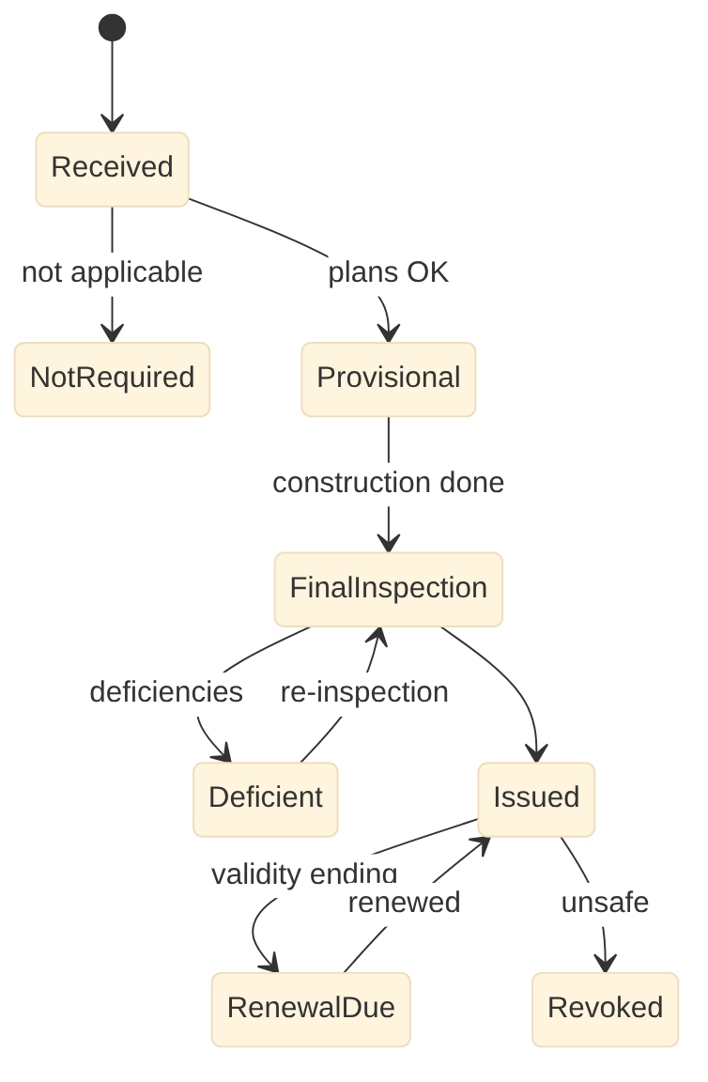
Figure 18. Fire NOC Management: fire noc application states

Scheduled jobs
Job | Schedule | Purpose
renewal-due | Daily | Renewal notices
risk-map-refresh | Weekly | Recompute risk with hydrants (I-39)
state-sync | Every 5 min | Integrate mode sync

Configuration and rules
Item | Mechanism | Example
Applicability | Config (state pack) | Height and occupancy thresholds
Checklists | Config | By occupancy class
Fees | DMN | By area and height

External adapters
ID | System | Purpose
E-02 | DigiLocker (issuer, requester, Entity Locker, Meri Pehchaan) | Issue and update certificates and licences; fetch citizen and business documents with consent; national login
E-03 | Payment gateway, UPI, BBPS | Online payments and bill presentment
E-06 | State fire services (Telangana Fire Services) | NOC processing and records
E-11 | Bhuvan (incl. CartoDEM), Survey of India (incl. high-resolution DEM), drone and LiDAR surveys | Base maps, imagery, elevation models and survey data
E-31 | State industrial single window (Telangana: TG-iPASS) | Industry applications and status for municipal licences
E-34 | Police permission and NOC systems (Telangana: TSCOP / police portal) | Police, traffic and fire NOCs for processions, festivals and gatherings
E-39 | Permissioned blockchain (National Blockchain Framework / Vishvasya on NIC, state ledger, or product-hosted) | Anchoring and verification of document and record hashes
E-48 | PESO and district explosives licensing | Firecracker and explosives licences for temporary stalls
E-49 | Fire command centre and building IoT monitoring | Fire pump, tank and generator status from monitored buildings

Security notes: all endpoints require a tenant-scoped token. Ward scope is applied to staff queries. Money, demand and master changes need maker-checker, and step-up OTP above the configured thresholds. Personal data fields are masked in list views and logs.

PART B | PHASE 3 | MONTHS 8 TO 14

20. Phase 3 LLD: Field operations
5 services: swm-service, eng-service, slm-service, prk-service, inv-service
7 Solid Waste Management
10 Engineering Project Management System
12 Street Light Management
14 Parks & Horticulture Management
17 Inventory & Stores Management

20.0 Phase 3 build notes
- Field app plug-ins for SWM gate scans, e-MB, pole repairs, tree inspections; offline sync load tested
- Road register moves from gis-service to eng-service (I-32); park availability from the uch calendar to prk-service (I-35)
- Adapters: AVLS/GPS, CCMS, DISCOM, CPCB portals, GeM, e-procurement, MSTC

20.1 7 Solid Waste Management (swm-service)
Item | Design
Service and schema | swm-service, PostgreSQL schema swm, base path /swm/v1
Scope | Four streams, collection, processing, C&D, star rating
Primary users | Sanitary Inspector; Collection crew and driver; Sanitation worker and supervisor; Transfer station and plant operators; Environmental engineer; Health Officer; Partner agencies
Requirements realised | 19 (SWM-FR-001 to SWM-FR-019), 17 processes (SWM-*)
Interfaces | Provides I-06, I-09, I-14, I-16, I-17, I-33; consumes I-08, I-15, I-20, I-22, I-27, I-30, I-32, I-34, I-36, I-41

Data model
Table | Key columns | Notes
generator | gen_no, type (household, BWG, commercial, institution), unit_or_est ref, qr_tag, ebwgr_ref | Registered generators
route / beat | route_no, vehicle_id, ward_id, geom, schedule | Collection routes and sweeping beats
collection_event | gen_id, route_id, scanned_at, segregated (wet, dry, sanitary, special), geom | Gate scans; daily status to I-06
vehicle_trip | vehicle_id, trip_no, start, end, gps_track ref, weighbridge_in, weighbridge_out | From AVLS
facility | facility_id, type (compost, biogas, MRF, C&D, landfill), capacity_tpd | Processing facilities
facility_ledger | facility_id, date, inflow_t, processed_t, rejects_t, outputs jsonb | Mass balance
gvp | point_id, geom, status, last_cleared | Garbage vulnerable points
enforcement | fine_no, gen_id, offence, amount | Spot fines and compensation

APIs
Endpoint | Purpose | Processes
POST /swm/v1/generators | Register generator and BWG | SWM-S01
POST /swm/v1/collection-events:batch | Gate scans from field app | SWM-S02, SWM-S03
GET /swm/v1/routes/{id}/live | Live route progress (AVLS) | SWM-S06
POST /swm/v1/facilities/{id}/ledger | Weighbridge and processing entries | SWM-S07-S09
POST /swm/v1/enforcement | Spot fine | SWM-S14
GET /swm/v1/reports/cpcb/{period} | CPCB return pack | SWM-S15

Events and interfaces
Direction | Interface | Counterpart | Topic or endpoint
Provides | I-06 | 6 User Charges | urban.swm.collection.daily-status.v1
Provides | I-09 | 4 Finance & Accounting | urban.<module>.demand.raised.v1, urban.<module>.receipt.created.v1
Provides | I-14 | 17 Inventory & Stores | POST /inv/v1/indents
Provides | I-16 | 9 Document Management | POST /dms/v1/documents, GET /dms/v1/documents/{id}
Provides | I-17 | 16 Legal Cases | POST /lgl/v1/cases
Provides | I-33 | 3 Citizen Desk & RTI | urban.<module>.service-event.v1
Consumes | I-08 | 3 Citizen Desk & RTI | urban.grv.service-request.routed.v1 / urban.<module>.service-request.updated.v1
Consumes | I-15 | 8 Payroll & HR | urban.hrm.roster.published.v1 / urban.<module>.attendance.captured.v1
Consumes | I-20 | 13 Town Planning | OGC WMS/WFS/Vector tiles /gis/ows
Consumes | I-22 | 5 Trade Licence | urban.trl.establishment.changed.v1
Consumes | I-27 | 1 Property Tax & Revenue | GET /ptx/v1/parcels/{ulpin}
Consumes | I-30 | 16 Legal Cases | urban.lgl.case.status-changed.v1
Consumes | I-32 | 10 Engineering Projects | GET /eng/v1/roads?bbox=, OGC layer roads
Consumes | I-34 | 3 Citizen Desk & RTI | urban.grv.rti.requested.v1 / urban.<module>.rti.replied.v1
Consumes | I-36 | 6 User Charges | urban.uch.event-service-order.issued.v1
Consumes | I-41 | 10 Engineering Projects, 11 Building Permission | urban.bpm.cnd-plan.approved.v1, urban.eng.cnd-plan.approved.v1

State model: Collection status per generator per day
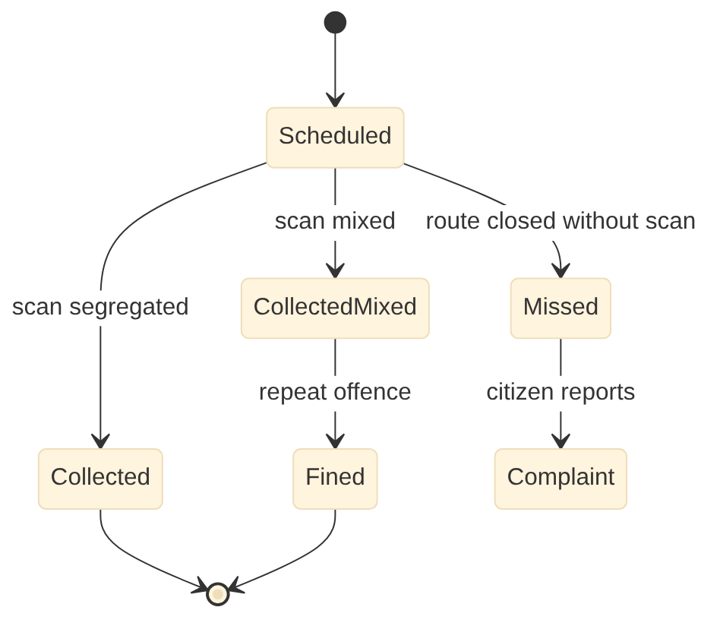
Figure 19. Solid Waste Management: collection status per generator per day states

Scheduled jobs
Job | Schedule | Purpose
daily-status | Nightly 23:00 | Publish I-06 batch
avls-ingest | Every 1 min | Vehicle positions
mass-balance | Daily | Facility balance and alerts

Configuration and rules
Item | Mechanism | Example
Streams and colours | Config | Four streams per SWM Rules 2026
BWG thresholds | Config | 20,000 sq m / 40,000 L / 100 kg per day
Fines | DMN | By offence and repeat count

External adapters
ID | System | Purpose
E-11 | Bhuvan (incl. CartoDEM), Survey of India (incl. high-resolution DEM), drone and LiDAR surveys | Base maps, imagery, elevation models and survey data
E-15 | Vehicle GPS / AVLS provider | Vehicle tracking for SWM fleet, water tankers and desludging vehicles
E-21 | MoHUA Swachhata app / SBM-U | Swachh Bharat complaints in, resolution status and photos out; citizen feedback
E-54 | Scheme MIS portals (AMRUT 2.0, Smart Cities Mission, SBM-U, PMAY-U, DAY-NULM, Finance Commission grants) | Physical and financial progress and utilisation reporting
E-55 | CPCB centralised portals (SWM returns, C&D and plastic EPR) | Waste returns and EPR records
E-56 | Authorised recyclers, RDF buyers, processors and common biomedical waste facilities | Hand-over and sale records for recyclables, RDF, special and biomedical waste

Security notes: all endpoints require a tenant-scoped token. Ward scope is applied to staff queries. Money, demand and master changes need maker-checker, and step-up OTP above the configured thresholds. Personal data fields are masked in list views and logs.

20.2 10 Engineering Project Management System (eng-service)
Item | Design
Service and schema | eng-service, PostgreSQL schema eng, base path /eng/v1
Scope | Works, tendering, e-MB, bills, road register, drains
Primary users | Assistant Engineer; Deputy Executive Engineer; Executive Engineer; Superintending Engineer; Quality control wing; Contractor; Accounts officer; Commissioner
Requirements realised | 21 (ENG-FR-001 to ENG-FR-021), 20 processes (ENG-*)
Interfaces | Provides I-07, I-11, I-14, I-16, I-32, I-33, I-41; consumes I-08, I-20, I-31, I-34, I-36

Data model
Table | Key columns | Notes
work | work_no, title, ward_id, scheme_ref, type, geom, status, estimate_amount | Works register
estimate / estimate_item | work_id, sor_version, items[{sor_code, qty, rate}], dem_derived flag | SoR estimates
sanction | work_id, type (AS, TS), authority, amount, date | Per delegation
tender / contract | tender_ref (e-proc), bidder, contract_no, value, dates | e-Procurement adapter
measurement (e-MB) | work_id, item, qty, measured_by, checked_by, geom, photos | Test checks
ra_bill | work_id, bill_no, gross, deductions, net, fin_bill_ref | I-11
road_segment | road_id, name, class, width_m, row_m, geom, pci | Road register (I-32)
drain_segment | drain_id, type, size, geom, last_desilted | Storm water drains

APIs
Endpoint | Purpose | Processes
POST /eng/v1/works | Create work from demand or grievance | ENG-E01
POST /eng/v1/works/{id}/estimates | Estimate from SoR, elevation-assisted quantities | ENG-E02
POST /eng/v1/works/{id}/sanctions | AS and TS; budget commitment I-11 | ENG-E03, ENG-E04
POST /eng/v1/works/{id}/measurements | e-MB entries from field app | ENG-E08
POST /eng/v1/works/{id}/bills | RA bill to Finance | ENG-E12
POST /eng/v1/works/{id}:complete | Completion; publishes I-07 | ENG-E14
GET /eng/v1/roads | Road register by bbox (I-32) | ENG-E16
POST /eng/v1/road-cuts | Road-cut permission (I-31) | ENG-E11

Events and interfaces
Direction | Interface | Counterpart | Topic or endpoint
Provides | I-07 | 15 Municipal Property | urban.eng.work.completed.v1
Provides | I-11 | 4 Finance & Accounting | POST /fin/v1/commitments, POST /fin/v1/bills
Provides | I-14 | 17 Inventory & Stores | POST /inv/v1/indents
Provides | I-16 | 9 Document Management | POST /dms/v1/documents, GET /dms/v1/documents/{id}
Provides | I-32 | 1 Property Tax & Revenue, 2 Water & Sewerage, 5 Trade Licence, 6 User Charges, 7 Solid Waste, 11 Building Permission, 12 Street Lights, 13 Town Planning, 18 Fire NOC | GET /eng/v1/roads?bbox=, OGC layer roads
Provides | I-33 | 3 Citizen Desk & RTI | urban.<module>.service-event.v1
Provides | I-41 | 7 Solid Waste | urban.bpm.cnd-plan.approved.v1, urban.eng.cnd-plan.approved.v1
Consumes | I-08 | 3 Citizen Desk & RTI | urban.grv.service-request.routed.v1 / urban.<module>.service-request.updated.v1
Consumes | I-20 | 13 Town Planning | OGC WMS/WFS/Vector tiles /gis/ows
Consumes | I-31 | 2 Water & Sewerage | urban.wtr.road-cut.requested.v1 / urban.eng.road-cut.restored.v1
Consumes | I-34 | 3 Citizen Desk & RTI | urban.grv.rti.requested.v1 / urban.<module>.rti.replied.v1
Consumes | I-36 | 6 User Charges | urban.uch.event-service-order.issued.v1

State model: Work
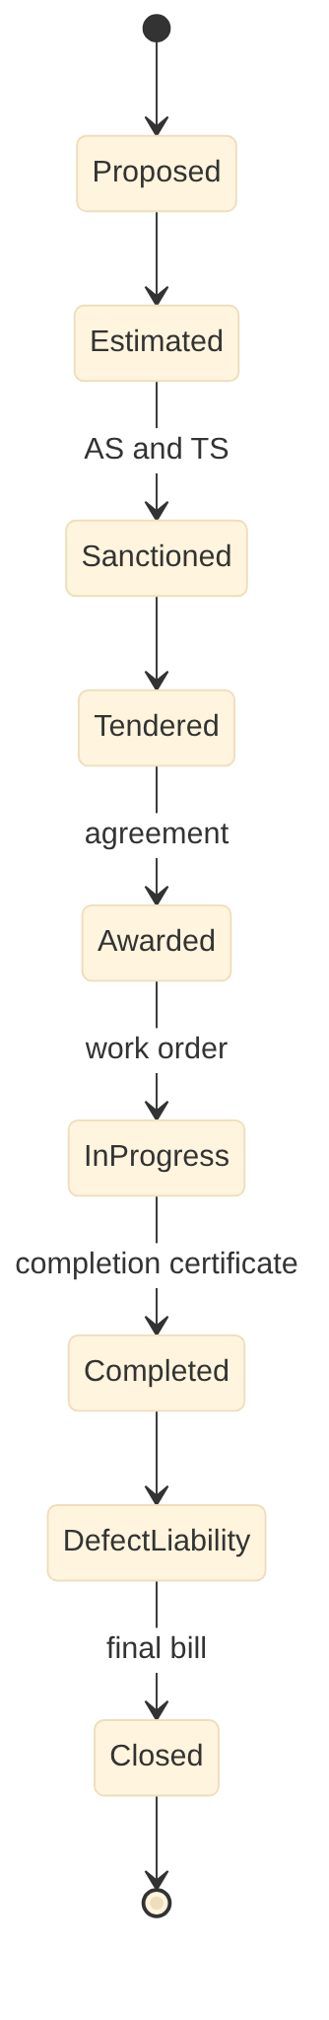
Figure 20. Engineering Project Management System: work states

Scheduled jobs
Job | Schedule | Purpose
eproc-sync | Hourly | Tender status from e-procurement
progress-alerts | Weekly | Delayed works
pci-recompute | Yearly | Pavement condition index

Configuration and rules
Item | Mechanism | Example
Schedule of Rates | Versioned table | State SoR per year
Delegation | Config | AS/TS limits
Deductions | DMN | GST TDS 2%, BOCW 1%, security

External adapters
ID | System | Purpose
E-10 | GeM / e-procurement | Procurement and tendering
E-11 | Bhuvan (incl. CartoDEM), Survey of India (incl. high-resolution DEM), drone and LiDAR surveys | Base maps, imagery, elevation models and survey data
E-54 | Scheme MIS portals (AMRUT 2.0, Smart Cities Mission, SBM-U, PMAY-U, DAY-NULM, Finance Commission grants) | Physical and financial progress and utilisation reporting

Security notes: all endpoints require a tenant-scoped token. Ward scope is applied to staff queries. Money, demand and master changes need maker-checker, and step-up OTP above the configured thresholds. Personal data fields are masked in list views and logs.

20.3 12 Street Light Management (slm-service)
Item | Design
Service and schema | slm-service, PostgreSQL schema slm, base path /slm/v1
Scope | Poles, CCMS, faults, dark spots, energy checks
Primary users | Citizen; Lineman / contractor technician; Supervisor; Assistant Engineer (Electrical); Executive Engineer; Contractor or ESCO
Requirements realised | 13 (SLM-FR-001 to SLM-FR-013), 12 processes (SLM-*)
Interfaces | Provides I-14, I-16, I-25, I-26, I-33; consumes I-08, I-15, I-20, I-32, I-34, I-36

Data model
Table | Key columns | Notes
pole | pole_no, geom, road_id, fixture_type, wattage, panel_id, status | Asset inventory
panel | panel_id, service_connection_no, ccms_id, geom | Feeder panels
fault | fault_no, pole_id, source (CCMS, complaint, patrol), reported_at, sla_due, status | Faults
repair | fault_id, crew_id, materials jsonb, closed_at, photo | Photo-proof closure
burning_log | panel_id, date, on_hours, energy_kwh | From CCMS
energy_bill_check | service_connection_no, month, discom_kwh, ccms_kwh, variance | I-25
esco_sla | contract_id, month, uptime_pct, penalty | Contract SLA

APIs
Endpoint | Purpose | Processes
POST /slm/v1/faults | Fault from CCMS, citizen or patrol; nearest pole match | SLM-L03
PATCH /slm/v1/faults/{id} | Dispatch, repair, close with photo | SLM-L04
POST /slm/v1/ccms/webhook | CCMS events and readings | SLM-L06
GET /slm/v1/dark-spots | Dark spots by ward | SLM-L07
POST /slm/v1/poles | New poles; publishes I-26 | SLM-L01, SLM-L10

Events and interfaces
Direction | Interface | Counterpart | Topic or endpoint
Provides | I-14 | 17 Inventory & Stores | POST /inv/v1/indents
Provides | I-16 | 9 Document Management | POST /dms/v1/documents, GET /dms/v1/documents/{id}
Provides | I-25 | 4 Finance & Accounting | urban.slm.energy.verified.v1
Provides | I-26 | 15 Municipal Property | urban.slm.pole.changed.v1
Provides | I-33 | 3 Citizen Desk & RTI | urban.<module>.service-event.v1
Consumes | I-08 | 3 Citizen Desk & RTI | urban.grv.service-request.routed.v1 / urban.<module>.service-request.updated.v1
Consumes | I-15 | 8 Payroll & HR | urban.hrm.roster.published.v1 / urban.<module>.attendance.captured.v1
Consumes | I-20 | 13 Town Planning | OGC WMS/WFS/Vector tiles /gis/ows
Consumes | I-32 | 10 Engineering Projects | GET /eng/v1/roads?bbox=, OGC layer roads
Consumes | I-34 | 3 Citizen Desk & RTI | urban.grv.rti.requested.v1 / urban.<module>.rti.replied.v1
Consumes | I-36 | 6 User Charges | urban.uch.event-service-order.issued.v1

State model: Street light fault
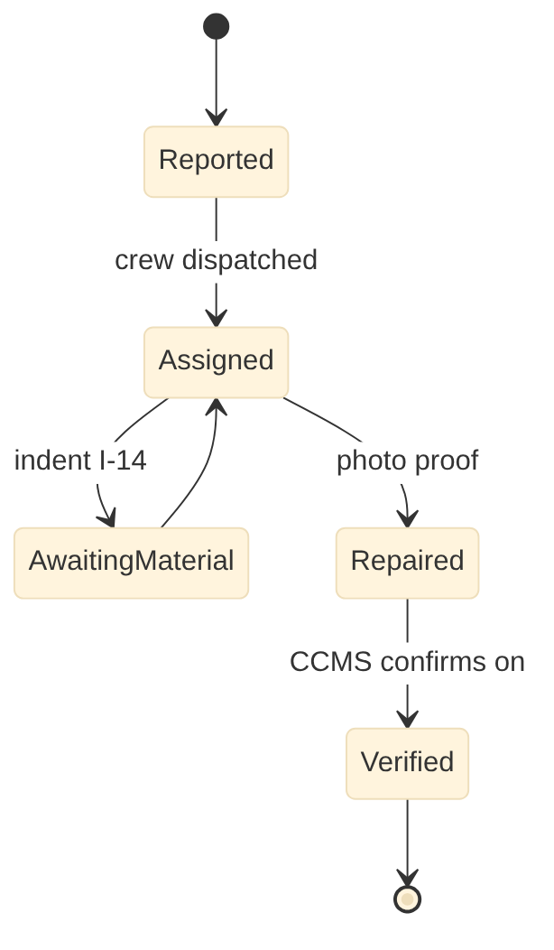
Figure 21. Street Light Management: street light fault states

Scheduled jobs
Job | Schedule | Purpose
burning-report | Daily 08:00 | Burning hours and dark spots
energy-verify | Monthly | Compare DISCOM and CCMS kWh
sla-penalty | Monthly | ESCO penalties

Configuration and rules
Item | Mechanism | Example
Lux standards by road class | Config | IS 1944
SLA | Config | Light out 48 h
Penalty rules | DMN | Per contract

External adapters
ID | System | Purpose
E-13 | Electricity distribution company (Telangana: TGNPDCL) | Energy readings per service connection
E-14 | CCMS (smart street-light controllers) | Panel status, faults, energy

Security notes: all endpoints require a tenant-scoped token. Ward scope is applied to staff queries. Money, demand and master changes need maker-checker, and step-up OTP above the configured thresholds. Personal data fields are masked in list views and logs.

20.4 14 Parks & Horticulture Management (prk-service)
Item | Design
Service and schema | prk-service, PostgreSQL schema prk, base path /prk/v1
Scope | Tree census, plantation, tree cutting, green budget
Primary users | Horticulture Officer; Supervisor; Gardener; Nursery supervisor; Emergency crew; Ward members and volunteers; Adopting RWA or company; Citizen
Requirements realised | 18 (PRK-FR-001 to PRK-FR-018), 18 processes (PRK-*)
Interfaces | Provides I-14, I-16, I-33, I-35; consumes I-08, I-15, I-20, I-34, I-38

Data model
Table | Key columns | Notes
park | park_id, name, type, area, geom, amenities jsonb, bookable flag | Parks and open spaces
tree | tree_id, species, girth_cm, height_m, heritage flag, geom, health | Tree census
plantation | drive_id, site geom, count, species mix, planted_at | Plantation drives
survival_audit | drive_id, month (3, 6, 12), alive_count, pct | 85% survival target
tree_request | req_no, type (prune, cut, transplant, fallen), tree_id, applicant, fee, deposit, permission_ref, status | Tree services
nursery_stock | nursery_id, species, qty | Nurseries
green_budget | fy, allocated, spent, pct_of_budget | 10% green budget

APIs
Endpoint | Purpose | Processes
POST /prk/v1/tree-requests | Tree service request | PRK-K12, PRK-K13, PRK-K15
POST /prk/v1/tree-requests/{id}:inspect|approve|execute | Lifecycle | PRK-K13, PRK-K15
POST /prk/v1/plantations | Plantation drive | PRK-K04
POST /prk/v1/plantations/{id}/audits | Survival audit | PRK-K04
GET /prk/v1/venues/availability | Park availability for bookings (I-35) | PRK-K10
GET /prk/v1/trees?bbox= | Tree census layer | PRK-K02

Events and interfaces
Direction | Interface | Counterpart | Topic or endpoint
Provides | I-14 | 17 Inventory & Stores | POST /inv/v1/indents
Provides | I-16 | 9 Document Management | POST /dms/v1/documents, GET /dms/v1/documents/{id}
Provides | I-33 | 3 Citizen Desk & RTI | urban.<module>.service-event.v1
Provides | I-35 | 6 User Charges | GET /prk/v1/venues/availability, GET /mpm/v1/venues/availability
Consumes | I-08 | 3 Citizen Desk & RTI | urban.grv.service-request.routed.v1 / urban.<module>.service-request.updated.v1
Consumes | I-15 | 8 Payroll & HR | urban.hrm.roster.published.v1 / urban.<module>.attendance.captured.v1
Consumes | I-20 | 13 Town Planning | OGC WMS/WFS/Vector tiles /gis/ows
Consumes | I-34 | 3 Citizen Desk & RTI | urban.grv.rti.requested.v1 / urban.<module>.rti.replied.v1
Consumes | I-38 | 13 Town Planning | urban.tpl.open-space.handed-over.v1

State model: Tree cutting request
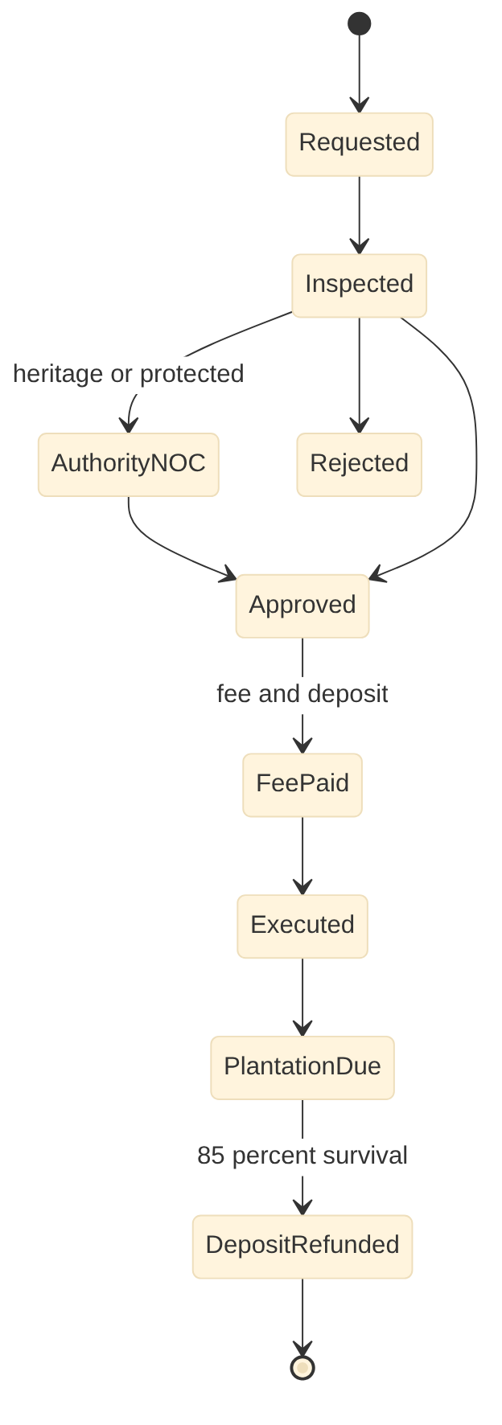
Figure 22. Parks & Horticulture Management: tree cutting request states

Scheduled jobs
Job | Schedule | Purpose
survival-audit-due | Daily | Audits at 3, 6, 12 months
hazard-survey | Yearly pre-monsoon | Hazardous tree tasks
green-budget | Monthly | Spend vs 10% target

Configuration and rules
Item | Mechanism | Example
Tree fees and deposits | DMN | By girth and species
Protected species | Config | State list
SLA | Config | Fallen tree 4 h

External adapters
ID | System | Purpose
E-51 | State forest department and tree authority (Telangana: Forest Department; WALTA) | Forest, urban forest park and eco-sensitive zone boundaries; tree felling permissions

Security notes: all endpoints require a tenant-scoped token. Ward scope is applied to staff queries. Money, demand and master changes need maker-checker, and step-up OTP above the configured thresholds. Personal data fields are masked in list views and logs.

20.5 17 Inventory & Stores Management (inv-service)
Item | Design
Service and schema | inv-service, PostgreSQL schema inv, base path /inv/v1
Scope | Indents, GeM, GRN, issues, fuel, scrap
Primary users | Stores officer; Storekeeper; Indenting and approving officers; Purchase committee; Inspection officer; Verification team; Condemnation board; Transport officer
Requirements realised | 17 (INV-FR-001 to INV-FR-017), 17 processes (INV-*)
Interfaces | Provides I-13, I-16, I-33; consumes I-14, I-15, I-34

Data model
Table | Key columns | Notes
item | item_code, name, uom, category, shelf_life_days, reorder_level | Item master
store / bin | store_id, location, bins | Stores
indent | indent_no, module, requester, items jsonb, status | I-14
purchase_order | po_no, route (GeM, tender, RC, direct), vendor_id, items, value, gem_ref | Purchase
grn | grn_no, po_id, received jsonb, inspected_by, accepted_qty, rejected_qty | Three-way match
stock_ledger | item_id, store_id, txn_type, qty, rate, value, balance | Weighted average
fuel_issue | vehicle_id, litres, odometer, gps_km | Fuel against GPS
disposal | lot_no, items, mstc_ref, proceeds | e-Auction

APIs
Endpoint | Purpose | Processes
POST /inv/v1/indents | Indent from modules (I-14) | INV-V04
POST /inv/v1/purchase-orders | PO after route selection | INV-V05, INV-V06
POST /inv/v1/grns | Goods receipt and inspection | INV-V07
POST /inv/v1/issues | Issue against indent; costing to Finance | INV-V08, INV-V10
POST /inv/v1/fuel-issues | Fuel issue | INV-V11
POST /inv/v1/disposals | Disposal lots | INV-V15

Events and interfaces
Direction | Interface | Counterpart | Topic or endpoint
Provides | I-13 | 4 Finance & Accounting | urban.inv.grn.valued.v1, urban.inv.issue.costed.v1
Provides | I-16 | 9 Document Management | POST /dms/v1/documents, GET /dms/v1/documents/{id}
Provides | I-33 | 3 Citizen Desk & RTI | urban.<module>.service-event.v1
Consumes | I-14 | 2 Water & Sewerage, 7 Solid Waste, 10 Engineering Projects, 12 Street Lights, 14 Parks & Horticulture | POST /inv/v1/indents
Consumes | I-15 | 8 Payroll & HR | urban.hrm.roster.published.v1 / urban.<module>.attendance.captured.v1
Consumes | I-34 | 3 Citizen Desk & RTI | urban.grv.rti.requested.v1 / urban.<module>.rti.replied.v1

State model: Indent
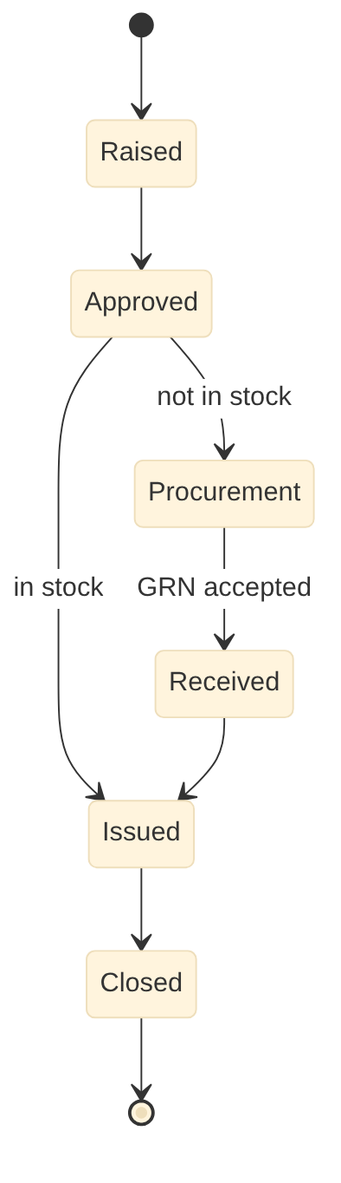
Figure 23. Inventory & Stores Management: indent states

Scheduled jobs
Job | Schedule | Purpose
reorder | Daily | Reorder suggestions
expiry-alerts | Daily | 60 days before expiry
gem-sync | Hourly | GeM order status

Configuration and rules
Item | Mechanism | Example
Purchase route limits | Config (state rules) | GFR limits as amended, state overrides
Valuation | Config | Weighted average
PPE entitlements | Config | By role

External adapters
ID | System | Purpose
E-10 | GeM / e-procurement | Procurement and tendering
E-15 | Vehicle GPS / AVLS provider | Vehicle tracking for SWM fleet, water tankers and desludging vehicles
E-57 | MSTC / GeM forward auction | E-auction of surplus, obsolete and scrap items

Security notes: all endpoints require a tenant-scoped token. Ward scope is applied to staff queries. Money, demand and master changes need maker-checker, and step-up OTP above the configured thresholds. Personal data fields are masked in list views and logs.

PART B | PHASE 4 | MONTHS 12 TO 18

21. Phase 4 LLD: Administration and welfare
4 services: hrm-service, mpm-service, lgl-service, gsc-service
8 Payroll & HR Management
15 Municipal Property Management
16 Legal Case Management
19 Government Schemes Management

21.0 Phase 4 build notes
- Org hierarchy migrates from tenant-config to hrm-service; workflow approver lookup switches provider
- Open legal items held in modules (petitions, notices) migrate into lgl-service; I-30 consumers already live
- Finance fixed asset schedule loads into mpm-service; I-42 switches provider
- Adapters: eCourts, EPFO, ESIC, NPS CRA, treasury pay bills, scheme portals, state family database

21.1 8 Payroll & HR Management (hrm-service)
Item | Design
Service and schema | hrm-service, PostgreSQL schema hrm, base path /hrm/v1
Scope | Service register, face attendance, payroll, pension
Primary users | Employee; Establishment section; Payroll clerk; Accounts officer; Reporting and approving officers; Supervisor; Outsourcing agency; Commissioner
Requirements realised | 19 (HRM-FR-001 to HRM-FR-019), 19 processes (HRM-*)
Interfaces | Provides I-12, I-15, I-16, I-17, I-33; consumes I-30, I-34

Data model
Table | Key columns | Notes
org_unit / post | unit_id, parent_id, type / post_id, cadre, sanctioned, filled | Drives workflow routing
employee | emp_no, category (regular, contract, outsourced), name, aadhaar_ref (vault), bank, pran | Employee master
service_event | emp_id, type (appointment, increment, transfer, promotion, penalty), order_doc_id, effective | e-Service register
attendance | emp_id, date, in_ts, out_ts, method (face, biometric), geom, liveness_score | Face recognition with liveness
roster | unit_id, date, shift, assignments jsonb | Published via I-15
payroll_run / payslip | period, status / emp_id, earnings jsonb, deductions jsonb, net | Monthly payroll
leave | emp_id, type, from, to, status | Leave
agency_compliance | agency_id, month, epf_paid, esi_paid, min_wage_ok | Outsourced workers

APIs
Endpoint | Purpose | Processes
POST /hrm/v1/employees | Onboard | HRM-H02, HRM-H03
POST /hrm/v1/attendance:batch | Attendance from app or devices | HRM-H05
POST /hrm/v1/rosters | Publish roster (I-15) | HRM-H05
POST /hrm/v1/payroll-runs | Compute payroll | HRM-H09
POST /hrm/v1/payroll-runs/{id}:approve | Approve with step-up OTP; journal I-12 | HRM-H09
GET /hrm/v1/org-units/{id}/approvers | Approver lookup for workflow engine | HRM-H01

Events and interfaces
Direction | Interface | Counterpart | Topic or endpoint
Provides | I-12 | 4 Finance & Accounting | urban.hrm.payroll.approved.v1 / urban.fin.payment.confirmed.v1
Provides | I-15 | 2 Water & Sewerage, 7 Solid Waste, 12 Street Lights, 14 Parks & Horticulture, 17 Inventory & Stores | urban.hrm.roster.published.v1 / urban.<module>.attendance.captured.v1
Provides | I-16 | 9 Document Management | POST /dms/v1/documents, GET /dms/v1/documents/{id}
Provides | I-17 | 16 Legal Cases | POST /lgl/v1/cases
Provides | I-33 | 3 Citizen Desk & RTI | urban.<module>.service-event.v1
Consumes | I-30 | 16 Legal Cases | urban.lgl.case.status-changed.v1
Consumes | I-34 | 3 Citizen Desk & RTI | urban.grv.rti.requested.v1 / urban.<module>.rti.replied.v1

State model: Payroll run
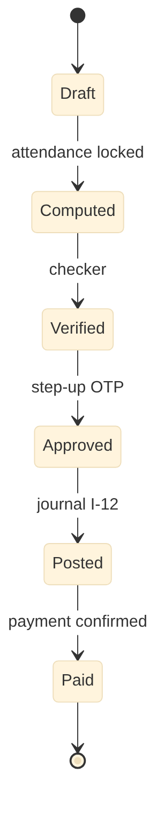
Figure 24. Payroll & HR Management: payroll run states

Scheduled jobs
Job | Schedule | Purpose
attendance-lock | Monthly last day | Lock attendance
retirement-alerts | Monthly | 12 months ahead
statutory-returns | Monthly / quarterly | TDS, PT, EPF, ESI, NPS

Configuration and rules
Item | Mechanism | Example
Pay matrix and DA | Versioned table | State pay commission
Professional tax | DMN (state pack) | Telangana slabs
Leave rules | Config | State leave rules

External adapters
ID | System | Purpose
E-01 | Aadhaar eKYC / OTP (UIDAI via authorised ASA) | Identity verification
E-27 | Income Tax (TRACES / TIN) | TDS returns, certificates and PAN validation
E-58 | EPFO and ESIC portals | Contributions and returns for eligible staff and agency compliance checks
E-59 | NPS CRA and state pension authority / Accountant General | NPS contributions and exits; pension papers and authorisations

Security notes: all endpoints require a tenant-scoped token. Ward scope is applied to staff queries. Money, demand and master changes need maker-checker, and step-up OTP above the configured thresholds. Personal data fields are masked in list views and logs.

21.2 15 Municipal Property Management (mpm-service)
Item | Design
Service and schema | mpm-service, PostgreSQL schema mpm, base path /mpm/v1
Scope | Asset register, leases, land bank, encroachments
Primary users | Estates officer; Accounts officer; GIS cell; Auction committee; Hall and crematorium in-charge; Verification team; Lessee; Commissioner; Council
Requirements realised | 15 (MPM-FR-001 to MPM-FR-015), 15 processes (MPM-*)
Interfaces | Provides I-09, I-16, I-17, I-33, I-35, I-42; consumes I-07, I-08, I-20, I-24, I-26, I-27, I-30, I-34, I-38

Data model
Table | Key columns | Notes
asset | asset_no, class (land, building, market, plant, movable), ulpin, geom, cost, source_fund, status | Immovable and movable
asset_component | asset_id, component, cost, life_years | Component capitalisation
title_document | asset_id, doc_id, type (deed, gift deed, handover) | In DMS
lease | lease_no, asset_id, lessee, rent, gst, from, to, auction_ref, deposit | Shops, stalls, spaces
rent_demand | lease_id, month, amount, gst, status | Monthly rent
verification | asset_id, year, condition, photo, geom | Annual verification
encroachment | asset_id, geom, detected_by, status | Protection
depreciation_run | period, total, status | I-42

APIs
Endpoint | Purpose | Processes
POST /mpm/v1/assets | Asset intake (from I-07, I-26, I-38, purchases) | MPM-M01-M03
POST /mpm/v1/leases | Lease after e-auction | MPM-M06
POST /mpm/v1/rent-runs | Monthly rent demand | MPM-M07
POST /mpm/v1/depreciation-runs | Depreciation posting (I-42) | MPM-M03
GET /mpm/v1/venues/availability | Halls and lots availability (I-35) | MPM-M08
POST /mpm/v1/assets/{id}/verifications | Physical verification | MPM-M05

Events and interfaces
Direction | Interface | Counterpart | Topic or endpoint
Provides | I-09 | 4 Finance & Accounting | urban.<module>.demand.raised.v1, urban.<module>.receipt.created.v1
Provides | I-16 | 9 Document Management | POST /dms/v1/documents, GET /dms/v1/documents/{id}
Provides | I-17 | 16 Legal Cases | POST /lgl/v1/cases
Provides | I-33 | 3 Citizen Desk & RTI | urban.<module>.service-event.v1
Provides | I-35 | 6 User Charges | GET /prk/v1/venues/availability, GET /mpm/v1/venues/availability
Provides | I-42 | 4 Finance & Accounting | urban.mpm.asset.capitalised.v1, urban.mpm.depreciation.posted.v1
Consumes | I-07 | 10 Engineering Projects | urban.eng.work.completed.v1
Consumes | I-08 | 3 Citizen Desk & RTI | urban.grv.service-request.routed.v1 / urban.<module>.service-request.updated.v1
Consumes | I-20 | 13 Town Planning | OGC WMS/WFS/Vector tiles /gis/ows
Consumes | I-24 | 4 Finance & Accounting | urban.fin.receipt.realised.v1
Consumes | I-26 | 12 Street Lights | urban.slm.pole.changed.v1
Consumes | I-27 | 1 Property Tax & Revenue | GET /ptx/v1/parcels/{ulpin}
Consumes | I-30 | 16 Legal Cases | urban.lgl.case.status-changed.v1
Consumes | I-34 | 3 Citizen Desk & RTI | urban.grv.rti.requested.v1 / urban.<module>.rti.replied.v1
Consumes | I-38 | 13 Town Planning | urban.tpl.open-space.handed-over.v1

State model: Lease
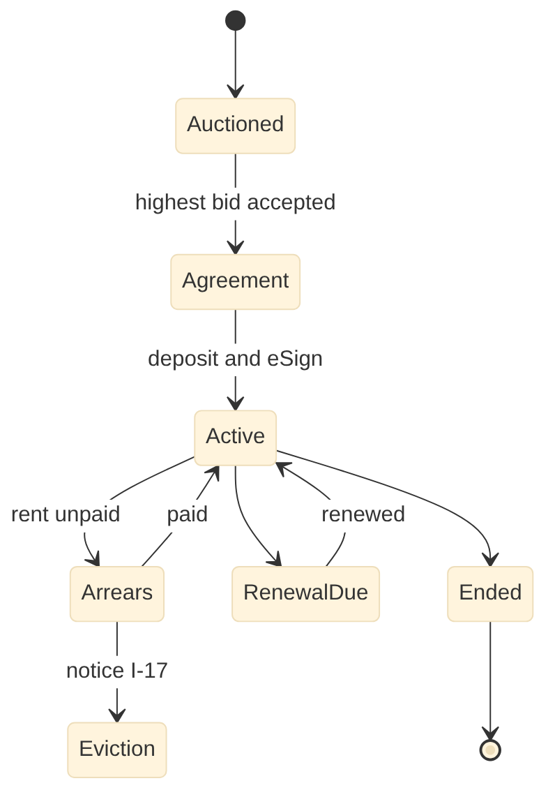
Figure 25. Municipal Property Management: lease states

Scheduled jobs
Job | Schedule | Purpose
rent-run | Monthly | Rent with GST
depreciation | Monthly / yearly | Post to Finance
lease-expiry | Daily | Expiry alerts

Configuration and rules
Item | Mechanism | Example
Depreciation rates | Config (manual) | By asset class
Rent enhancement | Config (state rules) | On renewal
Capitalisation threshold | Config | Rs 5,000

External adapters
ID | System | Purpose
E-03 | Payment gateway, UPI, BBPS | Online payments and bill presentment

Security notes: all endpoints require a tenant-scoped token. Ward scope is applied to staff queries. Money, demand and master changes need maker-checker, and step-up OTP above the configured thresholds. Personal data fields are masked in list views and logs.

21.3 16 Legal Case Management (lgl-service)
Item | Design
Service and schema | lgl-service, PostgreSQL schema lgl, base path /lgl/v1
Scope | Cases, limitation, hearing calendar, contempt
Primary users | Legal officer; Standing counsel and panel advocates; Department nodal officers; Commissioner; Council
Requirements realised | 17 (LGL-FR-001 to LGL-FR-017), 17 processes (LGL-*)
Interfaces | Provides I-16, I-18, I-30, I-33; consumes I-17, I-29, I-34

Data model
Table | Key columns | Notes
case | case_no, cnr, court, type, subject, originating_module, originating_ref, risk, amount_at_stake, status | Case register
hearing | case_id, date, purpose, outcome, next_date | From eCourts
deadline | case_id, type (counter, compliance, limitation), due_date, owner, status | Limitation engine
document_requirement | hearing_id, doc_type, owner, due, ready flag, doc_id | Hearing checklist (J17)
order | case_id, date, doc_id, summary, directions jsonb | Orders and directions
counsel_assignment | case_id, advocate_id, from, to | Counsel
fee_bill | case_id, advocate_id, stage, amount, status | Advocate bills (I-18)

APIs
Endpoint | Purpose | Processes
POST /lgl/v1/cases | Create case from module (I-17) or inward | LGL-J01
POST /lgl/v1/cases/{id}/hearings | Hearing and outcome | LGL-J06
GET /lgl/v1/calendar?officer=&from=&to= | Officer hearing calendar with document readiness; ICS feed | LGL-J17
POST /lgl/v1/cases/{id}/orders | Order with directions; publishes I-30 | LGL-J08, LGL-J11
POST /lgl/v1/cases/{id}/deadlines | Limitation and compliance deadlines | LGL-J07
POST /lgl/v1/fee-bills | Advocate bill | LGL-J12

Events and interfaces
Direction | Interface | Counterpart | Topic or endpoint
Provides | I-16 | 9 Document Management | POST /dms/v1/documents, GET /dms/v1/documents/{id}
Provides | I-18 | 4 Finance & Accounting | urban.lgl.payment.ordered.v1
Provides | I-30 | 1 Property Tax & Revenue, 2 Water & Sewerage, 3 Citizen Desk & RTI, 5 Trade Licence, 6 User Charges, 7 Solid Waste, 8 Payroll & HR, 9 Document Management, 11 Building Permission, 13 Town Planning, 15 Municipal Property, 18 Fire NOC | urban.lgl.case.status-changed.v1
Provides | I-33 | 3 Citizen Desk & RTI | urban.<module>.service-event.v1
Consumes | I-17 | 1 Property Tax & Revenue, 2 Water & Sewerage, 3 Citizen Desk & RTI, 5 Trade Licence, 6 User Charges, 7 Solid Waste, 8 Payroll & HR, 11 Building Permission, 13 Town Planning, 15 Municipal Property, 18 Fire NOC | POST /lgl/v1/cases
Consumes | I-29 | 9 Document Management | GET /dms/v1/dossiers/{ulpin}
Consumes | I-34 | 3 Citizen Desk & RTI | urban.grv.rti.requested.v1 / urban.<module>.rti.replied.v1

State model: Case
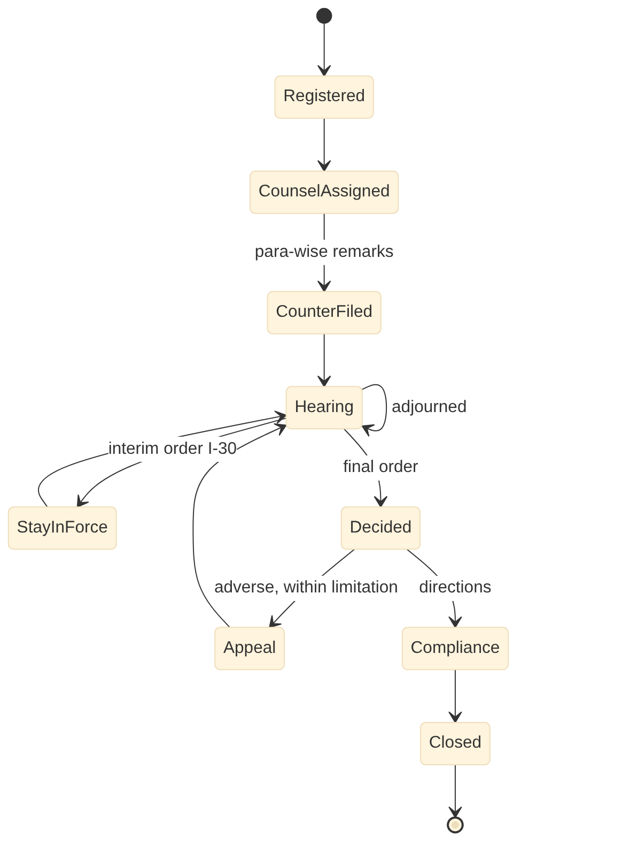
Figure 26. Legal Case Management: case states

Scheduled jobs
Job | Schedule | Purpose
ecourts-sync | Daily 05:00 | Status, cause list, orders by CNR
morning-digest | Daily 07:30 | Officer digest with documents due
limitation-alerts | Daily | Escalate as expiry nears

Configuration and rules
Item | Mechanism | Example
Limitation rules | Config | Period per remedy
Alert schedule | Config | 7, 3, 1 days
Advocate fee schedule | Config | By court and stage

External adapters
ID | System | Purpose
E-09 | eCourts services (CNR), High Court and tribunal case portals, NJDG | Case status, hearing dates, cause lists and orders

Security notes: all endpoints require a tenant-scoped token. Ward scope is applied to staff queries. Money, demand and master changes need maker-checker, and step-up OTP above the configured thresholds. Personal data fields are masked in list views and logs.

21.4 19 Government Schemes Management (gsc-service)
Item | Design
Service and schema | gsc-service, PostgreSQL schema gsc, base path /gsc/v1
Scope | PMAY-U, SHGs, PM SVANidhi, DBT, convergence
Primary users | Citizen / applicant; Community organiser; Field verifier; Welfare officer; ULB or state committee; Accounts officer; Commissioner
Requirements realised | 14 (GSC-FR-001 to GSC-FR-014), 14 processes (GSC-*)
Interfaces | Provides I-16, I-19, I-23, I-33, I-43; consumes I-08, I-27, I-34

Data model
Table | Key columns | Notes
scheme | code, sponsor, shares jsonb, eligibility_rule_ref, benefit, dbt_mode, portal | Scheme catalogue
beneficiary | ben_id, household_id, aadhaar_ref (vault), bank, category, family_db_ref | De-duplicated register
application | app_no, scheme_id, ben_id, status, eligibility_result jsonb | Applications
housing_stage | app_id, stage, photo, geom, bhuvan_ref, verified | Geo-tagged stages
disbursement | app_id, instalment, amount, pfms_ref, status | DBT (I-19)
concession | ben_id, ulpin, type, valid_to | I-23
shg | shg_id, members, bank_link, loans jsonb | Livelihoods

APIs
Endpoint | Purpose | Processes
POST /gsc/v1/applications | Apply; eligibility via rules; ownership check I-27 | GSC-C04
POST /gsc/v1/applications/{id}:verify|approve|reject | Verification and approval | GSC-C05
POST /gsc/v1/applications/{id}/stages | Housing stage evidence | GSC-C06
POST /gsc/v1/disbursements | DBT batch to PFMS | GSC-C10
GET /gsc/v1/concessions | Concessions for PTX and WTR (I-23) | GSC-C09
GET /gsc/v1/households/{id} | Household convergence view | GSC-C13

Events and interfaces
Direction | Interface | Counterpart | Topic or endpoint
Provides | I-16 | 9 Document Management | POST /dms/v1/documents, GET /dms/v1/documents/{id}
Provides | I-19 | 4 Finance & Accounting | urban.gsc.disbursement.made.v1
Provides | I-23 | 1 Property Tax & Revenue, 2 Water & Sewerage | GET /gsc/v1/concessions?ulpin=
Provides | I-33 | 3 Citizen Desk & RTI | urban.<module>.service-event.v1
Provides | I-43 | 11 Building Permission | urban.gsc.housing-permission.requested.v1 / urban.bpm.permit.issued.v1
Consumes | I-08 | 3 Citizen Desk & RTI | urban.grv.service-request.routed.v1 / urban.<module>.service-request.updated.v1
Consumes | I-27 | 1 Property Tax & Revenue | GET /ptx/v1/parcels/{ulpin}
Consumes | I-34 | 3 Citizen Desk & RTI | urban.grv.rti.requested.v1 / urban.<module>.rti.replied.v1

State model: Scheme application
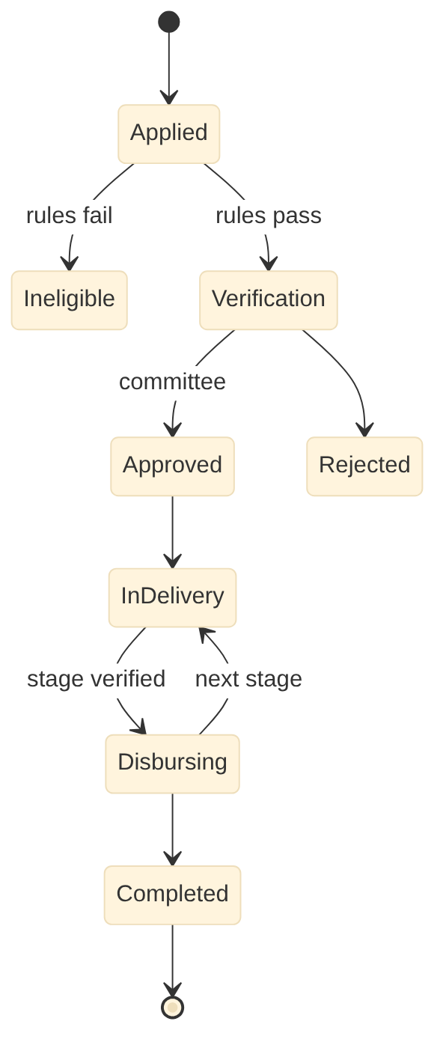
Figure 27. Government Schemes Management: scheme application states

Scheduled jobs
Job | Schedule | Purpose
dbt-batch | Per payment cycle | PFMS files and status
dedup | Nightly | Cross-scheme duplicate check
portal-report | Monthly | Scheme MIS uploads

Configuration and rules
Item | Mechanism | Example
Eligibility rules | DMN | PMAY-U income bands, no pucca house
Instalment schedule | Config | By scheme and stage
Concession types | Config | Tax and water

External adapters
ID | System | Purpose
E-01 | Aadhaar eKYC / OTP (UIDAI via authorised ASA) | Identity verification
E-08 | Treasury, IFMIS, PFMS | Grants, DBT disbursement, treasury reporting
E-54 | Scheme MIS portals (AMRUT 2.0, Smart Cities Mission, SBM-U, PMAY-U, DAY-NULM, Finance Commission grants) | Physical and financial progress and utilisation reporting
E-60 | State family / beneficiary database (e.g. Telangana family digital card) [confirm] | Household verification and de-duplication of benefits

Security notes: all endpoints require a tenant-scoped token. Ward scope is applied to staff queries. Money, demand and master changes need maker-checker, and step-up OTP above the configured thresholds. Personal data fields are masked in list views and logs.

Appendix A. Interface realisation
How each SRS interface is implemented: event topic, synchronous endpoint or both.
ID | Provider | Consumer | SRS mode | Topic | Endpoint
I-01 | 13 Town Planning | 11 Building Permission | Sync API | - | GET /tpl/v1/plots/{ulpin}/development-control
I-02 | 11 Building Permission | 18 Fire NOC | Event (two-way) | urban.bpm.fire-noc.requested.v1 / urban.fnc.noc.decided.v1 | -
I-03 | 11 Building Permission | 1 Property Tax & Revenue | Event | urban.bpm.occupancy-certificate.issued.v1 | -
I-04 | 18 Fire NOC | 5 Trade Licence | Sync API | - | GET /fnc/v1/nocs/verify?ulpin=&use=
I-05 | 1 Property Tax & Revenue | 2 Water & Sewerage | Sync API | - | GET /ptx/v1/units/{ulpin}
I-06 | 7 Solid Waste | 6 User Charges | Batch (daily) | urban.swm.collection.daily-status.v1 | -
I-07 | 10 Engineering Projects | 15 Municipal Property | Event | urban.eng.work.completed.v1 | -
I-08 | 3 Citizen Desk & RTI | 1 Property Tax & Revenue, 2 Water & Sewerage, 5 Trade Licence, 6 User Charges, 7 Solid Waste, 10 Engineering Projects, 11 Building Permission, 12 Street Lights, 13 Town Planning, 14 Parks & Horticulture, 15 Municipal Property, 18 Fire NOC, 19 Government Schemes | Event (two-way) | urban.grv.service-request.routed.v1 / urban.<module>.service-request.updated.v1 | -
I-09 | 1 Property Tax & Revenue, 2 Water & Sewerage, 5 Trade Licence, 6 User Charges, 7 Solid Waste, 15 Municipal Property | 4 Finance & Accounting | Event + daily batch | urban.<module>.demand.raised.v1, urban.<module>.receipt.created.v1 | -
I-10 | 11 Building Permission, 13 Town Planning, 18 Fire NOC | 4 Finance & Accounting | Event | urban.<module>.fee.paid.v1 | -
I-11 | 10 Engineering Projects | 4 Finance & Accounting | Sync API | - | POST /fin/v1/commitments, POST /fin/v1/bills
I-12 | 8 Payroll & HR | 4 Finance & Accounting | Batch (monthly, two-way) | urban.hrm.payroll.approved.v1 / urban.fin.payment.confirmed.v1 | -
I-13 | 17 Inventory & Stores | 4 Finance & Accounting | Event | urban.inv.grn.valued.v1, urban.inv.issue.costed.v1 | -
I-14 | 2 Water & Sewerage, 7 Solid Waste, 10 Engineering Projects, 12 Street Lights, 14 Parks & Horticulture | 17 Inventory & Stores | Sync API | - | POST /inv/v1/indents
I-15 | 8 Payroll & HR | 2 Water & Sewerage, 7 Solid Waste, 12 Street Lights, 14 Parks & Horticulture, 17 Inventory & Stores | Batch (daily, two-way) | urban.hrm.roster.published.v1 / urban.<module>.attendance.captured.v1 | -
I-16 | All modules | 9 Document Management | Sync API | - | POST /dms/v1/documents, GET /dms/v1/documents/{id}
I-17 | 1 Property Tax & Revenue, 2 Water & Sewerage, 3 Citizen Desk & RTI, 5 Trade Licence, 6 User Charges, 7 Solid Waste, 8 Payroll & HR, 11 Building Permission, 13 Town Planning, 15 Municipal Property, 18 Fire NOC | 16 Legal Cases | Event | - | POST /lgl/v1/cases
I-18 | 16 Legal Cases | 4 Finance & Accounting | Event | urban.lgl.payment.ordered.v1 | -
I-19 | 19 Government Schemes | 4 Finance & Accounting | Batch | urban.gsc.disbursement.made.v1 | -
I-20 | 13 Town Planning | 1 Property Tax & Revenue, 2 Water & Sewerage, 3 Citizen Desk & RTI, 5 Trade Licence, 6 User Charges, 7 Solid Waste, 9 Document Management, 10 Engineering Projects, 11 Building Permission, 12 Street Lights, 14 Parks & Horticulture, 15 Municipal Property, 18 Fire NOC | GIS service | - | OGC WMS/WFS/Vector tiles /gis/ows
I-21 | 11 Building Permission | 13 Town Planning | Batch | urban.bpm.unauthorised-construction.detected.v1 | -
I-22 | 5 Trade Licence | 1 Property Tax & Revenue, 6 User Charges, 7 Solid Waste, 18 Fire NOC | Event | urban.trl.establishment.changed.v1 | -
I-23 | 19 Government Schemes | 1 Property Tax & Revenue, 2 Water & Sewerage | Sync API | - | GET /gsc/v1/concessions?ulpin=
I-24 | 4 Finance & Accounting | 1 Property Tax & Revenue, 2 Water & Sewerage, 5 Trade Licence, 6 User Charges, 15 Municipal Property | Event | urban.fin.receipt.realised.v1 | -
I-25 | 12 Street Lights | 4 Finance & Accounting | Batch (monthly) | urban.slm.energy.verified.v1 | -
I-26 | 12 Street Lights | 15 Municipal Property | Event | urban.slm.pole.changed.v1 | -
I-27 | 1 Property Tax & Revenue | 2 Water & Sewerage, 5 Trade Licence, 6 User Charges, 7 Solid Waste, 11 Building Permission, 15 Municipal Property, 18 Fire NOC, 19 Government Schemes | Sync API + event | - | GET /ptx/v1/parcels/{ulpin}
I-28 | 1 Property Tax & Revenue | 13 Town Planning | Event (two-way) | urban.ptx.setback-deviation.referred.v1 / urban.tpl.regularisation.decided.v1 | -
I-29 | 9 Document Management | 1 Property Tax & Revenue, 2 Water & Sewerage, 3 Citizen Desk & RTI, 16 Legal Cases | Sync API | - | GET /dms/v1/dossiers/{ulpin}
I-30 | 16 Legal Cases | 1 Property Tax & Revenue, 2 Water & Sewerage, 3 Citizen Desk & RTI, 5 Trade Licence, 6 User Charges, 7 Solid Waste, 8 Payroll & HR, 9 Document Management, 11 Building Permission, 13 Town Planning, 15 Municipal Property, 18 Fire NOC | Event | urban.lgl.case.status-changed.v1 | -
I-31 | 2 Water & Sewerage | 10 Engineering Projects | Event (two-way) | urban.wtr.road-cut.requested.v1 / urban.eng.road-cut.restored.v1 | -
I-32 | 10 Engineering Projects | 1 Property Tax & Revenue, 2 Water & Sewerage, 5 Trade Licence, 6 User Charges, 7 Solid Waste, 11 Building Permission, 12 Street Lights, 13 Town Planning, 18 Fire NOC | GIS service + event | - | GET /eng/v1/roads?bbox=, OGC layer roads
I-33 | All modules | 3 Citizen Desk & RTI | Event + sync API | urban.<module>.service-event.v1 | -
I-34 | 3 Citizen Desk & RTI | All modules | Event (two-way) | urban.grv.rti.requested.v1 / urban.<module>.rti.replied.v1 | -
I-35 | 14 Parks & Horticulture, 15 Municipal Property | 6 User Charges | Sync API + event (two-way) | - | GET /prk/v1/venues/availability, GET /mpm/v1/venues/availability
I-36 | 6 User Charges | 2 Water & Sewerage, 7 Solid Waste, 10 Engineering Projects, 12 Street Lights | Event | urban.uch.event-service-order.issued.v1 | -
I-37 | 13 Town Planning | 1 Property Tax & Revenue | Event | urban.tpl.layout.approved.v1, urban.tpl.door-number.assigned.v1 | -
I-38 | 13 Town Planning | 14 Parks & Horticulture, 15 Municipal Property | Event | urban.tpl.open-space.handed-over.v1 | -
I-39 | 2 Water & Sewerage | 18 Fire NOC | GIS service | - | OGC layer hydrants, GET /wtr/v1/hydrants?bbox=
I-40 | 11 Building Permission | 1 Property Tax & Revenue, 2 Water & Sewerage | Event | urban.bpm.rwh-certificate.changed.v1 | -
I-41 | 10 Engineering Projects, 11 Building Permission | 7 Solid Waste | Event (two-way) | urban.bpm.cnd-plan.approved.v1, urban.eng.cnd-plan.approved.v1 | -
I-42 | 15 Municipal Property | 4 Finance & Accounting | Event + monthly batch | urban.mpm.asset.capitalised.v1, urban.mpm.depreciation.posted.v1 | -
I-43 | 19 Government Schemes | 11 Building Permission | Event (two-way) | urban.gsc.housing-permission.requested.v1 / urban.bpm.permit.issued.v1 | -

Appendix B. Glossary
Term | Meaning
ULPIN | Unique Land Parcel Identification Number; spine of the property model (parcel, building, unit, segment)
PTIN | State property tax identification number (Telangana CDMA)
BFF | Backend for frontend: channel-specific API layer
Outbox / inbox | Tables that make event publishing and consumption reliable and idempotent
DMN | Decision Model and Notation; decision tables for fees, taxes, eligibility
BPMN | Business Process Model and Notation; executable workflows
RLS | PostgreSQL row-level security used for tenant isolation
Integrate mode | Module connected to an existing state system instead of running the Urban module as system of record
Step-up OTP | Extra transaction-bound verification before a high-risk action

