**ChatApp- A Desktop Chatting Application**

**Project Description**

This is a desktop application which will help people to chat each other. Here we are developing an application were one person will act as the server and the other as the client. We will develop the code for server-client communication.

**Programming Language**

Java

**Prerequisite**

Core Java (Swing, AWT)

Server-Socket Basics

**IDE used:**

Eclipse

**Overview**

**Objective**

Creating a desktop application which will help two people to communicate between each other. Here we are developing a server and a client. This server can send and receive the message to client. The same manner client can also send message to the server and client can receive the message send by the server. So, it is a two-way communication between the client and the server using Socket Programming. The overall outlook of the client and server is similar to the WhatsApp interface.

**Primary Goals**

* Create Server Page
* Setup the design of server page
* Create Client Page
* Setup the design of client page
* Establish the connection between Server and client

Use Case Diagram

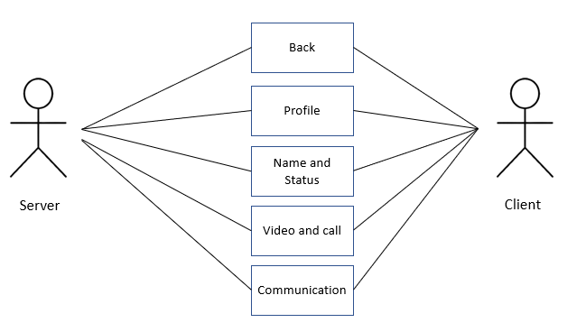

**Task 1**

Before starting the coding part of the project, we need to setup the environment according to our application needs.

**Prerequisites**

Install Eclipse IDE

<https://www.eclipse.org/downloads/>

Install and setup JDK

<https://www.oracle.com/java/technologies/downloads/>

Install WindowBuilder

<https://www.eclipse.org/windowbuilder/>

**Task 2**

Once you have all the prerequisites to start the coding we need to start with the first part. Now we can create the Server Page initially.

Make the changes properly so that the server page looks like as shown below. (You can design as you like)

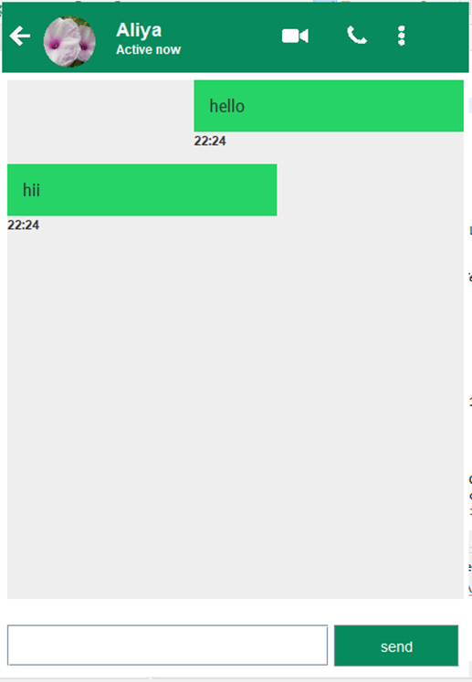

**Task 3**

Creating Client Page. The user interface of the client page is same as that of the server page. Here the profile picture and the name of the person is different from that of the server.

The page looks like as shown in the figure below.

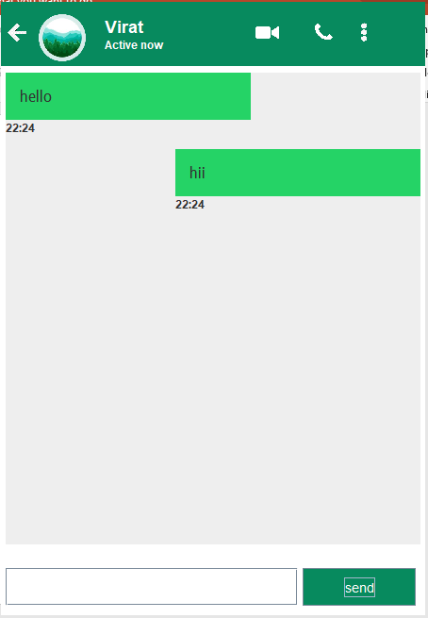

Now both the client and the server are ready with its design. Now we need to establish the connection between server and the client. If we send message from the server that needs to be displayed in the client and if we send the message from client that needs to be displayed in the server. This will be established by creating a socket.

**Task 4**

Here we have to establish the connection between the server and client as described earlier. Finally, the messages from the server need to be visible in the client page and the message from the client need to be displayed in the server also.

You can refer the designs for it. In both server and the client along with the message the time at which the message is send is also displayed along with it.

**Conclusion**

This desktop application will help people to communicate with each other. The design of the server and the client page is similar to the WhatsApp user interface. Here the message from the server is send to the client and the client can receive message from the server and give the response back to the server also. This is a basic application. This application will help people to communicate with each other in simple manner.