INTENTS

We craete the main activity and collect or craete the object of Inetnt class to move or navigate from one activity to another activity
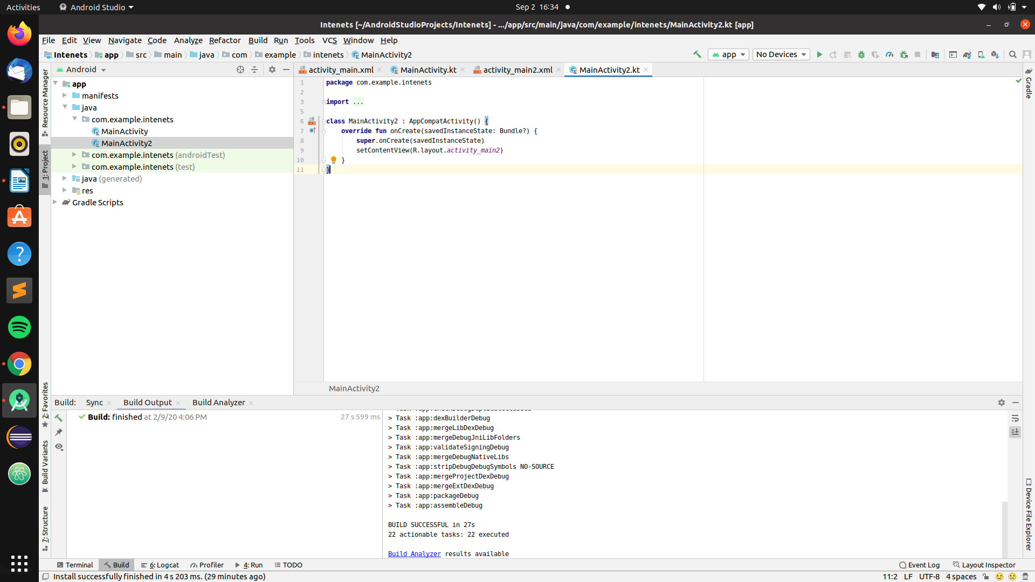

Now we made another activity2 where we want to move
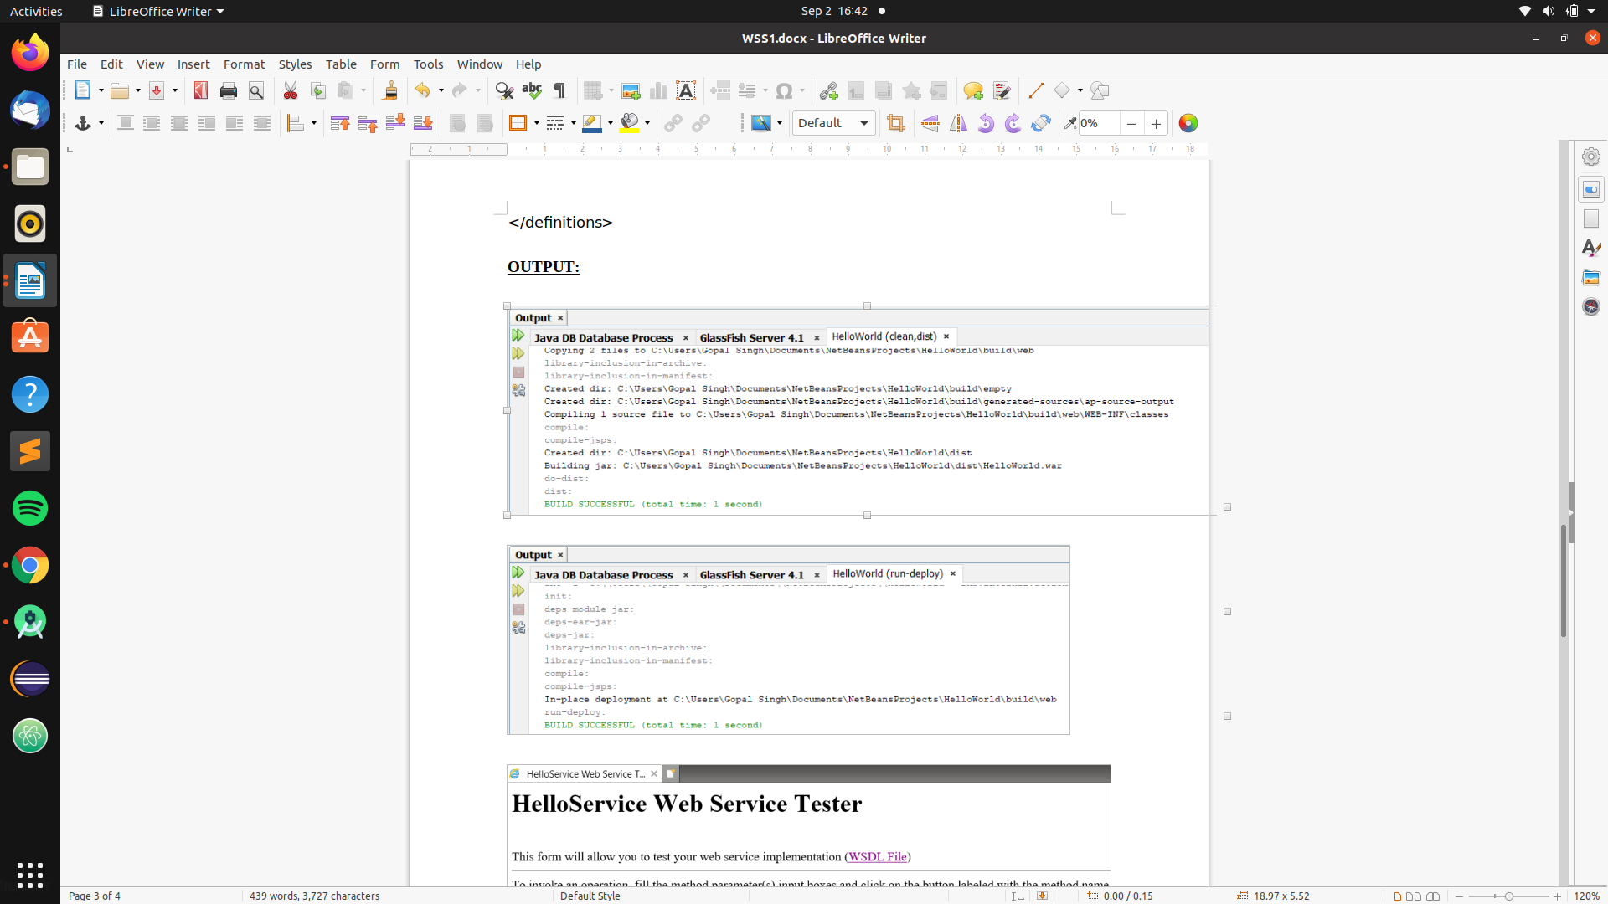

How to transfer data from one activty to another activity

we use sort of hashmap thing with key and value
The key can be only of String type but the value can be of any type
we have function name putExtra(key,value) ->This function sends datat from one activity to other activity where we want to send the data

One more thing we do is we have to collect the passed intenet in activity2 so that we can have access to data passed by activity1
for this we have fucntion like getStringExtra(key), getIntExtra(key)

Below Image show how to use putExtra() functon

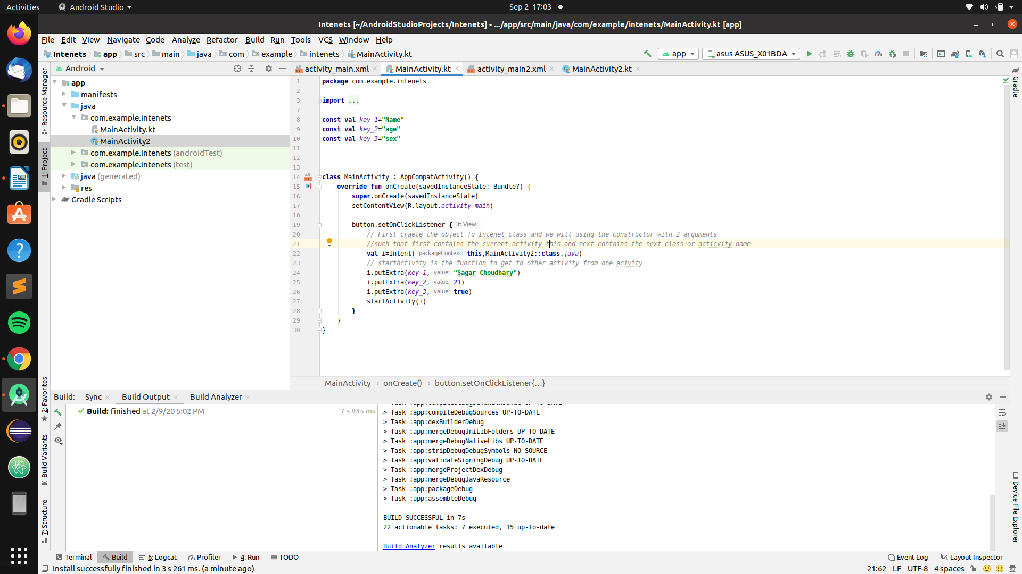
Below Image show how to use or collect the data passed by mainActivity
using intent.getStringExtra()
