Batch: A1 Roll No.: 1711008

Experiment / assignment / tutorial No.___03____

Grade: AA / AB / BB / BC / CC / CD /DD

Signature of the Staff In-charge with date

Title: To find Fibonacci series of N given terms
______________________________________________________________________
Objective: To understand usage of SI.
______________________________________________________________________
Expected Outcome of Experiment:
CO 1: Explain the process of Compilation from Assembly language to machine language.

______________________________________________________________________
Books/ Journals/ Websites referred:
Microcomputer Systems: 8086/8088 family Architecture, Programming and Design: By Liu & Gibson (PHI Publication).
_______________________________________________________________
Pre Lab/ Prior Concepts:
What is the significance of index registers?
An index register in a computer's CPU is a processor register used for modifying operand addresses during the run of a program, typically for doing vector/array operations.
The contents of an index register is added to (in some cases subtracted from) an immediate address (one that is part of the instruction itself) to form the "effective" address of the actual data (operand). Special instructions are typically provided to test the index register and, if the test fails, increments the index register by an immediate constant and branches, typically to the start of the loop. Some instruction sets allow more than one index register to be used; in that case additional instruction fields specify which index registers to use. While normally processors that allow an instruction to specify multiple index registers add the contents together.

Algorithm:
Step1: load array on si and 05 in cx register
Step2: first insert 0 in arary , increment si ,then insert 1 in array again increment si
Step3: start loop1
1:mov [si-1] in ax
2:mov [si-2] in bx
3:add contents of ax and bx
4:store ax in [si]
5.increment si
6.decrement cx
7.if cx=0 break from loop else goto 1
Step 4.end

Program:
data segment
a db (?)
ans db (?)

data ends
code segment
assume ds:data,cs:code
start:
mov cx,05h
mov [si],offset a
mov [si],00h
inc si
mov [si],01h
inc si
loop1:
mov ax,[si-1]
mov bx,[si-2]
add ax,bx
mov [si],ax
inc si
dec cx
jnz loop1
mov ah,4ch
int 21h
code ends
end start

output:
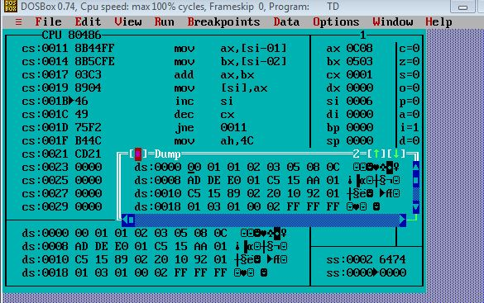

Conclusion: therfore fibonaci sereis program is sucessfully executed and implmented.

Post Lab Descriptive Questions (Add questions from examination point view)

Explain various types of instruction sets in 8087

The 8087 instruction mnemonics begins with the letter F which stands for Floating point and distinguishes from 8086. These are grouped into Four functional groups. The 8087 detects an error condition usually called an exception when it executing an instruction it will set the bit in its Status register.
Types
I. DATA TRANSFER INSTRUCTIONS.
These instructions are generally used for moving data from one register to other or to stack or from stack to some register. Loading values and storing values are also some of the tasks performed by them.
REAL TRANSFER
- FLD Load real
- FST Store real
- FSTP Store real and pop
- FXCH Exchange registers
INTEGER TRANSFER
- FILD Load integer
- FIST Store integer
- FISTP Store integer and pop
PACKED DECIMAL TRANSFER(BCD)
- FBLD Load BCD
- FBSTP Store BCD and pop
Example
v FLD Source- Decrements the stack pointer by one and copies a real number from a stack element or memory location to the new ST.
•FLD ST(3) ;Copies ST(3) to ST.
v FLD Destination- Copies ST to a specified stack position or to a specified memory location .
•FST ST(2) ;Copies ST to ST(2) and increment stack pointer.
v FXCH Destination – Exchange the contents of ST with the contents of a specified stack element.
•FXCH ST(5) ;Swap ST and ST(5)
v FILD Source – Integer load. Convert integer number from memory to temporary-real format and push on 8087 stack.
•FILD DWORD PTR[BX] ;Short integer from memory at [BX].
v FIST Destination- Integer store. Convert number from ST to integer and copy to memory.
•FIST LONG_INT ;ST to memory locations named LONG_INT.
v FISTP Destination-Integer store and pop. Identical to FIST except that stack pointer is incremented after copy.
v FBLD Source- Convert BCD number from memory to temporary- real format and push on top of 8087 stack.

II. ARITHMETIC INSTRUCTIONS.
This includes all the arithmetic instructions like addition, subtraction, multiplication, etc.
Ø Addition
· FADD Add real
· FADDP Add real and pop
· FIADD Add integer
Ø Subtraction
· FSUB Subtract real
· FSUBP Subtract real and pop
· FISUB Subtract integer
· FSUBR Subtract real reversed
· FSUBRP Subtract real and pop
· FISUBR Subtract integer reversed
Ø Multiplication
· FMUL Multiply real
· FMULP Multiply real and pop
· FIMUL Multiply integer
Ø Advanced
· FABS Absolute value
· FCHS Change sign FPREM
Ø Partial remainder
· FPRNDINT Round to integer
· FSCALE Scale
· FSQRT Square root
· FXTRACT Extract exponent and mantissa.
Example
v FADD – Add real from specified source to specified destination Source can be a stack or memory location. Destination must be a stack element. If no source or destination is specified, then ST is added to ST(1) and stack pointer is incremented so that the result of addition is at ST.
•FADD ST(3), ST ;Add ST to ST(3), result in ST(3)
v FSUB - Subtract the real number at the specified source from the real number at the specified destination and put the result in the specified destination.
•FSUB ST(2), ST ;ST(2)=ST(2) – ST.
v FSUBP - Subtract ST from specified stack element and put result in specified stack element .Then increment the pointer by one.
•FSUBP ST(1) ;ST(1)-ST. ST(1) becomes new ST
v FISUB – Integer from memory subtracted from ST, result in ST.
•FISUB Cars_Sold ;ST becomes ST – integer from memory

III. COMPARE INSTRUCTIONS.
Comparison operations to compare values and give out the result accordingly.
- FCOM Compare real
- FCOMP Compare real and pop
- FCOMPP Compare real and pop twice
- FICOM Compare integer
- FICOMP Compare integer and pop
- FTST Test ST against +0.0
- FXAM Examine ST xample:

IV. TRANSCENDENTAL INSTRUCTIONS. (Trigonometric and Exponential)
- FPTAN Partial tangent
- FPATAN Partial arctangent F2XM1 2x - 1
- FYL2X Y log2X
- FYL2XP1 Y log2(X+1)

Date: _____________ Signature of faculty in-charge

