Batch: A1 Roll No.:1711008

Experiment No: 3

Grade: AA / AB / BB / BC / CC / CD /DD

Signature of the Staff In-charge with date

Title: To develop UML diagrams for selected project
______________________________________________________________________
Aim: To learn and understand the way of creating various UML diagrams for requirement analysis
______________________________________________________________________

CO3: Model the defined problem with the help of UML diagram.
______________________________________________________________________

Books/ Journals/ Websites referred:
- Roger Pressman, “Software Engineering”, sixth edition, Tata McGraw Hill.
- System Analysis & Design by Satzinger, Jackson and Burd, Cengage Learning, 2007
- System Analysis and Design Methods by Jeffery l. Whitten, Lonnie D Bentley,McGraw Hill, 7th edition.
- System Analysis and Design by Alan Dennis, Barbara H. Wixom, Roberta M. Roth,Wiley India 4th edition
- http://en.wikipedia.org/wiki/Software_requirements_specification
- http://en.wikipedia.org/wiki/Use_case

__________________________________________________________________

Pre Lab/ Prior Concepts:
In software and systems engineering, a use case is a list of steps, typically defining interactions between a role (known in Unified Modeling Language (UML) as an "actor") and a system, to achieve a goal. The actor can be a human or an external system.
In systems engineering, use cases are used at a higher level than within software engineering, often representing missions or stakeholder goals. The detailed requirements may then be captured in Systems Modeling Language (SysML) or as contractual statements.
As an important requirement technique, use cases have been widely used in modern software engineering over the last two decades. Use case driven development is a key characteristic of process models and frameworks like Unified Process (UP), Rational Unified Process (RUP), Oracle Unified Method (OUM), etc. With its iterative and evolutionary nature, use case is also a good fit for agile development.
A sequence diagram is a graphical view of a scenario that shows object interaction in a time-based sequence of what happens first, what happens next.
Sequence diagrams establish the roles of objects and help provide essential information to determine class responsibilities and interfaces.

In UML, class diagrams are one of six types of structural diagram. Class diagrams are fundamental to the object modelling process and model the static structure of a system. Depending on the complexity of a system, you can use a single class diagram to model an entire system, or you can use several class diagrams to model the components of a system.
Class diagrams are the blueprints of your system or subsystem. You can use class diagrams to model the objects that make up the system, to display the relationships between the objects, and to describe what those objects do and the services that they provide.
In its basic form, an activity diagram is a simple and intuitive illustration of what happens in a workflow, what activities can be done in parallel, and whether there are alternative paths through the workflow. Activity diagrams as defined in the Unified Modeling Language are derived from various techniques to visually illustrate workflows. Activity diagrams are used to visualize the workflow of a business use case. A complete workflow description will have a basic flow, and one or several alternative flows. This workflow has a structure that we can define textually, using informal if, if-then-else, or does-until statements of various kinds. For a simple workflow with a simple structure such textual definitions may be quite sufficient, but in the case of more complex structures, activity diagrams help to clarify and make more apparent what the workflow is. Historically, activity diagramming techniques have mostly been used in the business process modeling domain, but this article will also briefly discuss how you can use it in the system modeling domain.

UML Diagrams are attached in separate document.

Requirement Modeling:
Significance of every diagram is to be written
- Use Case
An important part of the Unified Modelling Language (UML) is the capability for drawing use case diagrams. Use cases are used during the analysis phase of a project to identify system functionality. They separate the system into actors and use cases. Actors represent roles that are played by users of the system.
What Use Cases Do
1. They hold Functional Requirements in an easy to read and tracking format.
2. They represent the goal of an interaction between an actor and the system.
3. They are multi-level, one use case can use/extent the functionality of another.

- Activity Diagram
Activity diagram is another important diagram in UML to describe the dynamic aspects of the system.
Activity diagram is basically a flowchart to represent the flow from one activity to another activity. The activity can be described as an operation of the system.
The control flow is drawn from one operation to another. This flow can be sequential, branched, or concurrent. Activity diagrams deal with all type of flow control by using different elements such as fork, join, etc
The purpose of an activity diagram can be described as −
- Draw the activity flow of a system.
- Describe the sequence from one activity to another.
- Describe the parallel, branched and concurrent flow of the system.

- Class Diagram
Class diagram is a static diagram. It represents the static view of an application. Class diagram is not only used for visualizing, describing, and documenting different aspects of a system but also for constructing executable code of the software application.
Class diagram describes the attributes and operations of a class and also the constraints imposed on the system. The class diagrams are widely used in the modeling of objectoriented systems because they are the only UML diagrams, which can be mapped directly with object-oriented languages.
The purpose of the class diagram can be summarized as −
- Analysis and design of the static view of an application.
- Describe responsibilities of a system.
- Base for component and deployment diagrams.
- Forward and reverse engineering.

- Sequence
Sequence Diagrams are interaction diagrams that detail how operations are carried out. They capture the interaction between objects in the context of collaboration. Sequence Diagrams are time focus and they show the order of the interaction visually by using the vertical axis of the diagram to represent time what messages are sent and when.

- State Chart Diagram
A state diagram is a type of diagram used in computer science and related fields to describe the behaviour of systems. State diagrams require that the system described is composed of a finite number of states; sometimes, this is indeed the case, while at other times this is a reasonable abstraction. It describes the flow of control from one state to another state. States are defined as a condition in which an object exists and it changes when some event is triggered.
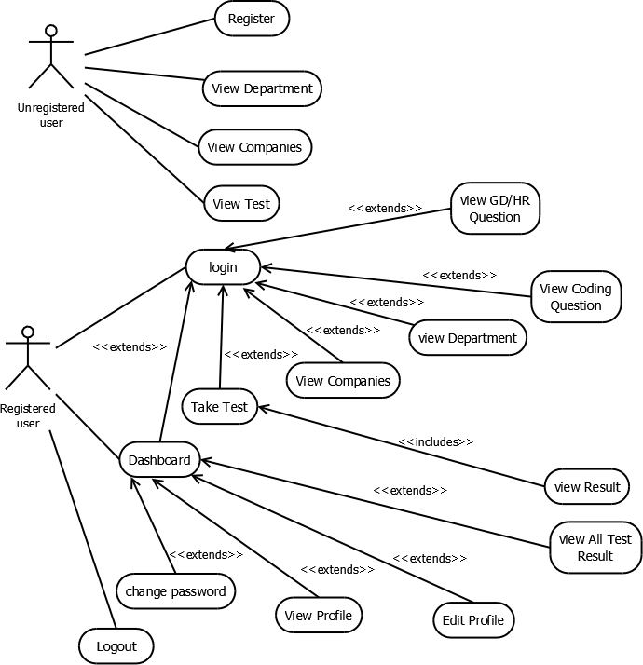

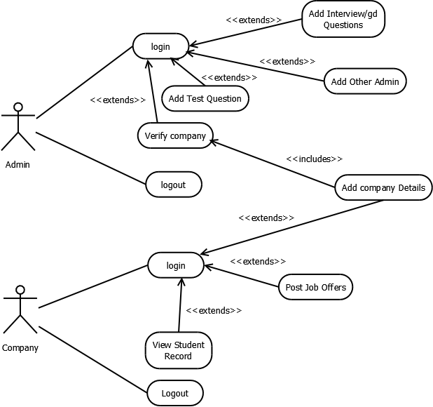
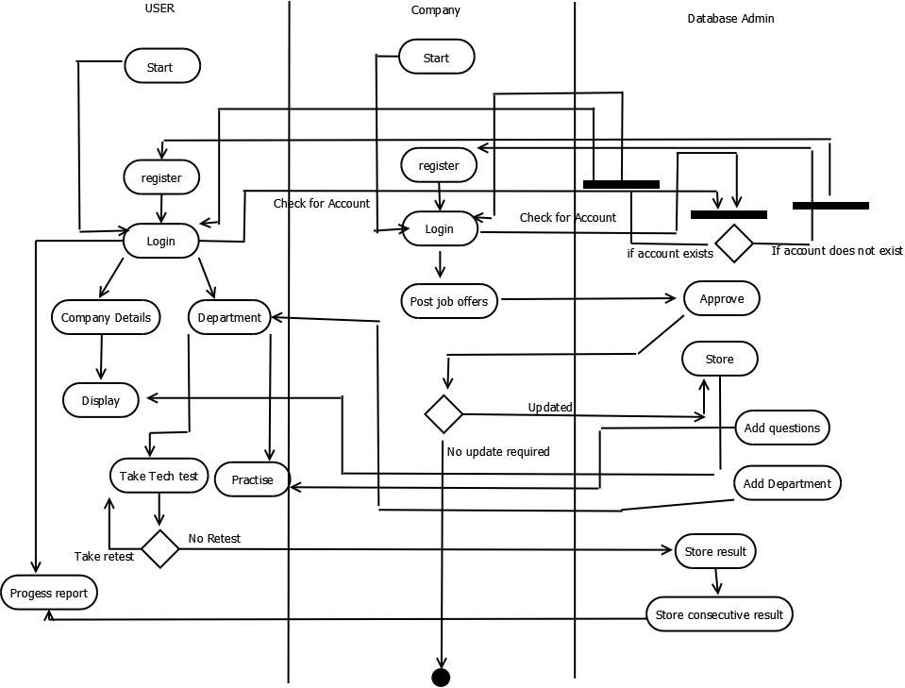

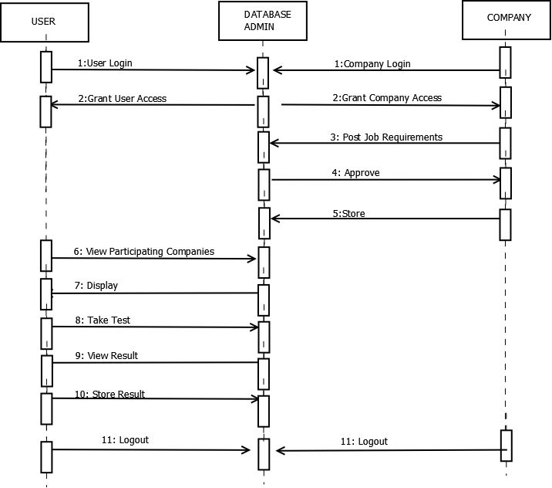
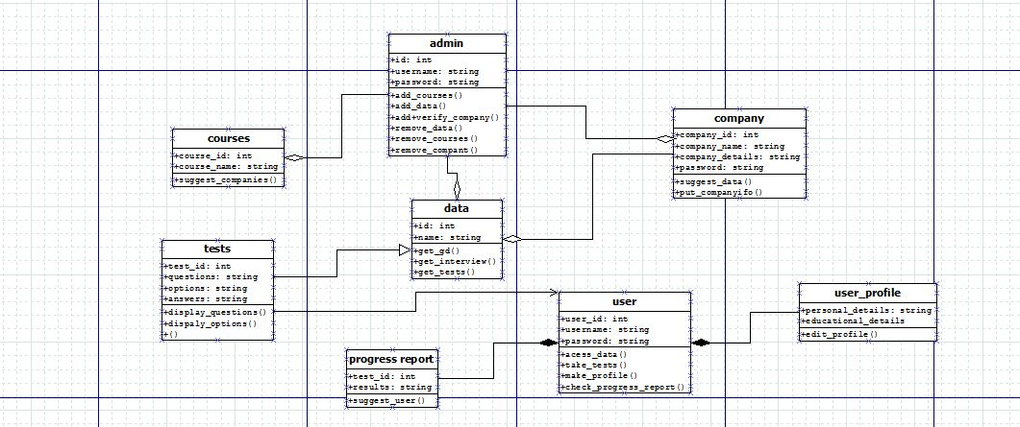

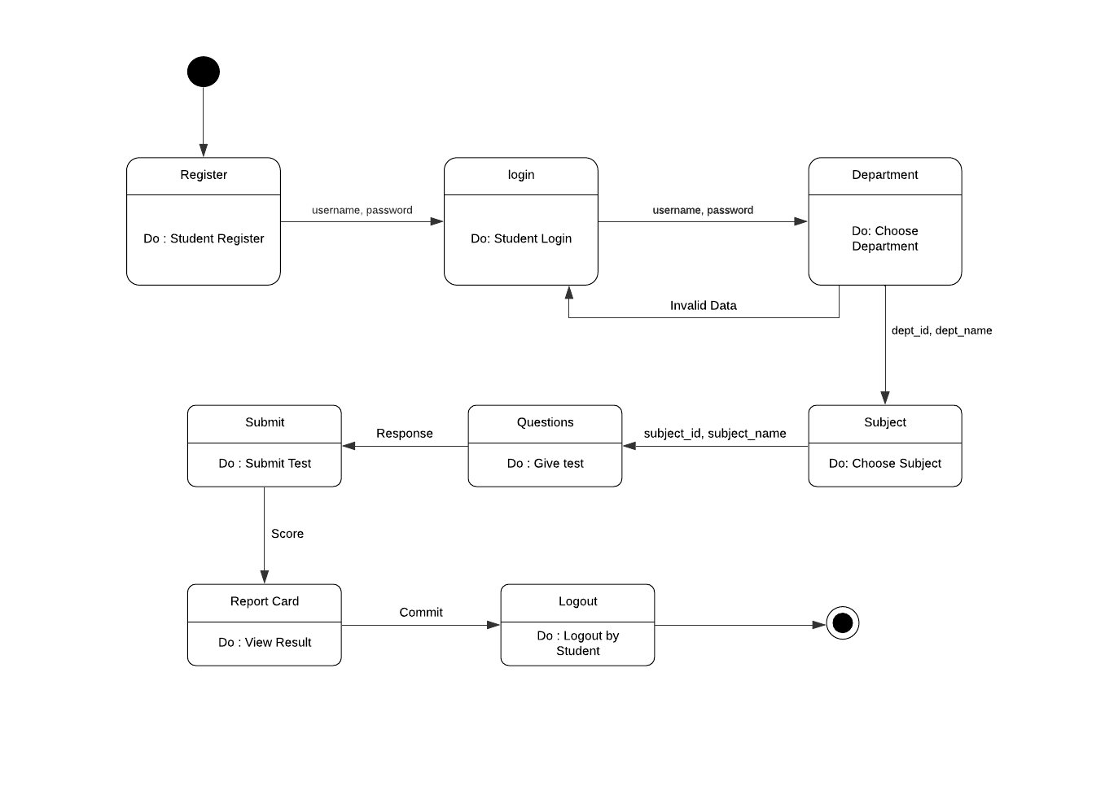

(note:GD HR CODING questions are static part of website test is only the dynamic part)

Conclusion: UML Diagrams for placement assitance were made were made.

Post Lab Descriptive Questions:
- Where do use cases fit in the software development life cycle?
ANS:
- Requirements: The use-case model is the result of the requirements discipline. Requirements work matures the use cases through the first three states, from Identified to Agreed.
- Analysis and Design: Use cases are realized in analysis and design models. Use-case realizations are created that describe how the use cases are performed in terms of interacting objects in the model. Analysis and design of the use cases matures them through the states of Analyzed and Designed. These states do not change the description of the use cases, but indicate that the use cases have been realized in the analysis and design of the system.
- Implementation: During implementation, the design model is the implementation specification. Because use cases are the basis for the design model, they are implemented in terms of design classes. Once the code has been written to enable a use case to be executed, it can be considered to be in the Implemented state.
- Testing: During testing, the use cases constitute the basis for identifying test cases and test procedures; that is, the system is verified by performing each use case. When the tests related to a use case have been successfully passed by the system, the use case can be considered to be in the Verified state. The Accepted state is reached when a version of the system that implements the use case passes independent user-acceptance testing.

- Compare sequence diagram with collaboration diagram. Explain pros and cons of each.
ANS

Sequence diagram:
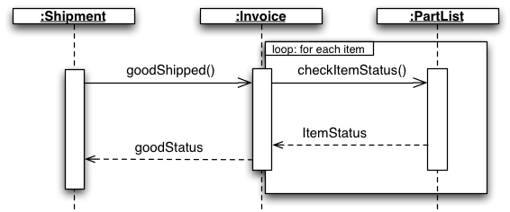

Collaboration Diagram:
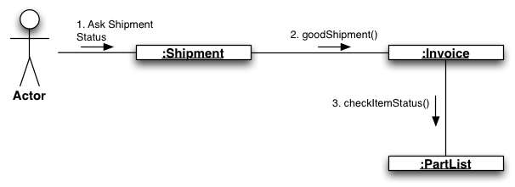

TYPE | PROS | CONS
Sequence | - clearly shows sequence or time ordering of messages  - large set of detailed notation options  - easier to see the call-flow sequence with sequence diagrams—simply read top to bottom. | - forced to extend to the right when adding new objects; consumes horizontal space
Collaboration | - space economical—flexibility to add new objects in two dimensions | • more difficult to see sequence of messages  • fewer notation options  • we must read the sequence numbers, such as "1:" and "2:".

- List different notations used in Class diagram with example
ANS
Class Name:
- The name of the class appears in the first partition.
Class Attributes:
- Attributes are shown in the second partition.
- The attribute type is shown after the colon.
- Attributes map onto member variables (data members) in code.
Class Operations (Methods):
- Operations are shown in the third partition. They are services the class provides.
- The return type of a method is shown after the colon at the end of the method signature.
- The return type of method parameters are shown after the colon following the parameter name. Operations map onto class methods in code
Relationships between classes:
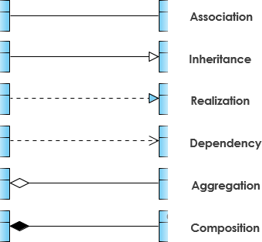

Example: Order System

