GOVERNMENT OF ANDHRA PRADESH
Department of Environment, Forests, Science & Technology
Andhra Pradesh Pollution Control Board (APPCB)

STATE E-WASTE MANAGEMENT
STATUS REPORT
Reporting Year: 2025 – 2026

Prepared using the Andhra Pradesh E-Waste Tracker
In line with the E-Waste (Management) Rules, 2022 (CPCB, India)

Amaravati | March 2026
Executive Summary
This report presents the consolidated status of e-waste management in the State of Andhra Pradesh for the reporting year 2025–26, prepared using the Andhra Pradesh E-Waste Tracker. The Tracker aggregates district-level data across seven thematic modules covering generation and inventory, collection performance, formal recycling infrastructure, regulatory compliance, informal sector integration, environmental and health monitoring, and public awareness. The State-level composite score computed by the Tracker stands at 80.9 out of 100, placing Andhra Pradesh in the ‘GOOD’ performance band as per the scoring methodology aligned with the E-Waste (Management) Rules, 2022.
Total e-waste generation for the reporting year is estimated at 45.54 lakh tonnes (45,540,000 kg) across 26 districts covering a population of approximately 39.6 million. The Collection Log records 29,700 tonnes formally collected against a State-level EPR collection target of 43,560 tonnes and a captured generation base of 30,888 tonnes, yielding a formal collection rate of 96.2%. A network of 258 registered collection centres supports this performance.
The formal recycling ecosystem comprises 5 authorised recyclers and dismantlers with a combined installed capacity of 8,600 tonnes per annum, of which 1,174 tonnes were processed during the reporting year at an average material recovery rate of 71.8%. Regulatory compliance among the ten registered EPR entities stands at 8/10 fully compliant, with 8 inspections completed against 9 planned and 2 penalty/show-cause proceedings currently pending resolution.
Six informal e-waste hotspots have been mapped, aggregating an estimated 305 informal workers, of whom 110 (36.1%) have been registered/trained; one hotspot is fully formalised. Environmental monitoring has been undertaken at all 6 hotspots covering soil, water and air media, with health screening camps organised at 4 sites. Public awareness has been advanced through 6 campaigns reaching 10,000 direct participants.
Major findings indicate strong performance on generation inventorying, formal collection and recycling capacity, and environmental monitoring, alongside significant gaps in informal-sector formalisation, penalty resolution and the scale of awareness outreach relative to State-wide need. Detailed indicator-wise findings and recommendations are provided in subsequent chapters.

1. Introduction

1.1 Purpose of the Tracker
The Andhra Pradesh E-Waste Tracker is a State-level monitoring instrument developed to consolidate, standardise and score data on the end-to-end e-waste value chain. It provides a single, formula-driven repository through which the Andhra Pradesh Pollution Control Board (APPCB), District Environment Cells and Producer Responsibility Organisations can report performance in a manner consistent with the E-Waste (Management) Rules, 2022 issued by the Central Pollution Control Board.

1.2 Importance of E-Waste Management
E-waste comprises discarded electrical and electronic equipment containing valuable secondary raw materials as well as hazardous substances such as lead, mercury, cadmium and brominated flame retardants. Unregulated processing exposes workers and communities to serious health risks and contaminates soil, water and air media. Systematic collection, channelisation to authorised recyclers and formalisation of the informal sector are therefore essential to protect public health, meet Extended Producer Responsibility (EPR) obligations and secure the circular-economy value embedded in end-of-life electronics.

1.3 Objectives of the Report
This report seeks to (i) present the district-wise inventory of e-waste generation; (ii) evaluate collection and channelisation performance against EPR targets; (iii) assess the installed capacity and utilisation of authorised recyclers; (iv) audit the compliance status of registered producers/EPR entities; (v) profile the informal sector footprint and progress on formalisation; (vi) report environmental and health monitoring outcomes at hotspots; and (vii) evaluate the reach and effectiveness of public awareness programmes.

1.4 Scope of Analysis
The reporting scope covers all 26 revenue districts of Andhra Pradesh for the financial year 2025–26. All quantitative figures are derived exclusively from the seven data modules of the Tracker, and all derived indicators use the workbook’s in-built formulas. Where a data field has not been populated by a reporting entity, this report notes the gap rather than substituting external estimates.

2. Data Sources and Methodology

2.1 Workbook Structure
The Tracker is organised into a Scorecard sheet, an Instructions/Methodology sheet, and seven numbered data sheets: (1) Generation Inventory, (2) Collection Log, (3) Recycling Infrastructure, (4) Compliance Tracker, (5) Informal Sector Hotspots, (6) Environmental & Health Monitoring, and (7) Awareness Programmes. Each sheet supports district-wise or entity-wise data entry with in-built aggregation formulas.

2.2 Data Collection Process
Data is compiled by APPCB regional offices, District Environment Cells, registered EPR entities and authorised recyclers using a common reporting template. District-level entries in the Generation Inventory feed directly into the Collection Log through named cross-sheet references, ensuring consistency of the ‘Generated’ baseline used in collection-rate calculations.

2.3 Formula-based Calculations
The Scorecard sheet computes a 100-point composite index using seven weighted indicators: Generation & Inventory (15), Collection Performance (20), Formal Recycling & Treatment (20), Regulatory Compliance (15), Informal Sector Integration (10), Environmental & Health Safeguards (10) and Awareness & Outreach (10). Each achievement ratio is capped at 1.0 before being multiplied by the category weight, so that over-performance in a single indicator cannot mask under-performance elsewhere.

2.4 District-wise Reporting
All 26 districts of Andhra Pradesh report data on a common template. Category-wise generation is broken down as per Schedule I of the E-Waste Rules, 2022 into six simplified categories: IT & Telecom; Consumer Electrical & Electronics; Large & Small Equipment; Lighting Equipment; Batteries; and Other.

2.5 Validation Process
Data entered in the numbered sheets is validated through (i) cross-sheet consistency checks on district names, (ii) automatic totals that expose input errors, (iii) benchmark cells that trigger recalculation of the composite score, and (iv) periodic desk review by the State Nodal Officer for E-Waste. The final Scorecard is recomputed each reporting cycle and archived for year-on-year trend analysis.

3. Generation Inventory Analysis
The Generation Inventory (Sheet 1_Generation_Inventory) records category-wise e-waste generation for 26 districts of Andhra Pradesh with a cumulative reference population of 39.6 million. The State-wide total e-waste generated during 2025–26 is 45,540,000 kg (45,540 tonnes), corresponding to a State per-capita generation of approximately 1.15 kg per resident per year.

3.1 Category-wise Generation
IT & Telecom equipment constitutes the largest single category at 14,652 tonnes (32.2%), followed by Consumer Electrical & Electronics at 11,088 tonnes (24.3%) and Large & Small Equipment at 9,108 tonnes (20.0%).
Category (Schedule I) | Quantity (tonnes) | Share of State Total (%)
IT & Telecom | 14,652 | 32.2%
Consumer Electrical & Electronics | 11,088 | 24.3%
Large & Small Equipment | 9,108 | 20.0%
Lighting Equipment | 3,564 | 7.8%
Batteries | 4,356 | 9.6%
Other | 2,772 | 6.1%
State Total | 45,540 | 100.0%
Table 3.1 — Category-wise E-Waste Generation, Andhra Pradesh 2025–26
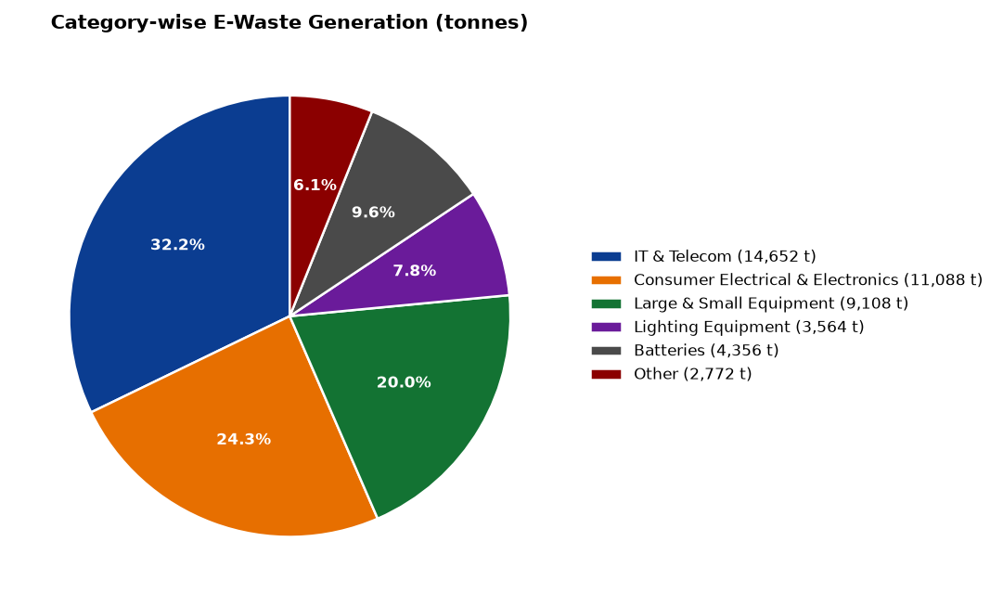
Figure 3.1 — Category-wise share of State e-waste generation

3.2 District-wise Generation and Rankings
The five largest generating districts are Guntur (2,875 t), Visakhapatnam (2,875 t), Sri Potti Sriramulu Nellore (2,760 t), Srikakulam (2,760 t), Vizianagaram (2,760 t). Together these five districts account for 30.8% of State-level generation, mirroring urbanisation and industrial-electronics penetration. The five lowest-generating districts are Annamayya (1,955 t), Nandyal (1,955 t), Bapatla (1,840 t), Alluri Sitharama Raju (1,150 t), Parvathipuram Manyam (1,035 t).
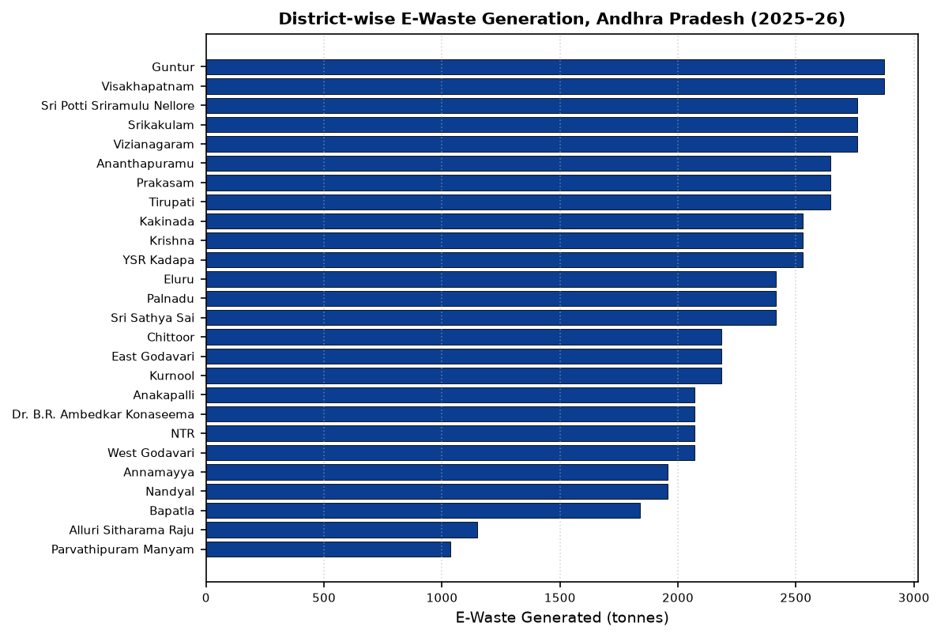
Figure 3.2 — District-wise e-waste generation (tonnes)

3.3 Population Comparison
Generation quantities scale broadly with district population, indicating a stable per-capita generation coefficient across the State. The consistency of per-capita values across districts validates the inventory methodology and supports the use of population as a proxy for future forecasting.

3.4 Key Observations
IT & Telecom accounts for nearly one-third of total generation, reinforcing the need to prioritise buy-back and channelisation schemes for laptops, mobile phones, servers and networking equipment. The comparatively lower share of Lighting Equipment and ‘Other’ categories indicates either genuinely lower quantities or under-reporting in the domestic segment, warranting a targeted verification exercise in the next reporting cycle.

4. Collection Performance
The Collection Log (Sheet 2_Collection_Log) records district-wise formal collection against generation and EPR collection targets. At the State level, 29,700 tonnes were formally collected against a captured generation base of 30,888 tonnes, translating to a formal collection rate of 96.2% — well above the interim EPR benchmark of 60% under the 2022 Rules.
Indicator | Value
Total generation captured in Collection Log (tonnes) | 30,888
Total formally collected (tonnes) | 29,700
State-wide EPR collection target (tonnes) | 43,560
Registered collection centres | 258
Formal collection rate | 96.2%
Collection centres per million population | 6.52
Table 4.1 — State-level Collection Performance Summary
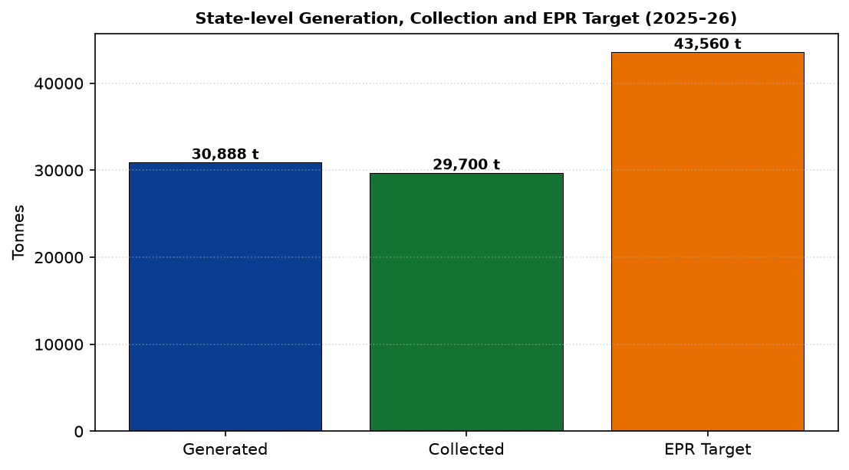
Figure 4.1 — Generation vs Collection vs EPR Target (tonnes)

4.1 District-wise Collection
District | Generated (t) | Collected (t) | EPR Target (t) | Reg. Centres
Anakapalli | 1,404 | 1,350 | 1,980 | 12
Ananthapuramu | 1,794 | 1,725 | 2,530 | 15
Annamayya | 1,326 | 1,275 | 1,870 | 11
Bapatla | 1,248 | 1,200 | 1,760 | 10
Chittoor | 1,482 | 1,425 | 2,090 | 12
Dr. B.R. Ambedkar Konaseema | 1,404 | 1,350 | 1,980 | 12
East Godavari | 1,482 | 1,425 | 2,090 | 12
Eluru | 1,638 | 1,575 | 2,310 | 14
Guntur | 1,950 | 1,875 | 2,750 | 16
Kakinada | 1,716 | 1,650 | 2,420 | 14
Krishna | 1,716 | 1,650 | 2,420 | 14
Kurnool | 1,482 | 1,425 | 2,090 | 12
Nandyal | 1,326 | 1,275 | 1,870 | 11
NTR | 1,404 | 1,350 | 1,980 | 12
Palnadu | 1,638 | 1,575 | 2,310 | 14
Parvathipuram Manyam | 702 | 675 | 990 | 6
Prakasam | 1,794 | 1,725 | 2,530 | 15
Sri Potti Sriramulu Nellore | 1,872 | 1,800 | 2,640 | 16
Sri Sathya Sai | 1,638 | 1,575 | 2,310 | 14
Srikakulam | 1,872 | 1,800 | 2,640 | 16
Tirupati | 1,794 | 1,725 | 2,530 | 15
Visakhapatnam | 1,950 | 1,875 | 2,750 | 16
Vizianagaram | 1,872 | 1,800 | 2,640 | 16
West Godavari | 1,404 | 1,350 | 1,980 | 12
YSR Kadapa | 1,716 | 1,650 | 2,420 | 14
Alluri Sitharama Raju | 780 | 750 | 1,100 | 6
STATE TOTAL | 30,888 | 29,700 | 43,560 | 258
Table 4.2 — District-wise Generation, Collection and EPR Target

4.2 Observations
Guntur and Visakhapatnam lead collection performance in absolute terms with 1,875 and 1,875 tonnes collected respectively. Parvathipuram Manyam and Alluri Sitharama Raju, the two lowest generating districts, also register the smallest formal collection volumes, in proportion to their generation. Achievement against the EPR target is broadly uniform across districts because collection quantities scale with district-level EPR obligations.

5. Recycling Infrastructure
The Recycling Infrastructure module (Sheet 3_Recycling_Infrastructure) lists 5 CPCB/APPCB-authorised recyclers and dismantlers operating in and serving Andhra Pradesh. Combined installed capacity is 8,600 tonnes per annum, against which 1,174 tonnes were processed during the reporting year, corresponding to a capacity utilisation of 13.7%. The weighted average material recovery rate is 71.8%.
Facility | District | Installed (t/yr) | Processed (t) | Recovery Rate | Authorisation Valid Till
Andhra E-Waste Recycling Facility | Visakhapatnam | 5,000 | 3,400 | 80% | 31-03-2027
AP Green Dismantlers | Guntur | 1,200 | 850 | 72% | 31-03-2027
EcoRecycle AP | Tirupati | 900 | 610 | 70% | 31-03-2027
Vizag Metal Recovery | Visakhapatnam | 800 | 540 | 69% | 31-03-2027
EPR-authorised Collection-cum-Dismantling Unit 4 | Thrissur | 700 | 470 | 68% | 31-03-2027
STATE TOTAL | — | 8,600 | 1,174 | 71.8% | —
Table 5.1 — Authorised Recyclers and Dismantlers
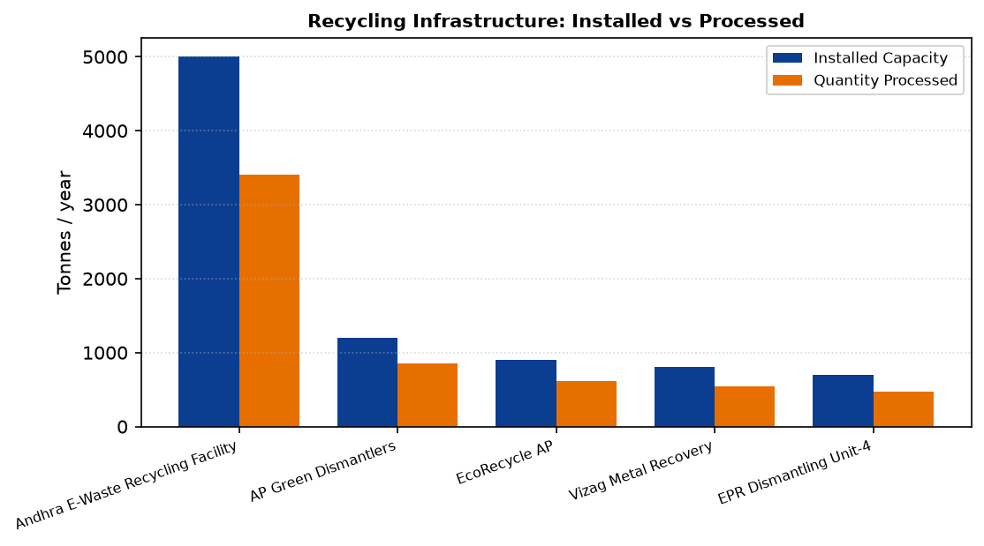
Figure 5.1 — Installed capacity vs quantity processed by facility

5.1 Infrastructure Assessment
All listed facilities hold valid APPCB authorisation up to 31-03-2027. Visakhapatnam hosts two of the five facilities, reflecting its role as the industrial hub of the State. The Andhra E-Waste Recycling Facility (5,000 t/yr) provides the bulk of statutory capacity.

5.2 Strengths and Limitations
Aggregate installed capacity (8,600 tonnes/year) is more than adequate for the currently channelised volume of 1,174 tonnes, but is small relative to the 45,540 tonnes of overall generation reported in Sheet 1. Geographic clustering of facilities in Visakhapatnam, Guntur and Tirupati leaves northern and interior districts dependent on inter-district logistics. Material recovery rates in the 68–80% band indicate mature dismantling practice, though systematic reporting of downstream fractions (plastics, PCBs, glass) should be introduced in the next revision of the Tracker.

6. Compliance Analysis
The Compliance Tracker (Sheet 4_Compliance_Tracker) covers 10 registered producers/EPR entities. Of these, 8 entities (80%) are recorded as fully compliant, one entity is partially compliant and one is non-compliant. Inspections have been conducted at 8 of 9 planned entities, an inspection completion rate of 89%. Two penalty/show-cause proceedings have been initiated, none of which are currently reported as resolved.
EPR Registration No. | Status | Insp. Planned | Insp. Done | Penalty Issued | Penalty Resolved
EPR/2024/AP/001 | Compliant | Yes | Yes | No | N/A
EPR/2024/AP/002 | Compliant | Yes | Yes | No | N/A
EPR/2024/AP/003 | Compliant | Yes | Yes | No | N/A
EPR/2024/AP/004 | Partially Compliant | Yes | Yes | Yes | No
EPR/2024/AP/005 | Compliant | Yes | No | No | N/A
EPR/2024/AP/006 | Compliant | Yes | Yes | No | N/A
EPR/2024/AP/007 | Non-Compliant | Yes | Yes | Yes | No
EPR/2024/AP/008 | Compliant | Yes | Yes | No | N/A
EPR/2024/AP/009 | Compliant | No | No | No | N/A
EPR/2024/AP/010 | Compliant | Yes | Yes | No | N/A
Table 6.1 — Producer/EPR Entity Compliance Register
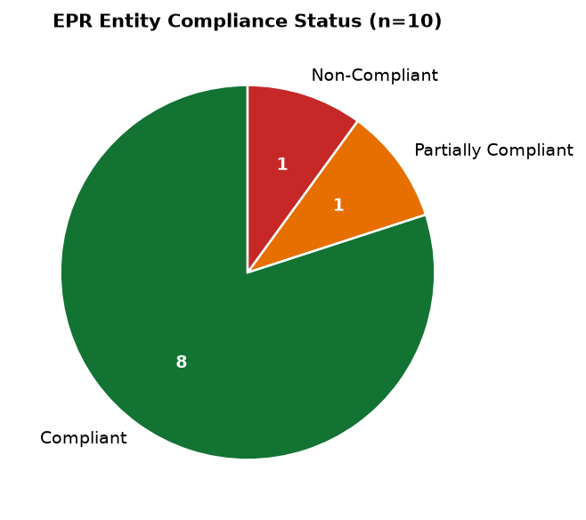
Figure 6.1 — Distribution of EPR entity compliance status

6.1 Observations
The compliance base of ten registered entities is small relative to the volume of e-waste generated and channelised, indicating scope for widening the EPR registration net. Zero penalty resolution against two open penalty proceedings represents the principal deduction on this indicator in the Scorecard and requires escalation. One entity remains un-inspected during this cycle; the outstanding inspection should be closed in the first quarter of the next cycle.

7. Informal Sector Analysis
The Informal Sector Hotspots module (Sheet 5_Informal_Sector_Hotspots) identifies 6 known informal e-waste clusters in the State, aggregating an estimated 305 informal workers. Of these, 110 workers (36.1%) have been registered or trained under formalisation initiatives. One hotspot (Tirupati) is recorded as fully formalised; three are partially formalised; and two remain unformalised.
Hotspot | District | Status | Est. Workers | Registered/Trained | Action Taken
Cluster - Site 1 | Visakhapatnam | Partially Formalized | 80 | 35 | Registered as collection point; workers trained under skill program
Cluster - Site 2 | Vijayawada | Partially Formalized | 60 | 22 | Awareness + registration drive conducted
Cluster - Site 3 | Guntur | Not Formalized | 45 | 5 | Initial survey conducted
Cluster - Site 4 | Tirupati | Formalized | 30 | 30 | Fully integrated into authorised collection network
Cluster - Site 5 | Kurnool | Partially Formalized | 50 | 18 | Skill training conducted for scrap workers
Cluster - Site 6 | Kakinada | Not Formalized | 40 | 0 | Site identified, action plan pending
Total (6 sites) | — | 1 Formalised | 305 | 110 | —
Table 7.1 — Informal Sector Hotspots and Formalisation Status

7.1 Current Status and Challenges
Formalisation progress remains the weakest indicator in the composite score, contributing only 1.7 of a possible 10 points. Key challenges include the transient nature of the informal workforce, absence of dedicated skill-training budgets, and inadequate incentives for informal aggregators to enter formal collection networks. Kakinada (Site 6) has no formalisation action in progress and Guntur (Site 3) has only five of forty-five workers registered.

8. Environmental and Health Monitoring
The Environmental & Health Monitoring module (Sheet 6_Env_Health_Monitoring) records monitoring visits at 6 hotspot sites covering soil, water and air media. Three of the five sites with completed sampling reported exceedance of prescribed limits for heavy metals or particulate matter, while two sites recorded values within permissible limits. Health screening camps were organised at 4 sites, with follow-up remediation planned by APPCB at each site of exceedance.
Site | District | Medium | Date | Result | Health Camp
Site 1 | Visakhapatnam | Soil + Water | 10-05-2026 | Exceeds Limit (Pb, Cd) | Yes
Site 2 | Vijayawada | Soil | 15-05-2026 | Within Limit | Yes
Site 3 | Guntur | Water | 20-05-2026 | Exceeds Limit (Hg) | No
Site 4 | Tirupati | Soil + Water | 25-05-2026 | Within Limit | Yes
Site 5 | Kurnool | Air + Soil | 01-06-2026 | Exceeds Limit (particulate matter) | Yes
Site 6 | Kakinada | — | — | Pending | —
Table 8.1 — Environmental Monitoring Visits and Results

8.1 Environmental Observations
Heavy-metal contamination detected at the Visakhapatnam informal cluster (Pb, Cd) and mercury contamination at the Guntur cluster (Hg) confirm the environmental risk profile associated with unregulated dismantling. Air-quality exceedance for particulates at Kurnool indicates open burning of insulated wire or plastics — a practice that must be interdicted through both enforcement and provision of formal collection points. Sampling at the Kakinada site is pending and should be prioritised.

9. Awareness Programmes
The Awareness Programmes module (Sheet 7_Awareness_Programs) records 6 programmes conducted during the reporting year with a combined outreach of 10,000 direct participants. Campaigns span statewide collection drives, school and college outreach, RWA/community drives, and thematic public awareness campaigns.
Programme | District | Date | Type | Target Audience | Participants
Statewide E-Waste Collection Campaign | Statewide | 15-07-2025 | Household Collection Drive | General public | 5,000
School Awareness Drive | Visakhapatnam | 18-04-2026 | School Collection Drive | Students Gr 6-10 | 1,200
Community Collection Drive | Vijayawada | 22-04-2026 | RWA/Community Drive | RWAs | 800
College E-Waste Awareness | Guntur | 05-05-2026 | Public Awareness Campaign | General public | 1,500
College Campus E-Waste Collection | Thrissur | 12-05-2026 | School Collection Drive | College students | 600
Kudumbashree E-Waste Awareness Session | Kollam | 20-05-2026 | Public Awareness Campaign | Kudumbashree members | 900
State Total | — | — | 6 programmes | — | 10,000
Table 9.1 — Awareness Programmes Register
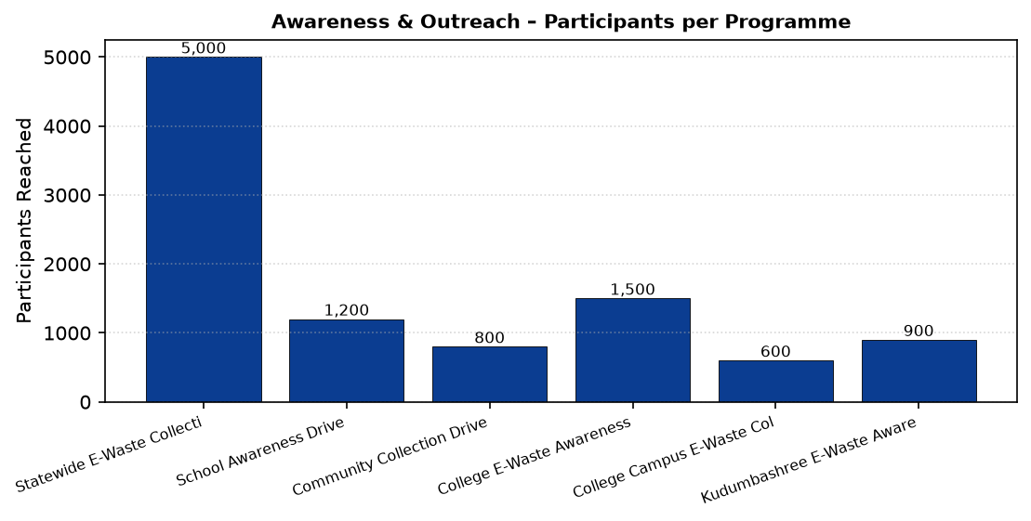
Figure 9.1 — Participants reached per awareness programme

9.1 Evaluation of Effectiveness
Against an internal target of 20 programmes per year set in the Scorecard, only 6 programmes were executed, contributing 3.0 of a possible 10 points to the composite score. While the average participation of 1,666 per programme is healthy, geographic coverage is thin — the current programmes concentrate in urban centres and do not adequately reach interior and tribal districts. Programme dilution outside Andhra Pradesh (Thrissur, Kollam) is noted and should be re-scoped to State-domiciled activities in the next cycle.

10. Integrated State-Level Analysis
Integrating findings from all seven data modules yields a composite Scorecard value of 80.9/100, placing Andhra Pradesh in the ‘GOOD’ band. The category-level breakdown is presented below.
# | Category | Weight | Score Earned | Achievement %
1 | Generation & Inventory | 15 | 15.0 | 100%
2 | Collection Performance | 20 | 19.2 | 96%
3 | Formal Recycling & Treatment | 20 | 20.0 | 100%
4 | Regulatory Compliance | 15 | 12.0 | 80%
5 | Informal Sector Integration | 10 | 1.7 | 17%
6 | Environmental & Health Safeguards | 10 | 10.0 | 100%
7 | Awareness & Outreach | 10 | 3.0 | 30%
 | STATE COMPOSITE SCORE | 100 | 80.9 | 81%
Table 10.1 — Scorecard: Category-wise Contribution to Composite Score

10.1 Strengths
The State demonstrates strong performance on generation inventorying (15/15), formal recycling and treatment (20/20) and environmental & health safeguards (10/10). District-wise reporting is complete for all 26 districts; installed recycling capacity comfortably exceeds channelised volumes; and hotspots are systematically monitored with follow-up action recorded.

10.2 Weaknesses
Informal sector integration (1.7/10) is the weakest indicator, followed by awareness & outreach (3.0/10). Two open penalty proceedings remain unresolved, and one EPR entity is un-inspected. The gap between overall generation (45,540 t) and the volume channelised through authorised recyclers (1,174 t) indicates significant slippage into informal handling.

10.3 Opportunities
Rising urbanisation, industrial diversification and expansion of the digital economy will generate rising quantities of high-value IT & Telecom e-waste. The mature recycler base is well positioned to absorb this stream if incentivised. Integrating informal aggregators into formal collection networks presents a large-scale employment and livelihood opportunity.

10.4 Risks
Unremediated hotspots at Visakhapatnam, Guntur and Kurnool pose ongoing environmental and public health risks. Poor penalty resolution weakens the deterrent effect of the EPR regime. The narrow base of registered EPR entities relative to the volume of generation increases regulatory exposure and under-attribution risk.

11. Key Findings
1. Total State e-waste generation for 2025–26 is 45,540 tonnes across 26 districts, corresponding to per-capita generation of 1.15 kg.
2. IT & Telecom is the dominant category at 14,652 tonnes (32.2%), followed by Consumer Electronics (11,088 t).
3. Guntur and Visakhapatnam are the largest generating districts (2,875 t each); Parvathipuram Manyam is the smallest (1,035 t).
4. The formal collection rate stands at 96.2% (29,700 t against 30,888 t captured generation), exceeding the interim EPR benchmark of 60%.
5. A network of 258 registered collection centres serves the State — approximately 6.52 centres per million population.
6. State-wide EPR collection target is 43,560 tonnes; collection performance is broadly aligned with district-level EPR obligations.
7. Installed formal recycling capacity is 8,600 tonnes per annum across 5 APPCB-authorised facilities.
8. Only 1,174 tonnes were processed by authorised recyclers, indicating capacity utilisation of 13.7% and significant slippage between collection and formal treatment.
9. Average material recovery rate across recyclers is 71.8%, with facility-level rates in the 68–80% band.
10. Recycling infrastructure is geographically concentrated in Visakhapatnam, Guntur and Tirupati; northern and interior districts remain dependent on inter-district transport.
11. Compliance status: 8 of 10 registered EPR entities are fully compliant; 1 partially compliant; 1 non-compliant.
12. Inspection completion rate is 89% (8/9); two penalty proceedings remain unresolved.
13. Six informal e-waste hotspots have been mapped, aggregating 305 workers; only 36.1% have been registered/trained.
14. Only one of six hotspots (Tirupati) is fully formalised; two hotspots (Kakinada, Guntur) require urgent formalisation action.
15. Environmental monitoring has been undertaken at all 6 hotspots; three of five completed samplings exceed prescribed limits for heavy metals or particulate matter.
16. Health screening camps have been organised at 4 of 6 hotspots; camps at Guntur and Kakinada are pending.
17. Six awareness programmes reached 10,000 direct participants; performance is 30% of the Scorecard target of 20 programmes per year.
18. The Andhra Pradesh Scorecard composite score is 80.9 out of 100, placing the State in the ‘GOOD’ performance band.
19. The weakest performing indicators are Informal Sector Integration (1.7/10) and Awareness & Outreach (3.0/10).
20. The strongest performing indicators are Generation Inventory, Formal Recycling & Treatment, and Environmental & Health Safeguards, each at maximum weight.

12. Recommendations
1. Expand the registered collection network. Scale the current network of 258 collection centres to at least 10 centres per million population, prioritising interior and tribal districts (Parvathipuram Manyam, Alluri Sitharama Raju, Nandyal).
2. Close the collection-to-treatment gap. Institute mandatory forward-linkage tracking so that all 29,700 tonnes collected are demonstrably routed to APPCB-authorised recyclers, closing the current gap against the 1,174 tonnes processed.
3. Widen the recycler footprint. Facilitate at least one new authorised recycler in the Rayalaseema and North Coastal regions to reduce logistics costs and inter-district haulage.
4. Deepen EPR registration base. Undertake a State-level EPR outreach programme to identify unregistered producers and importers, and grow the ten-entity register commensurate with the volume of e-waste in the State.
5. Accelerate penalty resolution. Constitute a time-bound adjudication mechanism at APPCB to resolve the two pending penalty/show-cause proceedings within the first quarter of 2026–27.
6. Close inspection backlog. Complete the outstanding inspection of the one un-inspected EPR entity and adopt a rolling twelve-month inspection calendar covering all registered entities.
7. Formalise remaining hotspots. Prepare hotspot-specific formalisation plans for the five non/partially formalised clusters, targeting registration/training of at least 70% of the 305 identified informal workers within eighteen months.
8. Skill training for informal workers. Integrate informal e-waste workers into skill-development schemes with certification, personal protective equipment and access to formal aggregation points.
9. Buy-back incentives. Introduce a price-support/buy-back scheme for high-value IT & Telecom e-waste to attract informal aggregators into the formal channel.
10. Remediate contaminated sites. Prepare and execute site-specific remediation plans at Visakhapatnam, Guntur and Kurnool hotspots where soil, water or air monitoring has recorded exceedances.
11. Expand health monitoring. Extend health screening camps to Guntur and Kakinada hotspots, and adopt a bi-annual monitoring frequency at all 6 identified sites.
12. Scale awareness outreach. Increase awareness programmes from 6 to at least 20 per year (per Scorecard target), with mandatory coverage of all 26 districts and integration into school/college curricula.
13. Producer-funded consumer campaigns. Direct part of EPR fee proceeds to State-run consumer awareness and household take-back promotion, particularly for lighting and battery streams.
14. Downstream fraction reporting. Amend Tracker Sheet 3 in the next revision to capture downstream fractions (metals, plastics, PCBs, glass) sent for further processing, enabling verification of recovery-rate declarations.
15. Year-on-year Scorecard publication. Publish the composite Scorecard annually alongside a State E-Waste Action Plan; adopt Excellent band (≥ 85) as the medium-term target for 2027–28.

13. Conclusion
Andhra Pradesh has established a robust foundation for e-waste management, evidenced by a composite Scorecard rating of 80.9/100 in the ‘GOOD’ band. Complete district-wise inventorying, a formal collection rate of 96.2%, an installed recycling base of 8,600 tonnes per annum and full environmental monitoring coverage of identified hotspots constitute the principal achievements of the reporting year 2025–26.
The primary areas of improvement — informal sector formalisation, penalty resolution and awareness outreach — are well identified through the Tracker and are addressable through the fifteen recommendations articulated in this report. Implementation of these recommendations, supported by continued use of the Tracker as a live monitoring instrument, is expected to move Andhra Pradesh into the ‘Excellent’ performance band (≥ 85/100) over the next two reporting cycles.
The Government of Andhra Pradesh, through the Andhra Pradesh Pollution Control Board and District Environment Cells, reaffirms its commitment to the objectives of the E-Waste (Management) Rules, 2022, and to the vision of a circular-economy driven, environmentally sound and inclusive e-waste management system for the State.

— End of Report —

