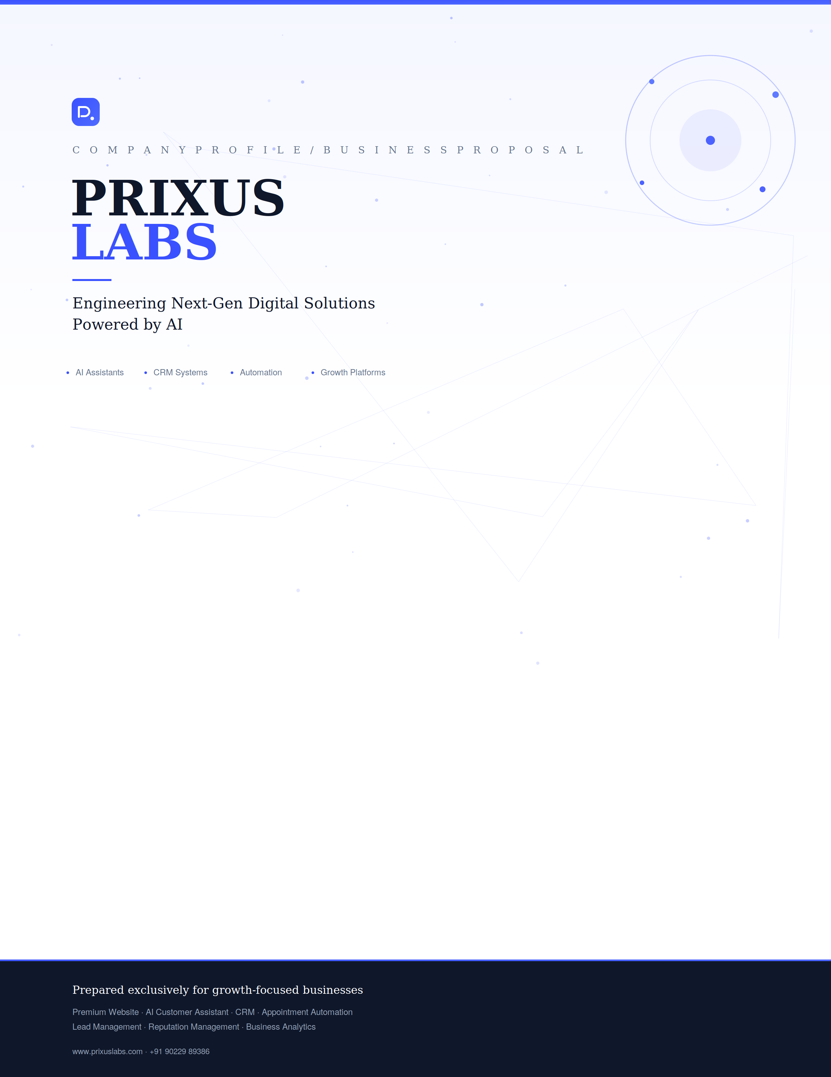

WHAT'S INSIDE
Contents
01 Mission & Vision
02 About Us
03 Our Services
04 The AI Growth Platform
05 Our Development Process
06 Industries We Serve
07 Why Choose PrixusLabs
08 Business Benefits
09 Case Study Framework
10 Project Deliverables
11 Client Experience
12 Contact & Next Steps

PURPOSE & DIRECTION
Mission & Vision

MISSION  To empower businesses with intelligent digital solutions that automate operations, enhance customer engagement, and accelerate sustainable business growth through AI-driven technology. | VISION  To become one of India's leading AI-powered business technology companies — delivering digital ecosystems that transform how businesses acquire customers, manage operations, and scale efficiently.

A Partner, Not a Vendor
PrixusLabs was founded on a simple observation: businesses don't fail from a lack of effort — they plateau because their digital systems are disconnected. A website that doesn't talk to a CRM. Leads that arrive and are never followed up. Appointments booked on paper while a calendar sits empty online. We exist to close those gaps with one connected, intelligent platform.

What Guides Us
● Engineering-first thinking, not templates | ● AI embedded in every customer touchpoint
● Measurable growth over vanity metrics | ● Long-term partnership over one-time delivery

WHO WE ARE
About PrixusLabs

Today, a business doesn't need a website. It needs a system.
Traditional websites only display information — a digital brochure that sits quietly while the real business of winning customers happens elsewhere, through scattered calls, spreadsheets, and sticky notes. Modern businesses need more: a premium web presence, an AI customer assistant, appointment automation, a dedicated CRM, organized lead management, reputation management, and clear analytics — all working as one system.
PrixusLabs develops complete business growth platforms that help businesses attract customers, automate customer interactions, manage appointments, organize leads, and improve operational efficiency — replacing a patchwork of disconnected tools with one intelligent ecosystem.

THE OLD WAY | THE PRIXUSLABS WAY
A website that only displays information | A growth platform that attracts, engages, and converts
Leads collected manually and often lost | AI-qualified leads organized automatically in one CRM
Appointments coordinated over calls and messages | Self-service booking with automated confirmations
Reputation left to chance | Reviews and trust actively built through automation

WHAT WE BUILD
Our Services

Eight interconnected systems, engineered as one platform. Each can stand alone — together, they form the growth infrastructure modern businesses run on.

 | 01 Premium Website Development  Develop a modern, responsive, high-performance website that strengthens brand identity and converts visitors into customers.

DELIVERABLES  - Custom UI design  - Responsive & mobile-optimized  - SEO-friendly structure  - High performance build  - Contact forms & WhatsApp integration  - Landing, service & portfolio pages  - Security best practices | BUSINESS BENEFITS  - Professional online presence  - Better customer experience  - Higher trust & credibility  - Increased inquiries  - Faster loading, better conversions  - Strong digital branding

 | 02 AI Customer Assistant  Provide an intelligent AI assistant that engages visitors 24/7, answers questions, recommends services, and qualifies leads.

DELIVERABLES  - Human-like conversations  - Service guidance & FAQ support  - Lead qualification  - Customer assistance  - Information collection  - Business recommendations | BUSINESS BENEFITS  - Instant customer response  - Reduced manual work  - Better customer engagement  - Improved lead quality  - Higher conversion rates  - 24/7 customer support

 | 03 Appointment Booking System  Allow customers to book appointments online without manual coordination.

DELIVERABLES  - Calendar booking & available slots  - Consultation booking  - Appointment confirmation  - Cancellation & rescheduling  - Customer information collection | BUSINESS BENEFITS  - Saves administrative time  - Better scheduling  - Reduced missed appointments  - Improved customer convenience  - Organized booking management

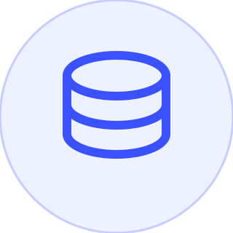 | 04 Dedicated CRM Platform  Centralize customer information, appointments, and leads into one intelligent dashboard.

DELIVERABLES  - Lead management & customer database  - Sales pipeline  - Appointment tracking  - Customer history & activity timeline  - Lead status & follow-up management  - Dashboard analytics | BUSINESS BENEFITS  - Organized customer records  - Better follow-up  - Increased conversion  - Centralized operations  - Better decision making

 | 05 Lead Management System  Capture, organize, and manage every customer inquiry efficiently.

DELIVERABLES  - Website & AI lead capture  - Contact form integration  - Lead tracking  - Customer segmentation  - Lead assignment & activity logs | BUSINESS BENEFITS  - Never lose a lead  - Faster response  - Better organization  - Improved sales management

 | 06 Business Automation  Automate repetitive business processes and improve operational efficiency.

DELIVERABLES  - Workflow automation  - Lead routing  - Internal notifications  - Email automation  - Follow-up reminders  - Appointment & customer alerts | BUSINESS BENEFITS  - Saves time  - Reduces manual work  - Increases productivity  - Improves workflow efficiency

 | 07 Google Review & Reputation Management  Help businesses build a stronger online reputation by simplifying the review collection process.

DELIVERABLES  - Google review QR code  - Review landing page  - Review request system  - Feedback collection  - Reputation dashboard | BUSINESS BENEFITS  - More Google reviews  - Better local SEO  - Improved trust  - Higher customer credibility

 | 08 Business Analytics Dashboard  Provide business owners with valuable insights into customer engagement and business performance.

DELIVERABLES  - Website & lead analytics  - Appointment reports  - Customer statistics  - Conversion tracking  - Performance dashboard | BUSINESS BENEFITS  - Data-driven decisions  - Better marketing ROI  - Business performance monitoring  - Growth insights

ONE CONNECTED SYSTEM
The AI Growth Platform

Every service we build isn't a standalone product — it's one stage of a single intelligent growth engine. A customer's first visit flows automatically into engagement, qualification, booking, and long-term relationship management, with reputation and analytics feeding insight back into the loop.
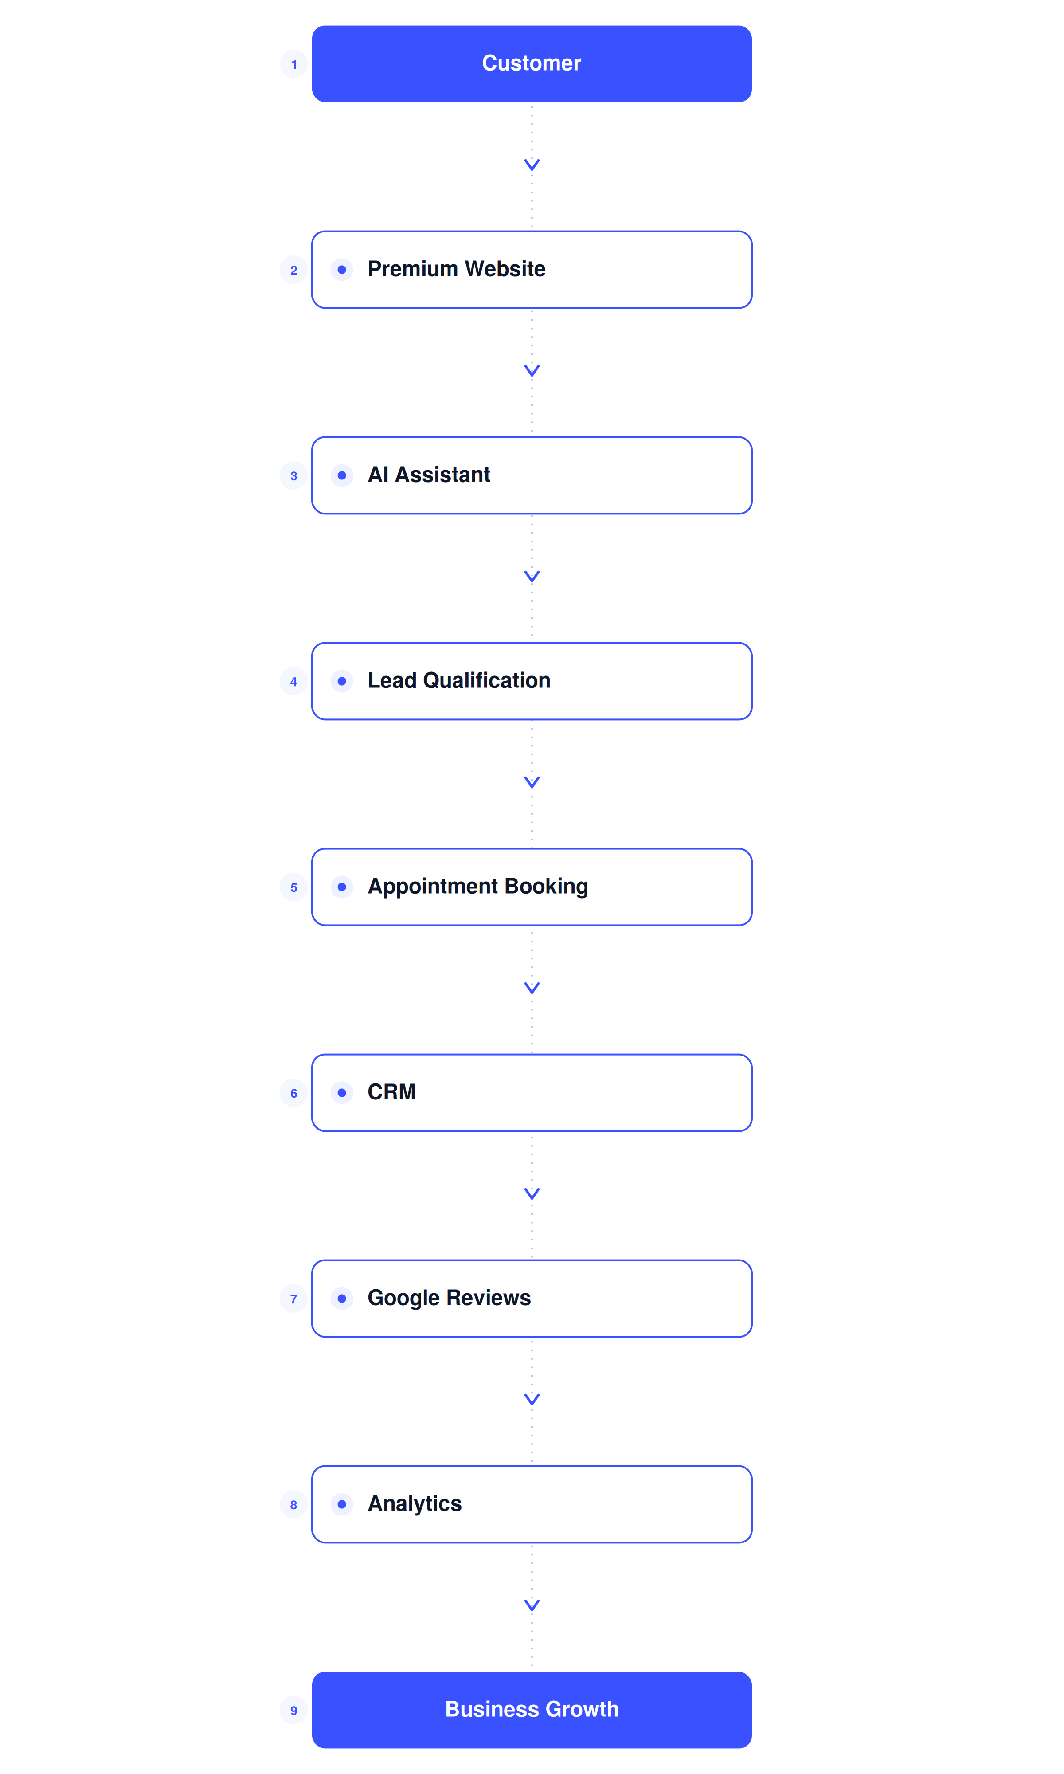

HOW WE DELIVER
Our Development Process

A disciplined, eight-phase methodology — refined across engagements — that takes a business from first discovery call to a fully deployed, supported growth platform.
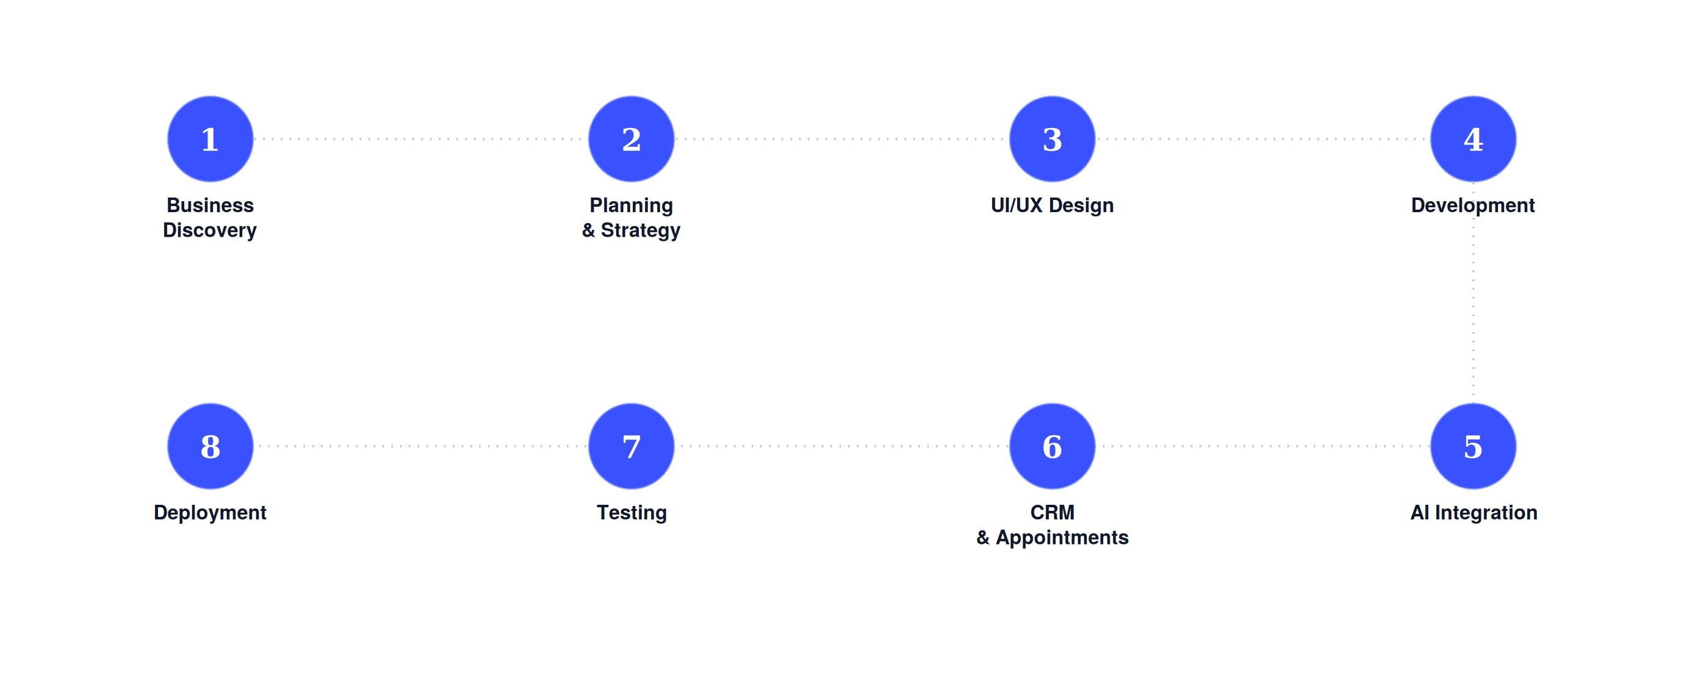

01 | Business Discovery  Requirement gathering, business research, competitor analysis, and goal identification.
02 | Planning & Strategy  Information architecture, system flow, user journey mapping, and project planning.
03 | UI/UX Design  Wireframes, premium interface design, responsive layouts, and interactive prototypes.
04 | Development  Frontend and backend development, database design, and API integration.
05 | AI Integration  AI assistant setup, knowledge base creation, lead qualification, and conversation design.
06 | CRM & Appointment System  Customer dashboard, lead management, appointment booking, and admin panel.
07 | Testing  Performance testing, responsive testing, security testing, and optimization.
08 | Deployment  Launch, training, documentation, and ongoing support.

WHERE WE WORK
Industries We Serve

PrixusLabs builds growth platforms across sectors where customer relationships, appointments, and reputation drive the business.

● Real Estate | ● Healthcare
● Clinics | ● Restaurants
● Hotels | ● Education
● Corporate Businesses | ● Startups
● Consultants | ● Professional Services
● Small Businesses

THE DIFFERENCE
Why Choose PrixusLabs

We don't simply build websites. We create AI-powered business growth ecosystems.
Businesses choose PrixusLabs because we deliver a connected platform — not a one-off project — engineered for performance, scale, and a lasting technology partnership.

 Premium design |  AI integration
 CRM platform |  Appointment automation
 Business automation |  Customer engagement
 Lead management |  Performance optimization
 Scalable architecture |  Long-term technology partnership

THE OUTCOME
Business Benefits

The combined effect of a connected growth platform, measured in the metrics that matter to your business.

 Increase customer engagement |  Capture more qualified leads
 Reduce manual work |  Automate customer communication
 Improve customer experience |  Increase appointments
 Better lead management |  Centralized CRM
 Higher online reputation |  Business growth

PROOF IN PRACTICE
Case Study Framework

Every PrixusLabs engagement is documented against this framework, so results are transparent, comparable, and easy to present internally.
01 | Client Background  Industry, size, and starting point before engaging PrixusLabs.
02 | Business Challenge  The operational or growth bottleneck holding the business back.
03 | Our Solution  The combination of services and systems designed to solve it.
04 | Implementation Process  How the platform was built, integrated, and rolled out.
05 | Results Achieved  Measurable outcomes — leads, appointments, engagement, reviews.
06 | Client Testimonial  In the client's own words.

WHAT YOU RECEIVE
Project Deliverables

A complete package, handed over ready to run — not a set of disconnected files.

 Premium responsive website |  AI customer assistant
 Appointment booking system |  Dedicated CRM dashboard
 Lead management system |  Google review management
 Business analytics dashboard |  Admin panel
 Training |  Deployment
 Technical support

WORKING WITH US
Client Experience

Technology is only half the engagement. The other half is how it feels to work with us — transparent, structured, and supportive from kickoff to launch and beyond.

 Dedicated project manager |  Weekly progress updates
 Premium UI/UX |  Professional documentation
 Testing & quality assurance |  Training sessions
 Deployment support |  Post-launch support

GET IN TOUCH
Contact

PRIXUSLABS
Engineering Next-Gen Digital Solutions Powered by AI
PHONE
9022989386

