**Visualization source: https://gramener.com/playground/wcscorecards/**

• **Who are the audience?**

The visualization is for the people interested in cricket game and looking to explore the statistics of world cup tournament of 2015.

**• Where is the data source?**

The data source for the information displayed in the visualization is ‘crickinfo.com’, it is a website which shows live score updates of cricket game.

**• Strengths and weaknesses?**

**Strength:** Screen1: The page has good use of symbols. The data is sorted. Screen2: The page has good aesthetics and it has consistent use of icons images, color to convey the information. [4] The page has good choice of colors [1] [3] The page has a good use of symbols when needed which makes easier to understand the information. The on-hover player image/name functionality helps to understand the batsman scored how many runs, in which overs or the bowler has given how many runs.

**Weakness:** Screen1: The tiles take up a lot of space. The color choice is not good the color on tiles matches with the background color, it makes hard for used to read any information on the screen. The background is dark, so the user’s attention is grabbed by it. The visual is difficult to find intended information. Screen2: The page has good aesthetics, but it throws a lot of information at user [2] Legends are not given for distribution graph on the right, the graphs are helpful to understand distribution of runs but it doesn't help to get any quantitative information. [5] The table on the middle does not provide any quantitative information such as numbers of 1’s, 4’s, 6’s scored by each player. [5]

**• What are your opinions?**

Screen1: The page must use light color for background and complementary color for tiles. [3] There should be option to filter matches based on country name, the matches are sorted by date in descending order. so, to find the match of interest user has to go through all the data. For screen2, there must be clear guidelines about how to interact with the visualization. User should not be overloaded with information.

**• How would you design it differently?**

Screen1: I will make use of tabular data timeline instead of tiles as it takes small space and a combination of color which will grab user’s attention to important details (result of game). [3]

Screen2: Instead of throwing all the information at once I will make if to be a progressive application. It will provide details to user based on user’s actions instead of giving all the information in one go. Tabular data for scoreboard with distributions of number of 1's 4's 6's scored for batsman and bowler, on click each player it will show the same distribution of runs on chart on right for each player. In this manner user can get overall information of event and user can explore more information by interacting with the visualization

**References:**

1. <http://people.renci.org/~borland/pdfs/RainbowColorMap_VisViewpoints.pdf>
2. Kaiser Fung, [Ruining the Cake with Too Much Icing](http://junkcharts.typepad.com/junk_charts/2013/01/ruining-the-cake-with-too-much-icing.html)
3. <https://www.perceptualedge.com/articles/b-eye/choosing_colors.pdf>
4. Jim Vallandigham, [Small Multiples with Details on Demand](http://vallandingham.me/small_multiples_with_details.html)
5. Emil Johansson, [Character Dialog in the Hobbit: An Unexpected Journey measured](http://lotrproject.com/blog/2013/01/15/character-dialog-in-the-hobbit-an-unexpected-journey-measured/)

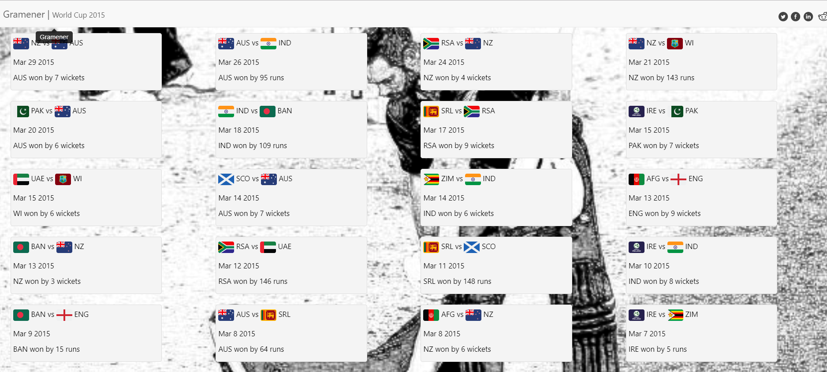

Screen 1

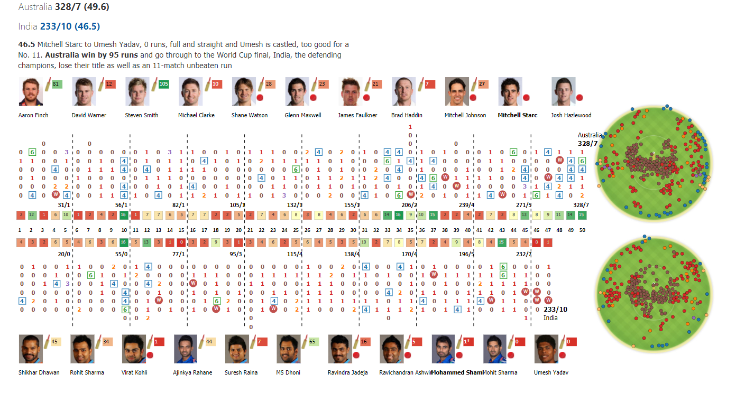

Screen 2