**Question 1: Sparse AutoEncoder**

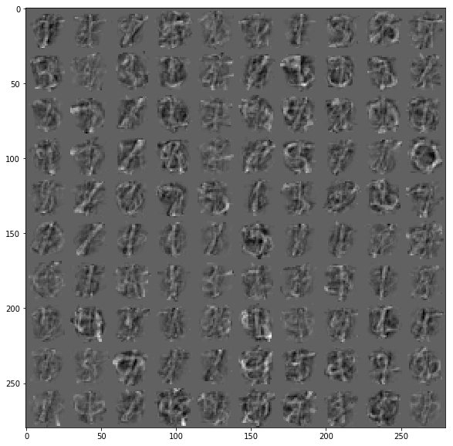

p = 0.01

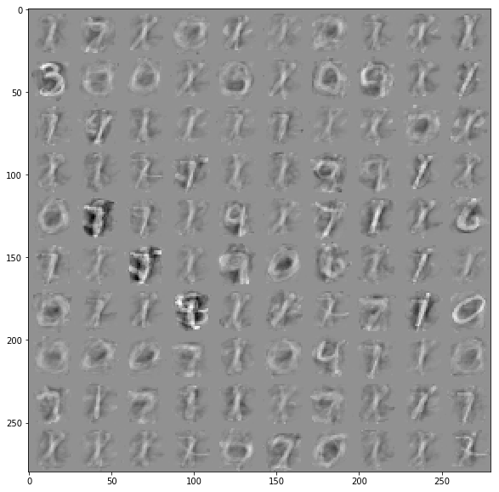

p = 0.1

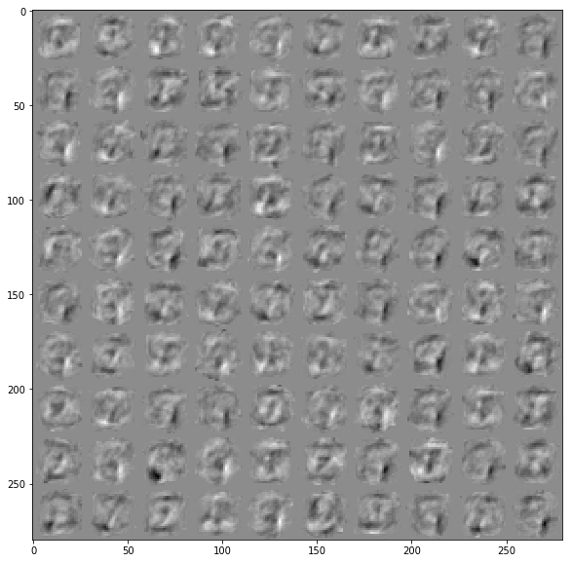

p = 0.5

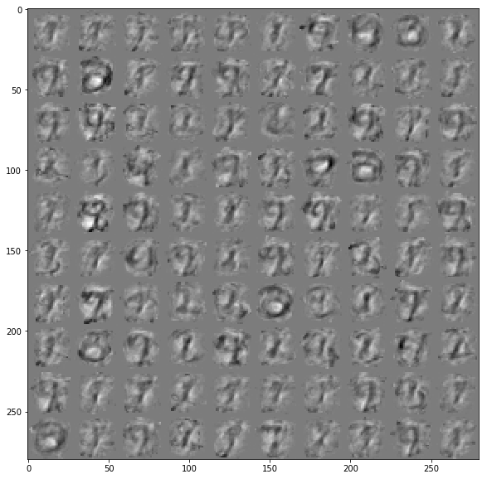

p = 0.8

Question 2.

Accuracy for 3 layer fully connected layer: 86.26

Accuracy for semi supervised learning: 66.04