For **Sportradar**

By Sagar Patil

Prepared for

Sportradar

Table of Contents

1. Introduction 3

2. About This Release 3

3. Compatible Products 4

4. Installation 4

5. Known Bugs and Limitations 4

5.1 General Note: 4

6. Application some Screens for reference 4

6.1 Home Screen: 4

6.2 Sport Event Calendar filters 5

7. Artifacts and reference Documents 9

7.1 Database Tables structure files 9

7.2 ERD 9

7.3 Application screens 9

7.4 Requirement Document 9

Sportradar Coding challenge

Introduction

The document communicates the Sportradar Coding challenge release. Basically this application built with using latest PHP Object oriented programming. Used bootstrap, HTML5, CSS3 3rd-party library as support and Mysql.

# About This Release

This release covered requirement from application.

* Refer Sportradar coding challenge requirement document. I followed all requirements tasks and rules.

Path: **Documents**/**Homework_Web_Developer_SR_EN.pdf**

* Database Models:

1. Sports
2. Leagues
3. Teams
4. Locations
5. Events

* Rules:

This application developed by following components.

1. Used MySQL 8.0.18 for solution.
2. PHP 7.4.1 used for solution.
3. Utilized 3rd-party library for date range filter.
4. Created dynamic filter for display sport events
5. Drawn ERD diagram
6. Application available in Docker Compose Setup
7. User version controlling system GIT.
8. Handled error exceptions.
9. Follow PHP coding standard (PSR)
10. Utilized OOPS concept.
11. Application Security.
12. Balanced load in DB and PHP.
13. Designed API.

# Compatible Products

This product has been tested and developed on the following platforms or with the following products:

* This product has tested on Windows 10 and Google chrome 76, Classic MAC OS and Google chrome 79.0
* PHP Version 7.4.1
* Mysql 8.0.18
* Apache/2.4.43 (unix) OpenSSL/1.1.1d
* Docker desktop 2.1.0.5
* Git version 2.20.1

# Installation

* Please refer README.md file.
* Path: Sportradar/README.md

# Known Bugs and Limitations

## General Note:

* Initial page loading I am loading all sport event(s) greater than or equal to Now (current date and time).
* You can user dynamic filter to filter sport events.
* If you apply filter(s) **Game status** or **Date range** then all sport events get populated (Old, current or feature).
* If you apply filter(s) with **Sport, team, location** then only current and feature events will get populated

# Application some Screens for reference

## Home Screen:

<http://localhost/sportradar/index.php>

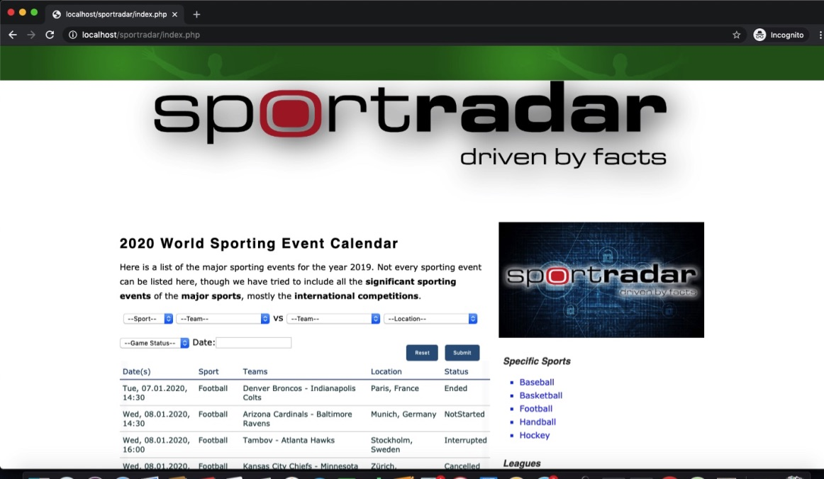

## Sport Event Calendar filters

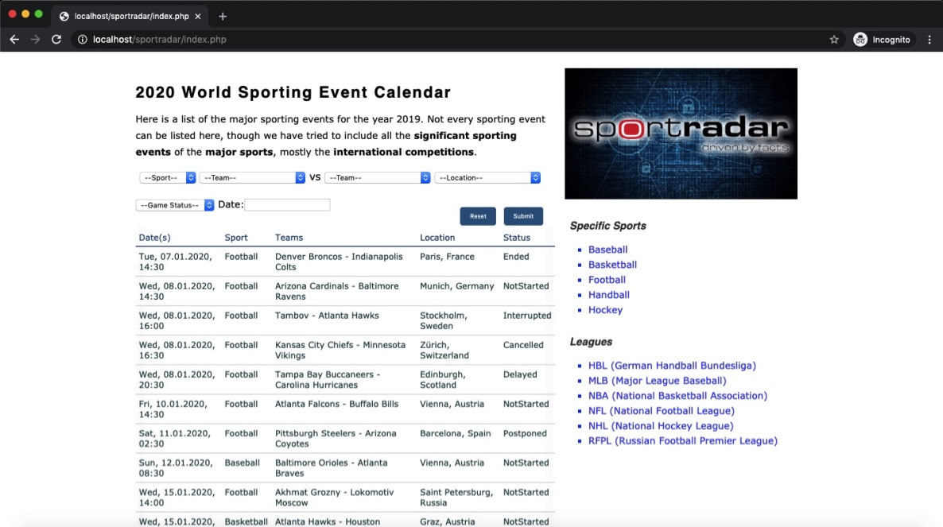

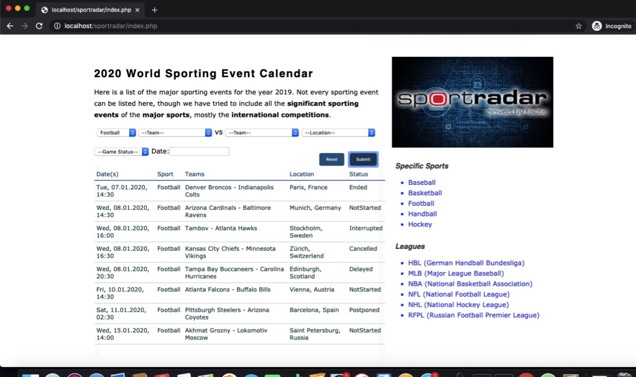

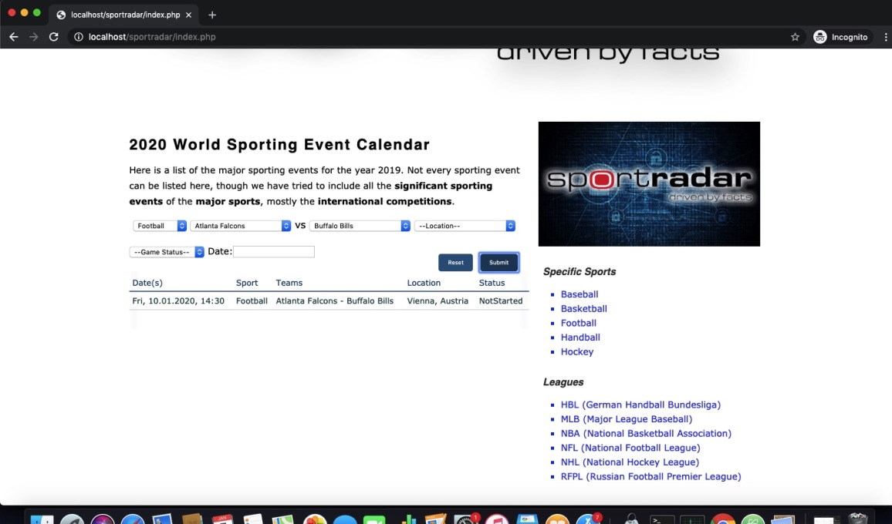

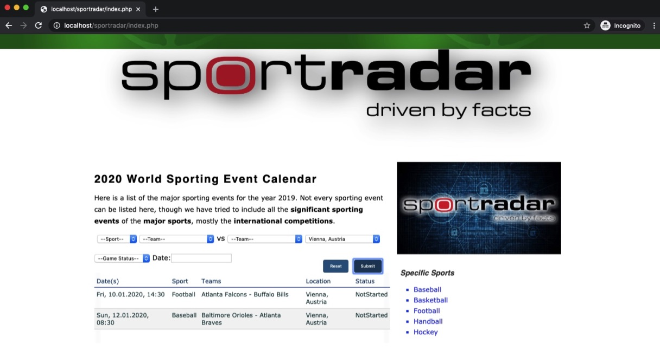

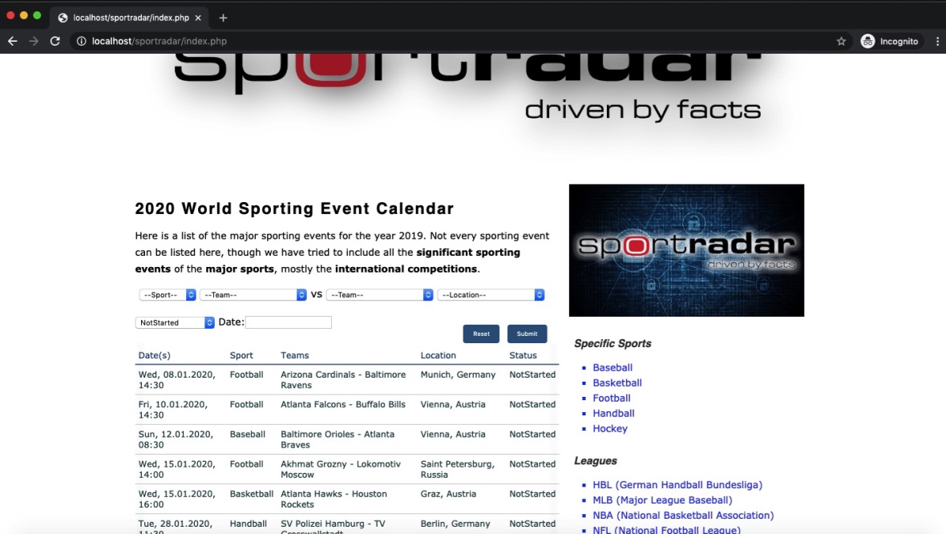

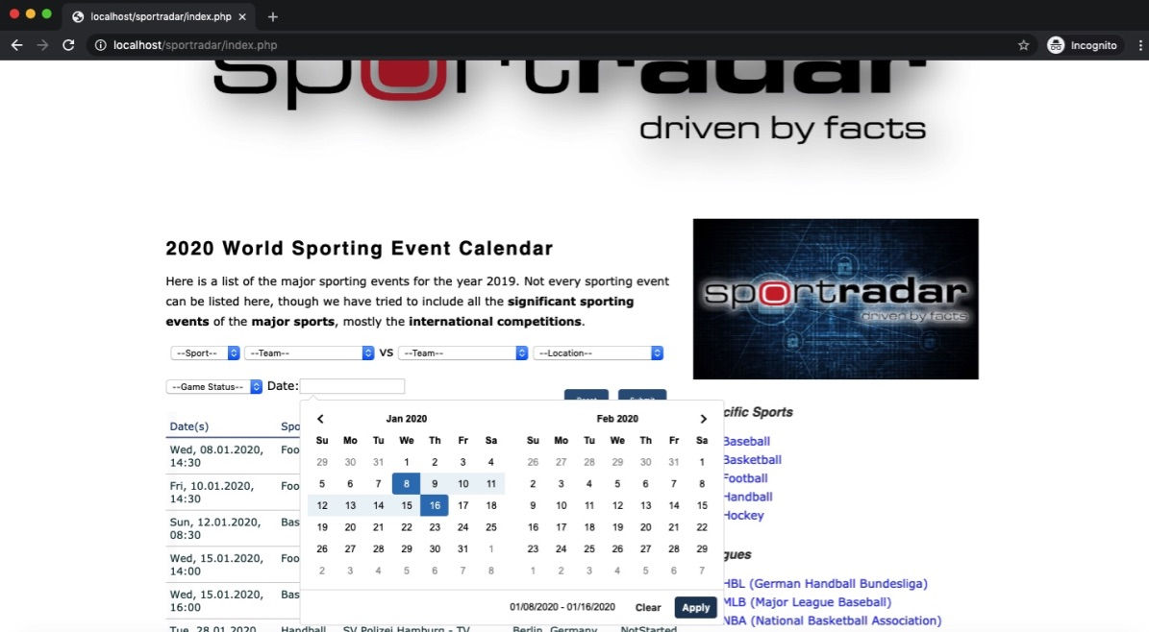

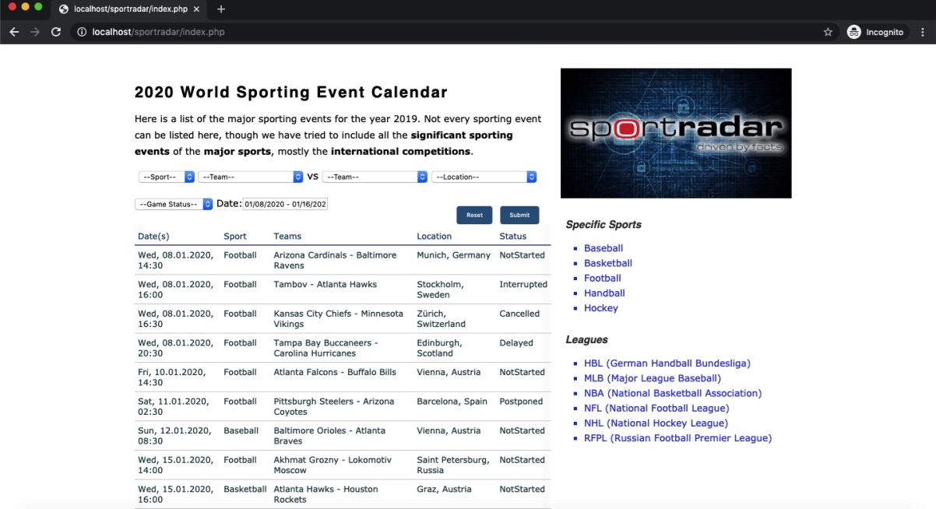

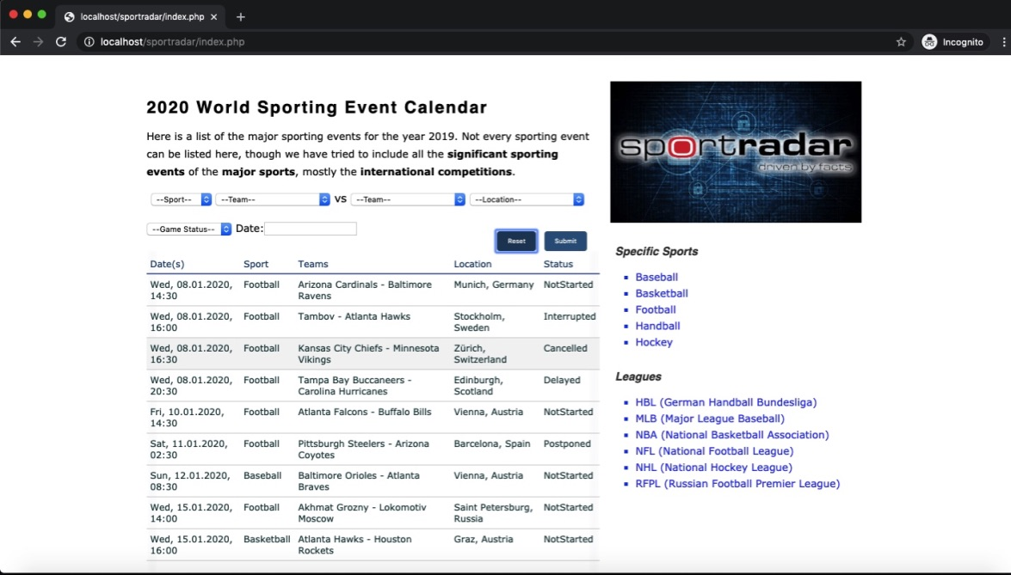

# Artifacts and reference Documents

Please refer Documents folder for Artifacts/reference.

## Database Tables structure files

Folder Path: Documents\ DB\sportradar.sql

## ERD

Folder Path: Documents\ ERD\Entity Relationship Diagram –Sportradar.pdf

## Application screens

Folder Path: Documents\Application Screens

## Requirement Document

Path: Documents\ Homework_Web_Developer_SR_EN.pdf

Revision History

| Version | Date | Summary of Changes | Author | Revision Marks (Yes/No) |
| --- | --- | --- | --- | --- |
| 0.1 | 07-Jan-2020 | Initial revision. | Sagar Patil |  |
|  |  |  |  |  |
|  |  |  |  |  |