Generative Language Model:

1. Text -> Text

Generative Image Model:

1. Image -> Image
2. Text -> Image
3. Image -> Text

ULM fit Research paper :

BERT - <https://arxiv.org/pdf/1810.04805.pdf>

GPT : <https://d4mucfpksywv.cloudfront.net/better-language-models/language-models.pdf>

How GPT is trained –

<https://www.linkedin.com/pulse/discover-how-chatgpt-istrained-pradeep-menon/>

Transformer –

<https://jalammar.github.io/illustrated-transformer/>

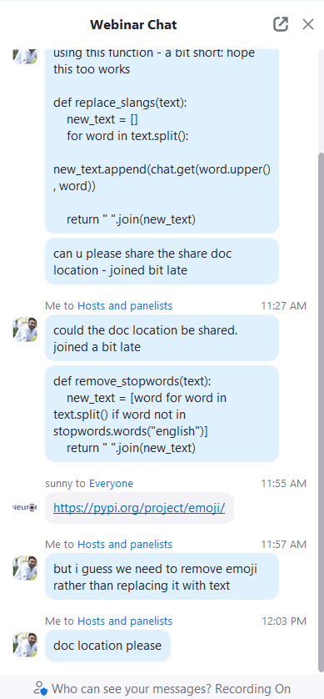

Shared DOC:

<https://docs.google.com/document/d/1nkKsY-ACTXQMVl42iat-ERO1tHIRcESm3AOSU5iLbcw/edit>