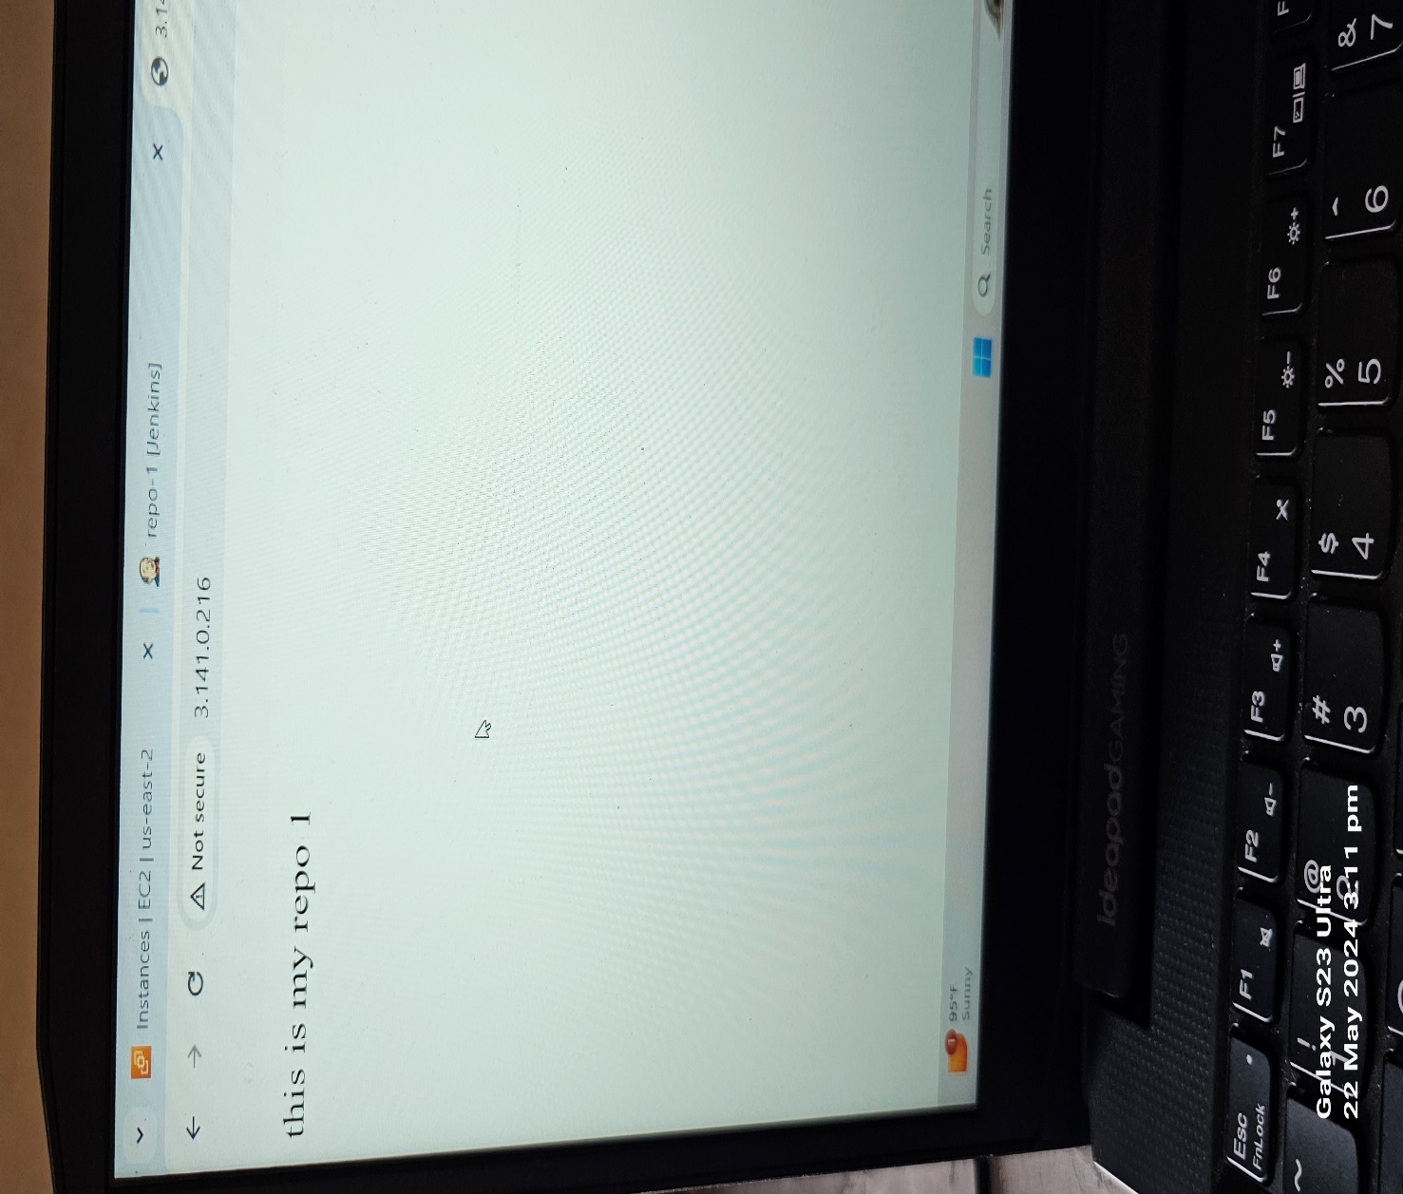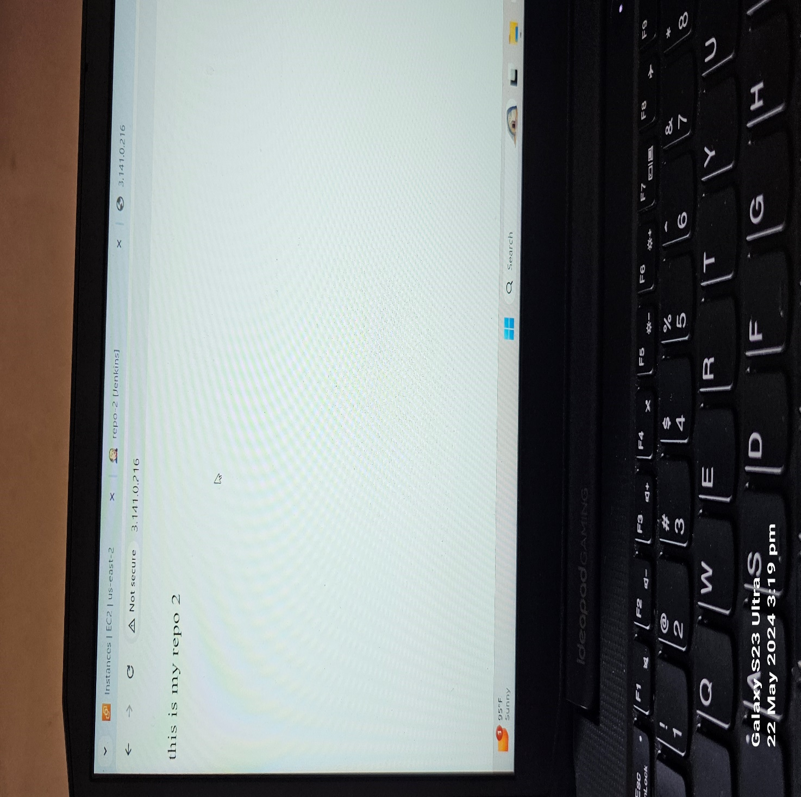



Step for build the project job-1

1.discard old build 5

2.use custom workspace /root/repo-1 (for job2 job3 change repo-2,repo-3

3.scm- repo url and credentials

4.build env. – delete workspace before build start)

5.build step-excute shell- for 1st job

Yum install httpd -y

Service httpd start

Cd /var/www/html

Cp -r /root/repo-1/index.html . (for job2 job3 change repo-2,repo-3)

Chmod -R 777 /var/www/html/index.html