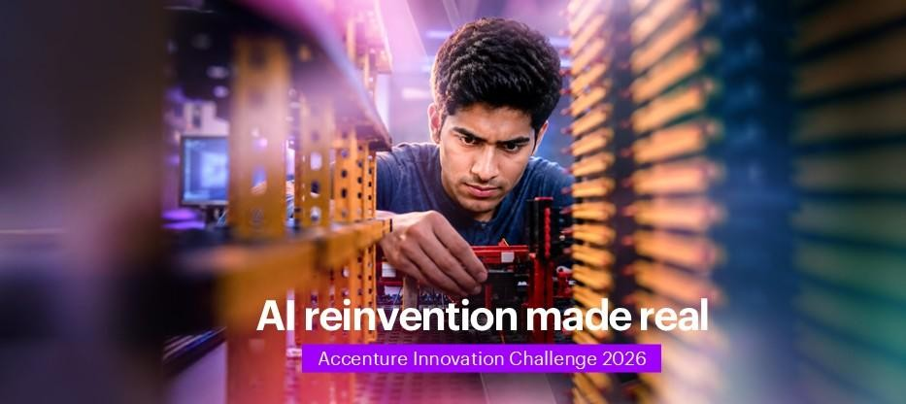
Round 2 - Prototype Development

Congratulations on advancing to Round 2. You've already pitched an initial concept for one of the four problem statements — now it's time to go deeper. This document expands your chosen track with the real-world complexity that companies grapple with, along with a broader option for solutioning areas you might explore. It is still intentionally open: there is no single "correct" architecture, and you are not expected to have access to a real company's proprietary data. Use reasonable assumptions and focus on innovation, creativity, and technical novelty.
Each problem track below expands on its Round 1 brief with deeper context, the real complexities such problems present inside real organizations, and a broad set of solutioning areas you're free to draw from selectively — you are not expected to address every point listed.

PROBLEM TRACK 4

DigitalTwin.ai

Recap & Expanded Context
In Round 1, you explored a digital twin prototype for a vehicle assembly line that helps plant teams see where bottlenecks are forming and predict likely defects before they happen. In practice, most assembly lines are a patchwork of legacy and modern equipment, and any twin must work with uneven sensor coverage rather than a perfectly instrumented, ideal factory.
For Round 2, extend your concept into a fuller solution design, backed by a working prototype that demonstrates the core predictive mechanism on realistic (even if simplified or simulated) production data.

Real-World Complexities to Consider
- Assembly lines mix legacy and modern equipment, so sensor coverage is often inconsistent — some stations are richly instrumented, others rely entirely on manual checklists.
- Bottlenecks and defects often have multi-causal, intermittent root causes (equipment wear, operator variation, upstream part quality, environmental conditions) that are hard to isolate from data alone.
- Modifying live production systems (PLCs, line control logic) carries real operational risk, and most plants only allow retrofits during scheduled, infrequent maintenance windows.
- A defect introduced early in the line may not surface until a much later inspection point, by which time many downstream units may carry the same undetected issue — making root-cause tracing after the fact especially difficult.
- Different stakeholders need very different views of the same twin — a floor supervisor needs realtime, in-the-moment signals, a plant manager needs weekly planning trends, and leadership needs a rollout business case.
- Extending a solution beyond a single line or plant means accounting for real variation in layout, equipment vintage, and sensor maturity across different sites.
- Predictive claims must be validated against real outcomes over time — false alarms about defects that don't materialise can erode floor-level trust in the system quickly.

Solutioning Areas You Could Explore
- Modelling approach — what to represent explicitly (cycle time, torque, vibration, temperature, throughput) versus infer indirectly, especially at sensor-poor stations
- Predictive techniques — anomaly detection, statistical process control, physics-informed models, or ML-based bottleneck/defect prediction, and how you'd validate them before trusting their output
- Handling data gaps — how the twin stays useful at stations with partial or no instrumentation, including any low-cost sensing you might propose
- User experience — distinct views for a floor supervisor's real-time needs, a plant manager's planning needs, and leadership's investment case, from the same underlying model
- Integration approach — working around legacy PLCs, OT data and live-production constraints without disrupting ongoing operations
- Scalability & ROI — how a prototype built for one line could reasonably extend to other lines, plants, or sites with different starting conditions

Reference Parameters (Illustrative — Adapt Freely)
- Assume a mixed-model assembly line with roughly 30–50 stations across body construction, paint, and final assembly
- Assume meaningful but uneven sensor coverage — a majority of stations well-instrumented, a meaningful minority reliant on manual checks
- Assume production can only be paused for instrumentation changes during a small number of scheduled maintenance windows per year
These parameters are directional, not a fixed dataset — you're encouraged to make your own reasonable assumptions, state them clearly, and design a solution that would generalize beyond one specific company.

What Round 2 Asks You to Deliver
- Detailed Business Proposal — problem framing, solution design, target users, business case and impact, a phased roadmap, and key risks with mitigations
- Working Prototype — a functional demonstration of your solution's core mechanism. It does not need to be production-grade or use real enterprise data; a working proof-of-concept on illustrative or sample data is expected and encouraged
- Pitch Presentation — presenting both your proposal and prototype for us to evaluate

