AI Agent Assignment - Sagar Zujam

# SECTION 1: BASIC DETAILS

Name: Sagar Zujam

AI Agent Title / Use Case: AI Agent to help students plan and revise effectively for upcoming exams

# SECTION 2: PROBLEM FRAMING

1.1. What problem does your AI Agent solve?  
This AI agent helps students plan their exam preparation by generating revision schedules, suggesting study strategies, and recommending practice questions.

1.2. Why is this agent useful?  
It provides personalized support to students during stressful exam times, helping them organize topics and stay focused.

1.3. Who is the target user?  
Engineering college students preparing for end-semester exams.

1.4. What not to include?  
It doesn’t handle syllabus uploading or auto-fetching from external platforms to keep scope limited.

# SECTION 3: 4-LAYER PROMPT DESIGN

## 3.1 INPUT UNDERSTANDING

Prompt: "What subject or topic are you revising today? And when is your exam?"

Responsible for understanding user’s current intent and timeframe.

## 3.2 STATE TRACKER

Prompt: "You last revised [Topic] and your exam is on [Date]. Let’s continue from there. Ready?"

Helps agent simulate memory. Used system message to hold and refer back to user state.

## 3.3 TASK PLANNER

Prompt: "Based on remaining days and topics, create a day-wise revision plan and recommend practice strategies."

Breaks down revision plan into a daily structure. Uses logical chaining for study suggestions.

## 3.4 OUTPUT GENERATOR

Prompt: "Here’s your Day 1 Plan: [List]. Would you like reminders or quiz suggestions too?"

Output is user-friendly, checklist format, offering interactive options.

# SECTION 4: CHATGPT EXPLORATION LOG

|  |  |  |  |
| --- | --- | --- | --- |
| Attempt | Prompt Variant | What Happened | What You Changed & Why |
| 1 | “Give me a revision plan” | Too generic | Added context about subject and exam date |
| 2 | “Plan for Data Structures exam on 14th” | Structured but no study techniques | Added suggestion to include practice methods |
| 3 | “Add quiz after each topic” | Included quiz section, but was too long | Asked to format as bullets |

# SECTION 5: OUTPUT TESTS

Test 1: Normal input  
Input: "Help me revise DBMS for tomorrow"  
Output: "Here’s your DBMS revision plan for today with focus topics and one mock test suggestion."

Test 2: Vague input  
Input: "I need help"  
Output: "Sure! Could you tell me which subject you’re preparing for and your exam date?"

Test 3: Empty input  
Input: ""  
Output: "Hi! Please type the subject or topic you’d like help with."

# SECTION 6: REFLECTION

6.1. Hardest part: Making the agent remember the last topic and simulate continuity.

6.2. Enjoyed most: Seeing how one prompt tweak improved the output dramatically.

6.3. Improvements: Add calendar sync and quiz auto-generation.

6.4. Learned: Prompt design is like programming logic — clarity matters.

6.5. Stuck moments: Got stuck on state memory, resolved by asking ChatGPT how to simulate session state.

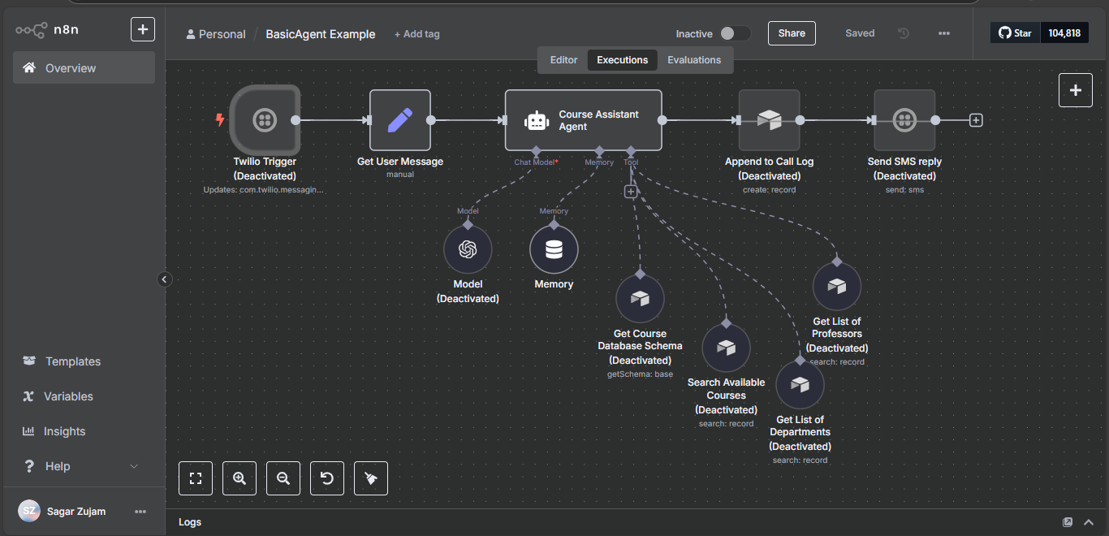

# SECTION 7: HACK VALUE

Tried branching logic — if user says “quiz”, agent gives multiple choice; else, shows summary. Also handled vague inputs with polite fallback.