1. What are the differences between operators and values in the following?

Operators are used to address basic calculations. Values are given to variables.

\* - It is a multiply operator which gives product of two entities.

'hello' – It is a string value

-87.8 – It is a float value

‘-‘ - is a subtraction operator

/ - is a division operator

+ - is a addition operator

6 – is a integer value

2. What is the difference between string and variable?

Spam – variable is an entity in which certain value is stored and also change value.

'spam' – String is a type of a value that is assigned to the variable.

3. Describe three different data forms.

1. Qualitative and Quantitative.

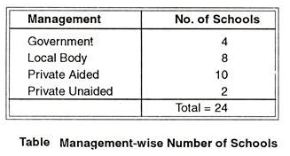

In table, number of schools has been shown according to the management of schools. So the schools have been classified into 4 categories, namely Government Schools, Local Body Schools, Private Aided Schools and Private Unaided Schools. A given school belongs to any one of the four categories. Such data is shown as Categorical or Qualitative Data.

Whenever the measurement of a variable or data is possible on a scale in some appropriate units, it is called a quantitative data. On such data, objects vary in magnitude and degree and the measurements indicate such variation. Examples of quantitative data are: age, height, income and intellectual ability etc.

2. Continuous and Discrete Data.

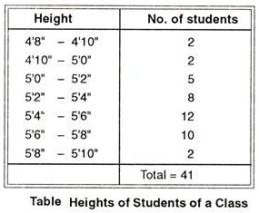

Such data are called Continuous Data, as the height is continuous. Continuous Data arise from the measurement of continuous attributes or variables, in which individual may differ by amounts just approaching zero. Weights and heights of children; temperature of a body; intelligence and achievement level of students, etc. are the examples of continuous data.

3. Primary and Secondary Data.

The data collected by or on behalf of the person or people who are going to make use of the data refers to Primary Data. For example, the attendance of children, the result of examinations conducted by you is primary data.

Sometimes an investigation may use the data already collected by some other person, such as the school attendance of children, or performance of students in various subjects, etc. for his/her study then the data are Secondary Data.

4. What makes up an expression? What are the functions of all expressions?

Expressions are used to describe an anonymous function. Expressions store the output of a function. Function expressions, on the other hand, do not hoist. If you try to run a function before you have expressed it, you will get an error.

5. In this chapter, assignment statements such as spam = 10 were added. What's the difference between a declaration and an expression?

Expressions are used to describe an anonymous function. Expressions store the output of a function.

Declarations are used to describe a named function.

6. After running the following code, what does the variable bacon contain?

bacon = 22

bacon + 1

Ans = 23

7. What should the values of the following two terms be?

'spam' + 'spamspam' = ‘spamspamspam’

'spam' \* 3 = ‘spamspamspam’

8. Why is it that eggs is a true variable name but 100 is not?

Variable name starts with a letter and not by number.

9. Which of the following three functions may be used to convert a value to an integer, a floating-point number, or a string?

10. What is the error caused by this expression? What would you do about it?

'I have eaten ' + 99 + ' burritos.'

Concatenate error – only one datatype can be concatenated here for example string. 99 needs to be converted to string

'I have eaten ' + str(99) + ' burritos.'