**INT217 Introduction to Data Management**

(Project Semester August-December 2022)

***Excel Dashboard - Call centre***

Submitted by

Sagar N Kolkar

12014228-RKM079A25

B. Tech -Computer Science and Engineering

Under the Guidance of

**Sameeksha Khare-26806**

**Discipline of CSE/IT**

**Lovely School of Science and Engineering**

**Lovely Professional University, Phagwara**



**CERTIFICATE**

This is to certify that Sagar N Kolkar bearing Registration no. 12014228 has completed INT 217(Introduction to Data Management) project titled, **“An Excel Dashboard - Call Center”** under my guidance and supervision. To the best of my knowledge, the present work is the result of his/her original development, effort and study.

**Signature and Name of the Supervisor**

**Sameeksha Khare - 26806**

**School of Computer Science and Engineering**

Lovely Professional University

Phagwara, Punjab.

Date: 10/11/2022

**DECLARATION**

I, Sagar N Kolkar a student of B.Tech Computer Science and Engineering under CSE/IT Discipline at, Lovely Professional University, Punjab, hereby declare that all the information furnished in this project report is based on my own intensive work and is genuine.



Signature

Sagar N Kolkar 12014228-RKM079A25

10/11/2022

**ACKNOWLEDGEMENT**

A project work is a combination of views, ideas, suggestions and contribution of many people. Thus, one of the pleasant parts of writing the report is to thank those who have contributed towards its fulfilment.

I consider it as great privilege to have esteemed Lecturer Ms. Sameeksha Khare as my project guide. I take this opportunity to express my sincere gratitude to him through constant advice and constructive criticism nourished my interest in the subject and provided a free and pleasant atmosphere to work against all odd situations. I avail this opportunity to extend my heart full thanks and deep respect to faculty member for their able guidance during this project.

My gratitude to all those, **who responded to my questionnaire** in a well-defined manner and helped me acquiring knowledge.

I would like to communicate a deep sense of gratitude to all these people without whom my project would not have been such a great learning experience.

Sagar N Kolkar

KM079-RKM079

12014228

10/11/2022

**Table of Content**

Cover page

Declaration

Abstraction

1. Introduction

2. Objectives/Scope of the Analysis

3. Source of dataset

4. ETL process

Analysis on dataset (for each analysis)

1. Introduction
2. General Description
3. Specific Requirements, functions and formulas and prediction models
4. Analysis results
5. Visualization

5. List of Analysis with results

6. References

7. Bibliography

**Abstraction**

Excel is a software program created by Microsoft that uses spreadsheets to organize numbers and data with formulas and functions. Excel analysis is ubiquitous around the world and used by businesses of all sizes to perform data analysis. Excel features calculation, graphing tools, pivot tables, and a macro programming language called Visual Basic for Applications, and several other features which make Excel a perfect choice to manage and analyze data. My project is an Excel Dashboard. The Excel Dashboard is used to display overviews of large data tracks. Excel Dashboards use dashboard elements like tables, charts, and gauges to show the overviews. The dashboards ease the decision-making process by showing the vital parts of the data in the same window. In this report, I have shared a project where I have done data analysis of an Call center dataset. This report also presents my learning during my course classes.

**1 – Introduction**

I have created an Excel Dashboard of an Call Center Data set. This Dashboard explains and highlights total calls, Average call/min, Abandon rate, Total calls and Total calls agent wise in a particular week.

The data set used contains information about Total calls during 2022. It includes information regarding answered call, abandoned call, agent, Department, average call time and ratings.

I have scrubbed and organized the entire data set and performed the analysis of a clean data set. I have deducted and calculated important results from the data set with help of various functions, conditional Formatting and represented them in the form a Interactive Dashboard using developer tools and various charts.

**2 – Objectives**

This project on Call center provides average call time , total calls agent wise, Abandoned rate , total calls week wise with respect to agent and abandon rate.

Main objectives that are discussed in the dashboard.

* Using scroll bar we can change week. According to week Total calls, Average answer speed, Abandon rate, Average calls/Minutes, Calls with score less than 3 and Calls answered in less than 180 seconds.
* Total number of calls in a week, Answered call, and Avg Speed with respect to Agent wise weekly.
* I have compared average call/min with respect to agent wise and presented it using Line chart with markers.
* I have shown call abandoned rate greater than 50% with respect to Department using combo charts.
* I have shown satisfaction score greater than 3.5 with respect to agent and if agent satisfaction rate is greater than 3.5, than smile emoji comes in front of the name in horizontal axis category. Presented this using combo chart.
* At last, I have calculated total calls abandoned agent wise and represented it using 3 d column chart.
* Using conditional formatting I have used icon sets to shown if the call resolution greater than 80% than it shows green arrow, if its less than 80% then it shows yellow circle and if its less than 69% it shows cross mark. I have presented call resolution according to day wise using line sparkline.
* I have inserted check button option using which we can sort Agent Name, Total calls, Calls Answered or calls resolution%.

**3 - Source of Dataset**

The dataset is taken from Kaggle. Kaggle is a community of data scientists and data enthusiasts. This platform allows users to find and publish data sets.

I have selected call center data set which contains details regarding agent wise calls answered, average call/min, Department agent wise, answered, not answered calls, abandoned calls and satisfaction rate.

Here are the specifics of the data collection I selected.

Name – Call center dataset

Link - <https://www.kaggle.com/datasets/ashishpandey5210/call-center-dataset>

Author – Ashish Pandey

Format- xlsx file

No of Data sets – 1

Size – 325 Kb

No of Rows - 5001

No of Columns – 10

Data set: Data Fields

* Call Id
* Date
* Agent
* Department
* Answered(Y/N)
* Resolved
* Speed of Answer
* Average Talk Duration
* Satisfaction rating

**4 – ETL Process**

ETL is a process in Data warehousing, and it stands for Extract, Transform and Load. It is a process in which an ETL tool extracts the data from various data source systems, transforms it in the staging area, and then finally, loads it in the Data Warehouse system.

**Extraction**

The first step of the ETL process is extraction. In this step, data from various source systems is extracted which can be in various formats like relational databases, No SQL, XML, and flat files into the staging area. It is important to extract the data from various source systems and store it into the staging area first and not directly into the data warehouse because the extracted data is in various formats and can be corrupted also. Hence loading it directly into the data warehouse may damage it and rollback will be much more difficult. Therefore, this is one of the most important steps of ETL process.

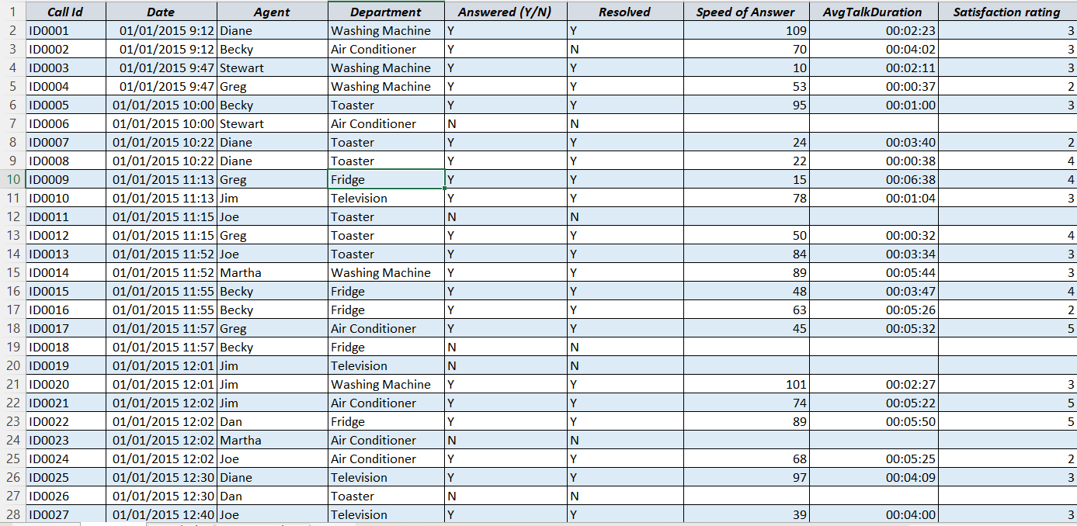

The raw data has been taken from Kaggle I directly downloaded xlsx as csv file was not given, before processing data it looked like this

**Transform**

The second step of the etl process is transformation. in this step, a set of rules or functions are applied on the extracted data to convert it into a single standard format. it may involve following processes/tasks: filtering – loading only certain attributes into the data warehouse. cleaning – filling up the null values with some default values, joining – joining multiple attributes into one. splitting – splitting a single attribute into multiple attributes. sorting – sorting tuples based on some attribute (generally key-attribute).

My data set was already transformed.

**Load**

The third and final step of the ETL process is loading. In this step, the transformed data is finally loaded into the data warehouse. Sometimes the data is updated by loading into the data warehouse very frequently and sometimes it is done after longer but regular intervals. The rate and period of loading solely depends on the requirements and varies from system to system

**Final Clean Data**

I have converted the data set into table format and applied style for table.

CLTL+T shortcut key

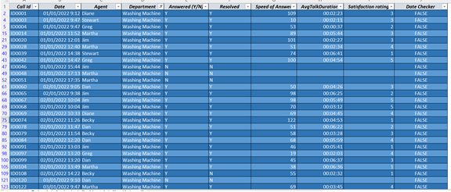

**5 – Data Analysis**

**Objective 1 – Changing the week using scroll bar.**

**Description - The objective is to change the week using scroll bar to calculate data week wise.**

**Requirements –**

* **Scroll bar**

**Steps to enable scroll bar**

* **To add Scroll bar first we must enable Developer option in the ribbon.**
* **To enable we must right click on the ribbon customize the ribbon then check the Developer option in main tabs.**

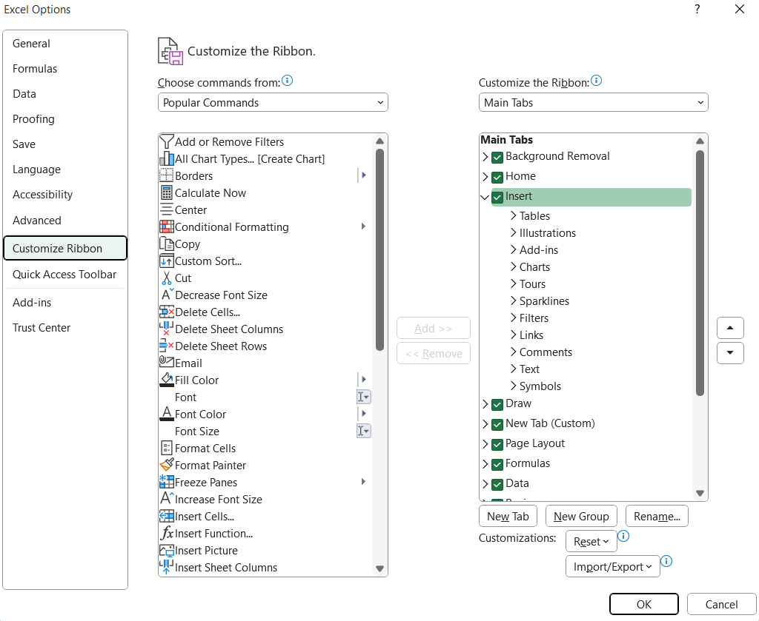

**To move the scroll bar, we must right click on the scroll bar and then select format control.**

**We have set incremental change to 1.**

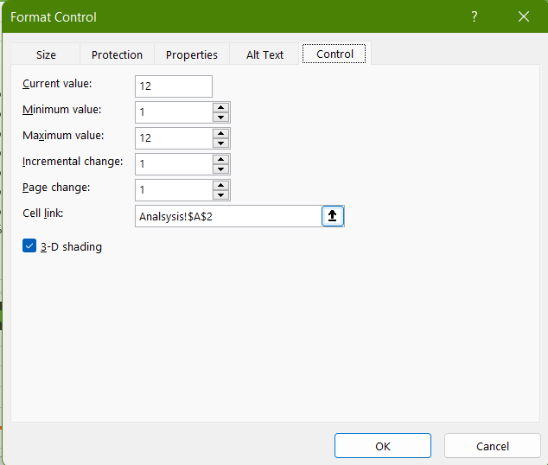

**Objective 2 – Showing the data according to week**

Description- I have added an extra column in main dataset which gives true false according to the week.

Formula to find the week according to which we calculate

=AND([@Date]>=Analsysis!$D$2,[@Date]<Analsysis!$D$2+7)

Formula to change date according to scroll bar incremental change

=DATE(2022,1,7)+7*(A2-1)

To change week beside scroll bar with respect change I have used this formula

= "Week "&A2



To show the total calls, Average answer speed, Abandon Rate, and Avg Call/Min.

According to the date check the values are calculated.

Formulas:

Total calls: =COUNTIF(Central_data[Date Checker],TRUE)

Average answer speed: = SUMPRODUCT(--(Central_data[Date Checker]=TRUE),Central_data[Speed of Answer])/B4

Abandon Rate: = (B4-B5)/B4

Avg call/Min: = B4/(7*9*60)

**Objective 3 – Showing total no of calls.**

Description: Total number of calls in a week, Answered call, and Avg Speed with respect to Agent wise weekly.

Requirements: Column chart to present it.

Formulas to calculate week wise calls according to agent.

=SUMPRODUCT((INT(Central_data[Date])=($D$2+COLUMNS($A$32:A32)-1))*(Central_data[Agent]=$A32)*(Central_data[Resolved]="Y"))

Data calculated

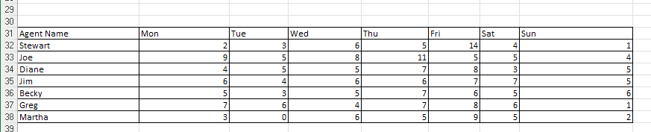

Data shown in dashboard using column chart

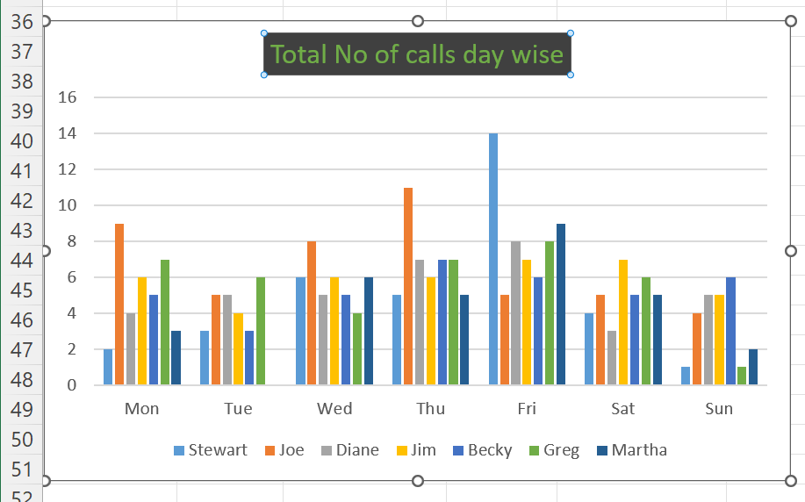

**Objective 4 – To sort the data using check box.**

Description: sorts the data according to the checkbox ticked in Total calls, Calls answered, Avg speed and Call Resolution.

Requirements: Check button.

Formulas to sort.

=IF($B$2=3,SMALL($J$16:$J$22,ROWS($J$16:J16)),LARGE($J$16:$J$22,ROWS($J$16:J16)))

=MATCH(K16,$J$16:$J$22,0)

=INDEX($A$16:$E$22,MATCH($M16,$A$16:$A$22,0),COLUMNS($L$14:M16))

Added checkbutton from developer.

Also added Call Resolution trend day wise using sparkline lines.

Values changes according to week.

Values shown and calculated.

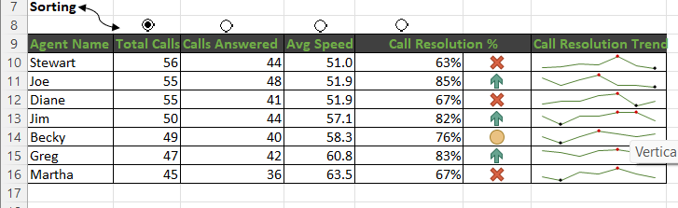

**Objective 5 – Call Abandoned Rate.**

* Description: I have shown call abandoned rate greater than 50% with respect to Department using combo charts.
* Requirements: Combo chart.
* Formulas to Calculate:

=(Total calls-calls abandoned)/Total calls.

Data calculated.

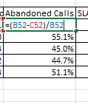

Data shown in dashboard using combo chart.

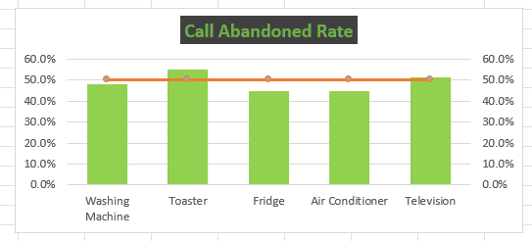

**Objective 6 – Call Abandoned agent wise.**

* Description: I have calculated the total calls rejected and shown it using 2d column chart
* Requirements: 2d column chart.
* Formulas to Calculate:

=Total calls(agent wise)-Calls Answered(agent wise).

Calculated Data agent wise.

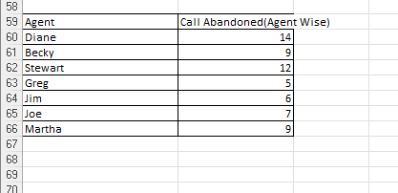

Data shown in dashboard using 2d column chart.

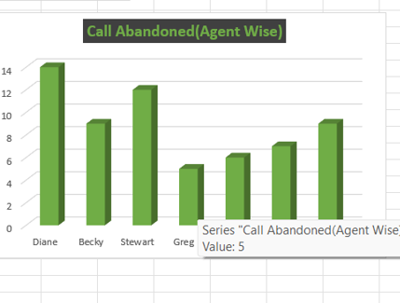

**Objective 6 – Call Abandoned agent wise.**

* Description: I have compared average call/min with respect to agent wise and presented it using Line chart with markers.
* Requirement: line chart
* Formulas To calculate average call/min.

=Total calls(agent wise)/(7*9*60)

Calculated Data agent wise.

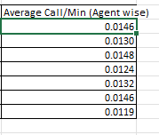

Data shown in dashboard using line chart.

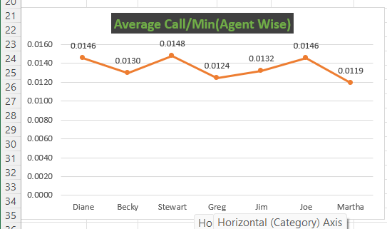

**Objective 6 – Conditional Formatting**

* Description: I have shown satisfaction score greater than 3.5 with respect to agent and if agent satisfaction rate is greater than 3.5, than smile emoji comes in front of the name in horizontal axis category. Presented this using combo chart.
* Requirement: combo chart
* Formulas To calculate.

=SUMPRODUCT((Central_data[DateChecker]=TRUE)*(Central_data[Agent]=$A42),(Central_data[Satisfaction rating]))/O16.

* =IF(B42>=C42,$A$49&" "&A42,A42) To shown smiley emoji if satisfaction score is greater than 3.5, I have used the formula
* Requirement: line chart

Calculated Data agent wise.

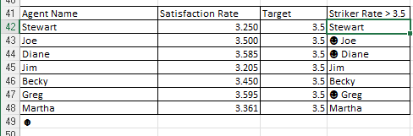

Data shown in dashboard using combo chart. 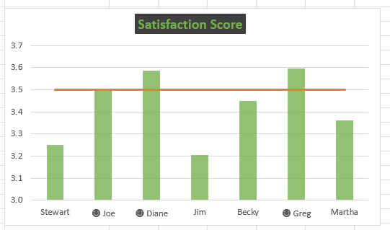

**Objective 7 – Calls with score less than 3 and Calls answered in less than 180 seconds.**

* Description: Calculated total calls with score less than 3 and calls answered. Then represented in dashboard
* Requirement: alt text
* Formulas To calculate.

Calls less than 180 seconds=SUMPRODUCT((Central_data[DateChecker]=TRUE)*(Central_data[AvgTalkDuration]<TIME(0,3,0))*(Central_data[Answered (Y/N)]="Y"))

Satisfaction less than 3 = SUMPRODUCT((Central_data[Date Checker]=TRUE)*(Central_data[Satisfaction rating]<=3)*(Central_data[Answered (Y/N)]="Y"))

Calculated Data weekly.

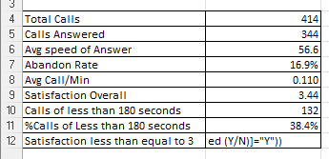

Data shown in dashboard.

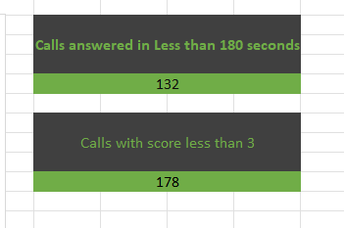

**Objective 7 – Call Resolution greater than 80% and day wise call resolution.**

* Description: Using conditional formatting I have used icon sets to shown if the call resolution greater than 80% than it shows green arrow, if its less than 80% then it shows yellow circle and if its less than 69% it shows cross mark. I have presented call resolution according to day wise using line sparkline.
* In Call resolution Trend I have shown the high point.
* Requirements: Conditional Formatting and Sparkline lines.

Data shown in dashboard.

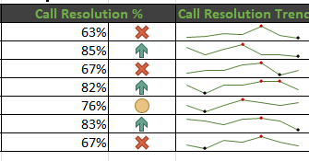

**List of Analysis with results**

* Using scroll bar we can change week. According to week Total calls, Average answer speed, Abandon rate, Average calls/Minutes, Calls with score less than 3 and Calls answered in less than 180 seconds.
* Total number of calls in a week, Answered call, and Avg Speed with respect to Agent wise weekly.
* I have compared average call/min with respect to agent wise and presented it using Line chart with markers.
* I have shown call abandoned rate greater than 50% with respect to Department using combo charts.
* I have shown satisfaction score greater than 3.5 with respect to agent and if agent satisfaction rate is greater than 3.5, than smile emoji comes in front of the name in horizontal axis category. Presented this using combo chart.
* At last, I have calculated total calls abandoned agent wise and represented it using 3 d column chart.
* Using conditional formatting I have used icon sets to shown if the call resolution greater than 80% than it shows green arrow, if its less than 80% then it shows yellow circle and if its less than 69% it shows cross mark. I have presented call resolution according to day wise using line sparkline.
* I have inserted check button option using which we can sort Agent Name, Total calls, Calls Answered or calls resolution%.

**Main Formula used to calculate values**

SUMPRODUCT: The **SUMPRODUCT** function returns the sum of the products of corresponding ranges or arrays. The default operation is multiplication, but addition, subtraction, and division are also possible.

Syntax: **=SUMPRODUCT (array1, [array2], [array3], ...)**

IF: The **IF** function is a premade function in Excel, which returns values based on a **true** or **false** **condition**.

Syntax = IF (**logical_test**, **[value_if_true]**, **[value_if_false]**)

INDEX: The INDEX array form returns the value of a certain element in a range or array based on the row and column numbers you specify.

Syntax = INDEX**(array, row_num, [column_num])**

**Match:** The MATCH function is used to determine the position of a value in a range or [**array**](https://exceljet.net/glossary/array).

Syntax = MATCH( value, array, [match type] )

Large: Used to calculate large value in a array.

Syntax = LARGE(array,k)

Small: Used to calculate small value in array.

Syntax = SMALL(array,k)

**Final Dashboard**

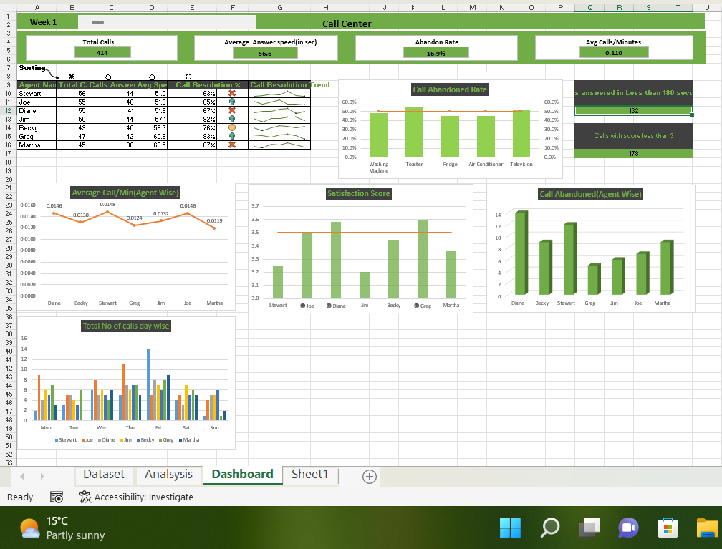

**References**

* [**https://www.kaggle.com/datasets/ashishpandey5210/call-center-dataset**](https://www.kaggle.com/datasets/ashishpandey5210/call-center-dataset)**.**
* [**https://excel-practice-online.com/**](https://excel-practice-online.com/)
* **https://www.geeksforgeeks.org/etl-process-in-data-warehouse/**

**Bibliography**

1. Microsoft Excel 2016 Bible: The Comprehensive Tutorial Resource by John Walkenbach, Wiley

2. Fundamentals of Business Analytics by R.N. Prasad, Seema Acharya, Wile