INDIVIDUAL REFLECTION

In a team-oriented environment, everyone contributes to the group's overall success. I collaborated with other members of the group to fulfill the tasks required. Having the proper individuals in the correct position is a crucial aspect in determining the success of a team, where I worked together with the other members to achieve the major objectives. One of the most essential things I've learned about working in groups is that individuals must be able to engage with one another in a healthy way by controlling their own and other people's emotions, as well as communicate effectively and work as a team.

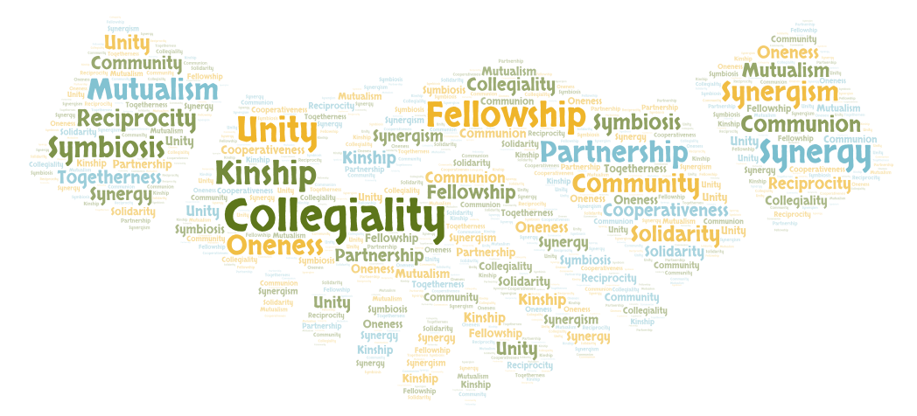

As a project, we were given the task of exploring the topic and designing industry-level software. Our group was made up of five individuals. Because we didn't know one other very well at first , one of the most challenging things was estimating how everyone's attitude toward working in a team was and how much effort each individual member would put into the project. My responsibility was to first suggest and then select a topic with the approval of the other team members. Furthermore, because only two of us had reviewed the criteria prior to our first group meeting, I had to describe what we were going to undertake. working on this project with great enthusiasm and passion I realized that if you want to be successful, you need a solid team and good teamwork. The most important thing is for your entire team to define a same aim and target.

We met on a regular basis, generally once a week, to discuss and review our progress. However, finding time to meet proved challenging due to everyone's hectic schedules and the several other assignments we all had going on at the same time. As a result, we established a group chat in which we could discuss our opinions, ideas, and issues.

We collaborated effectively. I was asked to design the frontend for the entire project. As I was familiar with React, I was able to develop amazing user interfaces. This project helped me become much more precise and educated to numerous other frontend languages and their working mechanisms in depth. After successfully accomplishing this assignment, I feel quite confident in working with different languages as frontend developer in the future.

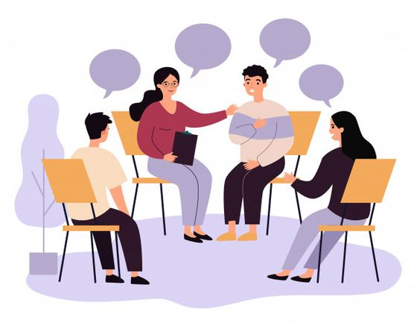

Working as a team was a wonderful experience. We had a successful project since we were able to use all of the tools and figures described in the proposal. Furthermore, we incorporated a few advanced options and ideas that were not included in our proposal. This project gave me more confidence in frontend programming than I had ever had before, and it taught me about numerous methods for developing user interfaces to improve interaction. This appeared to be a well-rounded assignment, and this type of real-world project assisted our small group in becoming more structured, as well as providing us with a framework for solving real-world problems using the information we had.