Moving Average Filter

TEST RESULTS:

NUMBER OF LUT'S | 362
NUMBER OF IO'S | 24
CRITICAL PATH DELAY | 28.198ns, postroute delay=2.037 ns

IO-Plot

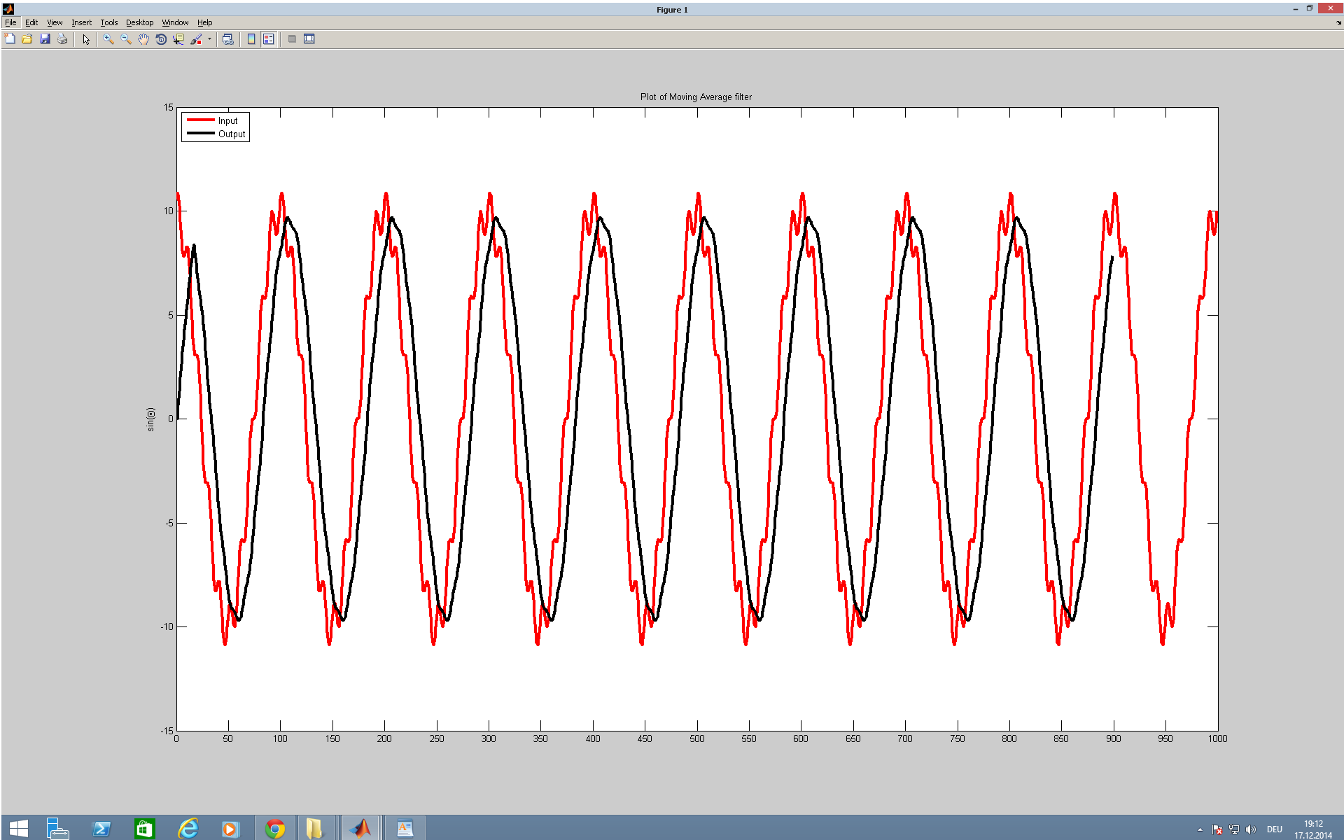

Maximum operating frequency=1/28.198(ns) =35 MHz

We are able to achieve the target 10MHz at which the circuit can clock

For post-route simulation and behavioral simulation, please refer

postroutemovingaverage.png
&
behaviorialmovingaverage.png

respectively.

