HOSPITAL MANAGEMEMENT AND INFORMATION SYSTEM

Shreyans Jain(12co86)
S Sharankumar (12co73)
Pawan M (12co62)

CONTENTS

1. Introduction
1.1 Problem definition
1.2 Drawbacks of existing system
1.3 The need for new system
1.4 Proposed system

2.Requirements

2.1 Requirement Tools

3.Design and Development

3.1 Design Tools

3.2 Development Tools

3.3 Database Tools

3.4 Web Servers

5.Conclusion

6. Bibliography

1. INTRODUCTION

1.1 PROBLEM DEFINITION
The manual handling of the record is time consuming and highly prone to error. The purpose of this project is to automate or make online, the process of day-to-day activities like Admission of New Patient, Discharge of Patient, Assign a Doctor, and finally compute the bill etc.

We have tried our best to make the complicated process Hospital Management System as simple as possible using Structured & Modular technique & easy to use interface. We have tried to design the software in such a way that user may not have any difficulty in using this package & further expansion is possible without much effort. Even though we cannot claim that this work to be entirely exhaustive, the main purpose of my exercise is perform each Hospital’s activity in computerized way rather than manually which is time consuming.

1.2 DRAWBACKS OF CURRENT MANUAL- SYSTEM

- The current manual system has a lot of paper work .
- To maintain the records of sale and service manually, is a Time-consuming job.
- With the increase in database, it will become a massive job to maintain the database.
- Requires large quantities of file cabinets, which are huge and require quite a bit of space in the office, which can be used for storing records of previous details.
- The retrieval of records of previously registered patients will be a tedious job.
- Lack of security for the records, anyone can disarrange the records of your system.
- If someone wants to check the details of the available doctors the previous system does not provide any necessary detail of this type.

1.3 THE NEED OF NEW SYSTEM

- Problem of Reliability: Current system is not reliable. It seems to vary in quality from one month to the, next. Sometimes it gives good output, but some times the output is worst.
- Problem of Accuracy: There are too many mistakes in reports.
- Problem of timeliness: In the current system the reports and output produced is mostly late and in most of the cases it is useless because it is not on time
- Problem of Validity: The output and reports mostly contains misleading information. The customer's information is sometimes not valid.
- Problem of Economy: The current system is very costly. We have to spend lots of money to keep the system up and going, but still not get the desired results.
- Problem of Capacity: The current system is suffering from problem of capacity also. The staff for organization is very less and the workload is too much. Few peoples cannot handle all the work.

1.4 PROPOSED SYSTEM

l. Employee Details: The new proposed system stores and maintains all the employees details.
2. Calculations: The new proposed system calculates salary automatically and it is very fast and accurate.
3. Registers: There is no need of keeping and maintaining salary and employee register manually. It remembers each and every record and we can get any report related to employee and salary at any time.
4. Manpower: The new proposed system needs less manpower. Less people can do the large work.
5. Efficiency: The new proposed systems complete the work of many salesperson in less time.
7. Reduces redundancy: The most important benefit of this system is that it reduces the redundancy of data within the data.
8. Work load: Reduces the work load of the data store by helping in easy updates of the products and providing them with the necessary details together with financial transactions management.
9. Easy statements: Month-end and day-end statement easily taken out without getting headaches on browsing through the day end statements.
2. REQUIREMENTS

In product development and process optimization, a requirement is a singular documented physical and functional need that a particular design, product or process must be able to perform. It is most commonly used in a formal sense in systems engineering or software engineering .It is a statement that identifies a necessary attribute, capability, characteristic, or quality of a system for it to have value and utility to a customer, organisation, internal user, or other stakeholder. A specification (often abbreviated as spec) may refer to an explicit set of requirements to be satisfied by a material, design, product, or service

Requirement Tool we used here was RTH i.e. Requirement and testing Hub. Which is a Web application build in PhP which can either be used online or can be used on the local computer with the help of xampp.

3. DESIGN

Systems design is the process of defining the architecture, components, modules, interfaces, and data for a system to satisfy specified requirements. Systems design could be seen as the application of systems theory to product development.

3.1 Design tools
Argo UML
ArgoUML is an UML diagramming application written in Java and released under the open source Eclipse Public License. By virtue of being a Java application, it is available on any platform supported by Java.
This is one of simplest tools available to design a system. It has a simple user interface and provides the user with options of creating many UML diagrams which aid a programmer/team working on a project to understand the requirements better and to design a structure for the product.

1.Use case diagram

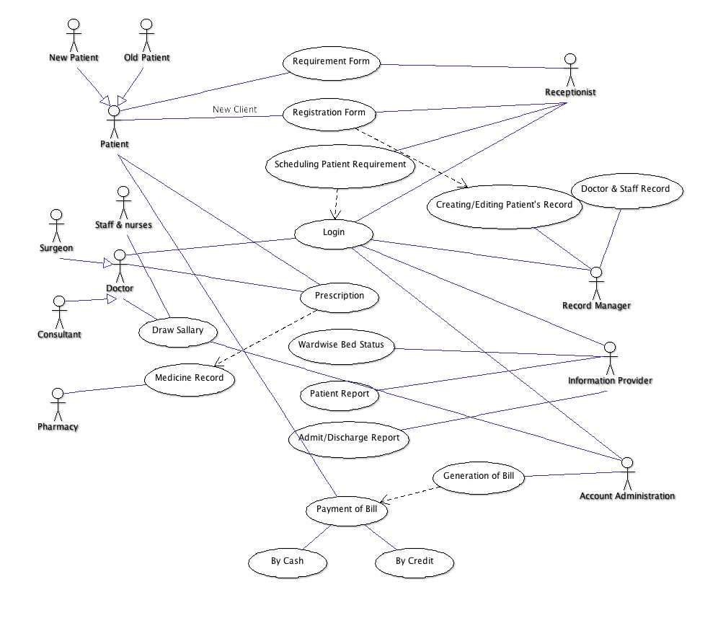

2.Class Diagram

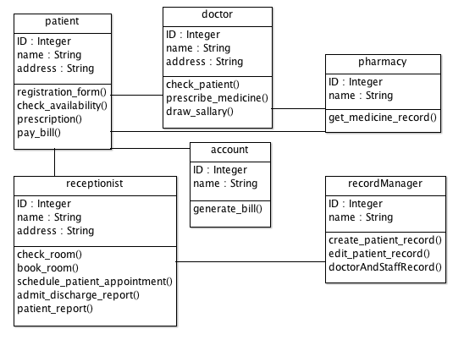

3.State Diagram

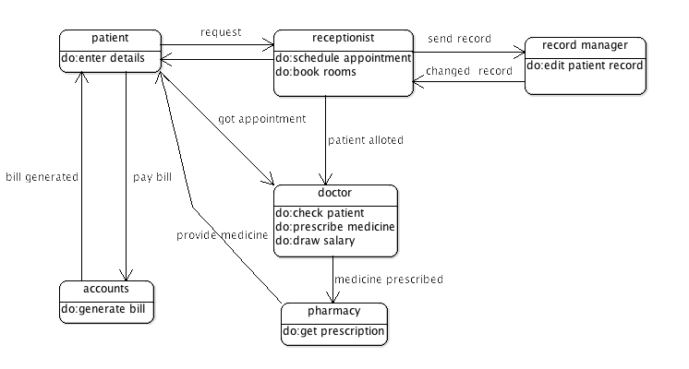

4.Sequence Diagram

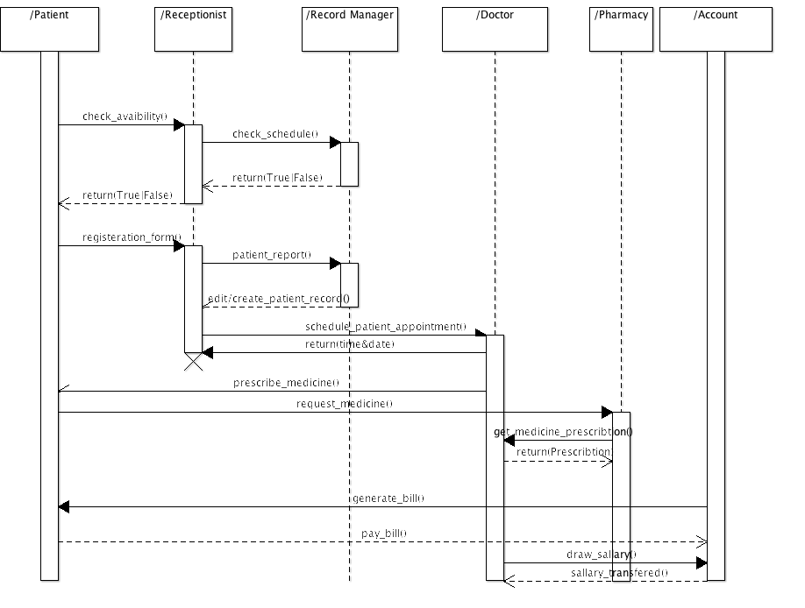

3.2 Development tools
Netbeans
NetBeans is an integrated development environment (IDE) for developing primarily with Java, but also with other languages, in particular PHP, C/C++, and HTML5. It is also an application platform framework for Java desktop applications and others .The NetBeans IDE is written in Java and can run on Windows, OS X, Linux, Solaris and other platforms supporting a compatible JVM.

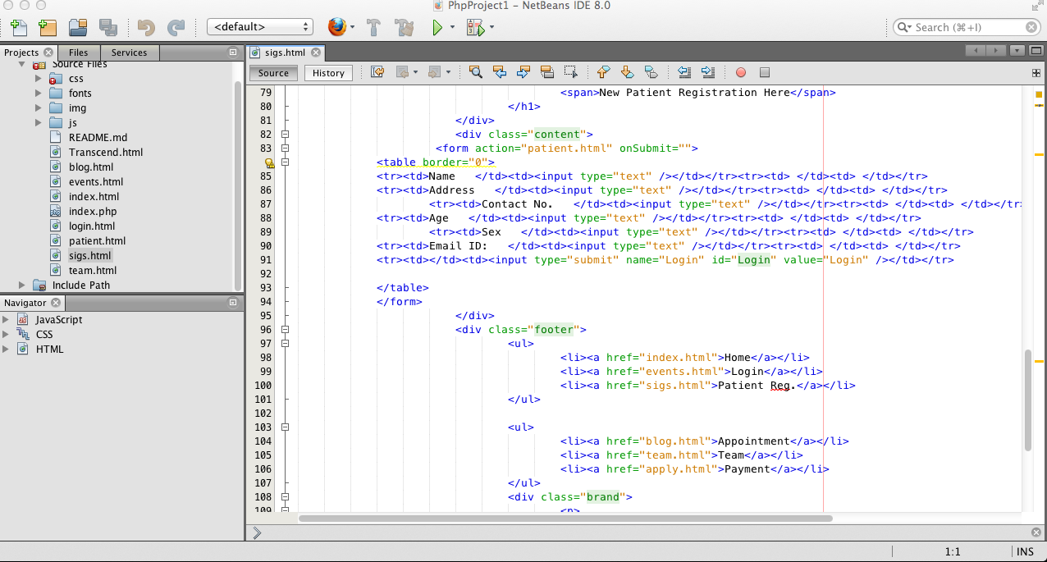

3.3 Database Tools
For Database management and creation we used MYSQL to create a an sql file and implemented it using phpmyadmin which is a feature in xampp,mamp,etc.
So it can be easily be setup in any of the servers by just importing the .sql file.
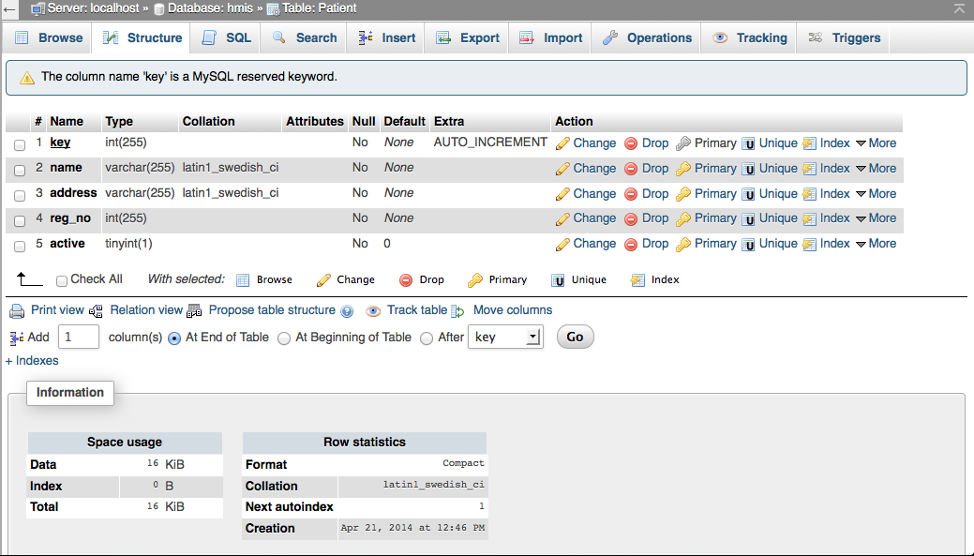

3.5 Web Servers
For web server we used an open source server Apache which comes with the combination of mysql & php by the name of XAMPP 1.8.3-2. Where
X=All Operating System Compatible
A=Apache
M=MYSQL
P=PHP 5.0
P=Perl
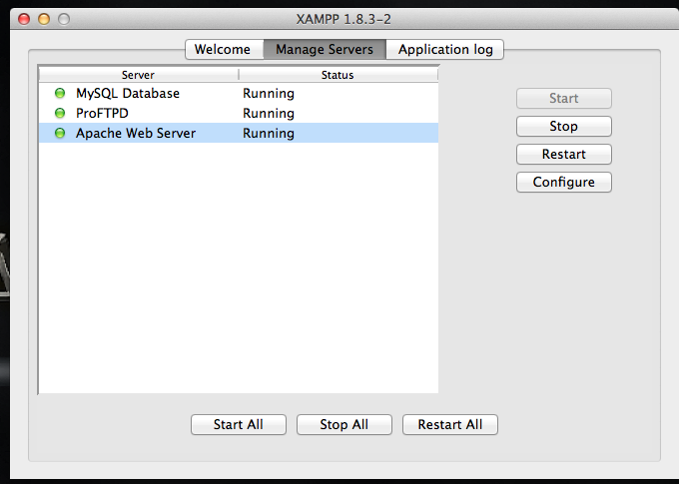

TESTING

One of the purposes of the testing is to validate and verify the system. Verification means checking the system to ensure that it is doing what the function is supposed to do and Validation means checking to ensure that system is doing what the user wants it to do.

CONCLUSION

- This project has been a rewarding experience in more than one way. The entire project work has enlightened us in the following areas.
- We have gained an insight into the working of the HOSPITAL. This represents a typical real world situation.
- Our understanding of database design has been strengthened this is because in order to generate the final reports of database designing has to be properly followed.
- Sense of teamwork has developed and confidence of handling real life project has increased to a great extent.

BIBLIOGRAPHY

1. Herbert Scheldt, Java Complete Reference, Fifth Edition, Tata McGraw Hill Edition.

2. Phil Hanna, JSP 2.0: The Complete Reference, Tata McGraw Hill Edition, 2003.

3. Ian Somerville, Software Engineering, Third Edition, Pearson Education.

4. Ali Bahrami, Object-Oriented System Development, Third Edition, Tata McGraw Hill Edition.

5. Ivan Bayross, SQL, PL/SQL programming language of Oracle, Second Edition, BPB Publication.

WEB REFERENCES

1. www.google.com
2. www.htmlcodetutorial.com
3.www.youtube.com

